

**Headteacher**

**Stoke Fleming Community Primary School**

**Candidate Information**





**Welcome from Education South West**

Dear Candidate

Thank you for your interest in Education South West - we are always on the lookout for exceptional talent to join us and contribute to our team of creative education professionals.

At Education South West we believe that education makes children’s lives better, it is as simple as that; it enables them to lead great lives in every sense of the word. We believe that every child has the right to achieve all that they are capable of and more, regardless of their background or raw ability.

Across all of our schools our staff aim to provide an educational experience which is outstanding; our schools all believe strongly in the power of and broad and balanced curriculum. Sport, art, technology drama and music play an important role in all of our schools.

We encourage innovation, creativity and individuality. By sharing this individuality and creativity we firmly believe that schools and communities become stronger through such unity and collaboration.

We are caring and compassionate. Every individual in our schools matters and we believe strongly that children and staff should enjoy their time at school, and work. A positive can-do attitude to their work and study is a must. The happier and more stimulated a person is the more motivated they are to improve.

We believe in developing a positive attitude to learning and to life, in having clear goals and in providing a supportive environment to help the realisation of these.

We support and challenge our school leaders and the staff in our schools to be the very best they can, leading effective teams at every level, growing future leaders and working together to provide an exciting education for all.

We welcome and support aspirational and ambitious teachers and classroom support staff, dedicated to supporting children through their time at school.

We offer excellent opportunities and professional development through in-school CPD, our Research School status, through our teaching schools and through our links with the wider education community. We are ambitious for our children and our employees and always looking to support, challenge and develop our talent, whatever stage you are in your career.

When recruiting staff to work with children we place great importance on:

* people who go the extra mile
* a commitment to professional development and a desire to continue learning, via research, private study and in learning from others
* a desire to ensure that everything that is done within schools is the very best it can
* a firm commitment to the philosophy that we work in education to improve young people’s lives and improve society; we serve our communities and the wider populace
* the ability to develop positive relationships with pupils, children and parents
* good interpersonal and communication skills when liaising with stakeholders
* a good sense of humour
* a commitment to working in partnership with others and sharing selflessly best practice within and outside of ESW

Your journey with ESW starts here and I look forward to meeting you in the future.

Yours faithfully,



**Matthew Shanks**

**CEO**

**Welcome from Graham Austin, Chair of the Board**

Dear Candidate,

Thank you for your interest in Stoke Fleming Community Primary School. I am delighted that you are considering joining the Education South West family and I hope that this information pack along with the school website gives you all of the information that you need to apply for the position of Headteacher.

ESW is the result of the merger of two MATs in January 2017. We have 12 schools spanning primary, all-through and secondary: over 5000 pupils and 600 staff in total.  The aim of the Trust is simple: to work together so that children can lead great lives.  We achieve this through collaboration and sharing of best practice at all levels but especially through the senior leadership teams. Stoke Fleming Community Primary School is a valuable part of the Trust. It is expected that its headteacher will make a significant contribution to the development of the other primary schools in the Trust.

We want to attract a high calibre of staff to ESW and we want them to progress. We want all of our staff to be exceptional and so offer unrivalled professional development and support.  Many of our senior and middle leaders started as teachers with us and have developed into highly talented practitioners. We offer internal and external training including participation in Teaching Schools South West and South West Teaching School - your professional development is important to us.

If you have a genuine desire to do the best for young people, then we would welcome your application.

Kind regards

**Graham Austin**

**Chair**

**Letter from Malcolm Wheatley, Chair of The South Hub Local Governing Body**

Dear Candidate,

On behalf of Education South West’s South Hub Primaries governing body, I’d like to thank you for your interest in Stoke Fleming Primary School, one of three rural village schools sharing a single governing body within Education South West.

As a school in a coastal village in the heart of Devon’s South Hams, Stoke Fleming Primary School is very much a genuine part of the local community, with an active and engaged parent body. The staff in the school put great energy and hard work into their day-to-day activities, while also devoting effort and thought to school improvement. They bring a wealth of experience and creativity to their roles, and work together as a strong team.

As governors, too, we’re passionate about driving and delivering excellence in our schools, but also passionate about celebrating each school’s individual character and distinctive culture.

We are now looking to appoint a passionate and committed Headteacher to help drive the school forward. The successful candidate will benefit from an engaged and supportive team of staff, a governing body with a keen interest in outcomes and excellence, an active parent body, and the support of the Education South West’s leadership, subject specialists, and resources.

Thank you in advance for the time that I know you will commit to this process.

Yours faithfully,

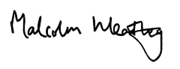

Dr Malcolm Wheatley

Chair of Governors

**THE POST**

We are looking for candidates who will:

* be innovative, determined and driven to constantly seek improvement for the children and communities that we serve

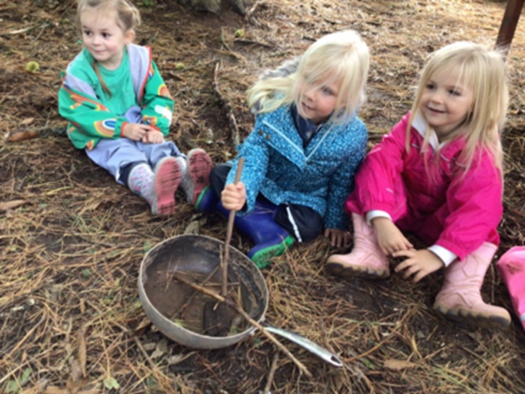

* have the creative flair and vision to maximize the resources of the school
* continue to promote the highest level of pastoral care
* have proven leadership, management and communication skills
* be proactive in engaging with other schools

This is a school that is embracing change whilst seeking to maintain all that led OFSTED to proclaim it “a good school” in 2022.  With the appropriate leader, Stoke Fleming will continue on its journey to becoming an outstanding one.

We can offer:

* the opportunity to lead a successful school as part of a successful and growing Multi Academy Trust
* challenge of developing and implementing a vision for the future of the school
* the opportunity of working with enthusiastic and well-behaved children
* a Trust which cares about its employees as well as its outcomes
* personalised CPD which is second to none as a leading part of South West Institute for Teaching and Kingsbridge Research School
* the opportunity to develop your career further as part of an expanding Trust
* a very supportive, dedicated and enthusiastic staff body

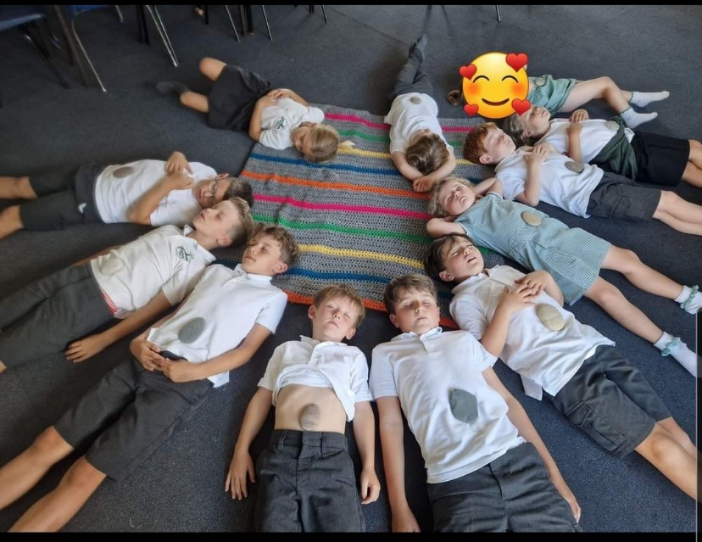

* a parent body committed to moving the school forward
* a highly effective, supportive and challenging Governing body
* the support of dedicated and experienced school leaders
* a shared services operation which cuts out the ‘white noise’ and enables our Headteachers to focus on running their school

Stoke Fleming Community Primary School is a popular, creative and vibrant school where children are enthusiastic about their learning. We have highly dedicated staff and committed governors who are seeking an exceptional Head Teacher to continue to lead our school.

The board of Education South West are looking to appoint an inspirational and dedicated Head Teacher to continue to emphasise the importance of our values of respect, resilience, responsibility and teamwork. We are looking for a Head Teacher who will continue to raise standards for all children and have the ability to communicate their vision effectively and engaging staff and the wider community in making it a reality.

If you think that you are a highly motivated, outward looking, passionate and creative person; one who wants to play a key role as part of a successful multi-academy trust, and is able to lead and inspire our team and make a difference to our children’s lives then we would be delighted to talk with you.

In return, we can offer you becoming part of a highly successful and growing Multi Academy Trust in a beautiful part of the country. Education South West and Stoke Fleming Community Primary School have a dedicated and hardworking staff team; pupils are well-behaved and have a love for learning.

Situated in a pleasant area of the South Hams, Stoke Fleming Community Primary is a fantastic place to work. With the coast on your doorstep and beautiful countryside within touching distance, the area has much to offer.

**ABOUT OUR SCHOOL**

​

**Our Pupils**

Our pupils are well motivated and responsible, and we receive many plaudits when they are out and about on visits or engaged in projects in the local community.

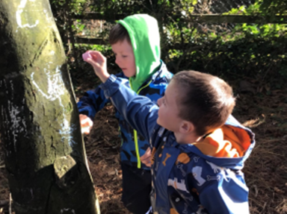

Relationships between staff and pupils at Stoke Fleming Community Primary School are excellent and are a real strength of the school.

**Our Curriculum**

We believe that learning should be fun, purposeful and challenging. Through our inspiring, broad and engaging curriculum, we aim to equip each child with the skills and knowledge they need for lifelong learning. We strive to develop confident and resilient learners, who are respectful of themselves and others. Teamwork and collaboration are fostered in an environment where everyone is encouraged to thrive and achieve as individuals, preparing them for their role as responsible and active citizens in modern Britain.

​We believe it is important to make the curriculum relevant and meaningful to pupils and for putting knowledge into context. We also place an emphasis on developing the qualities our children need for future learning, including our school values of ‘Considerate, Confident, Creative and Cultured’ which permeate all areas of school life.

**Our Community**

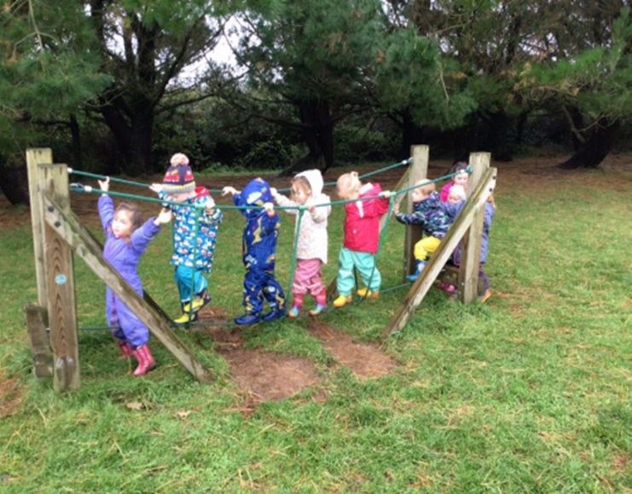At Stoke Fleming Community Primary School Primary School, we are proud of our local community. We think it is vitally important for the children to develop a sense of responsibility and pride for the town in which they live. We help them to understand the way that their village and surrounding towns have developed over time and give them a range of opportunities to get involved in projects and work with local groups to improve our community for future generations.

**Facilities and School Grounds**

All visitors to our school are struck with our impressive facilities which are too many to mention, but include the following;

* Well equipped classrooms with up-to-date technology.
* A well-stocked library to inspire reading.
* Extensive outside learning and play spaces.
* A forest school area.
* Dedicated office and staffroom space.



**STOKE FLEMING COMMUNITY PRIMARY SCHOOL**

**Job Description**

**Post Title:** Headteacher

**Responsible to:** CEO, Education South West

**Scale:** L6-L11

## Job Purpose

To provide professional Leadership and Management of the School that will promote a secure foundation from which to achieve high standards in all areas of the School’s work.

To achieve success, the Headteacher will work with the Directors, Governing Body and other key stakeholders to:

1. Provide vision, leadership and direction
2. Effectively lead teaching and learning
3. Promote excellence, equality and high expectations of all children
4. Deploy resources to achieve the School’s aims
5. Evaluate School performance and identify priorities for continuous improvement
6. Carry out day-to-day management, organisation and administration
7. Secure the commitment of the wider community
8. Create a safe and productive learning environment that is engaging and fulfilling for all children

## Key Responsibilities

## Qualities and Knowledge

1. Hold and articulate clear values and moral purpose, focused on providing a world class education for the children they serve.
2. Demonstrate optimistic personal behaviour, positive relationships and attitudes towards their children and staff, and towards parents, governors and members of the local community.
3. Lead by example - with integrity, creativity, resilience, and clarity - drawing on their own scholarship, expertise and skills, and that of those around them.
4. Sustain wide, current knowledge and understanding of education and school systems locally, nationally and globally, and pursue continuous professional development.
5. Work with political and financial astuteness, within a clear set of principles centred on the School’s vision, ably translating local and national policy into the School’s context.
6. Communicate compellingly the School’s vision and drive the strategic leadership, empowering all children and staff to excel.

## Children and Staff

1. Demand ambitious standards for all children, overcoming disadvantage and advancing equality, instilling a strong sense of accountability in staff for the impact of their work on children’ outcomes.
2. Secure excellent teaching through an analytical understanding of how children learn and of the core features of successful classroom practice and curriculum design, leading to rich curriculum opportunities and children’ well-being.
3. Establish an educational culture of ‘open classrooms’ as a basis for sharing best practice within and between the Academies in Education South West, drawing on and conducting relevant research and robust data analysis.
4. Create an ethos within which all staff are motivated and supported to develop their own skills and subject knowledge, and to support each other.
5. Identify emerging talents, coaching current and aspiring leaders in a climate where excellence is the standard, leading to clear succession planning.
6. Hold all staff to account for their professional conduct and practice.

## Systems and Processes

1. Ensure that the School’s systems, organisation and processes are well considered, efficient and fit for purpose, upholding the principles of transparency, integrity and probity.
2. Provide a safe, calm and well-ordered environment for all children and staff, focused on safeguarding children and developing their exemplary behaviour in the School and in the wider society.
3. Establish rigorous, fair and transparent systems and measures for managing the performance of all staff, addressing any under-performance, supporting staff to improve and valuing excellent practice.
4. Welcome strong governance and actively support the governing body to understand its role and deliver its functions effectively – in particular its functions to set School strategy and hold the Principal to account for student, staff and financial performance.
5. Exercise strategic, curriculum-led financial planning to ensure the equitable deployment of budgets and resources, in the best interests of children’ achievements and the School’s sustainability.
6. Distribute leadership throughout the organisation, forging teams of colleagues who have distinct roles and responsibilities and hold each other to account for their decision making.

## The Self-Improving School System

1. Create an outward-facing School which works with other schools in Education South West and organisations - in a climate of mutual challenge - to champion best practice and secure excellent achievements for all children.
2. Develop effective relationships with fellow professionals and colleagues in other public services to improve academic and social outcomes for all children.
3. Challenge educational orthodoxies in the best interests of achieving excellence, harnessing the findings of well evidenced research to frame self-regulating and self-improving schools.
4. Shape the current and future quality of the teaching profession through high quality training and sustained professional development for all staff.
5. Model entrepreneurial and innovative approaches to school improvement, leadership and governance, confident of the vital contribution of internal and external accountability.
6. Inspire and influence others - within and beyond the School - to believe in the fundamental importance of education in young people’s lives and to promote the value of education.

The Headteacher will carry out his/her professional duties in accordance with and subject to, the National Conditions of Employment for Headteachers and Education and Employment legislation.

The Headteacher is accountable to the CEO of Education South West, the Directors and Governors for the standards achieved and the conduct, management and administration of the School, subject to any policies that the DfE may make.

This job description is subject to annual review.

|  |  |  |  |
| --- | --- | --- | --- |
| **Name:** |  | **Date:** |  |

|  |  |  |  |
| --- | --- | --- | --- |
| **Signed:** | (CEO) | **Signed:** | (Member of Staff) |

**STOKE FLEMING COMMUNITY PRIMARY SCHOOL**

**Headteacher**

**Person Specification**



The successful candidate will meet the following person specification. Please note that the listed criteria will form the basis of the selection process.

|  |  |
| --- | --- |
| **Essential** | **Desirable** |
| **Qualifications** | |
| * Qualified teacher status * Good honours degree or equivalent | * NPQH |
| **Professional Experience and Knowledge** | |
| * Successful recent experience of whole school leadership * Proven track record of contributing to sustained school improvement * Experience of leading and managing innovation and change * Experience of performance management processes to maximise the contribution of colleagues throughout the School | * Proven track record of developing community links * Experience of working with other schools * Experience of more than one school |
| **Skills** | |
| * Proven ability to drive sustained improvements in teaching and learning * Proven ability to analyse and interpret student performance data, set challenging targets, devise and oversee effective intervention strategies and monitor outcomes * Ability to empower, challenge and motivate staff to become high performing as individuals and as teams * Ability to develop, embed and maintain systems and processes to ensure excellent outcomes are delivered * Ability to build and develop strategic partnerships * Ability to communicate vision confidently, clearly and passionately | * Proven ability to build capacity in colleagues through coaching or mentoring and brokering/delivering INSET |
| **Knowledge** | |
| * Thorough knowledge of the statutory requirements and relevant legislation relating to school leadership and management, including health and safety, child protection and safeguarding * Understanding of current issues in education locally, nationally and internationally |  |
| **Personal qualities and attitude** | |
| * Strong personal presence * Determination and commitment with an exceptional capacity for productive work * Sense of personal drive and ambition * Enjoys being highly visible and meeting with a range of audiences * Approachability, openness and integrity | * Ability to further own leadership skills |





**How to apply**

**Application deadline**

Completed applications must be received by **12th January 2024**

Please submit your application to **Jodie Carson at** [**Jodie.carson@educationsouthwest.org.uk**](mailto:Jodie.carson@educationsouthwest.org.uk)

**Completing your application**

Candidates are asked to complete all the standard information required on the application form, and to submit a supporting statement outlining your suitability for the role.

The Governors are committed to safeguarding and promoting the welfare of children and applicants must be willing to undergo child protection screening appropriate to the post, including checks with past employers and an enhanced disclosure via the Disclosure and Barring Service.

**Discussion and visits**

Confidential and informal discussions with the Chair of Governors are welcomed, as well as visits to the school. Please arrange a suitable time with **Jodie Carson at** [**Jodie.carson@educationsouthwest.org.uk**](mailto:Jodie.carson@educationsouthwest.org.uk)

**References**

Candidates are advised that references will be taken up immediately after shortlisting. Candidates are asked to ensure that their referees are informed of the need to respond within the timescale set. In all cases, at least one professional reference is required.

****The post will be offered subject to satisfactory completion of pre-employment checks.