Valentine Primary school
Valentine Avenue
Southampton
SO19 0EQ

023 8044 8944
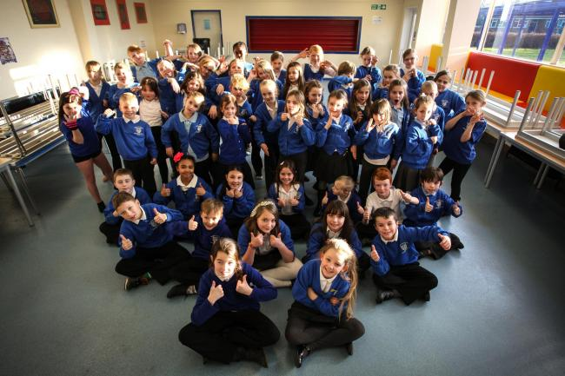

HEADTEACHER
APPLICATION PACK

Context
Valentine Primary School currently has 680 pupils in 26 classes and a total of 142 staff. The school, like many in Southampton, is reducing its numbers due to the falling school numbers across the city, with year 2 and below having moved from 4 form to 3 form entry. The school is 90% white British with English as a first language. 47% of pupils are supported by Pupil Premium, an increase of 7% since the start of the pandemic. Valentine Primary is proud of being a highly inclusive school: there are 16% of pupils who are identified as having SEND needs and 26 pupils have an EHCP. These children are supported through the ‘Woodland’ provision, either 1:1 or in a small group. The school also runs a nurture group for 10 pupils which has been accredited with the Marjorie Boxall quality mark award. Families are supported through our family support workers and ELSA provision.
Valentine Primary School has adapted the National Curriculum to meet the needs of the children at Valentine. The curriculum is organised through half termly projects where foundation subjects are blocked to allow greater depth of knowledge and understanding.
Just before Covid struck, part of the school was rebuilt to create 16 classrooms, a large hall, DT space and the Deputy Headteachers’ office. The new building allowed for the extensive grounds to be revamped and for allotments to be developed. The administration area in the old part of the school has recently been reconfigured.

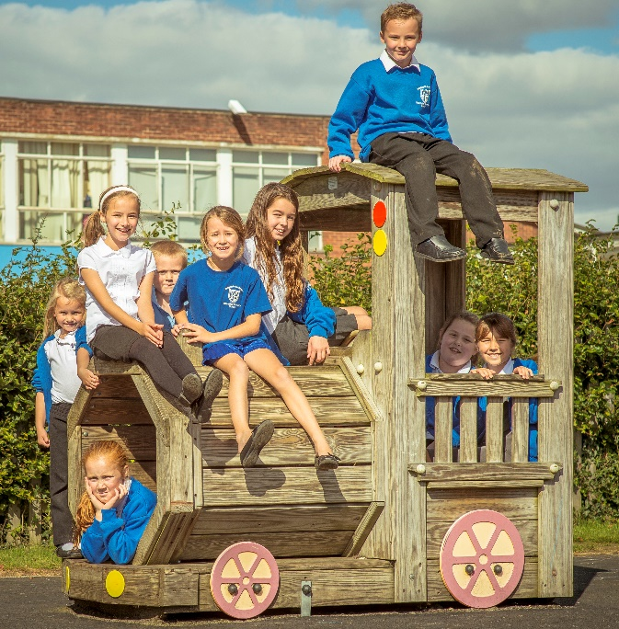
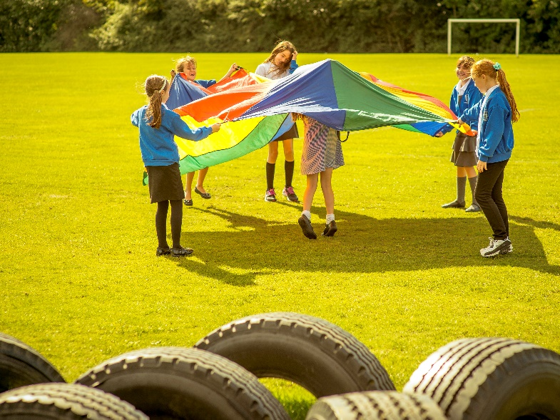

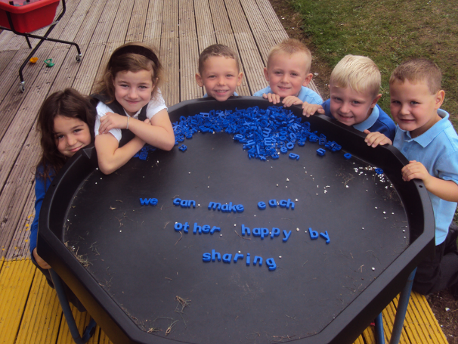

School Improvement
The school is closely focussed on school improvement.
In November 2016 and March 2019, Ofsted inspections concluded that Valentine Primary School required improvement. The priorities identified a need for improvement in the quality of teaching and learning and outcomes for pupils linked to effectiveness of leadership and management. Behaviour was recognised to be good.
We are very pleased that recent Ofsted monitoring visits in March 2021 and July 21 stated that ‘Leaders and those responsible for governance are taking effective action in order for the school to become a good school.’
During the July 2021 Ofsted, the quality of teaching was shown to be good and it was noted that the staff work hard to address priorities. The 3 recommendations identified during the inspection were to:
- put in place a complete, systematic phonics programme from the beginning of the Reception Year, where pupils read books that match the sounds they have learned, and train all staff to deliver this programme effectively
- continue with planning all subjects so that knowledge is well sequenced, and staff are clear what pupils should learn and by when
- sharpen school improvement planning so that it clearly sets out leaders’ actions for the intent and implementation of the school’s curriculum so that impact is linked to what pupils know and remember.
During the last couple of years, the school has worked closely with the Local Authority School Improvement Officers to drive the school towards being a securely good school. The priorities below are being addressed, in conjunction with Ofsted identified priorities.

School priorities from the SIP
- To ensure that knowledge and skills are sequenced progressively and cumulatively across the curriculum (particularly in the foundation subjects) to ensure that children learn more, know more and remember more.
- To fully embed a complete, systematic, synthetic, programme for the teaching of phonics that will be taught with fidelity by staff who are fully trained in the programme.
- To continue to focus on filling gaps in knowledge due to the pandemic and raising the attainment of disadvantaged pupils.

What staff would like in a new Headteacher

A Headteacher fully committed to inclusion, who understands and celebrates diversity. Someone who is approachable and down to earth.
Clear continuation of vision for development off practices, with a sympathetic and accommodating understanding and acceptance of current systems and practice. A sensitive approach to change, and not change for the sake of change.

A willingness to promote Restorative Practice. Someone who will have an open door policy. Someone we can go to when we need to. It is imperative that time is made for staff and children when needed.
Someone that goes above and beyond to meet the needs of some of Southampton's most vulnerable children.

The school community is strong and valuable to parents and children. A new Headteacher needs to embrace this and build on it and will continue with events that bring the school together like firework night, Summer fayre and Christmas Fayre.

Someone who values the experience of ALL staff who are already at the school. This includes leaders, teachers and support staff.
Someone who: is not afraid to get stuck in, is creative, has a clear vision, considerate of individual needs (staff and children), is passionate about the community and will lead by example/role model.

Recent staff turnover is low. The new Headteacher will be well supported by a staff motivated to provide the best for the children. The Leadership Team is experienced, positive and responsive to change. They have been closely involved in school improvements and the drive towards achieving a good Ofsted.
The staff is self-reflective and focussed on making a difference in the classroom. Staff undertake a range of CPD with several having completed substantial courses.
The Governing Body has been strengthened with recent additions. There are regular visits to school, including a presence at Pupil Progress Meetings.
‘Governors’ work has helped to keep the spotlight on the achievement of all groups of pupils, particularly the most vulnerable.’ Ofsted March 2021

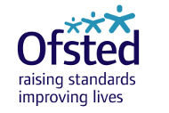

School Values
School Values were reviewed as a school community.
Aspiration – We strive to develop an understanding of the importance of setting high expectations of ourselves and achieving personal goals in order to be happy and successful. We expect all team members to always try their best to achieve a given goal, no matter how big or small this may be.
Confidence – We expect all team members to believe in their own abilities, to meet challenges and succeed; our safe, supportive environment allows learners to take risks without judgement or fear of failure.
Empathy – We expect all team members to understand and acknowledge the feelings of themselves and others, embracing and celebrating difference and diversity. We strive to always be caring and understanding of the needs of ourselves and others, managing our emotions effectively.

Teaching, Learning and the Curriculum
The school has rewritten the curriculum which is taught through a series of projects that the children become fully engaged in. Teachers plan as part of a team. The current focus is to develop knowledge organisers for every foundation subject which is being done on a half termly basis. This will ensure that knowledge is carefully sequenced in each subject and increase consistency within and across year groups.
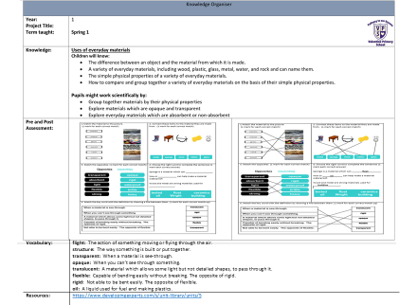

‘Leaders are indeed thinking carefully about the essential knowledge pupils need to learn from early years to Year 6.’ Ofsted July 2021

What do pupils think about learning?
Pupils demonstrate an enthusiasm for learning. Relationships between pupils and staff are strong. Through a well-developed system of pastoral support, children are helped and guided in the choices they make. As a highly inclusive school, there are a small minority of children that struggle to make the right choices at times. These children are supported by our Behaviour Inclusion Support Officer.
We have dedicated PE coaches who provide all of the PPA time and run a number of after school clubs. Since the start of the pandemic, we have not yet been able to re-introduce a full range of extra-curricular activity. We also have music specialists who provide class and individual lessons.

What do pupils want from a new Headteacher
We still want to have afternoon tea with the Headteacher
They should be a bit light hearted and crazy at times
They keep everyone in the school safe
I want them to be kind and make us feel happy
To be supportive of children and be a good listener
They come to the classroom and watch us learn and help us

Partnerships across the board
Southampton is a small unitary authority with 37 Primary Schools. Headteachers across the city are supportive and make connections through the Primary Headteachers’ Conference. Valentine works closely with other schools including with an NLE from Halterworth Primary with whom they have focussed on developing the curriculum, tackling educational disadvantage and a creativity project. The English hub has provided support for phonics. Valentine is at the heart of the community and works in partnership with social workers, family engagement workers, the local church, the NSPCC, SAINTS and Honeypots, a charity to support young carers, amongst others.

Facilities / budget
The school is well equipped. The new building has provided a new DT room, a new staffroom and a new hall large enough to accommodate the whole school. It has been designed to be used as a community space. There is also a separate community room in the old building. The school has spacious grounds and has recently developed an allotment area where classes grow and harvest vegetables. The school needs to develop the use of the school grounds.
The school has close links with St Francis pre-school on the school site.
The school has a deficit budget and is working towards the deficit recovery plan agreed with the city council.

Covid
Although Covid has dominated the past two years, the school has continued to focus on improvement priorities. Remote learning was put in place and vulnerable families supported where needed. At the very end of March 2021 lockdown Ofsted carried out a remote monitoring inspection.
‘Leaders acted promptly to ensure that pupils were able to continue their education during the pandemic. Since the previous lockdown, they have refined the school’s remote learning offer. They have considered pupils’ home circumstances and parents’ views.’ Ofsted March 2021

Ofsted – July 2021
At the end of July, the school had a second Ofsted inspection, this time on site, which again referred to the school’s amazing work during Covid. The Governors would like to emphasise their appreciation of the dedication of the staff during these incredibly difficult times.
‘‘You have led with moral purpose to support a school community that has faced adversity throughout the pandemic but have not let this detract you from work to improve the school. Nonetheless, COVID-19 has impacted upon your plans of where you would like to be at this stage.’ Ofsted July 2021

