
Headteachers
Information
Pack


Welcome to WJS
From the Governors.
Thank you for your interest in Westbury Church of England (VC) Junior School. We hope that the information in this pack will be of interest to you and encourage you to think about joining us as our new headteacher.
Westbury is a market town in west Wiltshire below the northeastern edge of Salisbury Plain. The town is overlooked by the iconic White Horse which is situated in the nearby parish of Bratton. Our school sits at the heart of an established housing estate and our partner infant school is on a neighbouring site. Westbury is an important junction on the railway network, forming good links with towns and cities locally and further afield.
As a Church of England school, we are committed to developing and maintaining stronger links with our church, All Saints, situated in the heart of Westbury. We do this by engaging in services throughout the year, such as our Easter Service and Harvest Festival, and through wider community activities when the children are encouraged to think of others beside themselves. Our school buildings have been improved and extended over time, most recently with a purpose-built suite for our Resource Base (Wiltshire Class). Our grounds are well established and, as well as a tarmac playground, we have an extensive school field, providing a fantastic base for outdoor learning and play. An exciting recent development has been the tree planting programme which aims to help realise the potential of the outdoor environment as a learning resource in support of the curriculum.
We are fortunate to have a dedicated and caring staff, who bring with them a range of experience and skills with which they can support and guide our pupils.
We need you to be resilient, empathetic, approachable, have strong interpersonal skills, be passionate about inclusion, open to innovation and be willing to take onboard different views whilst leading us through the next phase of our improvement journey.
We are an improving school. We care deeply about the children in our school family and want to do our best for them. We invite you to join us in this pursuit in making our school the best it can be.
We look forward to meeting you.

Our Vision
As a Church of England School, core Christian values underpin our school day. All adults in the school model these values to our children; parents speak very highly about how this contributes to a positive learning environment. Our children understand that, regardless of background or personal circumstance, we are a place where everyone can succeed and everyone has worthy contributions to make to our whole school community
. 
At Westbury CE Junior School we show respect to all, show care for all and inspire all to be the best version of themselves they can be. This journey of Respect, Care and Inspire, which both the children and adults are on during their time at Westbury CE Junior School, is founded in the Biblical text and the children are reminded of it every day as it appears as a key part of the logo on their school uniform.
The journey of Respect, Care and Inspire that the whole school community is on is founded in our school biblical quote.
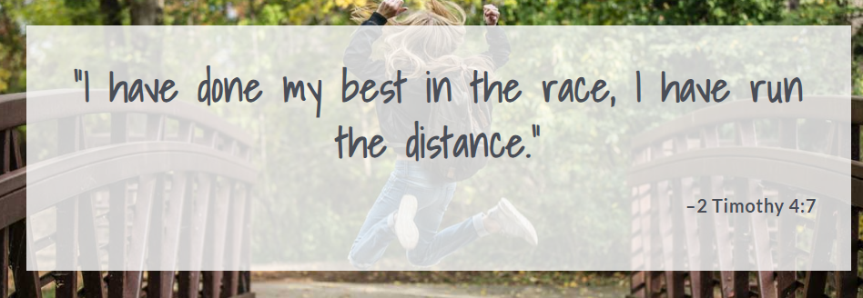
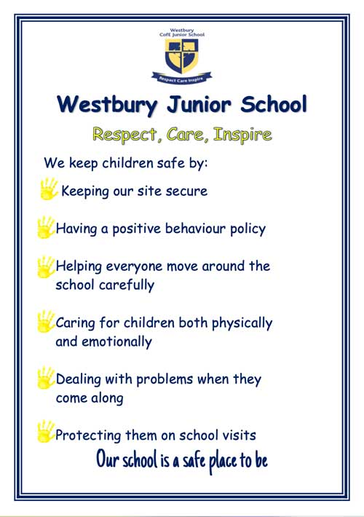
Our whole school community will…
- Take responsibility for our actions
- Support and encourage others
- Strive to be healthy and safe
- Show respect to everyone and everything
- Expect challenges and meet them with enthusiasm
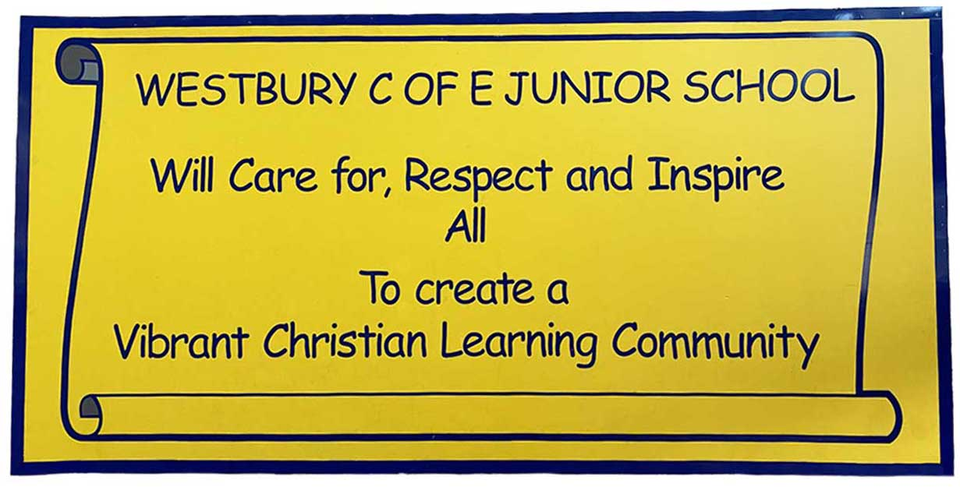


Information about WJS and the appointment process
The School
Number of children on roll: 263
Number of classes: 10 (including the resource base ‘Wiltshire Class’)
Last Ofsted rating: ‘Requires Improvement’ May 2024
Last SIAMS rating: ‘Requires Improvement’ May 2023
Link to website: https://westbury-jun.wilts.sch.uk/ Please note that the school website is currently in the process of being updated.
Below are the headlines from our 2024 KS2 tests. 40% of all our pupils are entitled to free school meals compared with a Wiltshire figure of 16%.
Context
Item | Westbury Junior | Wilts LA | National
Gender  Boys  Girls | 50.4%  49.6% | 51%  49%
SEN support | 17.7% | 14.7% | 13.3%
EHCP | 12.3% | 5.3% | 4.6%
Ethnicity (BME) | 14.6% | 15.8% | 37.4%
Language (EAL) | 6.9% | 7.6% | 22.8%
Disadvantaged | 42.5% | 19.2% | 29.2%

- One child was absent (holidays) during SATs week. Two families refused to allow their children to take the SATs papers for mental health reasons.
- Some children from the Resource Base took the reading and maths papers.
- A small number of children did not reach the WTS standard in writing, working a pre Key Stage 2 level.
- Science is teacher assessed.

Attainment 2023/2024
 | Westbury Junior | Wilts LA | National 2024 | National 2023
RWM expected | 27.6% | 56.3% | 61% | 59%
RWM higher standard | 0% | 6.5% | 7% | 8%

 | Expected standard Westbury Junior | Expected standard Wilts LA | Expected standard National 2024 | Expected standard National 2023 | Greater than expected standard Westbury Junior | Greater than expected standard Wilts LA | Greater than expected standard National 2024 (tbc) | Greater than expected standard National 2023
Reading | 45% | 73.3% | 74% | 73% | 16% | 28% | 28% | 29%
Writing | 38% | 70.3% | 72% | 71% | 3% | 12.6% | 12% | 13%
Maths | 50% | 68.7% | 73% | 73% | 9% | 19% | 23% | 25%
GPS | 43% | 68% | 72% | 72% | 10% | 26.4% | 31% | 31%
Science | 50% |  | 81% | 80%


The appointment process
Salary range for new headteacher: Group 2 L15-21
Closing date (and time): 10.00am Monday 27th January 2025
Interview date: 12th – 13th February 2025
Commencement date: 1st September 2025

Safeguarding Statement
The school is committed to safeguarding and promoting the welfare of children
and young people and expects all staff, governors and volunteers to share this
commitment.

Safer Recruitment Statement
Westbury Junior School is committed to safer recruitment and will follow all
relevant safer recruitment processes for our school, including relevant sections of
Keeping Children Safe in Education (2024).
All applicants will be subject to a Disclosure and Barring Service check before an
appointment is confirmed.

An invitation to the school
Please email admin@westbury-jun.wilts.sch.uk to arrange a visit.

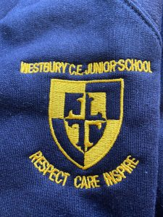


WJS - Our Parish and Community

Westbury Church of England Junior School is situated in the Parish of Westbury which is part of the White Horse Team Ministry, being a Church of England Benefice including the Parish of Dilton Marsh. The Rector, Reverend Rebecca Harris, is a welcome and familiar visitor to the school, being a Governor and fostering links with the Parish and wider community. Two other Foundation Governors from the Parish also form part of the Governing Body. Visit https://www.whtministry.org.uk to learn more about the benefice and its work in the area.

The School and Benefice are in the Diocese of Salisbury, which currently serves approximately 42,000 students in 192 Church of England schools. Every church school has the opportunity to partner with the Salisbury Diocesan Board of Education (SDBE) through the Partnership Service Agreement and so to receive the support and challenge of the SDBE staff. For further information about the SBDE’s vision, mission and support it offers please visit https://www.salisbury.anglican.org/schools.

The Parish encompasses the town of Westbury and the adjacent ‘village’ of Westbury Leigh. There are two churches in the Parish, All Saints Church in the town centre being late 14th Century Grade 1 listed with the accolade of the third heaviest peal of bells in the country, and Holy Saviour Church in Westbury Leigh of Victorian build with its nave converted to a Community Hall.


The school has an historic link with the Parish Church of All Saints due to the original school building being adjacent to the churchyard. From the mid 1950s, when the school moved to its current site, the building is currently the Parish Hall. Consequently, the Parish Church is situated just over ½ a mile from the school, making any church visit a major logistics challenge. However, this does not prevent the school visiting the Church at least 3 times during the year for services at Easter, Harvest and Christmas. These services are put together by the school, led by the children with the help of the staff and clergy and include prayers, poems and other work written by the children.

The school is also invited to All Saints to three Experience Events through the year, these currently being Easter, Pentecost and Communion. These are for smaller groups of children but are valued as being very visual and interactive.
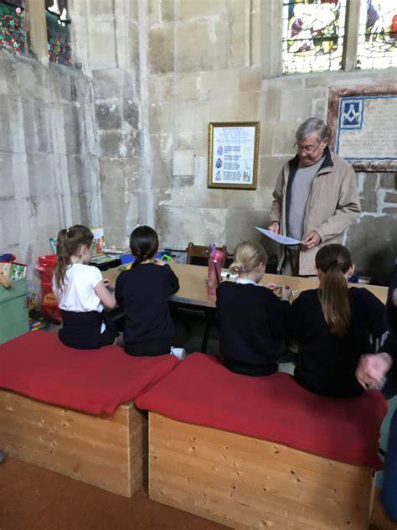
A previous Curate from All Saints was instrumental in starting the Prayer Council at Westbury Junior School. This is an after school club currently run by a member of staff. Reverend Rebecca supports this when she can, and the Prayer Council occasionally lead Collective Worship and take part in the school’s services at All Saints.

At least once a month Collective Worship is led by clergy or lay ministers from different Westbury Churches, although at present is mainly Anglican due to vacancies at some of the other churches. Open the Book also visit as part of Collective Worship once a term, and this is again an ecumenical group from local churches. The Parish hold a Café Church service once a month in the school hall, providing outreach to the local community and an alternative form of worship.

Westbury Area Churches Together (WACT) have obtained and present all children in years 3 to 6 with copies of a Children’s Bible, so that every child has one of their own. To help with transition to secondary school, WACT also purchase copies of ‘It’s Your Move’ books and Reverend Rebecca presents them to year 6 leavers at a summer term Class Worship.

Working in Wiltshire

With its stunning countryside and superb community spirit, Wiltshire is a fantastic place to live and work. It has great schools that work well together and who benefit from a very proactive and supportive Local Authority team. A range of support to new and experienced Headteachers is provided by the LA. This includes the Headteacher Induction Programme and the Headteacher Mentoring Scheme.

The Headteacher Induction Programme.
Following appointment, the new Headteacher will receive details of the Wiltshire induction programme which will fully support you through your first year of Headship in Wiltshire. Wiltshire Council is committed to ensuring that new Headteachers and experienced Headteachers new to Wiltshire receive effective induction to enable them to fulfil their role. The programme follows a sequence of modules, covering a wide range of topics, delivered through a mixture of face to face and online events.
The programme will:
- Provide you with a valuable opportunity to establish a supportive network with new to role Headteacher colleagues, across Wiltshire.
- Introduce you to our Wiltshire Local Authority services, key contacts and offer.
- Allow you to access training which develops your knowledge and expertise in specific areas of school practice including: Safeguarding, Working with Governors, Curriculum, Health and Safety, Finance, Early Years, Assessment and Moderation, Targeted Support, SEND & Inclusion.
- Provide a termly, face to face opportunity to meet collaboratively with your new Headteacher colleagues in a Wiltshire school and take part in training led by an experienced Wiltshire Headteacher which will develop your expertise and practice. These sessions are the only traded part of the programme for academy colleagues.
- Enable you to have access to Wiltshire LA Officers who can respond quickly to questions, thoughts and challenges which will support you in your role.

The Wiltshire Headteacher Mentoring Scheme.
The Wiltshire Headteacher Mentoring Scheme has been running for over 20 years and has a proven track record of successful and supportive partnerships organised by headteachers for headteachers. The Wiltshire Mentor Scheme is completely confidential and has received an excellent independent evaluation from Bath Spa University.
The Wiltshire scheme has as its rationale: “to enable a headteacher to feel comfortable and supported in the first year of their new post through a professional relationship with a colleague”. This support is also available to heads in their second or subsequent headship as every headship is different.

The scheme offers a choice of colleagues to act as your mentor for a year. The mentor is given the equivalent of three days’ supply to assist them in this. All the mentors are experienced heads and have had at least 3 years successful headship in Wiltshire. They have all been specially trained to prepare them for the role and receive regular refresher mentor training. They are there to help by listening to you and acting as a sounding board, as well as offering you practical help and support during the first year of your new headship.

What does our School community say?:
We asked our children, what do you think a headteacher should be like, what makes a good headteacher?

- Be smiley and give lots of head teacher rewards.
- Happy, joyful, smiley, fun.
- Strict when they need to be, children should feel a little bit worried if they get sent to the head teacher. Forgiving.
- Very kind and caring.
- Very welcoming and calm.
- Respectful and polite.


We also asked our staff: What sort of school would you like to be part of?

- Well behaved one, professional development opportunities, good reputation
- A happy, calm, respectful school where we all work together (adults and children) to achieve the very best for our pupils.
- A school that cares about the pupils and staff. A school that communicates well with pupils, staff and parents/carers.
- Happy, respectful, fun place where I can teach with good support staff. Where the majority of my time isn't dealing with behaviour but delivering lessons.

And finally, we asked our parents: What qualities would you like to see in a Head Teacher at Westbury Junior School?

- I would like an empathetic, kind head teacher who has firm boundaries in behaviour
- A good understanding of children with SEN, not quick to suspend children, good communication with parents, supportive and welcoming/approachable.
- To be strong, honest and not judge people on their appearance, and get to know both children and parents
- One who prioritises children's autonomy, who is gentle and empathetic, who makes sure their SENCO has the capacity to meet regularly with parents.
- Someone that commands respect, but is approachable by everyone. Great leadership qualities, that makes the children and their families feel part of the school community. Not afraid to push

Our new headteacher- The person specification

Qualifications and Training | Essential | Desirable
- Qualified Teacher Status | x
- Evidence of recent and relevant continuing professional development including leadership and preparation for headship | x
- Degree | x
Relevant Experience
- Recent experience as a successful senior leader in the primary phase; including leadership of curriculum and raising standards of teaching and learning | x
- Recent experience of embracing and developing the distinctive and effective Christian character of a Church school |  | x
- Proven outstanding teaching ability across the full primary age range |  | x
- Strategic leadership in building and maintaining effective relationships with Governors, parents, the community, LA and Diocese | x
- Strategic planning and resource management through effective financial planning and budget management | x
- Experience of leading and managing successful change | x
- Experience of managing Personnel and Health/ Safety issues |  | x
- Experience of working in a school with a SEND resource base |  | x
Knowledge & Understanding of:
- Models of effective teaching and learning that raise standards for all as well as disadvantaged learners | x
- Models of behaviour and attendance management | x
- Commitment to inclusion, supporting pupils with SEND and meeting the needs of all children; including the vulnerable, disadvantaged learners and those with special needs /disabilities. | x
- Up to date knowledge of the National Curriculum (& EYFS curriculum) | x
- Safeguarding requirements | x
- Current educational priorities, legislation, research and developments |  | x
- School improvement strategies; including self-evaluation, improvement planning, raising attainment, developing teaching and learning | x
- Successful strategies to develop staff through monitoring, data analysis, target setting and appraisal | x
- Placing vision first; developing a vision, embracing church school status, to impact ethos, culture, inclusion and diversity |  | x
- Successful collaboration and partnership working with other agencies and the wider community |  | x
Professional Skills
- Outstanding strategic leadership skills; motivating, self-managing, interpersonal, creative thinking and effective communicator (including written, oral, ICT and presentation) | x
- The delivery (use and impact) of new technologies to support teaching and learning |  | x
- Fully supportive of the school’s Christian values and church school foundation; fully committed to developing links between the parish church and school | x
Personal Qualities
- Resilient, empathetic, approachable, have strong interpersonal skills and passionate about inclusion. | x
- Open to innovation and willingness to take onboard different views | x



Our new Headteacher- The job description
Our new Headteacher –

Post Title: Headteacher (full time).
Responsible to: The Governing Body of Westbury Junior Church of England (VC) School.
Responsible for: All staff, volunteers and children within the school.
Main Purpose: To carry out the duties of Headteacher in accordance with the Teachers’ Pay and Conditions Act and The Headteachers’ Standards (2020).

Ethics and professional conduct.

The Headteacher will demonstrate consistently high standards of principles and professional conduct. The Headteacher will meet the teachers’ standards and be responsible for providing the conditions in which teachers can fulfil them. The Headteacher will uphold and demonstrate the seven Nolan principles of public life.

The Headteacher will:
- Demonstrate the school’s vision and Christian values in everyday work and practice.
- Serve in the best interests of the school’s pupils.
- Conduct themselves in a manner compatible with their influential position in society by behaving ethically, fulfilling their professional responsibilities and modelling the behaviour of a good citizen.
- Uphold their obligation to give account and accept responsibility.
- Know, understand, and act within the statutory frameworks which set out their professional duties and responsibilities.
- Take responsibility for their own continued professional development, engaging critically with educational research.
- Make a positive contribution to the wider education system.
- Key Areas of Responsibility

1. School Culture: Working with the Governing Body, the Local Authority, the Diocese of Salisbury and other leaders, the Headteacher will create a shared Christian vision and strategic plan which inspires and motivates pupils, staff and all other members of the school community.

This vision should express core educational values and moral purpose and be inclusive of stakeholders’ values and beliefs. The strategic planning process is critical to sustaining school improvement and ensuring that this Church School moves forward for the benefit of its pupils, providing a world class education for pupils it serves.

The Headteacher will:

- Establish and sustain the school’s Christian values, ethos and strategic direction in partnership with those responsible for governance and through consultation with the school community.
- Create an inclusive culture where pupils experience a positive and enriching school life.
- Uphold ambitious educational standards which prepare pupils from all backgrounds for their next phase of education and life.
- Promote positive and respectful relationships across the school community and a safe, orderly and inclusive environment.
- Ensure a culture of high staff professionalism.

2. Teaching and Learning:
The Headteacher has a central responsibility for raising the quality of teaching and learning. This involves high expectations, maintaining and evaluating outcomes and establishing a successful learning culture which will enable pupils to become effective, enthusiastic, independent learners, committed to life-long learning.

The Headteacher will:
- Ensure high-quality, expert teaching across all subjects which reflects the distinctively Christian vision and values of the school and is built on an evidence-informed understanding of effective teaching and how pupils learn.
- Ensure teaching is underpinned by high levels of subject expertise, and approaches which respect the distinct nature of subject disciplines or specialist domains.
- Ensure effective use is made of formative assessment.

3. Curriculum and assessment

The Headteacher will:
- Ensure teaching and learning reflects the distinctively Christian vision and values of the school in order that pupils flourish as learners and the highest possible standards are achieved.
- Ensure a consistent and continuous school-wide focus on pupils’ achievement, using data and benchmarks to monitor progress in learning and using a robust system of assessment of pupil achievement in order to set ambitious but realistic targets for all children.
- Ensure a broad, structured and coherent curriculum entitlement which sets out the knowledge, skills and values that will be taught.

- Establish effective curricular leadership, developing subject leaders with high levels of relevant expertise with access to professional networks and communities.
- Ensure that all pupils are taught to read through the provision of evidence-informed approaches to reading, particularly the use of systematic synthetic phonics.
- Ensure valid, reliable and proportionate approaches are used when assessing pupils’ knowledge and understanding of the curriculum.

4. Behaviour
Create and maintain an environment and implement a Behaviour Policy that reflects the school’s ethos and promotes development and learning and secures safety and discipline. Provide a safe and calm and well-ordered environment for all pupils and staff, focused on safeguarding pupils and developing their exemplary behaviour in school and in wider society.

The Headteacher will:
- Establish and sustain high expectations of behaviour for all pupils, built upon relationships, rules and routines, which are understood clearly by all staff, pupils and parents.
- Ensure high standards of pupil behaviour and courteous conduct in accordance with the school’s behaviour policy.
- Implement approaches to managing behaviour which are consistent, fair and respectful and which are underpinned by the school’s Christian values.
- Ensure that adults within the school model and teach the behaviour of a good citizen.

5. Additional and special educational needs and disabilities
The Headteacher takes responsibility for a professional community which enables all children to flourish. The Headteacher ensures that the curriculum is accessible and relevant to all children.

The Headteacher will:
- Ensure the school holds ambitious expectations for all pupils with additional and special educational needs and disabilities. This includes pupils placed in mainstream classes and also those placed in the complex needs resource base.
- Establish and sustain culture and practices that enable pupils to access the curriculum and learn effectively.
- Ensure the school works effectively in partnership with parents, carers and professionals, to identify the additional needs and special educational needs and disabilities of pupils, providing support and adaptation where appropriate.
- Ensure the school fulfils its statutory duties with regard to the SEND code of practice.

6. Professional Development
Effective communication and relationships are key to effective headship. The Headteacher needs to build a professional learning community which enables all to flourish. They need to manage the complexity of a school team and be committed to their own continuing professional and spiritual development, including attending distinct training and development as appropriate for Church school leadership.

The Headteacher will:
- Ensure staff have access to high-quality, sustained professional development opportunities, aligned to balance the priorities of whole school improvement, team and individual needs.
- Prioritise the professional development of staff, ensuring effective planning, delivery and evaluation which is consistent with the approaches laid out in the standard for teachers’ professional development.
- Ensure that professional development opportunities draw on expert provision from beyond the school, as well as within it, including nationally recognised career and professional frameworks and programmes to build capacity and support succession planning.

7. Organisational Management
The Headteacher provides effective management of the School and continuously seeks to improve organisational structures based on self-evaluation. The Headteacher leads by example, modelling the professional conduct and practice of teachers in a way that minimises unnecessary teacher workload and leaves room for high quality continuous professional development for all staff.

The Headteacher will:
- Ensure that the school’s ethos and commitment to Christian values is evidenced in how all work and learn.
- Create an organisational structure which reflects the school’s values, and enables the management systems, structures and processes to work effectively in line with legal requirements.
- Ensure the protection and safety of pupils and staff through effective approaches to safeguarding as part of the duty of care.
- Prioritise and allocate financial resources appropriately, ensuring efficiency, effectiveness and probity in the use of public funds.
- Ensure staff are deployed and managed well with due attention paid to workload.
- Establish and oversee systems, processes and policies that enable the school to operate effectively and efficiently.
- Ensure rigorous approaches to identifying, managing and mitigating risk.

8. Continuous school improvement
Working with the Governing Body, the Local Authority, the Diocese of Salisbury and other leaders the Headteacher will create a shared Christian vision and strategic plan which inspires and motivates pupils, staff and all other members of the school community. This vision should express the school’s core Christian educational values and moral purpose and be inclusive of stakeholders’ values and beliefs. The strategic planning process is critical to sustaining school improvement and ensuring that this Church School moves forward for the benefit of its pupils, providing a world class education for pupils it serves.

The Headteacher will:
- make use of effective and proportional processes of evaluation to identify and analyse complex or persistent problems and barriers which limit school effectiveness and identify priority areas for improvement.
- develop appropriate evidence-informed strategies for improvement as part of well-targeted plans which are realistic, timely, appropriately sequenced and suited to the school’s context.
- ensure careful and effective implementation of improvement strategies, which lead to sustained school improvement over time.

9. Working in partnership
The Headteacher should engage with the internal and external school community to secure engagement collaborate strategically and operationally with a wide range of partners to bring positive benefits. They should work collaboratively at both strategic and operational levels with parents and carers and across multiple agencies the well-being of all children. The Headteacher shares responsibility for leadership of the wider educational system and should be aware that school improvement and community development are interdependent.

The Headteacher will:
- Forge constructive relationships beyond the school, working in partnership with parents, carers and the local community.
- Commit their school to work successfully with other schools and organisations in a climate of mutual challenge and support.
- In particular, the Headteacher will seek to work in close partnership with Westbury Infant School, ensuring a positive and cooperative relationship, by which the two schools serve the community together and in which they seek an ever-closer working relationship.
- Establish and maintain working relationships with fellow professionals and colleagues across other public services to improve educational outcomes for all pupils.

10.Governance and accountability
- With the school’s values at the heart of leadership, the Headteacher has a responsibility to the whole school community and is accountable to a range of groups, in particular: pupils, parents, carers, Governors, the Diocese of Salisbury and the Local Authority.

The Headteacher will:
- Understand and welcome the role of effective governance, upholding their obligation to give account and accept responsibility.
- Establish and sustain professional working relationship with those responsible for governance.
- Ensure that staff know and understand their professional responsibilities and are held to account.
- Ensure the school effectively and efficiently operates within the required regulatory frameworks and meets all statutory duties.
- Welcome strong governance and provide information, objective advice and support to actively support the governing body to enable it to meet its responsibilities. These include the securing of effective teaching and learning; the highest standards of attainment and for achieving efficiency and value for money.
- Develop and present a coherent, understandable and accurate account of the school’s performance to a range of audiences including Governors, parents and carers.
- The Headteacher will support the governing body in fulfilling its functions to set school strategy and to hold the Headteacher to account for pupil, staff and financial performance.
- This job description outlines the key responsibilities for the role of Headteacher and it may be necessary to undertake additional duties as the governing body may require. This job description will be reviewed at least annually as part of the Headteacher’s Performance Management programme.

Dated: 6 January 2025

