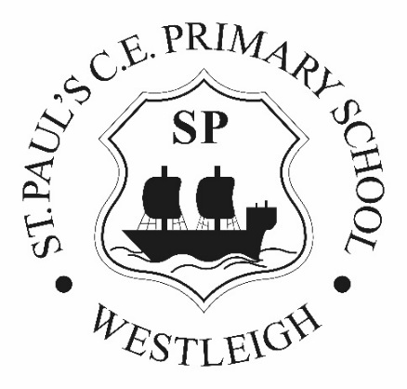 | WIGAN METROPOLITAN BOROUGH  Westleigh St. Paul’s C.E. Primary School  School Street  LEIGH  Lancs  WN7 5JN

Tel: 01942 672611

Headteacher Mrs J. Hankinson BA QTS (Hons) NPQH

Fax:01942 608481

Email: enquires@admin.westleighsaintpauls.wigan.sch.uk

1st March 2024

Dear Applicant

Thank you for expressing an interest in the post of Headteacher here at Westleigh St Paul’s CE Primary School. We believe that this is an exciting opportunity, and that the successful applicant will be joining a happy, welcoming school. The vacancy has arisen as a result of the current Headteacher deciding to retire after a very successful 22 years at our school.

Here at Westleigh St Paul’s, our children’s safety and happiness is paramount and we are proud that our school provides a nurturing environment, where all our children can flourish. Everything we do here is underpinned by our strong Christian ethos. We are looking to appoint a practising Christian with a commitment to upholding our Christian Values.

The person appointed will satisfy the Governors’ desire to appoint an enthusiastic, passionate and professional individual with outstanding leadership qualities capable of building on an excellent foundation laid by our retiring Headteacher, our leadership team and our dedicated staff; a leader with the aim of delivering the best we can for our young people.

Further information about our school can be found on our website, but I warmly invite you to visit us, meet our wonderful children and staff and see for yourself all that we can offer.

Once again, thank you for your interest in the role and we look forward to receiving your application.

Yours sincerely

Jackie Birt
Chair of Governors

