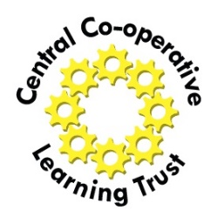
Central Co-operative Learning Trust
Equality and Diversity Monitoring Form
Strictly Confidential
Central Co-operative Learning Trust wants to meet the aims and commitments set out in its equality policy. This includes not discriminating under the Equality Act 2010, and building an accurate picture of the make-up of the workforce in encouraging equality and diversity.
Information collected via recruitment monitoring helps the Trust fulfil this commitment.
Information you provide will be treated in strict confidence.
Person/Role details
Job title:
Pay reference for this post (if known)
Please indicate your ethnic origin:
Asian or Asian British – Bangladeshi |  |  | Asian or Asian British – Chinese
Asian or Asian British – Indian |  |  | Asian or Asian British – other
Asian or Asian British – Pakistani |  |  | Black or Black British – African
Black or Black British – Caribbean |  |  | Black or Black British – other
Mixed – other |  |  | Mixed Ethnic Group – White & Asian
Mixed Ethnic - ~White & Black African |  |  | Mixed Ethnic – White & Black Caribbean
Other Ethnic Origin – Arab |  |  | Prefer not to say
White – Welsh/English/Scottish/N.Ireland |  |  | White – Irish
White – other |  |  | White – Gypsy/Irish Traveller
Other ethnic group: (Please state)
Please indicate your religion/belief:
Buddhist |  |  | Christian
Hindu |  |  | Jewish
Muslim |  |  | Sikh
Other/prefer not to say |  |  | No religion or belief

Please indicate your sexual orientation:
Bisexual |  | Gay man |  | Heterosexual
Lesbian/gay woman |  | Prefer not to say

Please indicate your gender: | Female |  | Male

Disability
Do you consider yourself to have such a disability or health condition? | Yes |  | No
What is the effect or impact of your disability or health condition on your ability to give your best at work? Please write in here:

