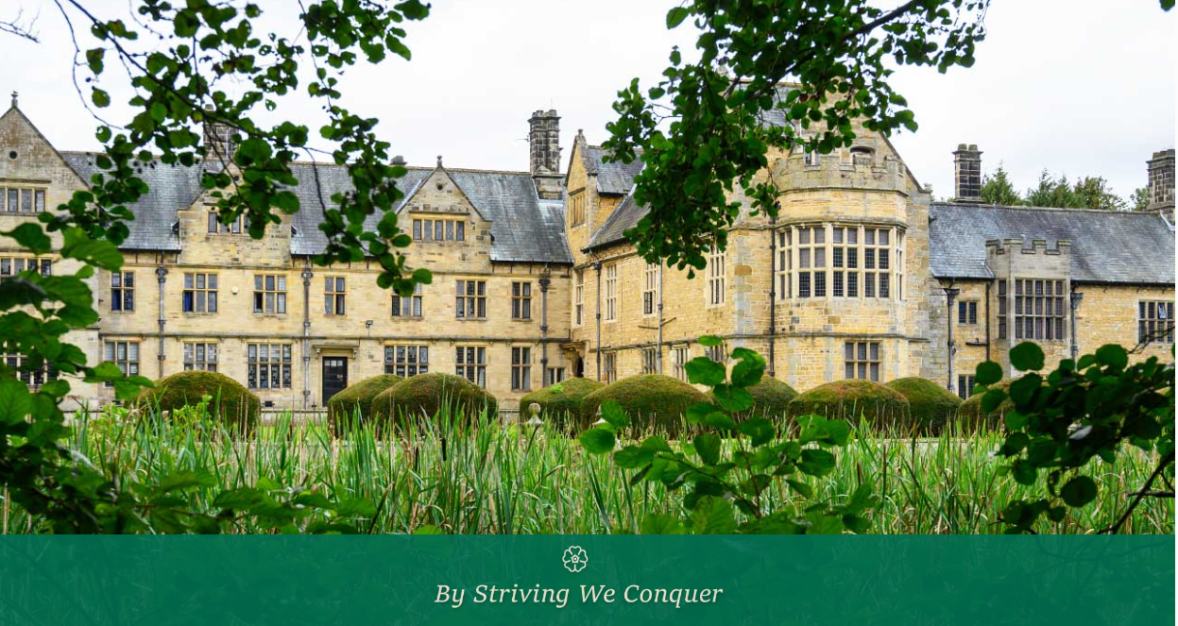

**Welburn Hall School**

**Higher Level Teaching Assistant**

**Recruitment Information Pack**

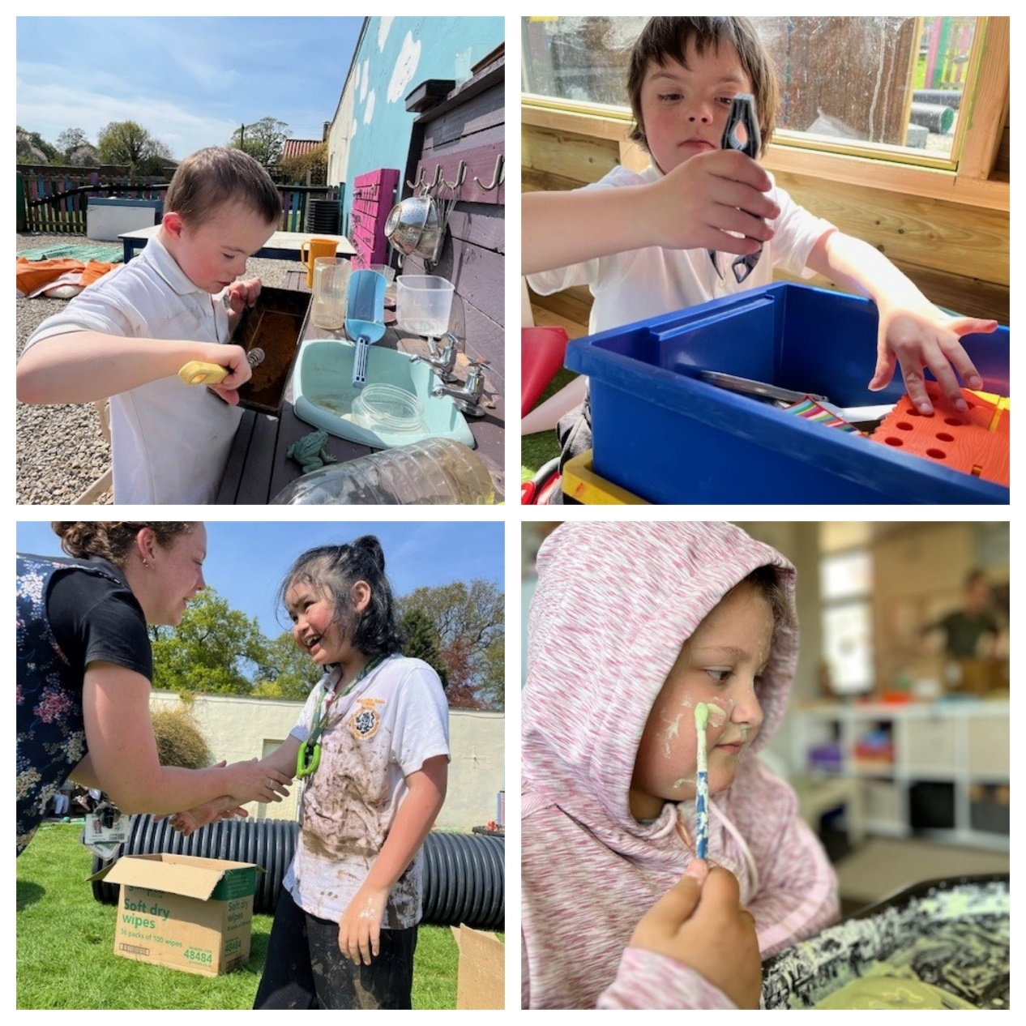

## CONTENTS

**About us 3**

**Our Vision and Values 4**

**Our pupils and staff 5**

**Application Process 6**

**Job Description and Person Specification 7**

**Application guidance 11**



**OUR VISION & VALUES**

**Welburn Hall school will continue to be locally and nationally recognised as a specialist provision for autism and complex needs. We remain committed to being a centre of excellence. We will continue to provide high quality support, teaching and outcomes for our pupils, families and local schools.**

**ABOUT US**

Welburn Hall is a special school/college for children and young people aged 8 to 19 years with a wide range of special educational needs.

Set in over 20 acres of stunning countryside, Welburn Hall School is situated in the market town of Kirkbymoorside; nestled on the edge of the North York Moors National Park. With dedicated staff, fantastic facilities and beautiful buildings, we create a calm and inspiring place to learn, live and work.

We are a Nurturing School and a National Autistic Society accredited specialist setting. Welburn Hall also boasts a vibrant and successful 6th Form College.

Our aim is to ensure all pupils and students have the opportunities they need to reach their full potential for academic achievement, independence and personal development. We pride ourselves in being a warm and friendly school; our staff are our greatest resource and are highly valued for the contribution and difference they make to the lives of our pupils. Our ethos and core values of respect, perseverance and excellence support this model and are lived out in the daily work of the school.

**WELBURN HALL SCHOOL**

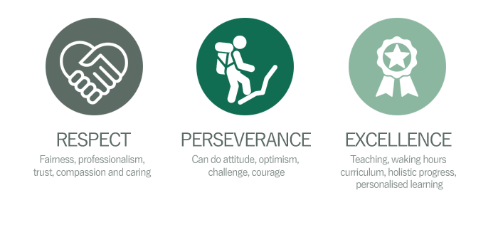****

**OUR PUPILS**

Our curriculum has been developed to ensure it meets the needs of all our pupils and offers a blend of formal and informal learning. We want to enable successful learners, who enjoy learning, make progress and achieve their aspirational goals. We operate different pathways of: preformal, semi-formal, formal, Nurture, bridging. We have ‘communication’ classrooms where appropriate and the whole setting is a neuro-affirmative environment.

As pupils progress and transition into adulthood, we want to develop confident individuals who can live safe, healthy and fulfilling lives as independently as possible and are responsible citizens, who can make a positive contribution to society and their communities.

**“Thank you doesn't even cover what I can say to you all; it's about 1% of what you all deserve but I don't know** **how to say the other 99%, just know I would if I could find the words.”**

*A Welburn Hall School parent*

**“Welburn Hall School is a warm and caring school. All staff want the very best for the**

**pupils who attend. As such, ambitions are high.”**

*Ofsted 2022*



**“Staff, both teaching and non-teaching, know their pupils well. Strong bonds have been forged between staff and pupils. Relationships are at the heart of the school…Staff expect pupils to achieve, which they do. Not least, this is because pupils are understood, treated and respected as individuals”**

*Ofsted 2022*

**OUR STAFF**

The work we do here and the development of our school would be impossible without our staff, who are an amazing team of dedicated and highly skilled people.

We are very proud of what we’ve achieved so far on our journey and we are supported by an incredibly able and involved governing body.

Further information on our Governors can be found [**here**](https://welburn-hall.n-yorks.sch.uk/governors.html)**.**



## APPLICATION PROCESS

The closing date for all applications is 11th July 2025

Interviews will be held week commencing 14th July

**Please apply online via the NYC Jobs Page**.

Please contact us should you require an application in a different format.

An email will be sent to candidates with details of the shortlisting outcome.

## Queries

Please contact Chloe Bullen on 01609 536 964 or via [chloe.bullen@northyorks.gov.uk](mailto:chloe.bullen@northyorks.gov.uk)

Chloe has been engaged to support us with recruiting to this exciting opportunity.

We actively welcome you to contact us to chat through the role and talk informally about the school/post and how working here will make a real difference to the children and young people in the area.

**When applying please take into account the following:**

**Employment History**

In line with KCSIE requirements, please complete your **full** employment history to ensure any gaps in your education and career history are accounted for.

**Suitable References**

When completing your application, please provide two employment referees. Generally, this should be your current and most recent Headteacher or line manager. Please note if your former Headteacher or line manager has since left, please use an alternative current senior staff member as they need to be in post at your former location to be able to confirm your details in full. Unfortunately, we cannot accept personal references or personal email addresses. Please get in touch for any queries if you are unsure.

**Supporting Information**

The supporting information section of your application should clearly evidence your ability to meet the requirements we have outlined in the job description & person specification. This will be used to shortlist applicants for this role and therefore it is imperative that you provide evidence as requested.

*We are committed to meeting the needs of our diverse community and aim to have a workforce reflecting this diversity. We are also committed to safeguarding and promoting the welfare of children, young people and adults. We have a robust* [***child protection policy***](https://welburn-hall.n-yorks.sch.uk/pdfs/School%20CP%20Policy%202023%20-%202024.pdf) *and all staff will receive training relevant to their role at induction and throughout employment at the school. We expect all staff and volunteers to share this commitment.*

*Please note this post is in regulated activity and exempt from the rehabilitation of Offenders Act 1974 and subject to satisfactory references and an enhanced DBS criminal records and barred list check for work with children. An online search may be undertaken as part of the recruitment process on information available in the public domain. Candidates should disclose anything that may be relevant in line with Keeping Children Safe in Education.*

##### **JOB DESCRIPTION**

**HLTA at Welburn Hall School**

|  |  |  |  |  |
| --- | --- | --- | --- | --- |
| **GRADE:** | | Grade H | | |
| **RESPONSIBLE TO:** | | Headteacher/Senior Leadership Team (SLT)/SENCO | | |
| **STAFF MANAGED:** | | Other support staff e.g GTA, ATA, PCA | | |
| **POST REF:** | |  | JOB FAMILY: | 7 |
| **JOB PURPOSE:** | * To complement the professional work of teachers by taking responsibility for agreed learning activities under an agreed system of supervision. * To advance pupils’ learning in a range of classroom settings, including working with individual pupils or groups and whole classes where the assigned teacher is not present, e.g. PPA time or covering short term absence. Activities involve planning, preparing and delivering learning lessons as well as monitoring pupils, assessing, recording and reporting on pupils’ achievement, progress and development, under the direction of the class/subject teacher. * May have specific responsibilities for the management and development of key areas within the school and/or management of other support staff (minimum of 3) including the allocation and monitoring of work, appraisal and training. | | | |
| **JOB CONTEXT:** | This school is committed to safeguarding and promoting the welfare of our pupils and young people. We have a robust Child Protection Policy and all staff will receive training relevant to their role at induction and throughout employment at the School. We expect all staff and volunteers to share this commitment. This post is subject to a satisfactory enhanced Disclosure and Barring Service criminal records check for work with children.  An ability to fulfil all spoken aspects of the role with confidence through the medium of English | | | |
| **ACCOUNTABILITIES / MAIN RESPONSIBILITIES** | | | | |
| **Supporting Learning & Development** | * Cover short-term teacher absence and communicate pupil work as planned by the classroom teacher and manage pupil behaviour * Within an agreed system of supervision, plan teaching and learning objectives, prepare and deliver learning activities and evaluate and adjust lessons/work plans according to pupil responses/needs * Monitor, record and evaluate pupil responses to learning activities through a range of assessment and monitoring strategies against pre-determined learning objectives * Interact with pupils in ways that support the development of their ability to think and learn, and work independently * Support the development and implementation of appropriate behaviour management strategies, to anticipate and manage behaviour constructively, promoting self-control and independence * Support pupils in their social and emotional wellbeing, and develop and implement related social, health and physical programmes * Take account of the effects of different parenting approaches, background and routines, and be involved in home school liaison * Encourage and motivate pupils to promote independence and resilience and increase self-esteem * Participate in the development, implementation and monitoring of systems relating to attendance and integration e.g. registration, truancy, pastoral systems etc. * Accompany or act as a group leader on educational visits, and other activities outside of the classroom, supervising the pupils * Provide supervision during breaks as required | | | |
| **Communication** | * Establish constructive and respectful relationships with parents/carers, exchange appropriate information, facilitate their support for their child’s attendance, access and learning and support home to school and community links. * Play an appropriate part in establishing effective relationships and communicate with other agencies/professionals, in liaison with the teacher, to support achievement and progress of pupils | | | |
| **Sharing Information** | * Provide objective and accurate feedback and reports on pupil attainment, progress and other matters, ensuring the availability of appropriate evidence * Participate in meetings with other staff, external professionals, and parents, regarding pupils, in a support capacity to the teacher, who will normally lead on such matters * Pay due regard to professional boundaries, maintaining appropriate levels of confidentiality * Participate in staff meetings * Share information about pupils with teachers and other professionals as required | | | |
| **Safeguarding and Promoting the Welfare of Children/Young People** | * Assist pupils with personal hygiene, and welfare, including physical and medical needs, whilst encouraging independence * Be responsible for promoting and safeguarding the welfare of pupils that you are responsible for and come into contact with, reporting concerns as appropriate | | | |
| **Administration/Other** | * Organise and manage an appropriate learning environment and resources * Co-ordinate the activities of students entering the school for the purpose of work experience/ work placements * Support the use of ICT to advance pupils’ learning and use common ICT tools for own and pupils’ learning * Assist with administrative support e.g. dealing with correspondence, compilation/ analysis, reporting on attendance, exclusions etc., making phone calls * Manage a team of support staff working across the school, including the appraisal, training and deployment of staff * Participate in the recruitment/ induction/ appraisal/ training/ mentoring of other support staff working across the school * Supervise and provide access arrangements for pupils sitting internal and external examinations, ensuring that examinations comply with Examination Board Regulations * Under the guidance and supervision of a class teacher be responsible for marking the register or being a form tutor * Participate in training and appraisal | | | |
| **Data Protection** | * To comply with the Council’s policies and supporting documentation in relation to Information Governance this includes Data Protection, Information Security and Confidentiality | | | |
| **Health & Safety** | * Be aware of and implement your health and safety responsibilities as an employee and where appropriate any additional specialist or managerial health and safety responsibilities as defined in the Health and Safety policy and procedure * Work with colleagues and others to maintain health, safety and welfare within the working environment | | | |
| **Equalities** | * Promote inclusion and acceptance of all pupils * Ensure services are delivered in accordance with the aims of the equality Policy Statement * Develop own and team members understanding of equality issues | | | |
| **Flexibility** | * North Yorkshire Council provides front line services, which recognises the need to respond flexibly to changing demands and circumstances. Whilst this job outline provides a summary of the post, this may need to be adapted or adjusted to meet changing circumstances. Such changes would be commensurate with the grading of the post and would be subject to consultation. All staff are required to comply with Council Policies and Procedures | | | |
| **Customer Service** | * The Council requires a commitment to equity of access and outcomes, this will include due regard to equality, diversity, dignity, respect and human rights and working with others to keep vulnerable people safe from abuse and mistreatment * The Council requires that staff offer the best level of service to their customers and behave in a way that gives them confidence. Customers will be treated as individuals, with respect for their diversity, culture and values | | | |
| **Date of Issue:** | May 2024 | | | |

##### **PERSON SPECIFICATION**

|  |  |
| --- | --- |
| **Essential upon appointment** | **Desirable on appointment** |
| **Knowledge**   * Good understanding of child/young people’s development and learning processes * Understanding of individual children and young peoples’ needs * An understanding that children/Young people have differing needs and knowledge of inclusive practice | * Knowledge of SEND * Knowledge of Behaviour Management techniques * Knowledge of Child Protection and Health & Safety legislations and procedures |
| **Experience**   * Significant experience of working with children in an education setting | * Experience with SEND * Line Management/supervisory experience * Experience of delivering evidence based interventions that accelerate learning * Experience in a relevant specialism e.g. Art/Music/Sport |
| **Occupational Skills**   * Demonstrable ICT skills and ability to use them as part of the learning process, or, the ability to develop ICT skills in a reasonable timeframe * Good written and verbal communication skills: able to communicate effectively and build good relationships with all teachers, children, young people, families and carers |  |
| **Qualifications**   * Level 2 numeracy & literacy qualification or equivalent * HLTA status or QTS ** * ** It is essential that Higher Level Teaching Assistants are assessed against and meet the HLTA standards, or have Qualified Teacher Status to enable them to deliver teaching and learning activities to a whole class | * Relevant NVQ level 4 or foundation degree * Appropriate first aid training (Dependent on the school’s needs - insert as appropriate) |
| **Personal Qualities**   * Demonstrable interpersonal skills * Ability to work successfully in a team * Able to exercise judgement * Confidentiality * Flexibility | * Creativity |
| **Other Requirements**   * Enhanced DBS clearance * To be committed to the school's policies and ethos * To be committed to Continuing Professional Development * Motivation to work with children and young people * Ability to form and maintain appropriate relationships and personal boundaries with children and young people * Emotional resilience in working with challenging behaviours and attitudes * Ability to use authority and maintaining discipline * An empathy for equality & diversity * The ability to converse at ease with customers and provide advice in accurate spoken English is essential for the post |  |



**APPLYING FOR A JOB WITH NORTH YORKSHIRE COUNCIL**

**IMPORTANT ADVICE ON COMPLETING THIS APPLICATION**

Your application form plays an important part in your selection. Please ensure you address all the essential requirements listed in the specifications. The following advice should help you to complete the application form as effectively as possible.

**Data Protection**

The information that you state on this application form will be used by the school and the Council to consider you for a job vacancy. To find out about how we use your personal data for the purposes of recruitment please see our Privacy Notice at [www.northyorks.gov.uk/working-us](http://www.northyorks.gov.uk/working-us).

**Rehabilitation of Offenders**

The post you are applying for requires you to have an enhanced Disclosure and Barring Service criminal records check for work with children, with a barred list check if you work in regulated activity. This check for disclosure of criminal history will include spent convictions, pending prosecutions / current court proceeding and police enquiries.

Should you be shortlisted, you will be asked to disclose full details of your criminal history prior to your interview. This includes any information deemed relevant as part of Keeping Children Safe in Education which may arise in an online search undertaken on shortlisted candidates. This information may be discussed with you at your interview in order to assess job related risks, but we emphasise that your application will be considered on merit and ability and you will not be discriminated against unfairly. Failure to disclose this information will result in any offer of employment being withdrawn.

Please also see the policy statement on the Recruitment of Ex-offenders below.

**Information in Support of your Application**

Every post advertised is supported by a full person specification. The specification lists all the essential skills, experience and qualifications which are necessary for the job and the criteria against which you will be assessed, both through your application form and at interview.

As part of the application process, you may have been asked to demonstrate within this application form how you meet some or all of the criteria or key competencies outlined in the person specification. Rather than simply repeating your career history, look at the skills and experience required by the job and provide evidence that you possess them by giving **specific and detailed examples** which include a focus on outcomes and on your own contribution to the scenario. Try to use different and varied examples wherever possible.

When completing these sections, do not forget the skills and experience you have gained outside full-time work. Outlining your previous work experience or other responsibilities may help you to uncover skills which you have taken for granted and which are clear signs of your ability to do the job.

**Canvassing**

You must not try to influence an elected Council Member, any council employee or a member of the school governing body, to act in your favour, as this will disqualify you. If you are related to a Councillor, a Council employee or a governor you must indicate this in the relevant section of the application form.



**POLICY STATEMENT ON THE RECRUITMENT OF EX-OFFENDORS**

1. As an organisation assessing applicants’ suitability for positions which are included in the Rehabilitation of Offenders Act 1974 (Exceptions) Order using criminal record checks processed through the Disclosure and Barring Service (DBS), this school complies fully with the DBS code of practice and undertakes to treat all applicants for positions fairly.

2. This school undertakes not to discriminate unfairly against any subject of a criminal record check on the basis of a conviction or other information revealed.

3. This school can only ask an individual to provide details of convictions and cautions that it is legally entitled to know about. Where a DBS certificate can legally be requested (where the position is one that is included in the Rehabilitation of Offenders Act 1974 (Exceptions) order 1975 as amended, and where appropriate Policy Act Regulations as amended) this school can only ask an individual about convictions and cautions that are not protected.

4. This school is committed to the fair treatment of its staff and potential staff, regardless of race, gender, religion, sexual orientation, responsibilities for dependents, age, physical/mental disability or offending background.

5. This school has this written policy on the recruitment of ex-offenders, which is made available to all DBS applicants at the start of the recruitment process.

6. This school actively promotes equality of opportunity for all with the right mix of talent, skills and potential and welcome applications from a wide range of candidates, including those with criminal records. Candidates are selected for interview based on their skills, qualifications and experience and criminal record information is only requested from short-listed candidates.

7. A disclosure is only requested from the DBS after a thorough risk assessment has indicated that one is both proportionate and relevant to the position concerned. For those positions where a criminal record check is identified as necessary, all application forms, job adverts and recruitment briefs will contain a statement that a DBS certificate will be requested in the event of the individual being offered the position.

8. This school ensures that all those who are involved in the recruitment process have been suitably trained to identify and assess the relevance and circumstances of offences.

9. This school also ensures that they have received appropriate guidance and training in the relevant legislation relating to the employment of ex-offenders, e.g. the Rehabilitation of Offenders Act 1974.

10. At interview, or in a separate discussion, this school ensures that an open and measured discussion takes place on the subject of any offences or other matter that might be relevant to the position. Failure to reveal information that is directly relevant to the position sought could lead to withdrawal of an offer of employment.

11. This school makes every subject of a criminal record check submitted to DBS aware of the existence of the code of practice and makes a copy available on request.

This school undertakes to discuss any matter revealed on a DBS certificate with the individual seeking the position before withdrawing a conditional offer of employment