The opportunity to transform lives

SALARY
G5 Points 12 to 15 being £16,085 to £17,946 (FTE £23,194 to £25,878)

START DATE
April 2023

WORKING HOURS
Part-Time, Permanent 30 hours per week 39 weeks per year (44.6 paid weeks)
Reduced days/hours will be considered for the right applicant.

LOCATION
Whaplode CofE Primary School, Mill Lane, Whaplode, Lincolnshire PE12 6TS

APPLICATION DEADLINE
Monday, 27th March 2023 9am

INTERVIEWS
Week commencing 27th March 2023

Higher Level Teaching Assistant
What if every child was unique with intrinsic value? What if every member of staff was unique with intrinsic value? What if every school was unique with intrinsic value? At LAAT we believe that they are.

We’re a Church of England trust - everything we do is because every child has an intrinsic value – which we call being made in the image of God. But you don’t have to. You just need to be able to look at our children and young people: however deprived or privileged; however difficult or compliant; whatever their background, ability, culture, or gender, and know that what you do, how you teach them, what you give to them, and how you relate to them can transform their lives. Then, you must have the energy, passion, and drive to give them your best.

We don’t ask you to do this alone. We’ll provide you with the support of an organisation which believes that you too are unique and valuable – valuable for who you really are.

So, is now the time to consider what you want by looking at what Greater Lincolnshire and Lincoln Anglican Academy Trust can offer you? A chance to grow your career, gain professional support, and the opportunity to transform lives.

Greater Lincolnshire is a fabulous county with beautiful beaches, woods, Wolds, fields, and fens. It offers reasonably priced housing and is home to the Red Arrows. Lincoln is a two-university city with access to new and growing technologies.

Is now the time to find out more about us and to join our community of excellence, exploration, and encouragement? To change lives with us, for the better.

Jackie Waters-Dewhurst
Chief Executive Officer

LAAT is a Multi-Academy Trust formed by the Diocese of Lincoln in 2013. We have grown to serve twenty academies across three local authorities of Lincolnshire, North Lincolnshire, and North-East Lincolnshire.

The Trust is committed to safeguarding and promoting the welfare of children and young people and expects all staff and volunteers to share this commitment. We will require the successful applicant to undertake an enhanced criminal record check via the DBS.
For more information about LAAT:
www.thelaat.co.uk

Higher Level Teaching Assistant

Whaplode Church of England Primary Academy has an exciting opportunity to appoint a Higher Level Teaching Assistant (HLTA) to join our team. The position is Monday to Friday, term time plus 5 days. Dedicated PPA time is given with high staff wellbeing within our recently rated ‘good’ by Ofsted school. Reduced days/hours will be considered for the right applicant.
BENEFITS
- Local Government Pension Scheme for support staff, Teachers Pension Scheme for Teachers
- 25 days annual leave
- Growth and Development processes in place for all employees to support continuous professional development
- Access to over 70 online E-Learning courses
- 24-hour confidential helpline covering legal, financial, wellbeing, health and nutrition etc.
- Confidential counselling – up to 6 sessions free of charge
- Physiotherapy – up to 4 free sessions free of charge
- Coaching - Personalised stress coaching plans over 6 weeks, one to one with an OH Practitioner
- Virtual GP – Accessible by smart phone or computer, same day appointments available at time to suit

The ideal candidate will:
- Have experience of working with pupils over the whole age and ability range to deliver a wide range of activities, which support and enhance learning, personal and social development.
- Have the ability to support and complement the professional work of teachers by managing and providing an extensive range of learning related activities.
- Demonstrate the highest expectations of pupil achievement and behaviour.
- Demonstrate a commitment to raising pupil attainment and achievement.
- Have enthusiasm and commitment.
- Share the Trust and School vision and values

We can offer you:
- an excellent working environment
- calm classrooms with well motivated pupils
- commitment to staff professional development
- a supportive working environment and friendly team.
Applications from experienced TA’s who meet the criteria set out in Person Specification and have relevant experience are welcome.

Visits to our school are warmly welcomed and encouraged.

Application packs are available via the school website https://www.whaplodeprimary.co.uk/news/vacancy.html or at the Trust website https://thelaat.co.uk/opportunities/

Please contact Mrs E Adie, Head of School or Miss A Muir, Executive Headteacher for an informal discussion on 01406 370447 or by email enquiries@whaplode.laat.co.uk
Completed application forms should be sent to Kim Davis, Finance and Admin Officer at kim.davis@whaplode.laat.co.uk

In line with Keeping Children Safe in Education 2022, please be advised that if shortlisted, we will carry out internet searches to support our commitment to safer recruitment. Please note that the purpose of this is to identify any incidents or issues that have happened, and are publicly available online, which the school might want to explore with applicants at interview. Internet searches will be carried out by someone who is not directly involved in the recruitment process and only relevant information will be shared with the interview panel.

About Us

Whaplode C of E School are part of the Lincoln Anglican Academy Trust (LAAT). LAAT is a multi-academy trust formed by the Diocese of Lincoln. We are a growing and thriving family of schools who are dedicated to providing an excellent education for pupils across Lincolnshire. We place a strong emphasis on continued development. The relationship with the Trust brings great strength to all schools and enhances CPD opportunities for all staff.
At Whaplode C of E Primary School our aim is to inspire everyone to believe in their ability to succeed through learning in a joyful and encouraging Christian atmosphere. This vision encourages our children to learn as much as possible and achieve their individual potential whilst developing respect and consideration for others. We have recently been graded as good by Ofsted who found, ‘behaviour is positive.’
Within our school we work very hard to create a team of teachers, non-teaching and support staff that will support each child in reaching their potential. Many who visit us comment on the strength of our ‘staff team’ and their shared commitment to help every child in the school achieve their best.
We value the broad and balanced curriculum which our staff offers and all children are able to access not only academic, but creative and physical areas of the National Curriculum fully, so that they receive the highest standard of education.
We are a school that prides itself on our Christian values and aims to ensure all of our pupils feel happy, secure and valued, enabling them to make a worthwhile contribution as young people within their community. Ofsted stated in May 2022, ‘Pupils describe the school as welcoming and inclusive. As one pupil said: ‘It doesn’t matter where you are from, the colour of your skin, your religion; everyone is perfect in their own way.’
Our school provides a gateway for children to discover, explore and learn in a caring environment. Childhood is a magical, wonderful time and our pupils follow a varied and active programme designed to give them the opportunity to build confidence and learn everything they will need for their future.

Job Description HLTA

Core Purpose

To complement the teachers’ delivery of the national curriculum and contribute to the development of other students, school policies and strategies.

To provide support for students, the teacher and the school to raise standards of achievement for all, by utilising advanced knowledge of planning, monitoring, assessing and managing classes.

To work collaboratively with teaching staff and assist on the whole planning cycle and the management and preparation of resources.

To provide support for the student’s welfare and support the inclusion of students in all aspects of school life.

To supervise whole classes during short-term absence of teachers.

Key Tasks and Responsibilities

Plan and prepare lesson with teachers, participating in all stages of the planning cycle, including evaluating and adjusting lesson plans.
Develop and prepare resources for learning activities.

Contribute to the planning of opportunities for students to learn in out-of-school contexts in line with school policies and procedures.

Within an agreed system of supervision and within lesson framework, teach whole classes covering PPA.

Provide detailed verbal and written feedback on lesson content, student responses to learning and student behaviour, to teachers and students.
Motivate and progress students’ learning by using clearly structured interesting teaching and learning activities.

Be familiar with lesson plans, IEP targets and learning objectives.

Use behaviour management strategies, in line with the schools’ policy and procedures, to contribute to a purposeful learning environment and encourage students to interact and work cooperatively with others.

Support the role of parents in students’ learning and contribute to/lead meetings with parents to provide constructive feedback on student progress, achievement and behaviour, maintaining sensitivity and confidentially at all times.

Assist teachers in evaluating progress through a range of assessment activities.

Assist in maintaining and analysing records of students’ progress.

Support and guide other less experienced teaching assistants work in the classroom when required and lead training for other support staff.

Recognise and challenge any incident which forms abuse of equal opportunities, ensuring compliance with relevant school policies.

Understand and implement school child protection policies and comply with legal responsibilities.

Foster and maintain constructive and supportive relationships with parents/carers, exchanging appropriate information, facilitating their support for their child’s attendance, access and learning, and supporting home to school and community links.

Other

The duties and responsibilities in this job description are not exhaustive. The postholder may be required to undertake other duties that may be required from time to time within the general scope of the post. Any such duties should not substantially change the general character of the post. Duties and responsibilities outside of the general scope of this grade of post will be with the consent of the postholder.

The postholder is required to carry out the duties in accordance with LAAT Equal Opportunities policies.

The postholder is required to carry out the duties in accordance with the LAAT Health and Safety policies and procedures.

All employees need to be aware of the possible abuse of children and vulnerable adults and if you are concerned you need to follow the Academies’ Safeguarding Policy. In addition, employees working with children have a responsibility to safeguard and promote the welfare of during the course of their work.

Person Specification - HLTA
“The smallest of all seeds, when it has grown, is the greatest of shrubs and becomes a tree, so that the birds of the air come and make nests in its branches.” Matthew 13:32

Selection decisions will be based on the criteria outlined below. At each stage of the process an assessment will be made by the appointment panel to determine
the extent to which the criteria have been met. When completing your application paperwork, you should ensure that you address each of the selection criteria and provide supporting evidence of how you meet the criteria through reference to your work or relevant experience.

Training/Qualifications/Experience Essential Desirable

5 O Level/GCSEs (English & Mathematics at grade C or above or equivalent) | *
Have HLTA status (or qualified teacher status) or similar experience | *
Other relevant qualifications (e.g. Foundation degree in Education) |  | *
Experience of working within a Primary School | *
Recent experience of working with children of relevant age and contributing to learning and development | *
NVQ in supporting teaching and learning |  | *
Previous experience of working as a HLTA |  | *
Planning and teaching individuals, groups and whole classes | *
Training or expertise in a specialist curriculum area (eg ICT, maths or literacy) |  | *

Professional knowledge and understanding

HLTA standards | *
Relevant policies, codes of practice and legislation including safeguarding | *
Understanding of planning requirements for pupils of differing ages and abilities | *
Experience and knowledge of implementing effective behaviour management strategies | *
Multi agency working |  | *
First Aid |  | *

Safeguarding Children

Current Safeguarding Training |  | *
Enhanced DBS Clearance (Trust will obtain) | *
Awareness of the importance of safeguarding and promoting the welfare of children | *
A commitment to maintaining up to date knowledge of child protection legislation and guidance | *

Personal and Professional Skills and Attributes
Have effective oral and written communication skills | *
Ability to form effective professional relationships including team working | *
Have good organisational and time management skills | *
Have sound ICT skills and the ability to apply this as required | *
Be able to plan effective activities for pupils at risk of underachieving | *
Develop their knowledge through the evaluation of their own learning needs | *
Be able to work independently | *
Remain calm under pressure and be able to adapt to change quickly | *

Approach to work – Candidates should:

Have flexibility to changing demands as needed | *
Prioritise as required to meet the demands of the role | *
Have attention to detail | *

Behaviour Competencies - Candidates should:

Be respectful and able to with tact and diplomacy | *
Possess sensitivity and awareness of other’s needs | *

Other - Candidates should:

Be a positive role model | *

Our Commitment to you

We believe that all our schools are fantastic places to work. Our commitment to you is important - throughout the recruitment process and beyond. Our culture is one of development, equality, and consistency. We aim to demonstrate this through:

- Transparency – we will treat you with respect, honesty, and fairness.
- Protecting your privacy – we will ensure your information is secure and handled sensitively and in line with our Privacy Policy for prospective staff.
- Showcasing talent – we’ll provide a good opportunity for you to share your skills, experience, and potential.
- Feedback – we will provide constructive feedback professionally.
- Listening – we welcome feedback.

We hope to ensure that you have a positive experience throughout the recruitment process by:

Please see the link to our privacy notice for prospective candidates:
Opportunities - LAAT (thelaat.co.uk)

The Trust promotes diversity. Applications are welcome from all, irrespective of gender, sexuality, race, religion, marital status, age, or disability.
- Providing you with clear, accurate and timely information.
- Giving you the opportunity to ask questions – and providing you with answers.
- Following a fair assessment process.

Our Schools

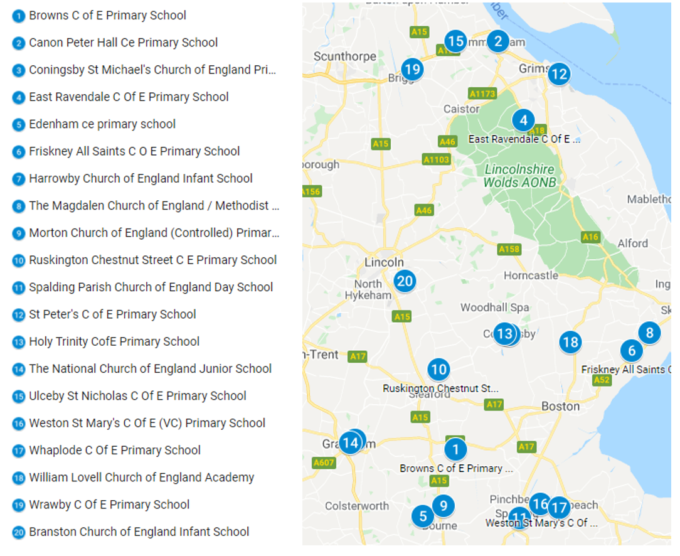

Where to Find Us

Address
Whaplode Church of England Primary School, Mill Lane, Whaplode, Lincolnshire PE12 6TS

Telephone
01406 370447

Email
Whaplode.reception@southlincs-hub.co.uk

