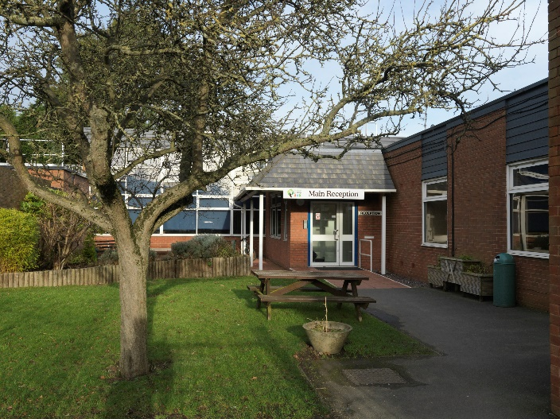

CANDIDATE INFORMATION BROCHURE

Welcome from the Headteacher
Welcome to Woodlands Academy and thank you for your interest in our school. where our staff team all work together with one core aim – ‘To make a real difference to some of the most vulnerable children in the learning system’.

As a convertor academy we have used some of the freedoms this has given us to make sure our curriculum offer is creative and tailored to the individual needs of the pupils. We adopt a ‘holistic approach’ focusing on the development of the ‘whole child’ using a personalised, pupil centered curriculum.

We are committed to providing the best education for all our pupils with all staff being passionate about providing a meaningful and motivating curriculum. Our aim is to help our pupils become responsible citizens who can make a positive contribution to the community.

Our community of 123 pupils (2-16) is filled with dedicated and talented staff, where all children will flourish. As a specialist school for children with a wide range of SEN needs we have a strong moral compass in everything we do and this has seen us develop and grow our number on roll (at the request of the Local Authority) and our specialisms which are predominant within Autism, Communication Needs and Social, Emotional and Mental Health.
Every day at Woodlands is different and we pride ourselves on the difference that we make each day to the lives of the children we serve. If you are the type of person who is passionate about helping each and every child, has a positive outlook, shows bags of resilience in the face of challenge and wants to inspire children and young people through fun and engaging learning activities then you will fit right in as part of our team.

We welcome visitors and hope that you will come and see for yourself the huge changes which have happened at Woodlands which make us the special school of choice for many.

We look forward to meeting you.

Michelle Hockham
Headteacher

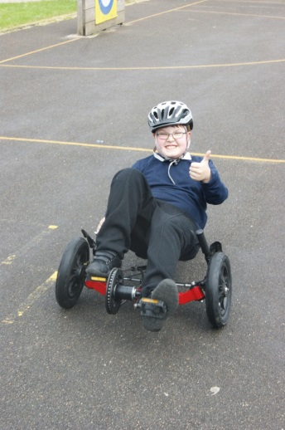
About our School
We transferred to academy status in April 2013

The Woodlands Academy is a co-educational special school for pupils 2-16. The school caters for pupils with a wide range of complex special needs. All have learning difficulties ranging from SLD to MLD. 88% have communication difficulties with a significant number of these pupils within the autistic spectrum.

The emphasis of the school is on providing a truly meaningful curriculum to an ever changing complex cohort of pupils which is accessible to all and which allows them to develop into confident individuals who through high expectation are able to achieve and
become as independent as possible finding a fulfilling place within the wider world.

Our vision is to:
- Provide high quality education for all children.
- To identify the need and talents of each student and support and educate them to reach their full potential.

We provide a supportive caring environment where every individual is valued and expected to give their best in order to raise standards. All pupils who attend the academy have SEN. The academy is a specialist provision.

To gain more of a feel of our school please visit our website at www.woodlands.n-yorks.sch.uk
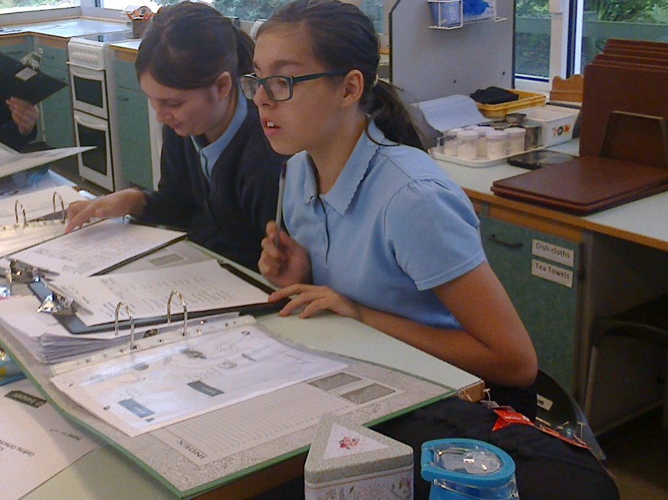

What our staff say about our school
Michelle Allison, Advanced Teaching Assistant
I have worked for Woodlands Academy for the past 10 years, working with children of different ages. At the Academy, I particularly enjoy working with the amazing children who present with different needs. I feel I am continually learning and I have the opportunities to develop further through training. No two days are the same, often challenging, but I feel very well supported by the fantastic team of people I work with.

Megan Prosser, Advanced Teaching Assistant
All staff are very welcoming, friendly and supportive. Staff are there to help you with any problems and are very approachable. I couldn’t ask for a better team of people to work with. Plenty of opportunities to gain experience and knowledge around different needs.

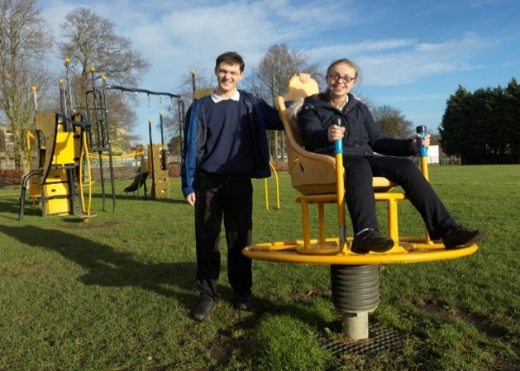
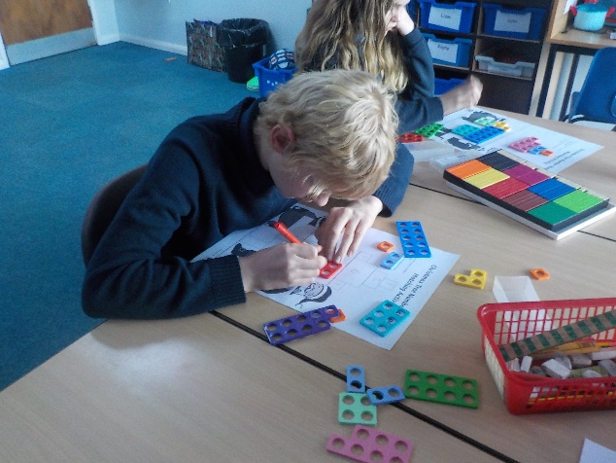

Application Process
The closing date for all applications is 12 noon on Tuesday 25 January 2022
Interviews will be held as soon as possible after the closing date.
Completed applications must be returned to Sam Silk at
sam.silk@woodlands.n-yorks.sch.uk
If you do not receive confirmation of receipt of your application within one working day please call Sam on 01723 373260
An email will be sent to shortlisted candidates with details of the interview process. If you have not heard from us within a week of the closing date please assume your application has been unsuccessful.
If you think you’re the person for the job, please complete the application form available on our website, www.woodlands.n-yorks.sch.uk and send to the email address above by the closing date.

Queries
Visits are advised and warmly welcomed. Please contact the school to arrange.
The Woodlands Academy is committed to safeguarding and promoting the welfare of children and young people and expects all staff and volunteers to share this commitment.
This post is exempt from the Rehabilitation of Offenders Act 1974 and the appointment is subject to a satisfactory enhanced level disclosure and S128 clearance from the Disclosure & Barring Service (DBS).

JOB DESCRIPTION - HLTA

Position | Higher Level Teaching Assistant (HLTA SEN)
Contract: | Full Time, Fixed Term until 26/07/2022
Grade: | Band G (Paid full year and entitled to non contact time)
Responsible to: | Headteacher/Member of Senior Management Team
Responsible for: | ATAs, GTAs, and other support staff working in the classroom environment supporting the learning process

JOB PURPOSE
To complement the professional work of teachers by taking responsibility for agreed learning activities under an agreed system of supervision.
To advance pupils’ learning in a range of classroom settings, including working with individual pupils or groups and whole classes where the assigned teacher is not present. Activities involve planning, preparing and delivering learning lessons as well as monitoring pupils, assessing, recording and reporting on pupils achievement, progress and development.
May have specific responsibilities for the management and development of key areas within the school and/or management of other support staff (minimum of 3) including the allocation and monitoring of work, appraisal and training

ACCOUNTABILITIES / MAIN RESPONSIBILITIES

Effective communication and engagement with children, young people and their families and carers. | - Establish constructive relationships with parents/carers, exchange information, facilitate their support for their child’s attendance, access and learning and support home to school and community links.  - Provide advice and guidance as required and appropriate.  - Develop and use effective communication systems appropriate to the audience.  - Listen in a calm, open, non – threatening manner and use questions to check understanding and acknowledge that you have heard what is being said.  - Understand how to present genuine choices to young people and how to obtain consent to sharing information.  - Provide support and encouragement to children and young people.  - Know that communication is a two way process.  - Know how to listen to people, make them feel valued and involved, and know when it is important to focus on the individual rather than the group.
Child and young person development | - Within an agreed system of supervision plan teaching and learning objectives and evaluate and adjust lessons/work plans as appropriate  - Deliver learning activities to pupils within agreed system of supervision, adjusting activities according to pupil responses/needs.  - Monitor and evaluate pupil responses to learning activities through a range of assessment and monitoring strategies against pre-determined learning objectives.  - Take an appropriate role in the development and implementation of appropriate behaviour management strategies.  - Provide objective accurate feedback and reports as required on pupil achievement, progress and other matters, ensuring the availability of appropriate evidence.  - Work with the School’s agreed discipline policy to anticipate and manage behaviour constructively, promoting self-control and independence.  - Challenge and motivate pupils, promote and reinforce self-esteem.  - As required take an appropriate role in the development, implementation and monitoring of systems relating to attendance and integration e.g. registration, truancy, pastoral systems etc.  - Participate in the marking of pupils’ work and accurately record achievement/progress.  - Listen actively and respond to concerns about developmental or behavioural changes.  - Know that development includes emotional, physical, intellectual, social, moral and character growth, and know that they can all affect one another.  - Know how to interact with children in ways that support the development of their ability to think and learn.  - Know how to obtain support and report concerns.  - Encourage a child or young person to value their experiences and knowledge.
Safeguarding and promoting the welfare of the child | - Be aware of and comply with policies and procedures relating to child protection, health, safety and security.  - Be responsible for promoting and safeguarding the welfare of children and young people that you are responsible for and come into contact with.  - Be able to recognise when a child or young person is in danger or at risk of harm, and take action to protect them.  - Have an awareness and basic knowledge where appropriate of the most recent legislation.
Supporting transitions | - Listen to concerns; recognise and take account of signs of change in attitudes and behaviour.  - Understand your own role and its limits, and the importance of providing care or support.
Multi agency working | - Play an appropriate part in establishing constructive relationships and communicate with other agencies/professionals, in liaison with the teacher, to support achievement and progress of pupils.  - Work in a team context – forging and sustaining relationships across agencies and respecting the contribution of others working with children, young people and families.  - Know how to work within your own and other organisational values, beliefs and cultures.  - Know the value and expertise you bring to a team and that brought by your colleagues.
Sharing information | - Work with other staff in planning, evaluating and adjusting learning activities as appropriate.  - Use clear language to communicate information unambiguously to others including children, young people, their families and carers.  - Liaise between managers/teaching staff and teaching assistants in the school/college.  - Attend staff meetings, training days and management meetings by agreement with the Headteacher.  - Know about the common assessment framework and, where appropriate, how to use it.  - Understand the importance of sharing information, how it can help and the dangers of not doing so.
Administration/Other | - Organise and manage an appropriate learning environment and resources.  - Co-ordinate the activities of students entering the school for the purpose of work experience/ work placements.  - Use ICT to advance pupils’ learning, use common ICT tools for own and pupils’ learning.  - As required, assist with administrative support e.g. dealing with correspondence, compilation/ analysis, reporting on attendance, exclusions etc., making phone calls.  - Manage a team of support staff working across the school.  - Participate in the recruitment/ induction/ appraisal/ training/ mentoring of other support staff working across the school.  - Participate in the School’s performance management scheme.  - Participate in training and other learning activities and performance development as required  - Supervise pupils sitting internal and external examinations, ensuring that examinations comply with Examination Board Regulations.  - Under the guidance and supervision of a class teacher be responsible for marking the register or being a form tutor.
Health & Safety | - Be aware of and implement your health and safety responsibilities as an employee and where appropriate any additional specialist or managerial health and safety responsibilities as defined in the Health and Safety policy and procedure
Equalities | - Ensure services are delivered in accordance with the aims of the equality Policy Statement  - Develop own and team members understanding of equality issues

Whilst this job outline provides a summary of the post, it is not a comprehensive list or description and the job will evolve to meet changing circumstances. Such changes would be commensurate with the grading and conditions of service of the post and would be subject to discussion and consultation. All staff are required to comply with the school's policies, procedures and ethos.

In relation to Data Protection, Information Security and Confidentiality, all staff are required to comply with the school's policies and supporting documentation in respect of these issues.

Equal Opportunities
The Woodlands Academy supports the principle of equality of opportunity in employment and has a clearly stated policy for Equalities.

PERSON SPECIFICATION

CRITERIA | ESSENTIAL | DESIRABLE | ASSESSMENT
Qualifications & Training  HLTA status or QTS **  GCSE Grade C or equivalent in English and Maths  Appropriate first aid training | X | X  X | 2 & 5  2 & 5  2 & 4
Experience  Experience of working in a classroom environment at Advanced Teaching Assistant Level. | X |  | 2 & 4
Skills & Knowledge  Demonstrable IT skills and ability to use them as part of the learning process, or, the ability to develop IT skills in a reasonable timeframe.  Good written and verbal communication skills: able to communicate effectively with all children, young people, families and carers  Good understanding of child/young person’s development and learning processes.  Understanding of individual children and young peoples’ needs. | X  X  X  X |  | 2, 3 & 4  2, 3 & 4  2 & 4  2 & 4
Personal Qualities  Demonstrable interpersonal skills.  Ability to work successfully in a team.  Able to exercise discretion and judgement.  Confidentiality | X  X  X  X |  | 2 & 4  2 & 4  2 & 4  2 & 4
Other Requirements  To be committed to the school’s policies and ethos.  To be committed to Continuing Professional Development.  Motivation to work with children and young people.  Ability to form and maintain appropriate relationships and personal boundaries with children and young people.  Emotional resilience in working with challenging behaviours; and, attitudes to use authority and maintaining discipline | X  X  X  X  X |  | 2 & 4  2 & 4  2 & 4  2 & 4  2 & 4
Equal opportunities  To assist in ensuring that The Woodlands Academy equalities policies are considered within the school’s working practices in terms of both employment and service delivery | X |  | 2 & 4

** It is essential that Higher Level Teaching Assistants have HLTA status, will undertake a course of study towards HLTA status or have Qualified Teacher Status to enable them to deliver teaching and learning activities to a whole class.
Assessment: 1. Test prior to shortlisting (i.e. all applicants)
2. From application form
3. Test after shortlisting
4. Probing at interview
5. Documentary Evidence
6. OTHER (Please specify)

JOB DESCRIPTION - ATA

Position | Advanced Teaching Assistant (ATA)
Grade | Grade D Pt 4-6 including SEN Allowance
Contract | 24 hours per week which includes  Fixed Term until July 2022
Responsible to | Headteacher
Line Manager | Headteacher/Senior Management Team
Safeguarding | Enhanced DBS

JOB PURPOSE
To work, under the direction of the class teacher and other appropriate staff, in assisting and contributing to the planning, delivery and evaluation of the learning process. The post holder will work in classes supervising groups and/or individual pupils and will assist in the induction and development of classroom support staff.
ACCOUNTABILITIES/MAIN RESPONSIBILITIES

Effective Communication and engagement with children, young people, their families and carers | - Establish rapport and respectful, trusting relationships and communicate effectively with children, young people, their families and carers.  - Listen and provide support and encouragement to children and young people.  - Know that communication is a two way process  - Supervise groups and individual pupils as required.
Child and young person development | - Assist in and contribute to the planning and evaluation of the learning process.  - Assist in the delivery of the learning process under the direction of the class teacher and other appropriate staff.  - Provide educational, emotional and physical support to pupils.  - Appreciate the impact of transition on child development  - Understand and take account of the effects of different parenting approaches, backgrounds and routines.  - Know how to interact with children in ways that support the development of their ability to think and learn.  - Support and assist in the development and implementation of appropriate behaviour management strategies.
Safeguarding and promoting the welfare of  the child | - Assist with the supervision of groups and individual students as required.  - Assist with playground supervision.  - Be responsible for promoting and safeguarding the welfare of children and young people that you are responsible for and come into contact with.  - Have an awareness and basic knowledge, where appropriate, of the most recent legislation.
Supporting Transitions | - Contribute to the provision of advice and guidance as required and appropriate.  - Listen to concerns; recognise and take account of signs of change in attitudes and behaviours  - Understand your own role and its limits and the importance of providing care or support.
Multi-agency working | - Know the value and expertise you bring to a team and that brought by your colleagues.  - Work in a team context – forging and sustaining relationships across agencies and respecting the contribution of others working with children, young people and families.  - Have a general knowledge & understanding of the range of organisations and individuals working with children, young people and those caring for them and be aware of the roles & responsibilities of other professionals.
Sharing information | - Provide structured judgement and feedback on pupils’ attainment and progress within assessment & reporting processes.  - Assist in the induction and development of classroom support staff.  - Be aware of and comply with policies and procedures relating to child protection, confidentiality, health, safety and security.  - Understand the importance of sharing information, how it can help and the dangers of not doing so.  - Be aware of own (and others’) professional boundaries.  - Ability to use clear language to communicate information unambiguously to others including children, young people, their families & carers.  - Attend staff meetings, training days and management team meetings by agreement with the Headteacher
Administration /Other | - Plan and prepare materials and undertake minor clericial duties.  - Participate in the School’s performance management scheme.  - Supervise pupils sitting internal and external examinations as required, ensuring that examinations comply with the Examination Board Regulations.  - Participate in training and other learning activities and performance development as required.
Health & Safety | - Be aware of and implement your health and safety responsibilities as an employee and where appropriate any additional specialist or managerial health and safety responsibilities as defined in the Health and Safety policy and procedure.
Equalities | - Ensure services are delivered in accordance with the aims of the equality Policy Statement.  - Develop own understanding of equality issues.

Whilst this job outline provides a summary of the post, it is not a comprehensive list or description and the job will evolve to meet changing circumstances. Such changes would be commensurate with the grading and conditions of service of the post and would be subject to discussion and consultation. All staff are required to comply with the school's policies, procedures and ethos.
In relation to Data Protection, Information Security and Confidentiality, all staff are required to comply with the school's policies and supporting documentation in respect of these issues.

Equal Opportunities

The Woodlands Academy supports the principle of equality of opportunity in employment and has a clearly stated policy for Equalities.

ATA Person Specificiation
CRITERIA | ESSENTIAL | DESIRABLE | ASSESSMENT
Qualifications & Training  Maths & English at Grade C or above  Childcare Qualification at Level 3 (or equivalent).  First aid training | X | X  X | 2 & 5  2 & 5  2 & 5
Experience  Experience appropriate to working with children in an education setting. | X |  | 2 & 4
Skills & Knowledge  Demonstrable IT skills and ability to use them as part of the learning process, or, the ability to develop IT skills in a reasonable timeframe.  Good written and verbal communication skills: able to communicate effectively and clearly with a range of staff, children, young people, their families and carers.  Good understanding of child development and learning processes.  Behaviour management | X  X  X  X |  | 2 & 4  2, 3 & 4  2 & 4  2 & 4
Personal Qualities  Demonstrable interpersonal skills.  Ability to work successfully in a team.  Confidentiality. | X  X  X |  | 2 & 4  2 & 4  2 & 4
Other Requirements  To be committed to the school’s policies and ethos.  To be committed to Continuing Professional Development  Motivation to work with children and young people.  Ability to form and maintain appropriate relationships and personal boundaries with children and young people.  Emotional resilience in working with challenging behaviours; and, attitudes to use authority and maintaining discipline. | X  X  X  X  X |  | 2 & 4  2 & 4  2 & 4  2 & 4  2 & 4
Equal opportunities  To assist in ensuring that The Woodlands Academy equalities policies are considered within the school’s working practices in terms of both employment and service delivery | X |  | 2 & 4

Assessment: 1. Test prior to shortlisting (i.e. all applicants) 4. Probing at interview
2. From application form 5. Documentary Evidence
3. Test after shortlisting 6. OTHER(Please specify)

The Woodlands Academy is committed to safeguarding and promoting the welfare of children and young people and expects all staff and volunteers to share this commitment.
This post is exempt from the Rehabilitation of Offenders Act 1974 and the appointment is subject to a satisfactory enhanced level disclosure and S128 clearance from the Disclosure & Barring Service (DBS).

