

All Saints Primary School
Aiming High CE Federation
“Aiming High. Working in partnership with Parents and Carers.”

Our School

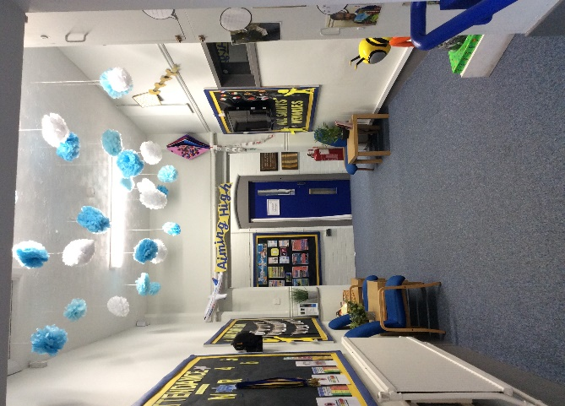
All Saints Primary School has been in existence since the 1860s and was sited next to All Saints Church. In 2004, All Saints was relocated to replace the former Gorton Brook Special School, in Gorton - an area of urban renewal/regeneration. Our last published OFSTED Inspection (November 2022) resulted in retaining the grade of Good. We also became part of the Aiming High C.E. Federation in September 2022 alongside Armitage C.E. Primary School. We currently have 231 children on roll and we operate as a one form entry school, with our children coming from a variety of backgrounds, religions and cultures. We have 51.75% of our children who are eligible for pupil premium funding; a high percentage of our school population have English as an additional language (55%) and 21% have been identified as having Special Educational Needs.

The majority of our children begin in the Nursery with very low attainment as reflected in our baseline on entry. However, we strive to achieve the very best that we can for our children.

Our Environment

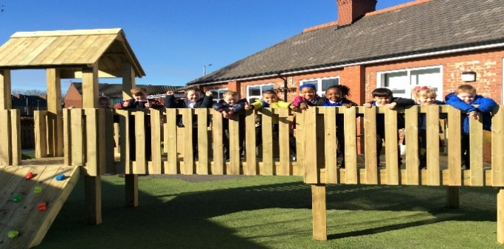
Our building has recently undergone renovations, which have included providing a modern, welcoming entrance for our children and parents/carers. We are all extremely proud of our environment which includes a recently renovated library, meeting room, intervention spaces and a base for our SEND children. All of our classrooms are equipped with computing equipment and all feature a smart board. Our staff have created rich learning environments for our children, keeping children engaged as well as stimulated. We use displays in communal areas to celebrate children’s achievements and publicise ‘theme days/weeks’ that happen in school.
We are equally proud of our developing outdoor space, which includes a wild area for children to partake in learning opportunities outside, including learning how to create a fire, scavenger hunts, den building and more.

Our Pupils

We are a small one-form entry school, with our pupils coming from over twenty-two different countries, providing us with a wide range of backgrounds and cultures. We pride ourselves in celebrating the differences in our community as well as the richness of our local area.
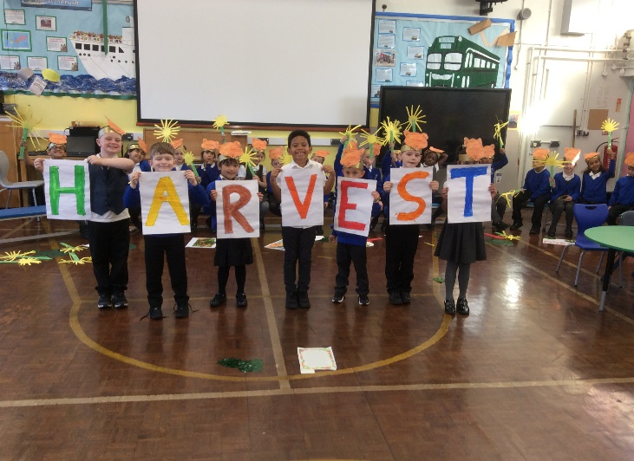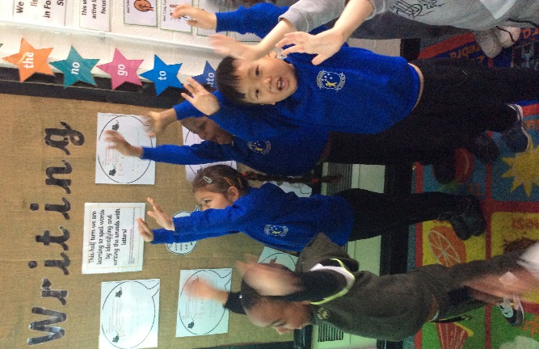

Our latest Ofsted report said that pupils at All Saints were ‘well mannered, friendly and respectful. They listen carefully to their teachers and concentrate on their learning. They are always keen to do their best and value the warm and friendly relationships that they have with staff.’ We firmly believe that our children contribute to the making of All Saints being a great place to learn. To support this, two children from each year group represent their class in the School Council to help run charity events, summer and winter fayres, whole school projects and general school improvement.

Our Staff

All of the staff at All Saints Primary School are committed to seeing all of our children thrive. We have a talented staff team, who each contribute something special to All Saints. We are a close-knit community, committed to supporting each other in any we can. Opportunities are provided for training and development, with staff being encouraged and supported to fulfil their own professional ambitions.

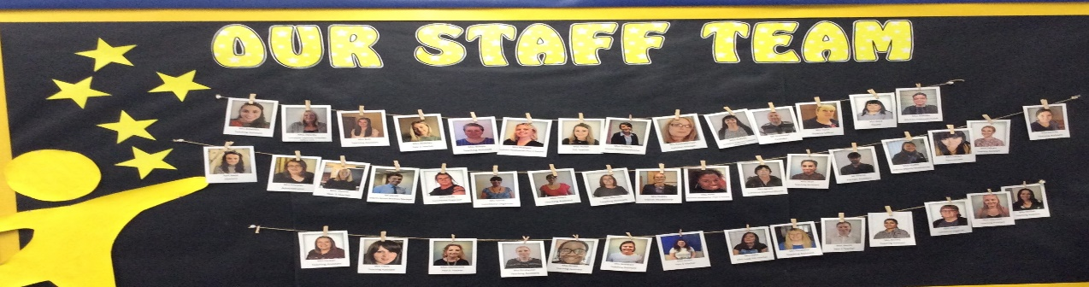

Our Community

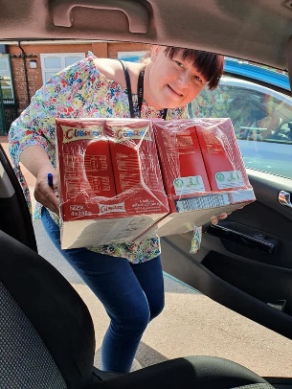
We are well known for the richness of our partnerships with community organisations. We bring a range of visiting professionals and educators into school to work with children and we believe in taking children out to experience and learn from everything their community and city has to offer. We work closely with Gorton Monastery, Gorton Visual Arts and Gorton Library to name a few. As well as the work we do with local charities and organisations, we support major U.K. charities such as Comic Relief and Children in Need.

Our Vision
All Saints Primary School seeks to become a centre of excellence for inclusive learning, enabling each pupil to explore their talents and achieve their full potential. This will be promoted in a welcoming environment of mutual respect ensuring each pupil feels safe, secure and valued.
