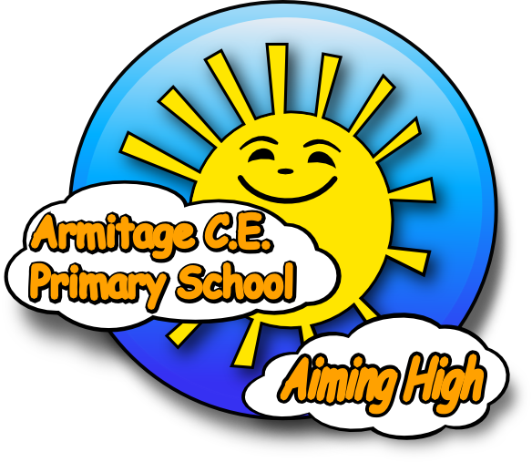

Our School
April 2024

We are a popular, progressive and inclusive school located in Ardwick, two miles outside of Manchester City Centre. There is much redevelopment currently taking place in the local area and our school is integral to this regeneration. Many of our children come from our local area however, due to our excellent reputation, many families travel a significant distance to attend Armitage; in fact, 50% of our school population are EAL learners, with children coming from all over the world to be part of our community! We have recently become part of ‘The Aiming High C.E. Federation’, a newly formed group of schools which currently includes ourselves and All Saints Primary in Gorton – it’s only a short drive between the two sites!

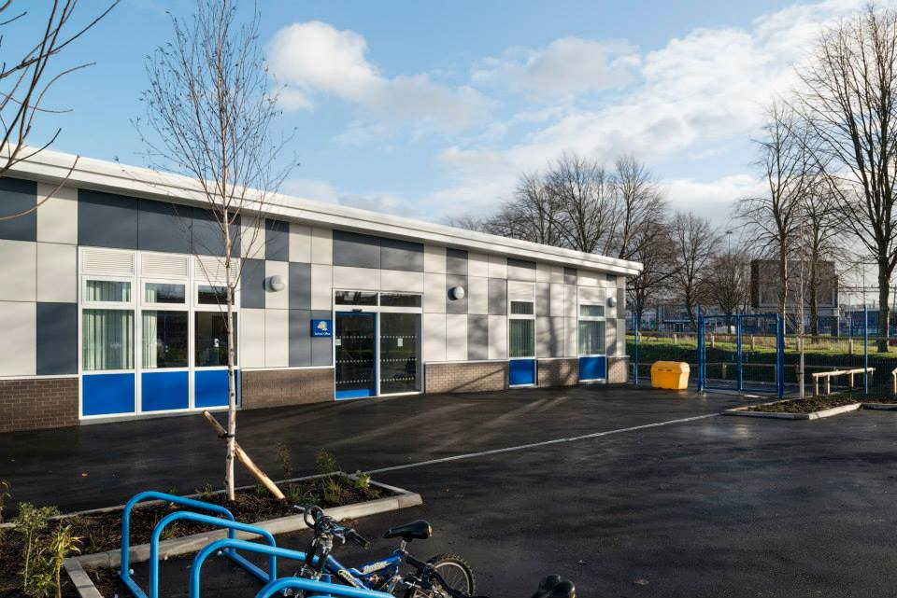
Our Environment
Our modern Key Stage Two building provides excellent facilities for future generations of Armitage learners. Our existing building has also been renovated, providing modern facilities for children in our EYFS unit and pupils in Key Stage One classes. We are extremely proud of our environment which includes a large School Library, numerous intervention spaces, a Focused Activity base for SEN children and Calm Spaces for children with additional needs. All classrooms are equipped with up to date Computing equipment and many feature brand new Smart Boards, supporting staff in providing the best possible learning opportunities for our children. We are equally proud of our developing outdoor environment, which stimulates learning opportunities outside of the classroom and facilitates opportunities for groups such as our Gardening Club. In January 2019, we opened a new facility on our school grounds which serves as a 2 year old provision base, as well as a bespoke Community Space.
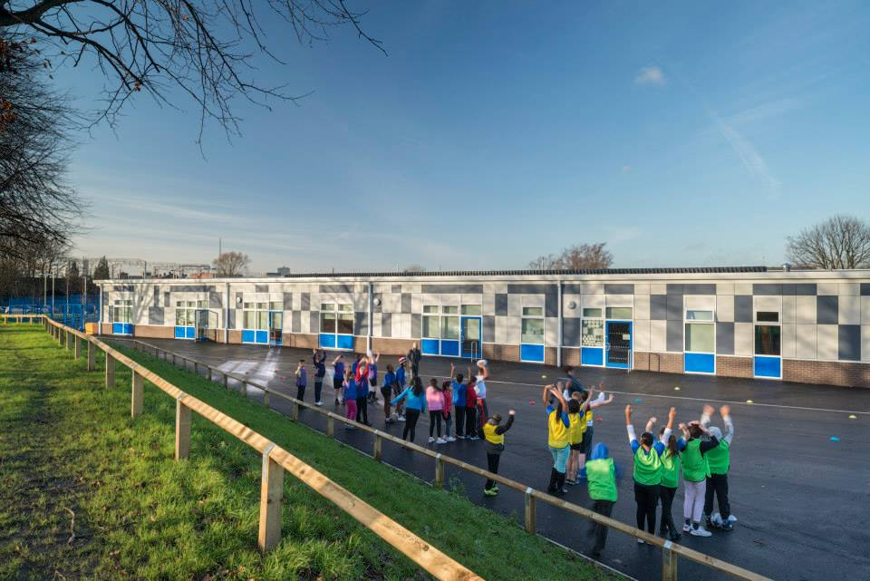
Our Pupils
Our children come from over 30 different countries, making Armitage a culturally diverse place to be. Difference and diversity are celebrated, with everyone’s unique identity valued and shared throughout the inclusive school community. We are particularly proud of the high praise that OFSTED gave to our pupils in March 2019, stating that their behaviour in and around school was exemplary. We believe that children are the heartbeat of our school and, as such, give them opportunities to support us in continuously making Armitage a great place to be. These opportunities come in the form of our thriving school council, peer mediation teams and Eco monitors; all of which put children at the heart of school improvement.

Our Staff
Our school has a large and talented team of staff, with every individual offering something unique for the benefit of our children. Opportunities are provided for training and development, with staff being encouraged and supported to fulfil their own professional ambitions. Roles within school are flexible, allowing individual’s strengths to be best used in a forward thinking and supportive manner. We have many smaller teams of staff working together for school improvement, including an S.E.N. team, community team and various subject teams.

Our Projects
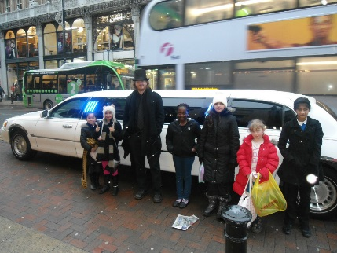
Armitage is a proud member of the local community and as such plays a pivotal role in ensuring that the local area continues to thrive. We are an open site, allowing access to our environment even when school is closed. Our facilities are used for adult learning courses and for our successful Parent Café project. In addition to this, we provide ‘Wrap Around Care’ to our Parents, providing a breakfast club from 7.45am and afterschool care until 6pm. Our other after school clubs provide children with exciting opportunities to participate in activities ranging from cooking to choir. Forward thinking projects such as ‘Calm Space’ are embedded in our practice, providing children with art and massage therapy to address their needs. Children are also given opportunities to learn a variety of musical instruments, participate in growing their own produce in our very own allotment and to care for our rare breed chickens.

Our Achievements
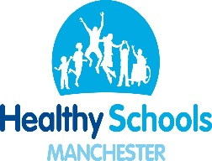
We were graded as an ‘Outstanding’ school, following our successful OFSTED inspection of March 2019. We are continually looking at ways to further develop and are currently focusing on ensuring that curriculum planning provides opportunities for prior and future learning to be linked. In addition, we are focusing on the development of PE, Music and DT to ensure that our curriculum is as effective as possible across all subjects. Our Key Stage Two SATs results are consistently in line with national levels, despite the fact that around 55% of children entering our school have not accessed pre-school education. Armitage currently holds a number of nationally recognised awards including Gold Healthy Schools status, School Games Gold and the Eco Flag in recognition of our continued work in supporting our children in looking after their environment.

Our Future
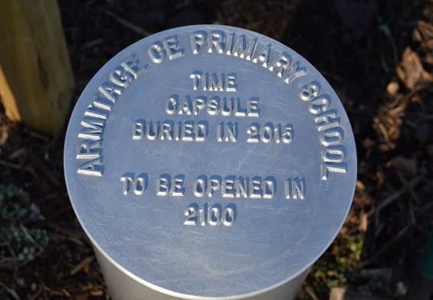
Current changes in education have allowed us to adapt our practice to ensure the best possible outcomes for all members of our school community. Our bespoke assessment system allows us to recognise the fantastic achievements of pupils, as well as recognising where we can provide extra support for those who have not yet reached their full potential. The new National Curriculum has provided us with the opportunity to immerse children in cross-curricular learning, engaging them in a number of exciting topics brought to life by theme days and out of school visits.
As a school, regardless of changes and developments within education, we will continue to strive to provide stability and order for our children, allowing them to learn, blossom and to enjoy being children. When our buried time capsule is opened in 2100, we hope that many more generations of Armitage pupils have continued to ‘Aim High’.

