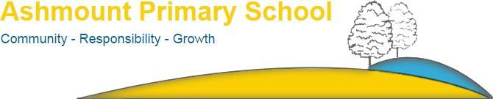
Contents
HLTA
Job reference: ASH/874
Closing date: noon on Friday, 15th October 2021

Information about the school
Page | 4 | Letter to applicants
Page | 6 | Our school
Page | 8 | Our vision and mission
Page | 10 | Key facts and statistics
Page | 11 | School location
Information about the role

Page | 13 | Advert
Page | 15 | Job Description
Page | 19 | Person Specification
Page | 21 | How to apply

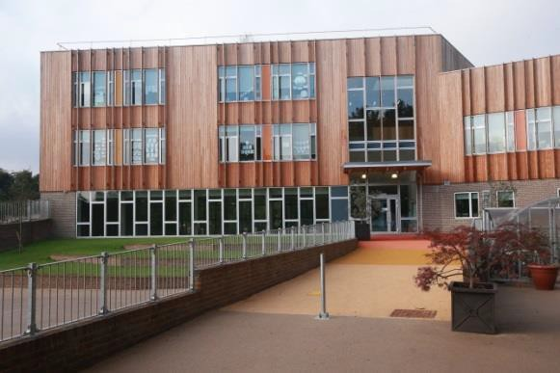

Information about the School

Letter to applicants

Dear Applicant,
Thank you for considering the position of HLTA at Ashmount Primary School. We are looking for two HLTA’s who have potential or experience who will be supporting children within a specific year group but also have wider responsibilities across the school including classroom cover in the absence of the classroom teacher.
We are proud of the welcoming, inclusive and diverse nature of our school community and we are looking for someone who shares our holistic, caring and creative school ethos and believes that everyone counts at Ashmount! We have worked hard over the last three years on our LBGTQ+ and Black History curriculum and would welcome new colleagues to join us on embedding our learning here.
You will be a key part of our dedicated and enthusiastic team of teachers, teaching assistants and support staff and will work closely with one of our Assistant Headteachers in ensuring the children make great progress in school.
In 2019 OFSTED judged Ashmount to be Good but were so impressed that they intend to come back to see if we are Outstanding! We are looking for a teacher who can continue to help us provide exceptional learning with children who have key needs. We want to provide an excellent standard of education for all our children, with each child challenged to make exceptional progress across the curriculum and equipped to realise their full potential in life. We value the breadth and creativity of our educational offer at Ashmount. We are proud to offer a range of after-school clubs and activities, recognising that a variety of creative arts and sports extends and diversifies the opportunities for individuals to excel.
Ashmount is housed in a new, carbon-neutral building, which has won national architectural awards. We are in a very special location at the edge of the Parkland Walk nature reserve on the Islington and Crouch End borders where there are plenty of opportunities for the children to learn outdoors in an environment that changes seasonally; they also encounter the local wildlife, including bats and woodpeckers.

Ashmount is a learning organisation, which is proudly committed to the development of its entire staff. This role is a fantastic opportunity to continue to learn professionally and to contribute to the growth and development of our school. We currently judge all our teaching and learning to be at least good, with much of it outstanding. We are, therefore, looking for someone who has the capacity to support and deliver excellent learning to one of our delightful classes.
Please do come and visit the school to find out more about what makes Ashmount special. We look forward to welcoming you and would welcome an HLTA from underrepresented groups.
Anthony Carmel (Headteacher)
Jonathan Harwood (Chair of Governors)
Our school
Music
At Ashmount, we are rightly proud of our outstanding music offer. We expect all children to engage in a variety of musical opportunities. All children from Nursery to Year 6 attend a music lesson with one of our trained music teachers. All children in Key Stage 1 and 2 attend weekly singing assemblies and children throng to join our 90 strong school choir, who are accompanied by our school orchestra. We regularly have visiting musicians from the Barbican, LSO and other musical organisations who work with the children. Similarly, our own children perform at school recitals. We also take part in choir ensembles at the Union Chapel. We offer after school music tuition and are beginning to send small numbers of children to train with other schools as part of a borough wide primary school orchestra! Our rich music heritage is part and parcel of what we do!

PE
We continue to have a fabulous offer of PE across the school. With specialist support in many year groups and an extensive array of sporting endeavour across the whole school – including Dance, Gymnastics and various ball sports. We are currently and have been in the past borough champions in an array of disciplines. Our trophy cabinet is overflowing, but our expectation is that all children will participate – but in the right way- with a generosity of spirit and a smile. We are renowned for our sense of fair play. This sporting endeavour continues at lunch and after school with a myriad of after-school clubs offering provision for children from Year 1 to Year 6.
Creative Curriculum
Ashmount is committed to a whole school over-arching creative curriculum where the children learn through topics that link their learning cohesively together. Topics vary throughout the school, which include Year 1 – Get out of my swamp to Year 6 Yes Minister and their focus on democracy. Our learning is hugely child-centred, rich in outdoor linked experiences and embedded with opportunities for English and Maths where we utilise The Power of Reading and Maths No Problem to further support children’s learning. This is further developed through home learning using our half-termly Power Projects. Learning at Ashmount both at school and at home utilises all of the wider experiences London has to offer. We feel we develop creative, independent learners who will be ready for all the world has to offer them as global citizens. We link this together by supporting our parents with bespoke workshops covering all curriculum areas.

Parental Involvement
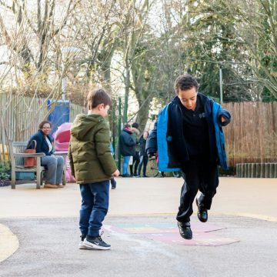
Parents and carers volunteer across the school in different ways, including as part of a highly skilled, effective and committed Governing Body. Our skilful Governing Body is currently full and consists of parents and carers, people from the local community, staff from the school, and representatives from the local authority. We have an incredibly active and strong parent-led PTA group, Ashmount Together, who regularly hold successful and fun social events that bring the school community together and help raise funds for the school. Ashmount Together has in the past few years raised money to install a lighting rig in the main hall, a drop-down screen and projector, playground improvements, new school iPads and classroom projectors. At Ashmount, all stakeholders are fully involved in improving the school.

Our Vision and Values
Vision
Our vision is for Ashmount to be a school that:
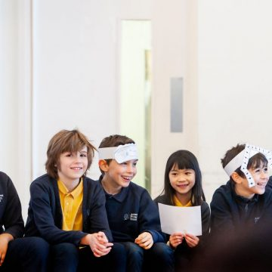
- Provides an ambitious and rigorous education for all children providing an excellent standard of education, with all children challenged to reach their full potential, so they leave our school well prepared for secondary school.
- Produces happy, well-motivated, well behaved, and healthy children who have a lifelong habit of learning.
- Has a welcoming and inclusive ethos, where everyone feels a sense of belonging.
- Is recognised for our high-quality teaching and a broad and balanced curriculum, including the provision of Arts, Music and PE / Sport.
- Enjoys a successful partnership with parents/carers who are fully engaged in their children’s learning.
- Has excellent links with other schools and other key external stakeholders.

Values
In delivering our vision, we at Ashmount seek to conduct ourselves in line with the following values:
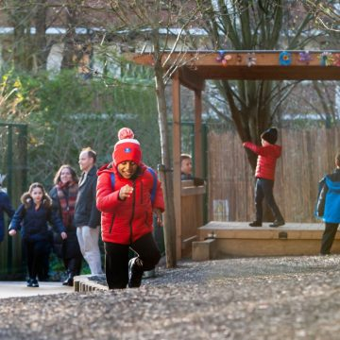
- We believe in a community where all children and all adults feel inspired and supported to provide an outstanding learning environment.
- We believe that everyone succeeds in a warm and welcoming school using a holistic child centred approach.
- We value kindness, co-operation and mutual respect.
- We value diversity in our community as a positive strength and will work actively against discrimination and prejudice and to create an environment where all people are treated fairly and with respect.
- We celebrate that everyone is able to achieve through meaningful opportunities to discover, explore and learn
- As a carbon neutral school we care for the environment and are committed to sustainability and bio-diversity

Achieving our vision
In order to achieve our vision, we seek to ensure that we have the following in place at Ashmount:
- Outstanding teaching and learning.
- High expectations of our staff, children, and parent/carers.
- A well-resourced staff team, which is well- motivated, confident, well trained, supported and empowered.
- High parental involvement and support, with full use of parents’ skills.
- High quality provision for SEN, pupil premium & ethnic minority achievement.
- A culture of self-awareness and improvement among the whole school community (Governors, staff, pupils and parents).
- An award winning, carbon neutral building with excellent facilities throughout and delightful learning spaces.
- Healthy and varied high-quality school meals and a chef who even makes fresh bread each day for the children.
- A growing school population with sound financial management that enables to us maximise our children’s potential.
- A highly committed and skilled governing body which is full, active, informed, and capable.
- Excellent links with the wider community.
- A great out of hours curriculum offer both within and outside of the school day and with external partners on the Crouch Hill campus.

Key facts and statistics

3 – 11 years
Age Range | Location  Crouch Hill Park, Islington, London | Denomination None | www.ashmountprimaryschool.co.uk
£ | 441 | 30
Surplus of £134,949 | Number of children | Average class size | Community School & Nursery
60 | 96.7% | 21 | 20
Planned admissions per year | Attendance | Teaching Staff | Support Staff
44% | 16% | 39% | 100%
Children eligible for Pupil Premium | Children with SEN | Children with EAL | ‘Good’ or better quality of teaching and learning

School Location

Ashmount Primary School Crouch Hill Park
83 Crouch Hill, Islington, London N8 9EG
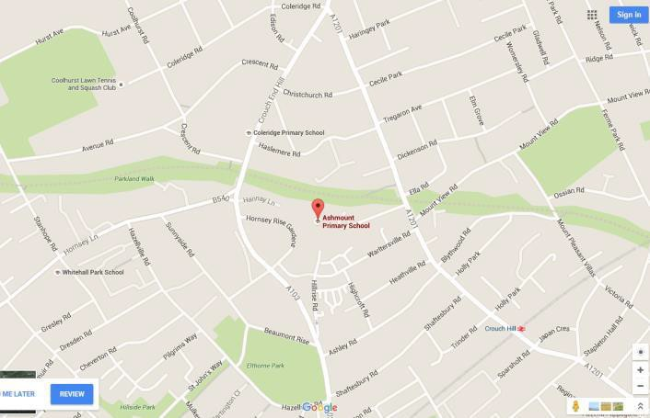

Nearest tube stations
Finsbury Park

Overground Station
Crouch Hill

Islington
Further information about Islington borough is available at www.islington.gov.uk
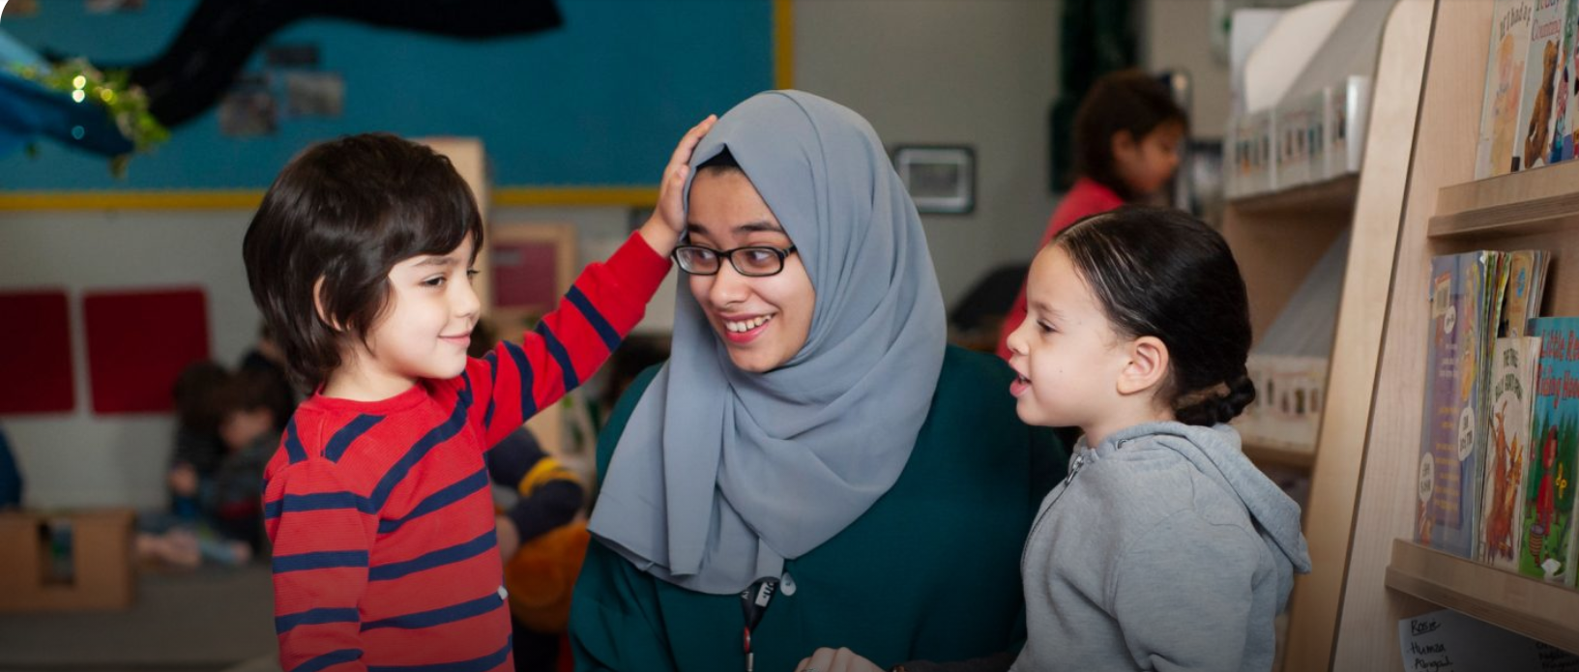

Information about the role

Advert
HLTA
- Salary range: SO1 Points 23-25 (depending on experience)
- Salary: £32,301 - £33,474 per annum
- Actual Salary: £27,876 - £29,402 per annum
- Hours: 35 hours per week
- Contract: Full time, Term time only
- Required November 2021

This is an exciting opportunity for a dynamic candidate to help drive our focus on high achievement and delivering excellence for all. You will be ambitious for the school, be able to build good relationships, and embrace the vibrancy and inclusiveness we value.
We are looking for someone who:
• Is enthusiastic, motivated and ready to make a difference
• Has a commitment to the promotion of high standards in teaching and learning
• Is passionate about enabling every child to fulfil his/her potential
• Has proven excellent classroom practice
• Recognises and values the diverse social and cultural needs of our children and community

Why Ashmount could be the school for you:
• A richly diverse school with a strong community ethos.
• A supportive governing body and a stable, enthusiastic and dedicated staff team.
• A ‘Good School’ that is on the road to Outstanding.
• In a great location - situated in Crouch Hill Park in north Islington with excellent transport links. If you believe you have the vision, drive, determination and enthusiasm to grasp the opportunities this role offers, we would love to hear from you.

Visits to the school are welcomed and encouraged. Please contact our School Business Manager, Mary McGreal, on (0207) 272 7145 to arrange a suitable date.
To apply for this post, please apply online at http://jobs.islington.gov.uk/disciplines. If you require assistance, please email Schools HR on schoolsrecruitment@islington.gov.uk quoting reference number ASH/874.

- Closing date for applications: Midday, Friday, 15th October 2021
- Shortlisting: Midday, Friday, 15th October 2021
- Interview: Friday, 22nd October 2021

Ashmount Primary School is committed to safeguarding and promoting the welfare of children and young people, and expects all staff and volunteers to share this commitment.
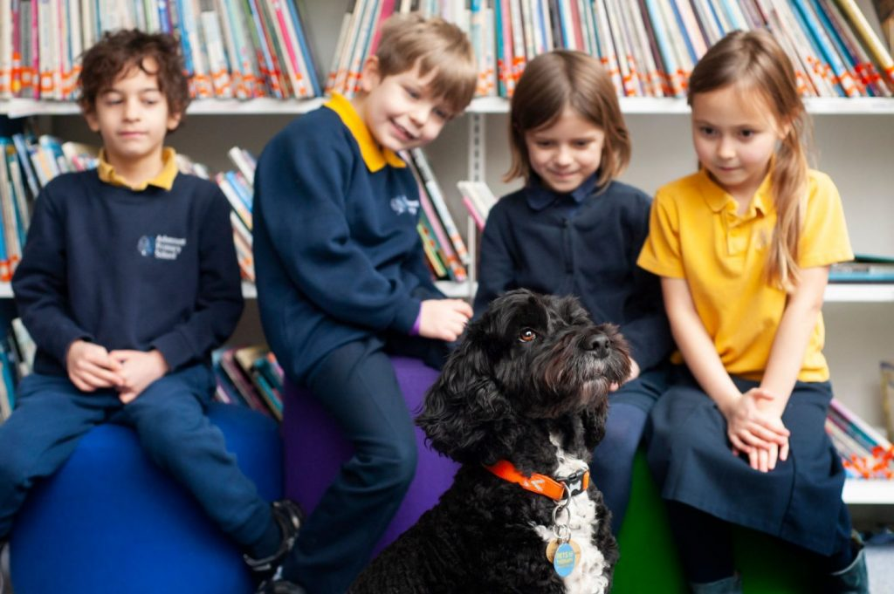
Job Description

POST TITLE: HIGHER LEVEL TEACHING ASSISTANT
GRADE: SO1
DEPARTMENT: Schools
RESPONSIBLE FOR: Allocated Teaching Assistants
REPORTING TO: Teacher

PURPOSE OF THE JOB
- All aspects of the job description are to be carried out within a system of supervision by qualified teachers, to be determined by schools prior to employing Level 4 teaching assistants.
- To complement teachers’ delivery of the national curriculum and contribute to the development of other support staff, pupils and school policies and strategies.
- To work collaboratively with teaching staff and assist teachers in the whole planning cycle and the management/preparation of resources. Also to supervise whole classes occasionally during the short-term absence of teachers.
- To provide support for pupils, the teacher and the school in order to raise standards of achievement for all pupils, by utilising advanced levels of knowledge and skills when assisting with planning, monitoring, assessing and managing classes, and to encourage pupils to become independent learners, to provide support for their welfare, and to support the inclusion of pupils in all aspects of school life.
- To supervise children and lead playground activities during mealtimes.

Main Duties
Planning
- Plan and prepare lessons with teachers, participating in all stages of the planning cycle, including in lesson planning, evaluating and adjusting lessons/work plans.
- Develop and prepare resources for learning activities in accordance with lesson plans and in response to pupil need.
- Contribute to the planning of opportunities for pupils to learn in out-of-school contexts in line with schools policies and procedures.

Teaching and Learning
- Within an agreed system of supervision and within a pre-determined lesson framework, teach whole classes.
- Provide detailed verbal and written feedback on lesson content, pupil responses to learning activities and pupil behaviour, to teachers and pupils.
- Motivate and progress pupils’ learning by using clearly structured, interesting teaching and learning activities.
- Support the teaching of the English e.g. by delivering bespoke interventions to groups of pupils, support the teaching of the National Numeracy Strategy and assist pupils to access the full curriculum. Be familiar with lesson plans, IEP targets and learning objectives.
- Be aware of and support difference and ensure all pupils have equal access to opportunities to learn and develop.
- Promote and support the inclusion of all pupils, including those with specific needs, both in learning activities and within the classroom.
- Use behaviour management strategies, in line with the school’s policy and procedures, to contribute to a purposeful learning environment and encourage pupils to interact and work co-operatively with others
- In accordance with arrangements made by the headteacher, progress pupils’ learning in a range of classroom settings, including working with individuals, small groups and whole classes where the assigned teacher is not present, in line with regulations and guidance under Section 133 of the Education Act 2002 and STPCD 2003.
- Organise and safely manage the appropriate learning environment and resources
- Promote and reinforce children’s self-esteem and independence and employ strategies to recognise and reward achievement of self-reliance
- Assist the classteacher in encouraging acceptance and integration of children with special needs, or from different cultures and/or with different first language
- Support the role of parents in pupils’ learning and contribute to/lead meetings with parents to provide constructive feedback on pupil progress, achievement and behaviour, maintaining sensitivity and confidentiality at all times.
Monitoring and Assessment
- With teachers evaluate pupils’ progress through a range of assessment activities.
- Assess pupils’ responses to learning tasks and where appropriate, modify methods to meet individual and/or group needs.
- Monitor pupils’ participation and progress and provide constructive feedback to pupils in relation to their progress and achievement.
- Assist in maintaining and analysing records of pupils’ progress.
- Contribute to programmes of observation and assessment as planned by the teacher and provide reports, evaluations and other information to assist in the provision of appropriate support for specific children.
- Support the teaching staff with reporting pupils’ progress and achievements at parents meetings which are usually held outside school hours.

Mentoring, Supervision and Development
- Manage other teaching assistants and undertake recruitment, induction, appraisal, training and mentoring for other teaching assistants.
- Assist teachers in offering mentoring support and guidance to other teaching assistants undertaking formal training.
- Offer mentoring support and guidance for older pupils undertaking work experience activities within secondary schools.
- Support and guide other less experienced teaching assistants’ work in the classroom when required and lead training for other teaching assistants.
- Contribute to the overall ethos, work, aims of the school by attending relevant meetings and contributing to the development of policies and procedures within the school. Also participate in staff meetings and training days/events as requested.

Behavioural and Pastoral
- Recognise and challenge any incidents of racism, bullying, harassment, victimisation and any form of abuse of equal opportunities, ensuring compliance with relevant school policies and procedures and making sure the individual/s involved understand it is unacceptable.
- Understand and implement school child protection procedures and comply with legal responsibilities.
- Assist in maintaining good discipline of pupils throughout the school and escort and supervise pupils on planned visits and journeys.
- Provide support and assistance for children’s pastoral needs, for example, dressing, caring for sick, injured or distressed children.
- Provide physical support and maintain personal equipment used by the children at the school. Administer medication as agreed.
- Foster and maintain constructive and supportive relationships with parents/carers, exchanging appropriate information, facilitating their support for their child’s attendance, access and learning, and supporting home to school and community links.
- Supervise pupils in the playground and plan and organise play time activities.
- Assist teachers by receiving instructions directly form professional or specialist support staff involved in the children’s education. These may include social workers, health visitors, language support staff, speech therapists, educational psychologists, and physiotherapists.

Other
- Any other duties required by the class teacher, Deputy headteacher, or the headteacher, which is within the scope of this post.
- At all times carry out duties with due regard to the school’s Health and Safety policy.
- To work within and encourage the school’s Equal Opportunity policy and contribute to diversity policies and programmes in relation to discriminatory behaviour.

Person Specification

TEACHING ASSISTANT – LEVEL 4
The person specification sets out the criteria to be used in determining whether an individual is likely to be able to undertake the duties in the job description.
EDUCATION & EXPERIENCE
- Meet HLTA standards or equivalent qualification or experience.
- Hold relevant qualifications at a level equivalent to at least NQF Level 3.
- Demonstrable levels of numeracy & literacy equivalent to GCSE (A-C) or NVQ Level 2 (or by test).
- Attend induction training; NLS, NNS, ALS, ELS, FLS training as appropriate and training relevant to the post, including behaviour management and Child Protection training.
- Training in relevant learning strategies e.g. literacy.
- A minimum of two years’ experience of working with children (either paid or unpaid capacity) preferably in an education setting.
- Evidence of specialism in specific curriculum areas or areas of particular learning difficulty.

KNOWLEDGE & UNDERSTANDING
- Knowledge of the requirements of the national literacy and numeracy strategies.
- Knowledge & understanding of the National Curriculum including the literacy and numeracy strategies.
- Understanding of behaviour management strategies.
- Understanding of First Aid procedures.

SKILLS
- Effective oral and written communication skills.
- Excellent interpersonal skills both in working relationship with young pupils and in forming effective professional relationships with a wide range of contacts.
- Good organisational and time management skills.
- Sound IT skills to support learning and maintain electronic information systems.

ABILITIES
- Able to form and maintain appropriate professional relationships and boundaries with children and young people.
- Ability to organise, lead and motivate a team.
- Ability and willingness to work constructively as part of a team
- Ability to supervise pupils effectively both in and out of school in line with the school’s behaviour policy.
- Ability to organise the classroom activities e.g. preparing and setting out resources.
- Ability to organise the classroom activities e.g. preparing and setting out resources and implementing strategies for T&L.
- Ability to deal with sensitive information in a confidential manner.
- Ability to help children and young people to transfer their learning to other parts of their lives.
- Ability to provide a good role model to young pupils.
- Ability to work in partnership with parents and teachers.
- Ability to use own initiative and work flexibly.

OTHER
- Willingness to attend school training sessions.
- Empathy with young people facing barriers to their learning.
- A commitment to helping young pupils achieve, through education and learning.
- An understanding of and a genuine commitment to Equal Opportunities.

How to Apply

Application Deadline
Completed application forms must be received by Midday, Friday, 15th October 2021
To apply, please do so online via http://jobs.islington.gov.uk/disciplines. If you would like assistance, please contact the Schools’ HR team on schoolsrecruitment@islington.gov.uk quoting reference number ASH/874.
Please note that application forms should not be returned to the school.

Completing your application
Candidates are asked to complete all the standard information required on the application form, and to submit a supporting statement, addressing all of the criteria identified at application stage.

Visits
Visits to the school in the week commencing Monday, 4th – 8th or 11th – 15th October 2021 are strongly encouraged. Please contact our School Business Manager, Mary McGreal on 0207 272 7145 to arrange a suitable date.

Selection procedure
The shortlisting process and appointment will be made by a panel of Governors, and members of the Senior Leadership Team, assisted by Islington Council staff.
All candidates will be notified of their shortlisting or otherwise Friday, 15th October 2021. Please would all applicants ensure that their preferred means of urgent contact (phone, mobile phone or email) are clearly identifiable from the application form, so that your confidentiality is maintained.
Shortlisted candidates will be given more details that day and the interview process will take place on Friday, 25th October 2021.

References
Candidates are advised that references will be taken up immediately after shortlisting. Candidates are asked to ensure that their referees are warned of the need to respond within the timescale set. In all cases, at least one professional reference is required.
The post will be offered subject to satisfactory completion of pre-employment checks.

Safeguarding children
Prior to appointment, formal checks will be made in accordance with the current statutory requirements relating to child protection.
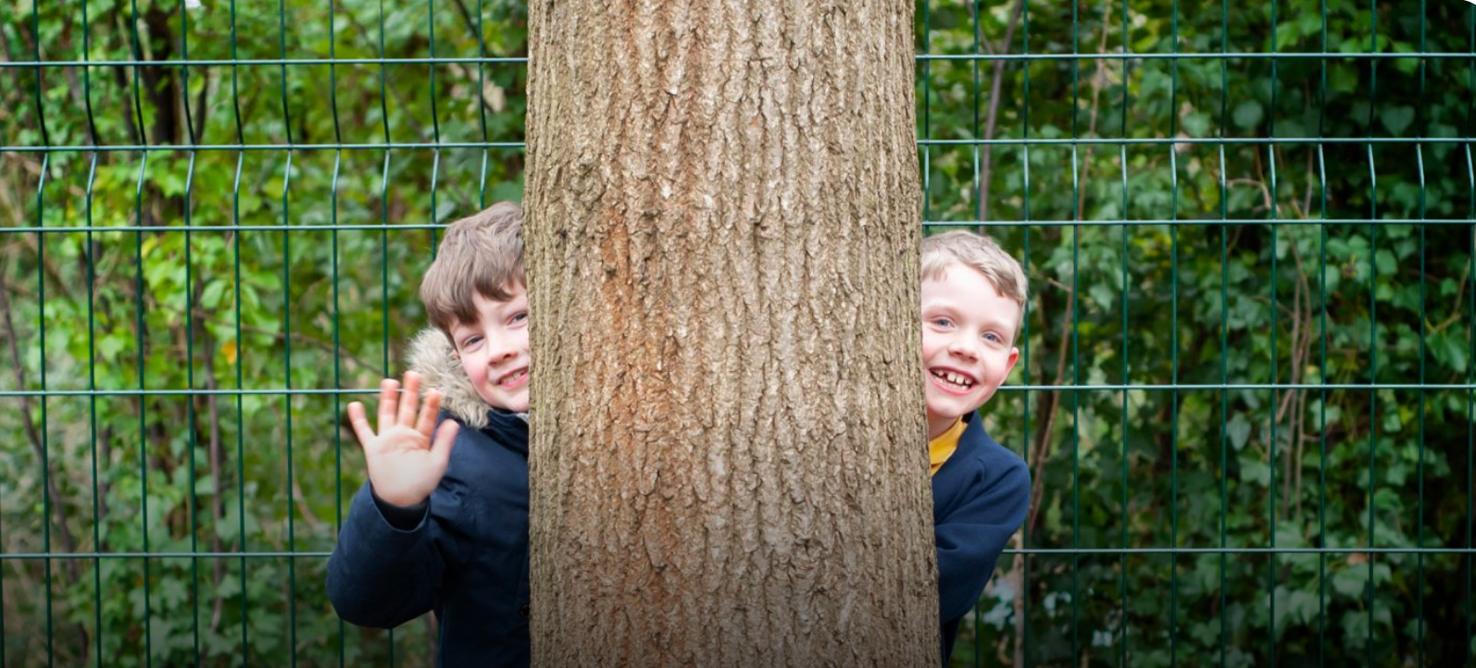

Ashmount Primary School
Crouch Hill Park
83 Crouch Hill, Islington, London N8 9EG

