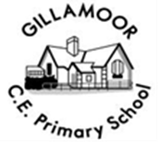
First the blade, then the ear, then the full grain

Gillamoor C of E (V C) Primary School

HLTA EYFS/KS1
Application pack

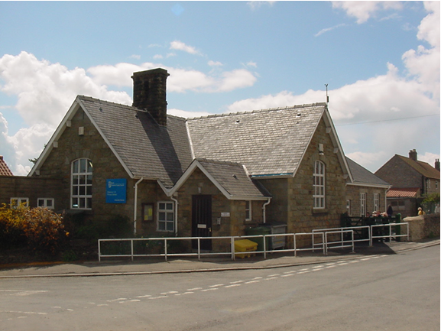
Our Vision

Our rural and community focused school aims to enable everyone in our community to flourish through a focus on nurturing first the blade, then the ear, then the full grain (Mark 4:28); from the youngest child to the oldest member of the village. Inspirational learning through curiosity and commitment will encourage aspiration and the desire to be the best they can, in their work and through the respect, care and love they have for each other. Enabling a life lived in all its fullness.

Our Values

Honesty, Love and Care, Respect
Main Street
Gillamoor
North Yorkshire
YO62 7HX
☏ 01751 431643
admin@gillamoor.n-yorks.sch.uk
School website: http://www.gillamoor.n-yorks.sch.uk/

Closing date for applications: 12 Noon Friday 3 June 2022
Welcome to Gillamoor CE (VC) Primary School

Dear Applicant,

Thank you for your interest in the post EYFS/KS1 HLTA to start in September 2022. The HLTA position is for 25 hours. Additional supply hours may be available. The successful candidate will mainly work with the EYFS/KS1 teachers.

This application pack contains the following:
- Application form
- Person specification

We are looking for an enthusiastic practitioner, who has experience of working in a mixed age EYFS/KS1 class, to be a valued member of the school team.
We are looking for someone who:
- Is an excellent practitioner, capable of effectively delivering a relevant and appropriate curriculum to a mixed age, mixed ability, EYFS/KS1 class.
- Is able to use assessment to plan quality provision to advance pupils’ development
- Is warm, friendly and approachable.
- Engages children through high quality and creative teaching.
- Is prepared to contribute to the life of the whole school.
- Has energy, determination and a sense of humour.
We can offer:
- Enthusiastic, happy, well-motivated children.
- A welcoming, caring, committed and professional staff team.
- A positive and supportive ethos.
- A pleasant working environment.
- Opportunities and support for your own continued professional development.
- A committed and supportive governing body.
- Planning time
- Supportive parents
The closing date for application is 12 noon Friday 3 June 2022.

If you have any further questions, or would like to visit the school, please contact Mrs Hayes or Mrs Hugill on 01751 431643 or by email at admin@gillamoor.n-yorks.sch.uk.

We are very proud of our school and I would be pleased to show you round.
We look forward to receiving your application.

Yours sincerely
Mrs Andrea Hayes

Head teacher

Our School
- Gillamoor CE (VC) Primary School is situated in the village of Gillamoor. An attractive village, nestled on the edge of the North York Moors, a predominantly farming community.
- The children are organised in three classes; Foundation/Key Stage 1, Lower Key Stage 2 (Y3/4) and Upper Key Stage 2 (Y5/6).
- There are currently 50 children on role
- The school has a very caring, supportive, family ethos and is an important part of the local community
- The school has use of the community playing field, including a Multi User Games Area.

Application process

Please email completed application to admin@gillamoor.n-yorks.sch.uk
Or post to; Mrs A Hayes
Gillamoor CE Primary School
Main Street
Gillamoor
North Yorkshire
YO62 7HX
Telephone 01751 431643

Closing date noon Friday 3 June 2022
Interviews will take place on Thursday 9 June 2022
The candidate should be committed to working as a member of a team, and be flexible in their approach to teaching. Daily contact with parents is a feature of the post.
Gillamoor is a school with a strong Church and community ethos. Candidates should know that this is a demanding post and they must be committed to the drive to continue maintaining high standards.
Other duties and responsibilities will be in line with HLTA pay and conditions and Pay grade.

Person Specification as per the HLTA standards
Key Duties and Responsibilities:

Professional Attributes
1 Have high expectations of children and young people with a commitment to helping them fulfil their potential
2 Establish fair, respectful, trusting, supportive and constructive relationships with children and young people
3 Demonstrate the positive values, attitudes and behaviour they expect from children and young people
4 Communicate effectively and sensitively with children, young people, colleagues, parents and carers
5 Recognise and respect the contribution that parents and carers can make to the development and wellbeing of children and young people
6 Demonstrate a commitment to collaborative and cooperative working with colleagues
7 Improve their own knowledge and practice including responding to advice and feedback

Professional Knowledge and Understanding
8 Understand the key factors that affect children and young people's learning and progress
9 Know how to contribute to effective personalised provision by taking practical account of diversity
10 Have sufficient understanding of their area(s) of expertise to support the development, learning and progress of children and young people
11 Have achieved a nationally recognised qualification at level 2 or above in English/literacy and Mathematics/numeracy
12 Know how to use ICT to support their professional activities
13 Know how statutory and non‐statutory frameworks for the school curriculum relate to the age and ability ranges of the learners they support
14 Understand the objectives, content and intended outcomes for the learning activities in which they are involved
15 Know how to support learners in accessing the curriculum in accordance with the special educational needs (SEN) code of practice and disabilities legislation
16 Know how other frameworks that support the development and well‐being of children and young people, impact upon their practice

Professional Skills*

Planning and Expectations
17 Use their area(s) of expertise to plan and prepare learning activities to enhance pupil’s development
18 Use their area(s) of expertise to plan their role and that of supporting Teaching Assistants in learning activities
19 Devise clearly structured activities that interest and motivate learners and advance their learning
20 Plan how they will support the inclusion of the children and young people in the learning activities
21 Contribute to the selection and preparation of resources suitable for children and young people's interests and abilities

Monitoring and Assessment
22 Monitor learners' responses to activities and modify the approach accordingly
23 Monitor learners' progress in order to provide focused support and feedback
24 Support the evaluation of learners' progress using a range of assessment techniques
25 Contribute to maintaining and analysing records of learners' progress

Teaching and Learning Activities
26 Use effective strategies to promote positive behaviour
27 Recognise and respond appropriately to situations that challenge equality of opportunity
28 Use their ICT skills to advance learning
29 Advance learning when working with individuals
30 Advance learning when working with small groups
31 Advance learning when working with whole classes without the presence of the assigned teacher
32 Organise and manage learning activities in ways which keep learners safe
33 Direct the work, where relevant, of other adults in supporting learning

