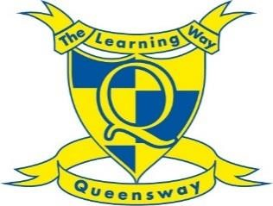**Queensway School**

**Higher Level Teaching Assistant (HLTA)**

# Grade 8, £29,269 - £32,076 pro-rata. Actual salary: £23,469 to £25,720,

# Monday-Friday, 8am-4pm (1-hour unpaid lunchbreak) = 35 Hours per week. Term time only

Do you think you could be the latest addition to our team?

The governors are looking to appoint a HLTA to join our welcoming, friendly school to provide release cover for class teachers.

The successful candidate will:

* Be a qualified teacher /HLTA or a very experienced Teaching Assistant
* Be extremely well organised & efficient
* Have high expectations of children’s behaviour and attainment
* Be flexible – willing to teach across the school (Reception to Year 6)
* Be open to advice, feedback and guidance from colleagues

We will offer you:

* Support from a motivated, friendly staff.
* Ongoing professional development.

# Application Procedure

Please note that all applications should be completed on an Oxfordshire County Council Support staff application form.

Early application is advised. Should a suitable candidate apply, the school will close the advertisement earlier than stated.

Visits to the school are welcome. Please ring Mrs Kukainis for an application pack on 01295 251631 or email office.2057@queensway.oxon.sch.uk

**Closing date for applications: Friday 27th September 2024, at midday**

# Interview date: Week commencing Monday 30th September 2024