



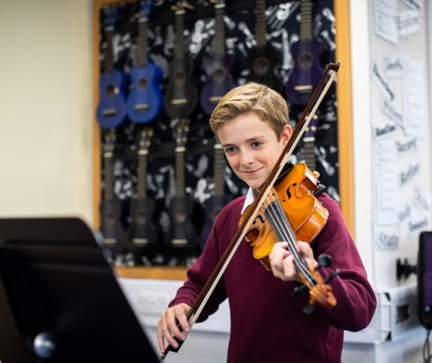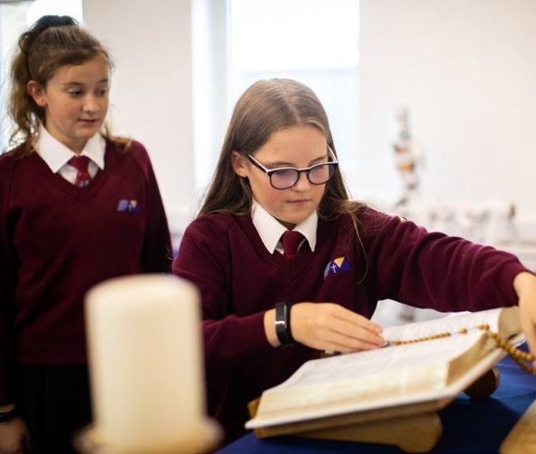

**Higher Level Teaching Assistant (HLTA)**

Start Date: September 2024

Line-manager: SENDCo &Deputy Headteacher

Welcome

**The St Thomas More Mission:**

**We the St Thomas More family,** ‘aspire not to have more but be more’.

We aspire not to have the world but be more for the world.

**#BeMore**

am delighted to welcome you to St Thomas More Catholic Voluntary Academy.

I

We think that STM is a special place where every child is seen as an individual, and where nurturing the gifts and talents of our children is central to our mission. Our motto of ‘aspire not to have more but to be more’ summarises our ambition for our young people to #BeMore.

We achieve this by offering the highest quality of education possible, which includes a broad range of experiences aimed at developing the whole child and enabling all to grow in their faith in a safe and happy environment.

Our academic achievements and the standards of our pastoral care are excellent. We are very proud of the academic progress our students make and we are also very proud of the personal growth that they achieve during their time at St Thomas More.

If you choose to join the St Thomas More family, you will be joining a school which strives for excellence through our strong Catholic faith, our commitment to high standards of achievement, our high expectations of behaviour and respect for all, and a belief in developing a love of learning and healthy living.



Mr D Redfern Headteacher

# About this post

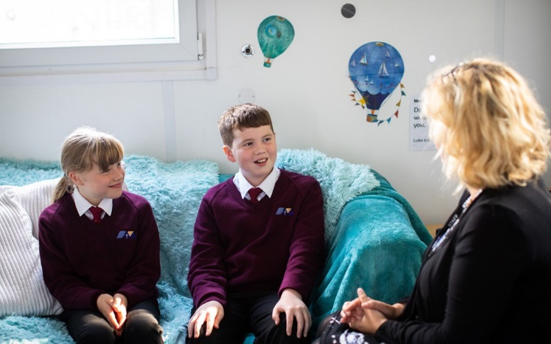

**The Role**

# The Post

In this role, you will be responsible for supporting, assessing and planning learning for pupils, encouraging them to develop and achieve. Your duties will include contributing towards learning plans, providing verbal and written feedback, managing behaviour as well as promoting inclusion within the learning environment.

## We are looking for an enthusiastic, determined and committed Higher Level Teaching Assistant to be part of our SEND Department from September 2024 at

## St Thomas More Catholic Voluntary Academy.

## This is an exciting time to join our SEND Department as we expand our team to support those pupils most in need.

**#BeMore**

*‘Aspire not to have more but to be more’*

Saint Oscar Romero

**St Ralph Sherwin Catholic Multi-Academy Trust**

**Job Description**

**Higher Level Teaching Assistant (HLTA)**

St Thomas More Catholic Voluntary Academy is committed to creating a diverse workforce. We’ll consider all qualified applicants for employment without regard to sex, race, religion, belief, sexual orientation, gender reassignment, pregnancy, maternity, age, disability, marriage or civil partnership.

**Reporting to:** Deputy Headteacher and SENDCo

**Responsible for:** TAs within the SEND Department

**Liaising with:** Staff, Parents and External Agencies

**Grade/Salary:** 15-20

**Contract Type:** Permanent (Term Time Only)

**Hours:** 32.5 hours per week

**Location:** St Thomas More Catholic Voluntary Academy

**Person Specification**

|  |  |  |  |  |
| --- | --- | --- | --- | --- |
| Key: I = Interview A = Application Form | | **Essential** | **Desirable** | **How evidenced?** |
| **Qualifications and Experience** | Level 2 or 3 Certificate in Supporting Teaching and Learning in Schools, Level 3 Diploma in Childcare and Education, or other relevant qualification in nursery work or childcare (or willingness to work towards a qualification if not already held) | ✓ |  | A |
| GCSEs at grades 9 to 4 (A* to C) including English and Maths | ✓ |  | A |
| Experience of working with children, primarily those of secondary age | ✓ |  | A |
| Experience of planning and leading teaching and learning activities (under supervision) | ✓ |  | A & I |
| **Skills and Knowledge** | Good literacy and numeracy skills | ✓ |  | A & I |
| Good organisational skills | ✓ |  | I |
| Ability to build effective working relationships with pupils and adults | ✓ |  | I |
| Skills and expertise in understanding the needs of all pupils | ✓ |  | I |
| Knowledge of how to help adapt and deliver support to meet individual needs | ✓ |  | I |
| Excellent verbal communication skills | ✓ |  | I |
| Subject and curriculum knowledge relevant to the role and ability to apply this effectively in supporting teachers and pupils | ✓ |  | I |
| Active listening skills | ✓ |  | I |
| Knowledge of guidance and requirements around safeguarding children | ✓ |  | I |
| Good ICT skills, particularly using ICT to support learning | ✓ |  | I |
| Understanding of roles and responsibilities within the classroom and wider school context | ✓ |  | I |
| Understanding of effective teaching methods | ✓ |  | I |
| Knowledge of how statutory and non-statutory frameworks for the school curriculum relate to the age and ability ranges of the learners they support |  | ✓ | I |
| Knowledge of how to support learners in accessing the curriculum in accordance with the SEND code of practice |  | ✓ | I |
| **Personal Qualities** | Enjoyment of working with children | ✓ |  | I |
| Sensitivity and understanding, to help build good relationships with pupils | ✓ |  | I |
| A commitment to getting the best outcomes for pupils and promoting the Catholic ethos and values of the school | ✓ |  | I |
| A good sense of humour | ✓ |  | I |
| Commitment to maintaining confidentiality at all times | ✓ |  | I |
| Commitment to safeguarding and equality | ✓ |  | I |

**Job Description**

**Main purpose**

The HLTA will:

* Work with class teachers to raise the learning and attainment of pupils
* Promote pupils’ independence, self-esteem and social inclusion
* Give support to pupils, individually or in groups, so they can access the curriculum, take part in learning and experience a sense of achievement
* Supporting and liaising with the special educational needs and disability co-ordinator (SENDCo)
* Lead, coordinate and support Teaching Assistants
* Working with external agencies and parents

**Duties and responsibilities**

**Teaching and learning**

* Demonstrate a secure curriculum knowledge and expertise in applying assessment procedures
* Demonstrate an informed and efficient approach to teaching and learning by adopting relevant strategies to support the work of the teacher and increase achievement of all pupils including, where appropriate the most vulnerable (SEND, disadvantaged)
* Promote, support and facilitate inclusion by encouraging participation of all pupils in learning and extracurricular activities
* Use effective behaviour management strategies consistently in line with the school’s policy and procedures
* Support class teachers with maintaining good order and discipline among pupils, managing behaviour effectively to ensure a good and safe learning environment
* Organise and manage teaching space and resources to help maintain a stimulating and safe learning environment
* Observe pupil performance and report observations to the class teacher
* Supervise a class if the teacher is temporarily unavailable
* Use ICT skills to advance pupils’ learning
* Undertake any other relevant duties given by the class teacher
* To cover and lead class teaching, as and when appropriate
* Direct the work, where relevant, of other adults in supporting learning

**Planning & Assessment**

* Contribute to assessment and planning by supporting the monitoring, recording and reporting of pupil performance and progress as appropriate to the level of the role
* Read and understand lesson plans shared prior to lessons, if available
* Prepare the classroom for lessons
* Use their area(s) of expertise to contribute to the planning and preparation of learning activities, and to plan their role in learning activities
* Use allocated time to devise clearly structured activities that interest and motivate learners and advance their learning
* Plan how to support the inclusion of pupils in learning activities
* Coordinate the planning and facilitation of interventions for specific pupils, to include in class, 1:1 and small group intervention
* Regularly update pupil profiles, ‘Pupil Passport’, to ensure information is current and shared support strategies remain pertinent.

**Working with colleagues and other relevant professionals**

* Liaise regularly with the SENDCo, providing insights and ideas
* Communicate effectively with other staff members and pupils, and with parents and carers under the direction of the class teacher or leadership team
* Communicate their knowledge and understanding of pupils to other school staff and education, health and social care professionals, so that informed decision making can take place on intervention and provision
* With the class teacher, keep other professionals accurately informed of performance and progress or concerns they may have about the pupils they work with
* Understand their role in order to be able to work collaboratively with classroom teachers and other colleagues, including specialist advisory teachers
* Liaise with external support agencies and professionals as directed by the SENDCo and/or headteacher
* Communicate with parents about specific interventions / support in place for their child
* Assist in the gathering of information and updating of documentation towards Annual Reviews of Education Health and Care Plans (EHCPs)
* Assist in the completion of referral documentation to explore undiagnosed needs and/or requirement for Education, Health and Care Plan Needs Assessments (EHCPNAs)
* Develop effective professional relationships with colleagues
* Provide advice, recommendations, and support for both TAs and teachers

**Whole-school organisation, strategy and development**

* Contribute to the development, implementation and evaluation of the school’s improvement plan, policies, practices and procedures, so as to support the school’s values and vision
* Make a positive contribution to the wider life and Catholic ethos of the academy

**Health and safety and Safeguarding**

* Promote the safety and wellbeing of pupils, and help to safeguard pupils’ well-being by following the requirements of Keeping Children Safe in Education and our academy’s child protection policy
* Managing accidents in line with academy’s policy and procedures.

**Professional development**

* Help keep their own knowledge and understanding relevant and up-to-date by reflecting on their own practice, liaising with Academy leaders, and identifying relevant professional development to improve personal effectiveness including research
* Take opportunities to build the appropriate skills, qualifications, and/or experience needed for the role, with support from the Academy and Trust
* Participate fully in the academy’s appraisal procedures

**Personal and professional conduct**

* Uphold public trust in the education profession and maintain high standards of ethics and behaviour, within and outside our academy
* Have proper and professional regard for the ethos, policies and practices of the academy, and maintain high standards of attendance and punctuality
* Demonstrate positive attitudes, values and behaviours to develop and sustain effective relationships with the school community
* Respect individual differences and cultural diversity

**Other areas of responsibility**

Desire to run extra curriculum / take responsibility for in school clubs and/or groups

The HLTA will be required to safeguard and promote the welfare of children and young people, and follow academy policies and the staff code of conduct.

Please note that this is illustrative of the general nature and level of responsibility of the role. It is not a comprehensive list of all tasks that the postholder will carry out. The postholder may be required to do other duties appropriate to the level of the role, as directed by the headteacher or line manager.

Any other duties which may arise during the course of work and are authorised by the Headteacher or member of the Senior Leadership Team. Such duties will be commensurate with the general level of this post and will be subject to the skills and abilities of the post holder.

**Headteacher/line manager’s signature:** _______________________________________

**Date:** _______________________________________

**Postholder’s signature:** _______________________________________

**Date:**  _______________________________________



*‘Aspire not to have more but to be more’*

Saint Oscar Romero

St Thomas More Catholic Voluntary Academy, Palace Fields,

Buxton, Derbyshire,

## SK17 6AF

[enquiries@stm.srscmat.co.uk](mailto:enquiries@stm.srscmat.co.uk)



01298 23167 scan the QR code to visit our website