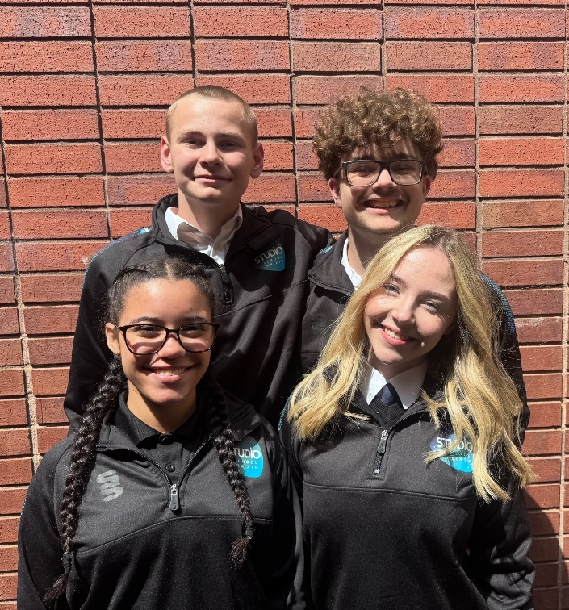

**Higher Level Teaching Assistant (HLTA) and Team (Crew) Leader**

**Walsall Studio   
School & Sixth**

**Required for September 2025**

**Permanent, Full-Time**

**Competitive Salary**

**Grade 6 SCP 15-23 (£25,135- £28,826)**

**plus SEN Allowance (£1,525)**

**Applicant**

**Pack**

**Deputy  
Headteacher**Quality of Education and Operations

**Walsall Studio   
School & Sixth**

**Required for September 2025**

**Permanent, Full-Time.**

**Competitive Salary**

**(Leadership L14 to L18)**

**Candidate Pack**

****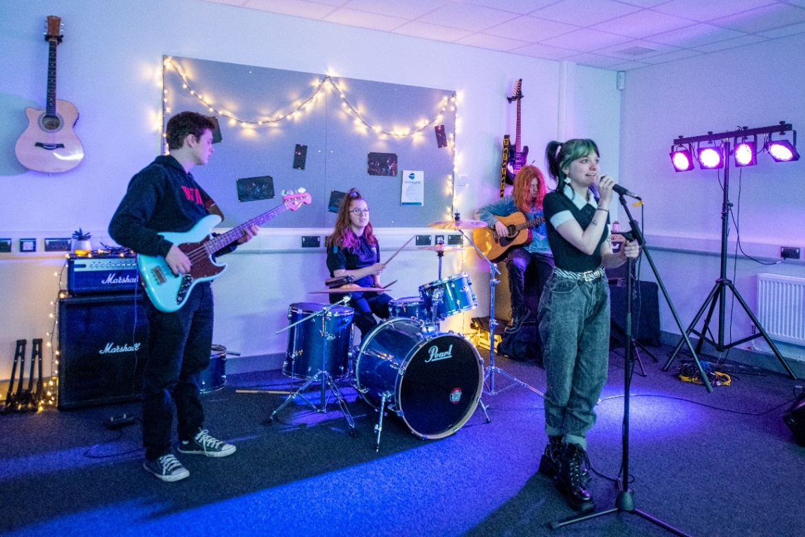

**WELCOME TO WALSALL STUDIO SCHOOL & SIXTH**

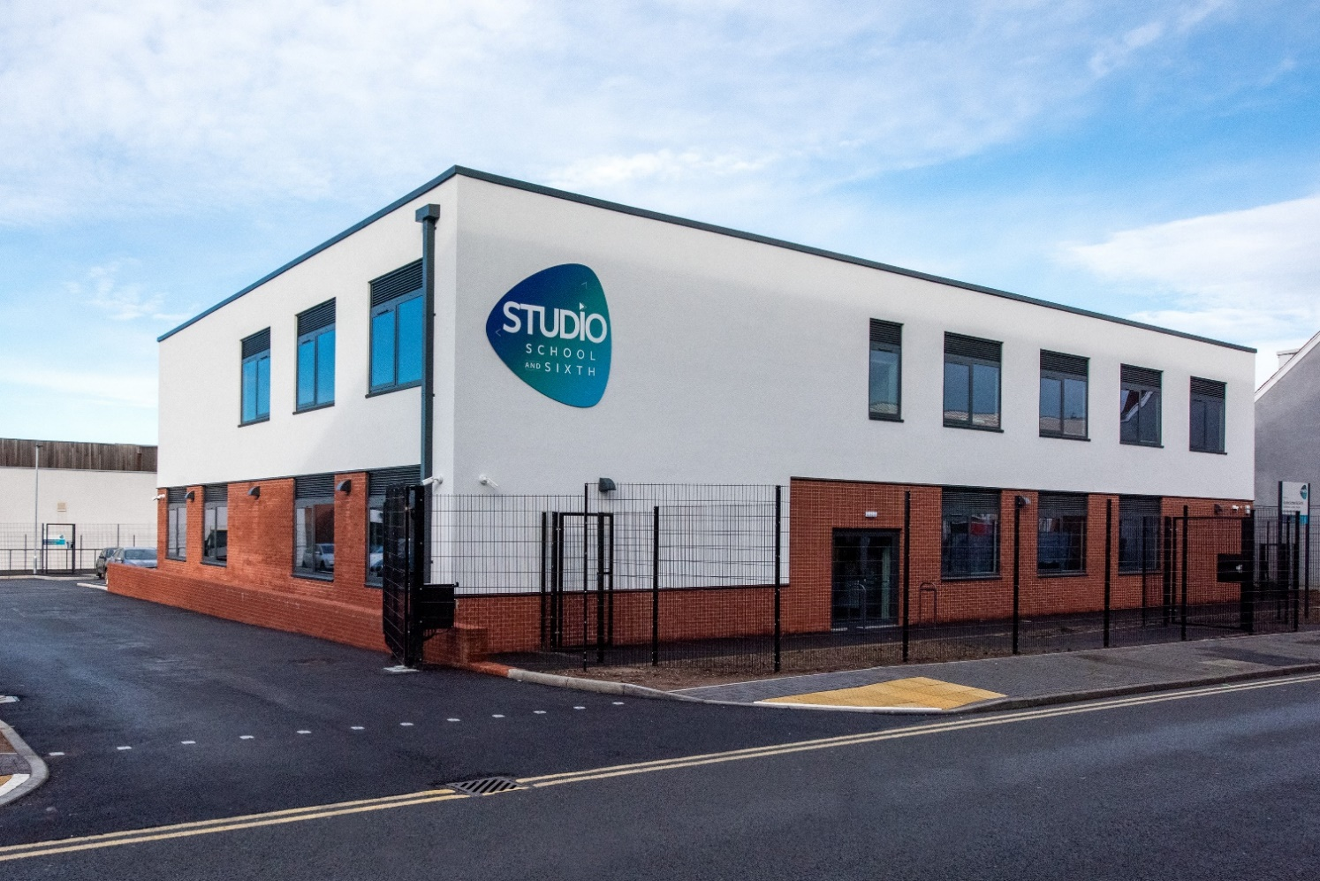

Dear Applicant,

Walsall Studio School and Sixth is a deliberately small, forward-thinking school serving young people aged 14 to 19 who are passionate about creative pathways in performance, music, and media. We offer a unique learning environment that looks and feels like a modern creative workplace rather than a traditional school, with flexible studio spaces and industry-standard facilities that reflect the real world our students are preparing to enter.

At the heart of our mission is a commitment to inclusion, aspiration, and professional standards. We believe in treating our students as young professionals, helping them to thrive both personally and creatively through high expectations, trauma-informed practice, and a deep understanding of the individual. Our culture is one where every student is known, seen, and supported.

As a founding member of *The Mercian Trust*, we are proud to be part of a family of schools that share our belief in partnership, collaboration, and community. We work closely with industry partners, creative professionals, and local organisations to ensure our students gain not just qualifications, but authentic experiences that prepare them for the world beyond education.

If you share our values and want to help shape the next generation of creative professionals, we would love to hear from you.

Yours sincerely,

Krissi Carter, Headteacher

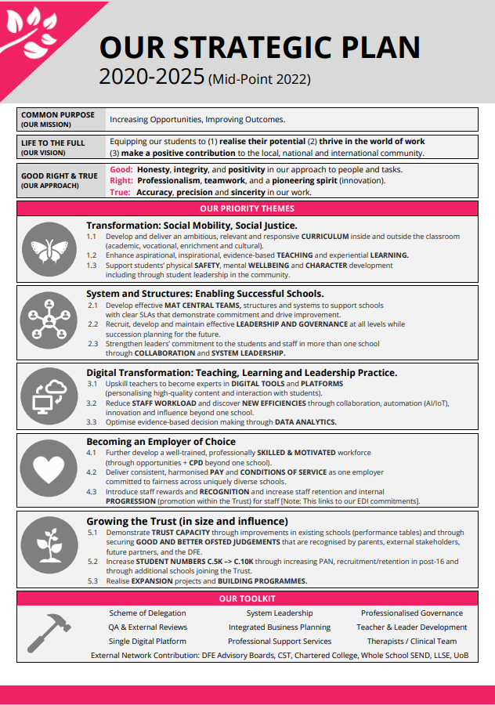

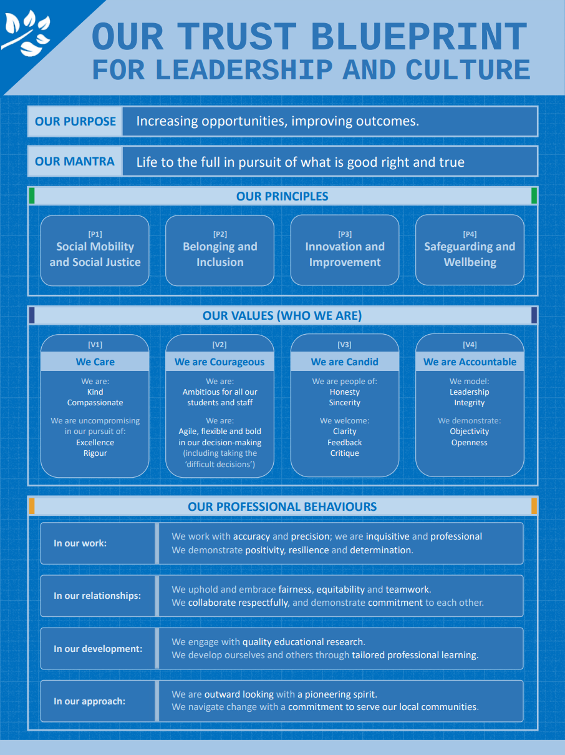

**THE MERCIAN TRUST**

The Mercian Trust is one of the largest regional Trusts in the West Midlands with 9 schools and more than 9,700 students. We are making strategic investments of time, focus, and resources into our people and organisational culture – and we are prioritising the development of leaders at all levels.

**About The Mercian Trust**

The Mercian Trust was incorporated in January 2018 and currently governs nine secondary schools, comprising selective grammar schools, large comprehensive schools, an alternative provision free school and a 14-19 specialist studio school.

In 2021, the Regional Schools Commissioner approved the merger between The Mercian Trust and Q3 Academies Trust. The formal merger transfer was completed on 1st May 2022 when all nine academies of the two Trusts became part of the same family of schools governed by The Mercian Trust.

* Aldridge School (11-18)
* Q3 Academy Great Barr (11-18)
* Q3 Academy Langley (11-16)
* Q3 Academy Tipton (11-18)
* Queen Mary’s High School (11-18, selective)
* Queen Mary’s Grammar School (11-18, selective)
* Shire Oak Academy (11-18)
* The Ladder School (Alternative Provision)
* **Walsall Studio School & Sixth (14-19)**

The Members of The Mercian Trust include The Vine Trust and the Queen Mary’s Foundation. Both are charitable organisations focused on improving the futures of local young people.

**Plans for the future**

We are nearing the conclusion of our current 2020-25 strategic plan:

1. **Leading students on a transformational journey** empowering social mobility and delivering social justice.
2. Develop and deliver an ambitious, relevant and responsive curriculum inside and outside the classroom (academic, vocational, cultural)
3. Enhance aspirational, inspirational, evidence based teaching and experiential learning
4. Support students’ physical safety, mental wellbeing and character development including student leadership in the community
5. **Establishing systems and structures** to enable successful schools
6. Develop effective MAT central teams and systems (finance/HR/Estates and more) to support schools with clear SLAs that demonstrate commitment and drive improvement
7. Recruit, develop and maintain effective leadership and governance at all levels while succession planning for the future
8. Strengthen leaders’ commitment to the students and staff in more than one school through collaboration and system leadership
9. **Driving the digital transformation**
10. Upskill teachers to become experts digital education (personalising high-quality content and interaction with students)
11. Reduce staff workload and discover new efficiencies through collaboration, automated operations, innovation, and influence beyond one school
12. Optimise evidence-based decision making through data analytics
13. **Becoming an employer of choice**
14. Further develop a well-trained, professionally skilled and motivated workforce (through opportunities and CPD beyond one school)
15. Deliver consistent, harmonised pay and conditions of service as one employer committed to fairness across uniquely diverse schools
16. Introduce staff rewards and recognition and increase retention and internal progression (promotion within the trust) for staff in all schools
17. **Growing the Trust in size and influence**
18. Demonstrate Trust capacity through improvements in existing schools (performance tables) and through securing good and better Ofsted judgements that are recognised by parents, external stakeholders, future partners and the DfE
19. Increase student numbers from c5k to c10k through increasing PAN, recruitment/retention in post 16 and through additional schools joining the Trust
20. Realise expansion projects and building programmes

***Areas of focus for the Trust board at the moment include:***

1. **Successful Growth**

Having consolidated following our successful Trust merger, we are now preparing for our next period of growth in size and influence including new schools joining our Trust, increases in PAN, and increases in sixth form numbers. Ensuring this growth enables us to develop and refine our structures, systems and staff to be even more successful for our schools and the communities we serve. We are well-positioned to make a significant contribution to a Trust-led education sector.

1. **Equality, Diversity and Inclusion (EDI) -** The Trust is passionate about its commitment to social mobility, social justice and inclusion in three significant areas.
2. **Students** - Closing the gaps in opportunity, attainment and progress for disadvantaged students, students with SEND, vulnerable students and others with protected characteristics that may mean they are more likely to face discrimination and prejudice.
3. **Staff** – Developing and nurturing opportunities for staff (including leadership development) particularly for those who are more likely to face discrimination and prejudice.
4. **Governance** - Increasing numbers of non-executive leaders and governors from underrepresented groups.
5. **Digital Transformation**

Delivering the digital transformation of how we teach, learn, lead and operate. The Trust is establishing a single consolidated digital ecosystem / infrastructure that facilitates ‘economies of scale’ and ‘network effect’ of being part of one charitable trust.

**Trust ethos & values**

Our name is rooted in history and expresses a geographical identity and ambition. The ancient kingdom of Mercia encompassed much of what we now recognise as the West Midlands – and crucially for us it included what we now call the Black Country. It was in Mercia that St Chad established an association of small monasteries which fostered unity through bonds of kinship.

Now, almost fifteen hundred years later, we look to demonstrate the same spirit in our approach. We are a family of schools committed to each other – diverse in nature, proud custodians of our history and success, but together, one charitable trust with a common purpose.

Our Trust exists to equip our students to:

* Realise their potential
* Thrive in the world of work
* Make a positive contribution to the local, national and international community.

Our mission is **increasing opportunities** and **improving outcomes**. Our mantra is Life to the full in pursuit of what is **good, right and true**.

Walsall Studio School  
**Higher Level Teaching Assistant (HLTA) – Studio 5 Team (Crew) Leader + 1 SEN Allowance Point**

**Job Title:** Higher Level Teaching Assistant (HLTA) – Studio 5 Team Leader

**Salary:** Grade 6 SCP 15-23 (£25,135- £28,826)

**Responsible to:** Deputy Headteacher and SENDCo

**Responsible for:** Studio 5 key worker team (Teaching Assistants / Therapeutic Workers)

**Role Type:** Support Staff

**Contract Type:** Term Time Only, 37 hours per week

**Working Hours:** Monday to Thursday, 8:00am – 4:00pm/Friday 8.00am – 3.30pm

**Job Purpose**

This is a unique opportunity to lead our specialist support provision (SRP), *Studio 5*, for students with social, emotional and mental health needs, communication and interaction needs, and anxiety.

As HLTA and Crew Leader, you will take a leading role in delivering high-quality, personalised support for students in Studio 5, while also coordinating the work of a small, dedicated team of Teaching Assistants and Therapeutic workers. You will work collaboratively with teaching staff, the wider SEND team, external agencies, and parents/carers to ensure that every student in Studio 5 receives the individualised support they need to thrive both within the SRP and in the wider school environment.

This role combines high-level classroom and pastoral support with leadership responsibility and the opportunity to make a meaningful difference in the lives of vulnerable young people.

**Key Responsibilities**

**1. Teaching and Learning Support**

* Deliver targeted small group and 1:1 interventions across a range of subject areas and social/emotional needs, in line with student EHCPs.
* Support students in accessing learning in mainstream lessons, promoting independence, confidence, and engagement.
* Adapt resources and approaches to meet the specific learning profiles of Studio 5 students.
* Use assessment for learning techniques to track and respond to student progress.
* Work closely with teaching staff to implement support strategies and differentiate appropriately.
* To cover and deliver sessions in the absence of teaching staff

**2. Team Leadership (Crew Leader Role)**

* Line manage a team of Teaching Assistants (TAs) and Therapeutic Workers within Studio 5, overseeing their day-to-day deployment, support, and development.
* Facilitate regular Crew meetings, support staff briefings, and contribute to SEND planning and reviews.
* Lead by example in upholding the school’s ethos, expectations, and trauma-informed practices.
* Provide coaching, modelling and in-role support for the team to ensure consistently high-quality practice.
* Work with the Deputy Headteacher to evaluate provision and contribute to strategic development planning.

**3. Student Support and Pastoral Care**

* Act as a key adult and trusted figure for a small caseload of Studio 5 students.
* Implement trauma-informed and attachment-aware approaches to behaviour, communication, and regulation.
* Support students in managing their emotions, transitions, and relationships in school.
* Liaise with parents/carers and external professionals to ensure a coordinated support plan is in place.
* Contribute to risk assessments, pastoral plans, and the safe management of crisis situations.

**4. Inclusion and Safeguarding**

* Champion inclusive practice and student voice within the SRP and wider school community.
* Ensure that safeguarding, confidentiality, and data protection policies are upheld at all times.
* Maintain accurate records and support statutory processes (EHCPs, annual reviews, etc.).
* Promote student attendance, punctuality, and readiness to learn.

**5. Professional Development**

* Engage in regular CPD linked to SEMH, autism, anxiety, neurodiversity, and inclusive education.
* Contribute to the development of others through mentoring, training, or sharing of best practice.
* Maintain HLTA status and undertake any additional qualifications or training as agreed.

**Safe Working Practices for Adults Working with Children**  
All staff at Walsall Studio School are expected to model and uphold the Trust’s ethos of safe, respectful, and professional conduct when working with students. The postholder must act in line with safeguarding principles and actively promote a culture of vigilance and care.

**Safeguarding Statement**  
Walsall Studio School is committed to safeguarding and promoting the welfare of children. All appointments are subject to an enhanced DBS check, satisfactory references, and other relevant employment checks.



Walsall Studio School

**HLTA – Studio 5 Provision Team (Crew) Leader**

**+1 SEN Allowance Point**

|  |  |  |  |
| --- | --- | --- | --- |
| **Criteria** | **Essential** | **Desirable** | **Assessment** |
| Qualifications | • HLTA status or equivalent qualification/experience • GCSE English and Maths (Grade 4/C or above) • Evidence of ongoing CPD in SEND/SEMH/communication needs | • Further qualification in SEND, SEMH or Trauma-Informed Practice | AF (Application Form) |
| Experience | • Experience working with students with SEMH, anxiety, or communication needs • Experience leading interventions or small-group learning • Experience supporting students with EHCPs • Experience of working in a trauma-informed and/or attachment-aware environment | • Experience in a specialist provision or alternative education setting • Experience of leading or line managing staff | AF, I (Interview), R (Reference) |
| Skills and Abilities | • Strong interpersonal skills and emotional intelligence • Ability to model calm, consistent and therapeutic behaviour management • Ability to lead and motivate a small team • Excellent organisational and communication skills • Skilled in adapting learning resources and activities to meet individual need | • Ability to deliver CPD or in-role coaching to others | AF, I |
| Knowledge and Understanding | • Good understanding of inclusive education, EHCPs and the SEND Code of Practice • Knowledge of safeguarding procedures and professional conduct • Understanding of regulation strategies, student voice, and wellbeing needs | • Familiarity with a range of interventions and tools to support SEMH and neurodiverse students | AF, I |
| Personal Qualities | • Compassionate, patient, and resilient • High expectations for all students • Reflective and open to feedback • Flexible and able to respond to changing situations with integrity | • A sense of humour and commitment to the Studio 5 and Walsall Studio School | I, R |
| Other Requirements | • Willingness to undertake an enhanced DBS and pre-employment checks   * Willingness to undertake further CPD e.g. First Aid |  | AF |

**OUR OFFER TO YOU**

* A superb staff team committed to doing their absolute best for all in our school community.
* Support from our Trust central teams and other schools in our Trust to ensure you have the tools to deliver success (our schools are all located close to one another, and we work better when we are working together).
* A wealth of support for your ongoing continuing professional development, including a Trust-wide programme for support staff drawing on expertise from across the Mercian Trust.
* A comprehensive employee assistance and staff benefits package including Simplyhealth (cash-back health plan and 24:7 video call and telephone access to GP and counselling), salary sacrifice schemes, and discounts portal (ranging from gym membership to discount cards and vouchers for online and high street retailers).
* There will never be a dull moment; we never stand still, every day offers new challenges and opportunities within an ambitious, forward-thinking team.

**SAFEGUARDING AND SAFER RECRUITMENT**

* The Mercian Trust is committed to equal opportunities, safeguarding, and promoting the welfare of children and young adults. We expect all staff to share this commitment. As this post involves working in regulated activity unsupervised with children all post-holders are subject to satisfactory pre-employment checks including an online search check, Enhanced Disclosure and Barring Service check.
* You are required to uphold all relevant policies in respect of child protection and safeguarding, which are based on KCSIE (2024) and Working Together to Safeguard Children (2018).
* You are required to demonstrate and model the Nolan Principles (The Seven Principles of Public Life): Selflessness, Integrity, Objectivity, Accountability, Openness, Honesty, and Leadership. <https://www.gov.uk/government/publications/the-7-principles-of-public-life>
* You should demonstrate your commitment to our equality policy and all our related work to promote diversity, inclusion and belonging.

**KEY INFORMATION – HOW TO APPLY**



|  |  |
| --- | --- |
| **Post** | HLTA and Team (Crew) Leader |
| **Responsible to** | Deputy Headteacher / SENDCo |
| **Contract and Salary** | Full time, permanent  Grade 6- SCP 15-23 |
| **Closing Date** | Monday 30 June 2025 |
| **Interview Dates** | Week commencing 30 June 2025 |
| **Start Date** | 1st September 2025 |
| **Informal Confidential Conversations and Visit of School** | To speak to someone about the post, please contact Angela Lingard, SLT PA and Office Manager at a.lingard@studio.merciantrust.org.uk |
| **How to apply** | Please complete the Online Application Form via our Mercian website. |