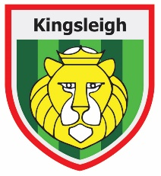
Higher Level Teaching Assistant required

Kingsleigh Primary School is a true community school and we firmly believe it is our responsibility to educate the children in our community. We believe that all children have the right to an education and actively promote educating the whole child and offering them the support they need to achieve both academically and personally.

We are seeking to appoint an efficient and proactive Higher Level Teaching Assistant to cover classes across our school as well as support the class teachers to ensure children make progress. This position is being offered on a permanent contract.

Working hours are 35 hours per week from 8.15am to 3.45pm with a 30-minute break for lunch - term time only. Salary being offered is Grade 6 - £29,572-£32,654 pro rata. Actual starting salary is £23,928.

‘Where everyone can be great!’

We are looking for someone who:
- Is enthusiastic and open-minded about teaching and learning.
- Will be proud to be a part of our school and will uphold our ethos and values.
- Is enthusiastic about working as part of a team at all levels: year group, phase and school.
- Puts children at the centre of their work.
We can offer:
- a caring ethos and a staff team who support each other
- an exciting vision for the future of our learning community
- a commitment to your professional development
- scope to develop ideas and innovate
- staff who trust in each other and thrive on working as a team
- strong and sensitive leadership by Directors and Senior Leaders
Closing date for applications: Wednesday 23rd April 2025 at midday
Interviews will be held on: Wednesday 30th April 2025

Please send an email to kim.bainton@kingsleighprimary.co.uk for an application pack.

Our school is committed to safeguarding and promoting the welfare of children. Rigorous checks will be made of the successful applicant’s background credentials, including enhanced DBS checks.

