Wright Robinson College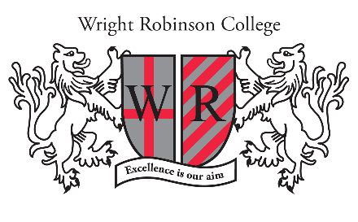

Headteacher: Martin Haworth

Higher-Level Teaching Assistant (HLTA)

**Grade 5** **SCP 13-19** **£24,948 - £27,852 FTE (Actual salary term-time only £20,908 - £23,342)**

**Start Date:**  **ASAP**

**Contract: Full Time. Permanent. Term Time Only.**

We have an exciting and rare opportunity to join our supportive and successful team as a Higher Level Teaching Assistant (HLTA). Within the role, you will support the SENDCO in ensuring that quality provision is provided for our SEND students by coordinating the daily timetable for a team of learning support assistants. Furthermore, you will support SEND students with a range of needs in class and during interventions and support the SENDCO with administrative tasks including coordinating and developing resources for SEND students.

We are looking for applicants with experience of working with young people with SEND. Ideally you will have proven success working as part of an effective team and demonstrate the ability to show initiative and lead a team.

Wright Robinson College is outstanding in every area of the Ofsted Inspection Framework 2021. As an ‘Outstanding School,’ we are fully committed to continuing to further raise academic standards and attainment, across an academic curriculum.

Wright Robinson College is committed to staff development and if you join our team, you will be based in a friendly and supportive school with a state-of-the-art building, providing access to the latest resources to facilitate learning. As well as offering you a competitive salary and access to our BUPA Healthy Minds Employee Assistance Programme, you will be provided with free access to on-site gym facilities, swimming pool and on-site parking. Located on the east side of Manchester, we are easily accessible through local and regional transport links.

Have you got the desire, experience and ambition to join our Team? If so, we would be delighted to hear from you. Informal enquiries can be directed to Ms Ward on 0161 370 5121.

**For further information on the position, to see what our staff have to say about working for us and for details on how to apply, please follow the link below:**

<https://www.wrightrobinson.co.uk/Vacancies-Non-Teaching/>

**Closing date: 9am on Friday 29th September 2023**

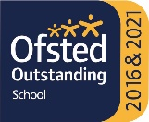**Interviews to be held w/c 2nd October 2023**

**Statement on Equality**

We are an Equal Opportunities Employer and we positively welcome applications from candidates regardless of age, disability, gender reassignment, marriage and civil partnership, pregnancy and maternity, race, religion or belief, sex and sexual orientation.

**Statement on Safeguarding**

Wright Robinson College is committed to safeguarding and promoting the welfare of children and young people and expects all staff and volunteers to share this commitment.  All employment offers are made subject to an enhanced DBS check and satisfactory references. When appointing new staff, we will ask shortlisted candidates to complete a self-declaration of their criminal record and to provide any information that would deem them unsuitable to work with children.

**Online checks for shortlisted candidates**

In accordance with DfE Keeping Children Safe in Education 2022, an online search, including social media, will be completed on all shortlisted applicants prior to interview. Any relevant information will be discussed further with the applicant during the recruitment process.

**GDPR**

A copy of our Privacy Notice is available on our website.

www.wrightrobinson.co.uk

Tel: 0161 370 5121

Abbey Hey Lane, Manchester, M18 8RL