Working to Learn Together

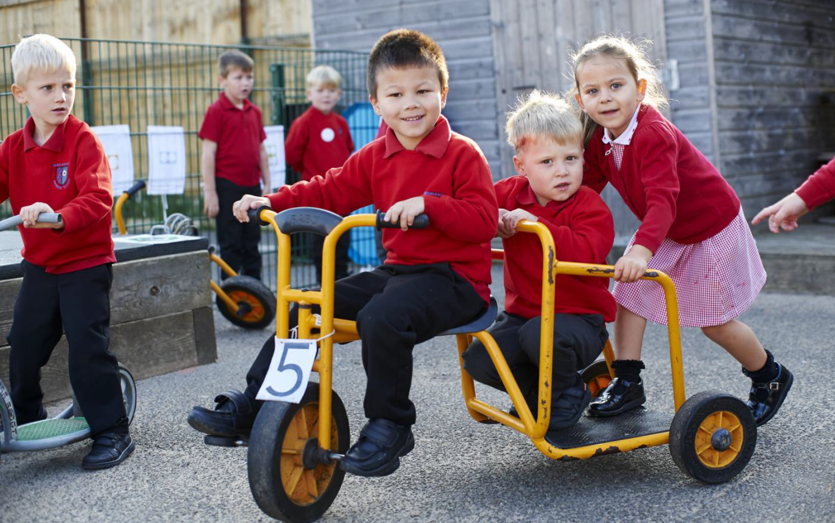

HLTA Grade F (SCP 8 – 13) Fixed Term until July 2022
37 hrs/week TTO plus training days.
Required January 2022
Recruitment Information Pack
Newby & Scalby Primary School
The Green, Scarborough, YO12 5JA

Contents

Welcome from the Headteacher 3
Our staff 4
Our schools 5
Application process and how to apply 6
Job Description and Person Specification 7-11

Dear applicant,

Allow me to extend a warm welcome from all governors, staff and children of Newby & Scalby Primary School. I am delighted you have shown interest in joining us and I look forward to sharing with you what makes our school a very special place to work.

Our children are delightful, happy, confident and energetic. They are passionate about their learning, be it in the classroom or through other areas of our developed curriculum such as dance, art, PE and music.

Over many years together we have built a learning community that puts the whole child and their development, along with harnessing the skills of our staff at our very heart. You will be joining a school with low staff turnover and high staff retention and as Headteacher it is my job to make sure colleagues are supported and challenged to be lifelong learners.

Working at Newby &Scalby is incredibly rewarding. Due to our well-deserved reputation across the area we place huge importance on developing talent – and in many ways our ‘research school’ ethos has resulted in many staff being developed as a support professional. I still get an incredible buzz from seeing our children reach their full potential through our staff training and development focus.

This is an exciting time to join us. As the founding primary member of the Coast and Vale Learning Trust (along with Scalby School) our team are working in partnership with our sister school Friarage Primary to share, learn and create a primary hub our area can be proud of. Through our Trust we are able to access the support and resources from our Teaching School, which means as a staff member you have a wide range of colleagues, tools and resources to help you develop not just in the classroom but beyond.

I hope that you will take the time to come and see and experience for yourself the warm and welcoming atmosphere which makes our vision a reality.

Good luck with your application. I look forward to reading it.

Chris Kirkham- Knowles
Headteacher

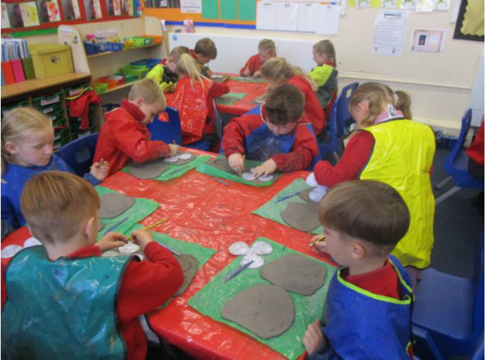
Our staff
Maddie Blakeley is an Early Career Teacher at Newby and Scalby Primary School in Scarborough. She has worked at the school since June 2017.
What do you enjoy most about your job?
I don't think there is any job that can be as varied as teaching is. You can't beat working with children: getting to know them as people; sharing their hopes and aspirations for the future; celebrating their successes and watching them finally get something they have been struggling with. That is when you truly know you have made a difference. Finding a school where this ethos is shared and where children are the driving force is what I have managed to do and I work alongside an incredible group of dedicated people that share that same goal. Not only have I found a group of work colleagues but also a group of friends that support me and make me laugh often.
What’s the best thing about the community that your school serves?
The community plays a large role in our teaching and learning and is a lovely area to work. We are lucky to work so closely with many services. Whether it be borrowing a book from the local library, visiting the local church for a tour of the war memorial or sharing harvest gifts with local residents, we gain a lot from this. Having open days and workshops means people are welcome to see how the school runs and how their children are getting on. It is a great way to get to know the school and teachers.
What would you say to a teacher thinking about moving to a school on the Yorkshire Coast?
I don't think you can beat working on the coast. Personally, I was brought up in Scarborough but after going to university in Lincoln and working in city schools and village schools I always knew that the coast would be where I ended up. Having the beach on your doorstep is ideal and I'm sure some of our children would agree, especially our Year 6s who have spent an afternoon surfing in the past with trained lifeguards. Trips to the beach and the local parks all add to the different experiences that children in our school are exposed to. We have a bit of everything that is only a walk or short drive away.

Our schools

Newby and Scalby Primary School

We are one of the schools of choice in our community and we are within commutable distance of Whitby, Teeside, York and surrounding areas. Ofsted in 2018 judged us to be ‘good’ in all areas and as a school we are very much outward facing both in terms of teaching and learning and in constantly thinking about how we can improve.
Since our “good” Ofsted, we continue to build on our successes and we are a family and a team, where everyone is given the challenge and support to be the best they can possible be in a safe, welcoming and positive environment. Children and staff will work and play together developing skills so that we all become ambitious and reflective lifelong learners as well as being respectful and respected members of the community.
To learn more about us please visit us at https://www.newbyandscalby.coastandvale.academy
Friarage Primary School

We are proud to serve the communities around the Castle Ward area of Scarborough as ‘Together we can’ make a real difference to the life chances of children and young people in Scarborough.

Children and staff will work and play together developing skills so that we all become ambitious and reflective lifelong learners as well as being respectful and respected members of the community.
We are committed to Restorative Practice Principles to nurture respect for all in our school community.

To learn more about us please visit us at https://www.friarage.coastandvale.academy

Scalby School

Scalby School is a successful and popular 11-16 community school and in recent years we have become the school of choice in our local community. We were judged ‘good’ by Ofsted in 2019 and in 2019 we celebrated sustained results. Our provisional P8 score has placed us in the top 20% of schools nationally. We are proud of our broad and balanced GCSE based curriculum.
To learn more about us please visit us at https://www.scalby.coastandvale.academy

Application Process
The closing date for all applications is 9am on Monday 13th December 2021

Interviews will be held on Wednesday 15th December 2021

Completed applications must be returned to Garry Morrison at garry.morrison@northyorks.gov.uk

If you do not receive confirmation of receipt of your application within one working day please call Garry on 07814935700

If you think you’re the person for the job, please complete the enclosed application form having looked at the job description and person specification.

An email will be sent to shortlisted candidates with details of the interview process. If you have not heard from us within a week of the closing date please assume your application has been unsuccessful.

Queries

We actively welcome you to contact Garry at North Yorkshire County Council to chat through the role and talk informally about the school/post and how working here will make a real difference to the children and young people on the coast.

Job Description

JOB TITLE: Higher Level Teaching Assistant (HLTA)
GRADE: Grade F (SCP 8 – 13)
RESPONSIBLE TO: Headteacher/Senior Leadership Team
STAFF MANAGED: None

JOB PURPOSE: | To complement the professional work of teachers by taking responsibility for agreed learning activities under an agreed system of supervision.  To advance pupils’ learning in a range of classroom settings, including working with individual pupils or groups and whole classes where the assigned teacher is not present, e.g. PPA time or covering short term absence. Activities involve planning, preparing and delivering learning lessons as well as monitoring pupils, assessing, recording and reporting on pupils’ achievement, progress and development, under the direction of the class/subject teacher.
ACCOUNTABILITIES / MAIN RESPONSIBILITIES
Supporting Learning & Development | - Cover short term teacher absence and communicate pupil work as planned by the classroom teacher and manage pupil behaviour  - Within an agreed system of supervision, plan teaching and learning objectives, prepare and deliver learning activities and evaluate and adjust lessons/work plans according to pupil responses/needs  - Monitor, record and evaluate pupil responses to learning activities through a range of assessment and monitoring strategies against pre-determined learning objectives  - Interact with pupils in ways that support the development of their ability to think and learn, and work independently  - Support the development and implementation of appropriate behaviour management strategies, to anticipate and manage behaviour constructively, promoting self-control and independence  - Support pupils in their social and emotional wellbeing, and develop and implement related social, health and physical programmes  - Take account of the effects of different parenting approaches, background and routines, and be involved in home school liaison  - Encourage and motivate pupils to promote independence and resilience and increase self-esteem  - Participate in the development, implementation and monitoring of systems relating to attendance and integration e.g. registration, truancy, pastoral systems etc.  - Accompany or act as a group leader on educational visits, and other activities outside of the classroom, supervising the pupils  - Provide supervision during breaks as required
Communication | - Establish constructive and respectful relationships with parents/carers, exchange appropriate information, facilitate their support for their child’s attendance, access and learning and support home to school and community links.  - Play an appropriate part in establishing effective relationships and communicate with other agencies/professionals, in liaison with the teacher, to support achievement and progress of pupils
Sharing Information | - Provide objective and accurate feedback and reports on pupil attainment, progress and other matters, ensuring the availability of appropriate evidence  - Participate in meetings with other staff, external professionals, and parents, regarding pupils, in a support capacity to the teacher, who will normally lead on such matters  - Pay due regard to professional boundaries, maintaining appropriate levels of confidentiality  - Participate in staff meetings  - Share information about pupils with teachers and other professionals as required
Safeguarding and Promoting the Welfare of Children/Young People | - Assist pupils with personal hygiene, and welfare, including physical and medical needs, whilst encouraging independence  - Be responsible for promoting and safeguarding the welfare of pupils that you are responsible for and come into contact with, reporting concerns as appropriate
Administration/Other | - Organise and manage an appropriate learning environment and resources  - Support the use of ICT to advance pupils’ learning and use common ICT tools for own and pupils’ learning  - Assist with administrative support e.g. dealing with correspondence, compilation/ analysis, reporting on attendance, exclusions etc., making phone calls  - Supervise and provide access arrangements for pupils sitting internal and external examinations, ensuring that examinations comply with Examination Board Regulations  - Under the guidance and supervision of a class teacher be responsible for marking the register or being a form tutor  - Participate in training and appraisal
Data Protection | - To comply with the Trust’s policies and supporting documentation in relation to Information Governance this includes Data Protection, Information Security and Confidentiality
Health & Safety | - Be aware of and implement your health and safety responsibilities as an employee and where appropriate any additional specialist or managerial health and safety responsibilities as defined in the Health and Safety policy and procedure  - Work with colleagues and others to maintain health, safety and welfare within the working environment
Equalities | - Promote inclusion and acceptance of all pupils  - Ensure services are delivered in accordance with the aims of the equality Policy Statement  - Develop own and team members understanding of equality issues
Flexibility | - The Trust provides front line services, which recognises the need to respond flexibly to changing demands and circumstances. Whilst this job outline provides a summary of the post, this may need to be adapted or adjusted to meet changing circumstances. Such changes would be commensurate with the grading of the post and would be subject to consultation. All staff are required to comply with Trust Policies and Procedures
Customer Service | - The Trust requires a commitment to equity of access and outcomes, this will include due regard to equality, diversity, dignity, respect and human rights and working with others to keep vulnerable people safe from abuse and mistreatment  - The Trust requires that staff offer the best level of service to their customers and behave in a way that gives them confidence. Customers will be treated as individuals, with respect for their diversity, culture and values
Date of Issue: | January 2015

Person Specification
Essential upon appointment | Desirable on appointment (if not attained, development may be provided for successful candidate)
Knowledge
- Good understanding of child/young people’s development and learning processes  - Understanding of individual children and young peoples’ needs  - An understanding that children/young people have differing needs and knowledge of inclusive practice  - A clear commitment to Safeguarding and promoting British Values | - Knowledge of Behaviour Management techniques  - Knowledge of Child Protection and Health & Safety legislations and procedures
Experience
- Significant experience of working with children in an education setting | - Experience of delivering evidence based interventions that accelerate learning  - Experience in a relevant specialism  - Knowledge of Characteristics of Effective Learning  - Experience of delivering PE
Occupational Skills
- Demonstrable ICT skills and ability to use them as part of the learning process, or, the ability to develop ICT skills in a reasonable timeframe
- Good written and verbal communication skills: able to communicate effectively and build good relationships with all teachers, children, young people, families and carers
Qualifications
- Level 2 numeracy & literacy qualification or equivalent  - HLTA status or QTS ** (or willingness to gain HLTA status)  ** It is essential that Higher Level Teaching Assistants are assessed against and meet the HLTA standards within 12 months, or have Qualified Teacher Status to enable them to deliver teaching and learning activities to a whole class | - Appropriate first aid training  - Relevant NVQ level 4 or foundation degree
Personal Qualities
- Demonstrable interpersonal skills  - Ability to work successfully in a team  - Able to exercise discretion and judgement  - Confidentiality  - Flexibility | - Creativity
Other Requirements
- To be committed to the school’s policies and ethos
- To be committed to Continuing Professional Development
- Motivation to work with children and young people
- Ability to form and maintain appropriate relationships and personal boundaries with children and young people
- Emotional resilience in working with challenging behaviours and attitudes
- Ability to use authority and maintaining discipline
- Enhanced DBS

We are committed to safeguarding and promoting the welfare of children and young people and expects all staff and volunteers to share this commitment.
This post is exempt from the Rehabilitation of Offenders Act 1974 and the appointment is subject to a satisfactory enhanced level disclosure and S128 clearance from the Disclosure & Barring Service (DBS).

