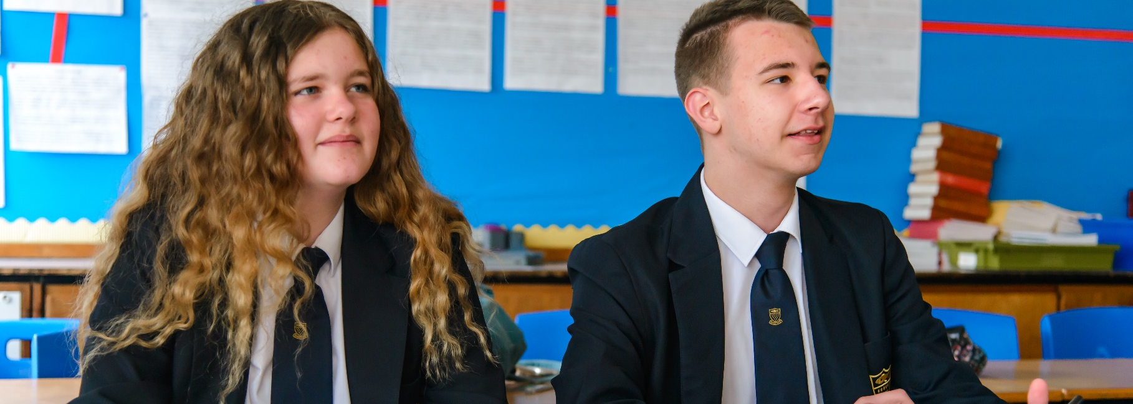


www.celtrust.org
Higher Level Teaching Assistant
Job Description & Person Specification

Job Description

Purpose of the Post: | To supervise classes during the short-term absence of the assigned teacher and to support the professional work of teachers in delivering programmes of work and taking responsibility for agreed learning activities under an agreed system of supervision.
Reporting to: | Teaching staff, Heads of Department, Senior Leadership and Headteacher
Location: | Based at Newquay Tretherras but there may be a requirement to travel to undertake work at or for other academies/sites within Cornwall Education Learning Trust.
Salary Grade: | Grade F
Hours: | 30 hours per week term time only plus 3 additional (44.194 weeks).  A flexible approach to working hours is required.

Principal Responsibilities:

Support for Teachers

- Supervise work that has been set by a teacher. Manage the behaviour of students whilst they are undertaking this work to ensure a constructive environment. Respond to any questions from students about process and procedures. Collect completed work after the lesson and pass to the appropriate teacher.

- Deal with any immediate problems or emergencies according to the school’s policies and procedures. Report, as appropriate using the school’s agreed referral procedures, on the behaviour of students during the class and on any problems arising.

- To assist the teacher in the planning of work programmes for individuals and groups of students. To work within a framework set by the teacher, ensuring involvement in the lesson and feedback to students and colleagues is appropriately planned.

- To advance students’ learning in a range of classroom settings, including working with individuals, small groups and whole classes within the agreed system of supervision.

- To deliver parts of the lesson and carry out pre-determined educational activities and work programmes whilst promoting independent learning, as agreed with the teacher.

- To meet with teachers, co-ordinators and SENCOs on a regular basis to review the provision of teaching support, discuss any updates in the curriculum/teaching activities and to consider the progress of individual students (including identification of any special support).

- To assist teachers in making smooth transitions between educational phases for students.

- To administer and invigilate examinations and tests as required by the teacher.

- To undertake some marking of tests in accordance with school policies and in consultation with the teacher.

- To support the teacher in the assessment of students’ progress through feedback of observations of students.

Support for the Curriculum

- To deliver local and national learning strategies (e.g.: literacy, numeracy) and assist individuals and groups of students in developing knowledge, skills and attitudes as defined by the curriculum. To take into account the learning support involved to aid the students to learn as effectively as possible.

- To remain aware and up-to-date with the school curriculum, the age-related expectations of students, the recognised teaching methods and the assessment frameworks for the subjects and age ranges in which they are involved.

- To be responsible for organising and managing teaching equipment, materials and other resources required to support the delivery of curriculum activities. To select and prepare teaching resources so as to deliver learning activities and recognise the diversity of students’ needs and interests.

Support for Students
- To be responsible for ensuring classrooms are left clean and tidy after lessons, and all teaching materials and resources accounted for and stored securely when not in use.

- To encourage students to interact and work co-operatively with others and to engage all students in learning activities.

- To feedback any information (including concerns) regarding the well-being and educational needs of students to the teacher or Headteacher as appropriate.

- To build and maintain supportive relationships with students, treating all individuals consistently and with respect and consideration. To encourage acceptance and inclusion of all students.

- To promote students’ independence and employ strategies which recognise and reward students’ self-reliance.

- To encourage social integration and individual development of students. To develop methods of promoting and reinforcing students’ self-esteem.

- To demonstrate and promote positive values, attitudes and high standards of behaviour. To anticipate and manage behaviour constructively, promoting students’ self-control and independence.

- To supervise and manage students’ behaviour in accordance with the recognised behavioural standards and the school’s Behaviour Policy to ensure an orderly and constructive environment for the class.

Support for the School

- To undertake lunch time supervision of students across the school.

- To carry out administrative tasks associated with all of the above duties.

- To contribute to the overall ethos and aims of the school.

General Responsibilities applicable to all staff:

- To demonstrate and promote the values of Cornwall Education Learning Trust at all times.

- To work effectively with other members of staff to meet the needs of all pupils.

- To work with professionalism in line with the Trust's Code of Conduct.

- To attend staff meetings and Trust-based INSET as required.

- To be responsible for his/her own self-development on a continuous basis, undertaking any training/professional development as appropriate.

- To be aware of and adhere to all applicable Trust policies and procedures.

- To maintain at all times the utmost confidentiality with regard to all reports, records, personal data relating to staff and pupils and other information of a sensitive or confidential nature acquired in the course of undertaking duties for the Trust, with due regard to General Data Protection Regulations.

Note:
- This Job Description is illustrative of the general nature and level of responsibility of the work to be undertaken commensurate with the grade. It is not a comprehensive list of all the responsibilities, duties and tasks relating to the post.
- The postholder may be required to undertake such work as may be determined by the Headteacher/line manager from time to time, up to or at a level consistent with the main responsibilities of the job.
- This Job Description may be amended at any time in consultation with the postholder.

SPECIAL CONDITIONS OF EMPLOYMENT
Cornwall Education Learning Trust is committed to safeguarding and promoting the welfare of children and young people and expects all staff to share this commitment. The postholder is required to follow all of the Trust’s policies and procedures in relation to safeguarding at all times, and to adhere to the statutory guidance ‘Keeping Children Safe in Education’. The postholder must take appropriate action in the event that they have concerns, or are made aware of the concerns of others, regarding the safety or wellbeing of children or young people.

All offers of employment are conditional and subject to an Enhanced DBS check and, where applicable, a prohibition from teaching check will be completed for all applicants.

Person Specification
Selection Criteria | Essential | Desirable | How Assessed
Education and  Training | - Level 2 qualifications in maths/numeracy and English/literacy or able to demonstrate competency equivalent to level 2.  - Ability and willingness to undertake professional development. | - Level 3 qualification (NVQ, AVCE or ‘A’ Level) in a subject related to the specialist area. | Application Form / Interview
Skills and Experience | - Experience of working with pupils in a formal learning environment without immediate supervision.  - Good communication skills, both written and verbal.  - A willingness to take action and to make decisions independently.  - A desire to understand how things work and to seek out opportunities to learn and grow.  - Ability to adapt easily to different situations.  - Demonstrate a willingness to learn.  - Organisational skills.  - Self-motivated.  - Enjoys working with children/young people.  - Ability to work on own initiative and as part of a team | - Relevant experience to include providing specialist support within certain areas of the curriculum, or with specialist student groups.  - At least 2 years’ experience of working in a technical support role.  - Ability to plan and deliver individual learning programmes.  - Knowledge of a range of issues relevant to education and child development.  - ICT Skills – able to support learning through ICT. | Application Form / Interview
Specialist Knowledge | - Demonstrates an awareness, understanding and commitment to the protection and safeguarding of children and young people.  - Demonstrates an awareness, understanding and commitment to equality and inclusion.
Values Related Qualities | - Collaborate – ability to work effectively as a team  - Empower – ability to take initiative and problem solve in order to improve performance  - Leadership – To lead by example and achieve shared goals  - Transformation – ability to recognise a need for change and adapt accordingly |  | Application Form / Interview

CORNWALL EDUCATION LEARNING TRUST
Units 15 & 16 St Austell Business Park, Treverbyn Road, Carclaze, St Austell, Cornwall, PL25 4FD

