LAWNSWOOD SCHOOL 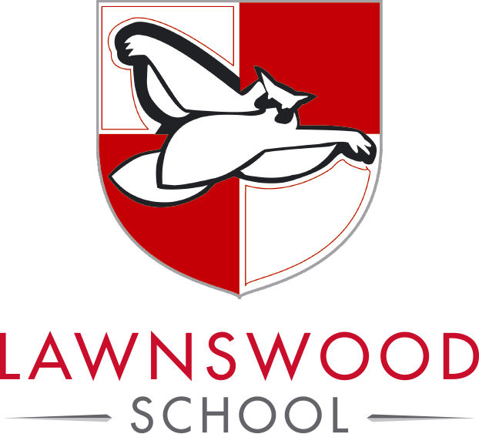
Ring Road, West Park, Leeds LS16 5AG

Higher Level Teaching Assistant – SEMH

Scale SO1 SCP 23-25 £33,366 - £35,235 FTE (actual salary £28,824 - £30,439)
Permanent, full-time; 37 hours per week, Term Time Only + 5 days
Required from: September 2025, or sooner if available

An exciting opportunity has arisen at Lawnswood School to join our on-site alternative provision as an HLTA. The provision supports our KS3 and KS4 students to succeed whilst remaining in school.

Lawnswood School is a thriving school with strong leadership and a dedicated and supportive team of staff. We are looking for someone with enthusiasm, a ‘can do’ mentality, and the drive and determination to ensure that the students with whom you work can overcome barriers to learning and progress; helping to keep them safe, happy and successful throughout their time with us.

Your experience in supporting students with SEMH needs will be key and you will be somebody looking to develop your skills further by taking a leading role in implementing our SEMH provision; as such, the role offers a professional challenge and a rewarding opportunity to be part of an inclusive school with a leadership team who are highly committed to improving the mental health and wellbeing of young people.

This school is committed to safeguarding and promoting the welfare of children and young people and expects all staff and volunteers to share in this commitment. Successful candidates will be subject to an enhanced DBS disclosure.

We promote diversity and want a workforce that reflects the population of Leeds.

For further information, and to download an application form, please visit www.lawnswoodschool.co.uk. Send your completed application form (Support Staff version) with a covering letter (of no more than 2 sides A4), addressed to Mrs. J. Bell, preferably by email to: hr@elawnswood.co.uk or by post to HR Admin, Lawnswood School, Ring Road, West Park, Leeds LS16 5AG.

Closing date: Monday 12 May 2025 at 9.00am

