Higher Level Teaching Assistant – Level 4
Applicant Pack

Contents
The vacancy 3
Post advert 3
Role summary 3
Job description 4
Specific duties and responsibilities 4
Support for the trust/school 4
Changes to these duties 4
Person Specification 5
Job Title: Higher Level Teaching Assistant – Level 4 5
Knowledge, experience and skills 5
Qualifications 5
Other skills 5
Interpersonal skills 6
Child protection 6
Silverdale School & Sixth Form 7
Chorus Education Trust 8
To apply 9

The vacancy

Post advert
Deadline for applications: | 11.59pm on 30th June 2024
Interviews to be held: | Week beginning 8th July 2024
To start: | September 2024

We are seeking to appoint a passionate and experienced Higher Level Teaching Assistant to deliver and coordinate literacy provision, including provision for learners with English as an additional language (EAL).
The successful candidate will require detailed understanding of the ways in which children learn to read, including expertise in phonics, spelling and comprehension strategies. Alongside this, a love of reading, an understanding of the secondary English curriculum, excellent interpersonal skills and an appreciation of different cultures are essential characteristics of the successful candidate.
Recent experience of planning and delivering literacy interventions is also essential.
Applicants should be keen to:
- Work with colleagues to establish a broad and effective literacy offer as part of the school’s reading strategy
- Play a key role in the delivery of literacy interventions and the integration of students with English as an additional language
- Develop teachers’ understanding of literacy, and in particular of phonics
Benefits include:
- CPD support from one of the largest Teaching Schools, the Sheffield Teacher Training Alliance, throughout your career.
- Opportunities to develop skills and experience as part of a growing, local Trust.
Chorus Education Trust is proud to support flexible working arrangements.

Role summary
Post title: | Higher Level Teaching Assistant – Level 4
Profile: | LD3
Grade: | 5
Grade spinal point range: | SCP 15 to 20
Salary: | £27,803 - £30,296 (pro rata £21,327 - £23,240)
Accountable SLT post: | SLT Lead for Inclusion
Line manager (if different): | SENco
Staff to be supervised or line managed by post holder: | N/A
Post holder will work with: | SLT Lead for Inclusion  SENco  Other teaching and support staff
Holiday and sickness relief: | By and for other Education Support staff
Purpose of post: | Working within an agreed framework of supervision to complement the professional work of teachers by taking responsibility for agreed learning activities, including planning, preparation and delivery. These activities can be for individuals/groups or whole classes including monitoring and assessment, recording and reporting on pupil achievement, progress and development.
Version revised: | September 2022

Contract: | Permanent | 33 hours/39 weeks

Job description
The post holder must at all times carry out his/her responsibilities within the spirit of the school and trust policies and within the framework of legislation relating to academies and education, with particular regard to the statutory responsibilities of the trust and the governing body of the school.
The specific duties and responsibilities include but are not limited to:

Specific duties and responsibilities
- To be responsible for providing pupil support for the students within and outside the classroom in order to raise attainment for vulnerable students to the standards required by the school/Trust and appropriate external bodies.
Support for Students:
- To jointly assess the needs of pupils and use detailed knowledge and specialist skills to support pupils’ learning.
- Establish productive working relationships with pupils, acting as a role model and setting high expectations.
- Develop and implement Personal Learning Plans.
- Promote the inclusion and acceptance of all pupils within the classroom.
- Support pupils consistently whilst recognising and responding to their individual needs.
- Encourage pupils to interact and work co-operatively with others and engage all pupils in activities.
- Promote independence and employ strategies to recognise and reward achievement of self-reliance.
- Provide feedback to pupils in relation to progress and achievement.
Support for the Teacher:
- Organise and manage appropriate learning environment and resources.
- Within an agreed system of supervision, plan challenging teaching and learning objectives to evaluate and adjust lessons/work plans as appropriate.
- Monitor and evaluate pupil responses to learning activities through a range of assessment and monitoring strategies against pre-determined learning objectives.
- Provide objective and accurate feedback and reports as required on pupil achievement, progress and other matters, ensuring the availability of appropriate evidence.
- Record progress and achievement in lessons/activities systematically and providing evidence of range and level of progress and attainment.
- Work within an established discipline policy to anticipate and manage behaviour constructively, promoting self-control and independence.
- Supporting the role of parents in pupils’ learning and contribute to/lead meetings with parents to provide constructive feedback on pupil progress/achievement etc.
- Administer and assess/mark tests and invigilate exams/tests.
- Production of lesson plans, worksheet, plans etc.
Support for the Curriculum:
- Deliver learning activities to pupils adjusting activities according to pupil responses/needs.
- Deliver local and national learning strategies e.g. literacy, numeracy, and make effective use of opportunities provided by other learning activities to support the development of pupils’ skills.
- Use ICT effectively to support learning activities and develop pupils’ competence and independence in its use.
- Select and prepare resources necessary to lead learning activities, taking account of pupils’ interests and language and cultural backgrounds.
- Advise on appropriate deployment and use of specialist aid/resources/equipment.

Support for the trust/school
- Be aware of and comply with policies and procedures relating to child protection, health, safety and security, confidentiality and data protection, reporting all concerns to an appropriate person.
- Work in a flexible way to respond to the needs of the trust and to fulfil other duties and responsibilities appropriate to the grade and role as and when required.
- Be aware of and support difference and ensure equal opportunities for all.
- Appreciate and support the role of other professionals.
- Attend and participate in relevant meetings as required.
- Contribute to the overall ethos/work/aims of the trust/schools.
- Participate in relevant training, other learning activities and performance management as required.
- Team responsibilities: all staff are considered part of the overall trust team and may be required to provide assistance to colleagues in other areas from time to time commensurate with the role, skillset and grade.
- From time to time, to meet the needs of the trust, you may be asked but not expected to work hours additional to your normal working hours. The trust will give you as much notice as possible and you will be paid/recompensed for such work. Situations where this might be required are, for example: relevant key school events such as open evenings, exam results days, trips, clubs, training etc.

Changes to these duties
The above duties are not exhaustive and the post holder may be required to undertake tasks, roles and responsibilities as may be reasonably assigned to them by the Headteacher/Principal.
The job description and allocation of particular responsibilities will be kept under review and may be amended via consultation with individuals, the governing body or board of trustees and/or senior leadership team as required. Trade union representation will be welcomed in any such discussions.

Person Specification

Job Title: Higher Level Teaching Assistant – Level 4
REQUIREMENTS | Essential | Desirablee | Assessment method  A = application  I = interview  R = reference

Knowledge, experience and skills
Generic administrative experience to include word processing/typing, filing, collating, proof-reading of material, data entry and spreadsheet use, using Microsoft Office packages. |  |  | A
Customer services experience. |  |  | A
Working in a busy environment with many priorities and conflicting deadlines. |  |  | A / I
Experience of an education, training or similar environment. |  |  | A
Organisation and bookings for events. |  |  | A / I

Qualifications
Good level of literacy and numeracy eg GCSE Maths and English or substantial relevant experience. |  |  | A
Evidence of regular, relevant and recent personal development. |  |  | A

Other skills
Communicate effectively with people at all levels eg school staff, students, governors and external contacts/ suppliers. |  |  | I
Work effectively as part of a team recognising own role as a team member. |  |  | A / I
Able to maintain a positive focus, accepting constructive criticism positively and learning from it. |  |  | A / I
Demonstrate an enthusiastic and positive approach regarding change, having a definite ‘can do’ mentality. |  |  | I
Ability to learn from experiences. |  |  | I
Ability to carry out instructions accurately and effectively as directed by line manager. |  |  | I
Demonstrate customer care. |  |  | A
Ability to work alongside young people (not necessarily in school environment). |  |  | A / I

Interpersonal skills
Ability to maintain confidentiality |  |  | A
Accuracy when receiving information (verbally and written) and communicate information effectively and accurately. |  |  | I
Able to make a positive contribution to the team. |  |  | A
Able to reflect on performance and further develop own knowledge and skills to improve performance. |  |  | I
Maintains standards set by the organisation. |  |  | I
Takes responsibility for own actions. |  |  | I
Ability to work alone unsupervised and manage own workload. |  |  | A / I

Child protection
A commitment to the responsibility of safeguarding and promoting the welfare of young people. |  |  | I

Silverdale School & Sixth Form
Silverdale School is an extremely popular and high achieving 11-18 comprehensive in the south west of Sheffield and is the founding school of Chorus Education Trust. Silverdale has 1,450 students on roll including 450 in Silverdale Sixth Form. In 2020 it was named the Sunday Times Top State Secondary School in the North of the Decade, in recognition of its sustained success.
Silverdale has an excellent record of student achievement at both key stage 4 and key stage 5. At our heart is one of the country’s original teaching school hubs, the South Yorkshire Teaching Hub, which includes the Sheffield Teacher Training Alliance and National Modern Languages SCITT.
At Silverdale, we benefit from a new building with excellent facilities, which was expanded in 2023 to provide further state of the art teaching facilities and a dedicated Sixth Form centre.

In addition to trust-wide benefits for all staff, those at Silverdale School also have access to:
- Supportive and friendly staff and leadership team.
- Free staff parking.
- Opportunity to be part of the varied extracurricular offering, including Duke of Edinburgh’s Award programme.
You can view the school website at: www.silverdale.chorustrust.org.

Chorus Education Trust
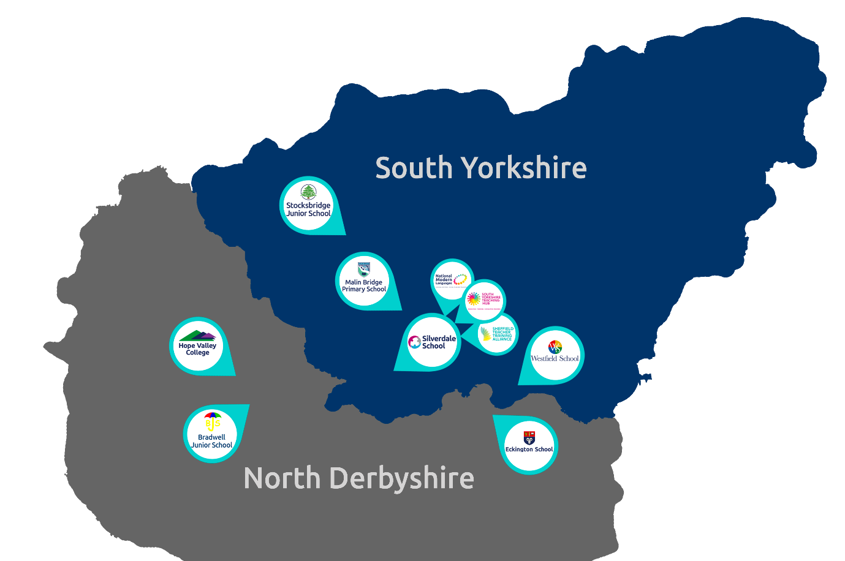
Chorus Trust is a growing trust, committed to providing every child with the best education in both primary and secondary schools across South Yorkshire and Derbyshire. We train and develop teachers, giving our children access to the very best educational thinking and practice.
Our vision is ‘Outstanding Achievement for All’. We want to create a culture of success in which our children and young people can succeed. We do this through the provision of safe and supportive schools, collaborating to ensure our children benefit from a more effective spend of public money.
As part of the Chorus Trust Team, all staff have access to:
 | An ethos of being a force for good; of being part of a team that enables ‘outstanding achievement for all’. |  | Leading edge training and development through the South Yorkshire Teaching Hub.
 | A collaborative environment encouraging knowledge sharing and support. |  | Access to discounted health schemes through Westfield Health and Westfield Rewards Schemes.
 | Competitive pension schemes: Teacher’s Pension Scheme (teaching staff) and local government pension scheme (support staff). |  | Term-time only contract postholders have the freedom of having school holidays off.
 | Career progression opportunities within a growing, local trust. |  | Support for flexible working arrangements.

You can read more about Chorus Trust at www.chorustrust.org.

To apply
- Full application pack and application forms available from: www.chorustrust.org/vacancies
- Completed application forms are to be sent to: Katie Beasley (HR Administrator)
at: recruitment@silverdale.chorustrust.org
- Please note that CVs and council application forms will not be accepted.
- Deadline for applications: 11.59pm on 30th June 2024.
- Interviews to be held: week beginning 8th July 2024.
At Chorus Trust we are committed to the safeguarding of all our pupils, please visit our website to access our safeguarding and child protection policy at www.chorustrust.org/policies.
The trust will conduct an online search of the successful candidate in line with the DfE’s keeping children safe in education advice.
The successful candidate will be required to complete a Disclosure and Barring Service (DBS) check in line with the Rehabilitation of Offenders Act (ROA) 1974 (Exceptions) Order 1975 and the Police Act Regulations.

