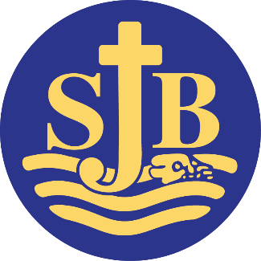
Website: www.stjohn.brighton-hove.sch.uk Headteacher: Tina Davidson MA
ST. JOHN THE BAPTIST

CATHOLIC PRIMARY SCHOOL

Diocese of Arundel & Brighton
Whitehawk Hill Road
Brighton BN2 0AH

HLTA TEACHING ASSISTANT (Level D)

St John the Baptist is a one form entry school with approximately 200 pupils on roll. We pride ourselves on our positive and inclusive, approach. We have a vacancy for permanent HLTA Teaching Assistant Level D.

Pay Scale
HLTA Scale 6 £27,852–£29,439 pro rata – 26.5 hours per week and paid for 47.15 weeks per annum

We are looking for candidates who meet Higher Level Teaching Assistant standards or equivalent qualification or experience and /or recent experience of working in a primary school or nursery school. The successful candidate will be fully committed to supporting the Catholic ethos of our school. They will also:

- Be enthusiastic and passionate about supporting children’s learning
- Have excellent numeracy and literacy skills to NVQ level 2 in English and Maths
- Have some experience of working with children with special needs
- Have excellent communication skills and a calm and positive approach to behaviour management
- Be keen to work with others as part of a team
- Have excellent time-management and organisational skills
We will offer you:
- Children who are genuinely a pleasure to teach, enjoy school and work hard.
- A happy working environment with a positive and inclusive ethos.
- A strong, committed and collaborative staff team.
- Opportunities for training and further development.
St John the Baptist Catholic Primary School is committed to safeguarding and promoting the welfare of children and young people and expects all staff and volunteers to share this commitment. This post will be subject to an enhanced criminal records bureau disclosure check.
Visits to the school are welcome, please telephone 01273 607924 or email joannelevy@stjohn.brighton-hove.sch.uk to make an appointment or to obtain an application pack.





Closing date: Midday, Monday 27th March 2023 Interview date: Thursday 30th March 2023




-----------------------------------
Telephone (01273) 607924 e-mail: admin@stjohn.brighton-hove.sch.uk

