
Teacher of History

Information for Applicants











Letter from the headteacher

May 2026

Dear applicant,

I am delighted that you are looking to apply for a job here at Birchwood Community High School. I feel very lucky to be the headteacher at this vibrant school. BCHS is an amazing place to work, with a unique sense of spirit and community – it is warm and welcoming, people-focused and totally dedicated to the community that we serve.

Our staff are passionate about education and believe that all young people should be inspired to be the very best that they can be. Our vision and values articulate the things that we put importance on and also encapsulate the school’s spirit: we are a team. The staff know this, our parents/carers know this and, most importantly, our students know this. Our vision at BCHS is to have students who understand the power of aspiration, knowledge and kindness.

We believe in the power of knowledge and the importance of a challenging, word-rich curriculum for all. That said, we are not all about the academic, we actively teach social responsibility and direct students in acts of kindness within the school setting but also in our wider community. We view it as our duty to ensure they leave us with high aspirations, secure knowledge and a kind heart.

We pride ourselves on the core ethos of our school being underpinned by the strongest foundations of discipline, respect, tolerance and compassion – we ensure our students are equipped with a strong moral compass. We offer a very strong extra-curricular programme with every member of staff offering a provision, it is an aspect of our school community that we are very proud of, and rightly so.

We know that our students are excellent people, and they thrive in a culture of achievement and success; we have high expectations, encouraging them to be aspirational in their learning and to enjoy all aspects of school life. Academic standards at BCHS are good for all students irrespective of their starting point. However, we know that we are all capable of even more. We continue to strive to improve levels of student achievement and move towards being recognised as outstanding in all areas.

Our website and this application summary can only give you a flavour of who we are, but I hope that it will inspire you to apply for the Teacher of History vacancy. If you have any questions or need any further information about this fantastic opportunity, please do not hesitate to contact the us on joinus@birchwoodhigh.org

Vacancy details:

Salary Scale
Teachers Pay Scale

Start Date:
September 2026

Contract
Permanent.

Method of Application
All applications must be made through SAM People Recruit.

Closing Date
Applications received after the closing time of 9am Monday 18th May 2026 will not be considered.

Interview Dates
Thursday 21st May 2026.

Safeguarding
All staff who teach, train or work regularly with children aged up to 18 and vulnerable adults are required to comply fully with legislation and Birchwood Community High School policies and practices to ensure learners are safeguarded and protected. The school is committed to safeguarding and promoting the welfare of children. (Rehabilitation of Offenders Act 1974).

Please feel welcome to come and have a visit before applying, but be assured that whether you visit or not, it will not affect the short-listing process. If you would like to have a look round, please email our HR Manager, Tina Wiegand (twiegand@birchwoodhigh.org) to arrange.

Thank you for considering our truly amazing school as the next chapter in your career, and hopefully I will be reading your application soon.

Yours sincerely,



Emma Mills
Headteacher



‘There is a ‘buzz’ of energy in classes, reflecting pupil’s positive attitudes to their learning.’


Our Vision

Team Birchwood believe in the power of aspiration, knowledge and kindness. We know that we achieve our best when we work together.

Our Ethos

High aspirations, high expectations and high achievement rely upon a positive working environment based upon respect. For us, respect means consistent positive regard for everyone in our learning community. A strong moral purpose enables students in our school to grow into independent, responsible young adults who can access a happy and healthy future.

At Birchwood we strive to ensure that every lesson counts, for every child, every day. We expect teachers to deliver engaging lessons that ensure students acquire powerful knowledge and develop both essential and desirable skills. For this to happen, behaviour must enable every teacher to teach and every child to learn. We expect students to come ready each day to challenge themselves to be the very best they can be. We have a wide variety of extra-curricular activities to help children develop all their skills and talents and there are many opportunities to develop their leadership skills throughout
their school life.

Our Mission

We are 100% committed to our students. We seek to sustain a community that is rooted in respect and the belief that every student can succeed. We endeavour to equip our young people with the qualities, qualifications and values that will enable them to lead fulfilling lives and become responsible citizens. We want the children in our care to leave us with high aspirations, secure knowledge and a kind heart.

We maintain high standards of ethics and behaviour; one of the ways this is by embracing the British Values: democracy; the rule of law; individual liberty and mutual respect; and tolerance of those with different faiths and beliefs.

Our Aims

We wish for our students to be:

- safe, happy and cared for in a secure and supportive environment.
- supported and challenged to do their best through excellent teaching, a broad and balanced curriculum and a wide variety of experiences.
- recognised, celebrated and rewarded for all their achievements that they develop confidence and independence.
- developed emotionally, intellectually and morally so that they are able to be successful in the rapidly changing, multicultural society in which we live.
- successful, whether through academic qualifications or a more vocational route, so they can move on to the next stage in their life.

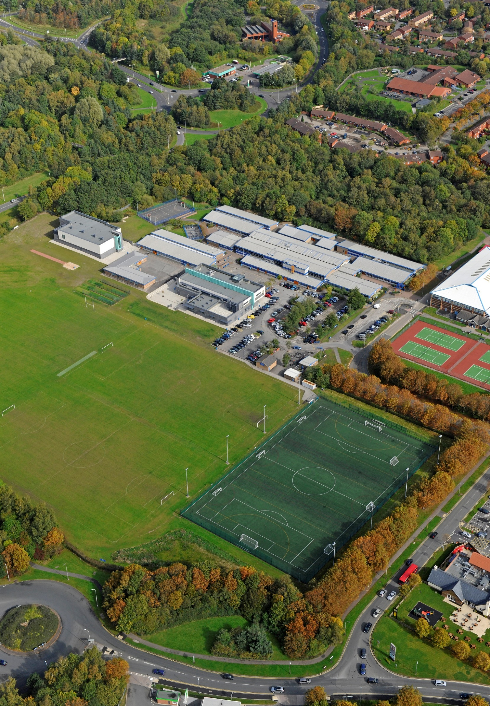

School Profile

JOB DESCRIPTION
- We joined One Community Multi Academy Trust on 1 September 2023
- The school is of an average size with 914 currently on roll.
- The most recent OFSTED inspection (December 2024) judged the school to be Good in all areas.
- The percentage of students on the Pupil Premium register is 39.1%, which is above the national average.
- The proportion of students with SEND (ECHP) is in-line with the national average.
- Most students are of white British heritage.
- Students arrive at the school with outcomes broadly in line with national averages.
Job title | Teacher of History
Reporting to | Head of Global Awareness Faculty
Job Purpose | The information contained below is to help staff understand and appreciate the nature of their post and the role they are to play in the organisation. However, it should be noted that, whilst every effort has been made to outline all the duties and responsibilities, a document such as this does not permit every item to be specified in detail. Broad headings may therefore have been used, in which case all the usual associated duties are included in this job description.  - You are required to carry out the duties of a school teacher as set out in the current School Teachers’ Pay and Conditions Document.  - You are required to carry out such particular duties which form part of the current School Teachers’ Pay and Conditions Document as the Headteacher may reasonably direct from time to time.  - In addition, you are required to undertake the following responsibilities for which you are paid your management allowance:
Key Tasks and Accountabilities | Strategic Leadership  - Identify areas for improvement within taught classes and contribute to the school self-evaluation and improvement planning.  - Use data and other information to inform strategic planning, to identify improvement targets, and to inform the school’s leadership.  - Analyse current performance of students within your groups and devise strategies for improving standards further.  - Establish, with the involvement of your line managers (head of department and head of faculty), plans for developing and resourcing the department to bring about continuous improvement in teaching and learning to promote student achievement.  - Monitor the progress being made towards targets established in subject planning.  Teaching and Managing Pupil Learning  - Manage resources efficiently so that teaching and learning is effectively supported.  - Support planning/schemes of work in the department.  - Ensure curriculum entitlement and progression is achieved.  - Ensure curriculum coverage, continuity and progression for all students through clearly written and regularly reviewed schemes of work.  - Ensure you are clear about teaching objectives and provide guidance on methodology.  - Develop and sustain students’ communication, literacy and numeracy skills through the subject.  Development  - Role model outstanding classroom practise.  - Achieve constructive working relationships with students.  - Sustain motivation; promote enthusiasm, openness to new ideas, commitment and a happy and homogenous team.  - Promote links and co-operation with other departments/faculties. Encourage department involvement in school wide initiatives and in the development of the whole school policy.  Planning and Setting Expectations/Pupil Achievement  - Ensure all ability students are catered for.  - Set expectations and targets for staff and students in relation to student achievement and monitor progress towards these targets.  Assessment and Evaluation  - Where appropriate establish and implement clear practices for assessing, recording and reporting on student achievement in line with school policy.  - Monitor pupil standards and achievement against annual targets and track progress of your classes.  - Lead the implementation of intervention strategies to ensure outstanding pupil progress for your groups.  Relationship with Parents and the Wider Community  - Establish excellent and effective communication with parents.  - Help develop links with the local community to extend and enhance the work of the department.  Manage Own Performance and Development  - Keep abreast of new curriculum thinking, teaching methods and examination syllabuses.  - Be aware of changes to the curriculum and assessment at KS3 and KS4.  - Ensure innovation takes place through the curriculum area.  - Any other tasks as required by the Headteacher.
The post holder may reasonably be expected to undertake other duties commensurate with the level of responsibility that may be allocated from time to time.

All employees have the responsibility to:
- Ensure any documentation produced is to a high standard
- Be aware and comply with policies, protocols and procedures relating to safeguarding, child protection, health, safety and security, confidentiality and data protection, reporting all concerns to the appropriate person
- Participate in training and other learning activities as required
- Provide appropriate guidance and supervision and assist in the training and development of staff as appropriate
- To promote the area of responsibility within the academy and beyond
- To represent the academy at events as appropriate
- To support and promote the academy ethos
- To undertake any other duties and responsibilities as required that are covered by the general scope of the post.

REVIEW ARRANGEMENTS
The details contained in this job description reflect the content of the job at the date it was prepared. However, it is inevitable that over time, the nature of the jobs may change. Existing duties may no longer be required and other duties may be gained without changing the general nature of the post or the level of responsibility entailed. Consequently, the Headteacher will expect to revise this job description from time to time and will consult with the post holder at the appropriate time.

Person specification

JOB TITLE | GRADE
Teacher of History | Teachers Pay Scale

NOTE TO APPLICANTS: Whilst all points on the specification are important, those marked ‘E’ are the key requirements. You should pay particular attention to these points and provide evidence of meeting them. Failure to do so may mean that you will not be invited to interview.

 | Necessary requirements
Qualifications and experience | A degree in a History | E
Qualifications and experience | PGCE/QTS or equivalent | E
 | Ability to teach across Key stage 3 and 4. | E
Skills and Abilities | Ability to use own initiative, make decisions and respond to problems | E
Skills and Abilities | Teach and plan lessons which are consistently good or outstanding | E
Skills and Abilities | Use a variety of techniques to engage pupils and ensure good standards of behaviour | E
Skills and Abilities | To be totally committed to continually improving the education of our pupils | E
Skills and Abilities | Contribute to the wider life Faculty, supporting extra-curricular activities | E
Skills and Abilities | Able to monitor progress and attainment of all taught classes | E
Skills and Abilities | Work well in a team, contributing ideas and assisting with faculty procedures | E
Skills and Abilities | Professional manner and good sense of humour | E
Skills and Abilities | A commitment to continuing professional; development to develop subject knowledge and pedagogy | E
Personal qualities | A genuine respect for, and motivation for working with, young people, a commitment to inclusive education and a willingness to respond to the needs of all | E
Personal qualities | To be totally committed to continually improving the education of our students | E
Personal qualities | The capacity for sustained hard work and resilience | E
Personal qualities | A strong commitment to improving outcomes for all students and the drive and determination to make this happen | E
Personal qualities | The ability to lead, motivate and inspire and to build warm and effective professional relationships with staff, students and parents | E
Personal qualities | Commitment to extra-curricular activities within the school | E
Personal qualities | Excellent organisational skills | E
Personal qualities | Reliability, professionalism and integrity | E
Other requirements | Enhanced DBS Disclosure | E







