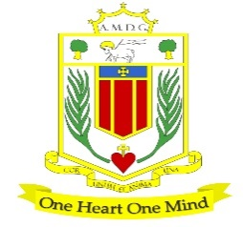
Broughton Hall Catholic High School
HISTORY Department
Overview
The History Department at Broughton Hall Catholic High School consists of committed, determined, passionate and enthusiastic teachers who strive to ensure there are no barriers to learning in order for our students to achieve above and beyond their potential regardless of ability. We aim to stimulate creativity, confidence and independence through a range of innovative teaching strategies so that we develop the ‘whole’ student and inspire a life-long love of learning. The History team consists of six teachers, including a member of the Senior Leadership Team.
Curriculum
Programmes of study are divided into a three-year KS3 and two-year KS4.
KS3
- In KS3, pupils are taught in mixed ability groups across half year bands and have two one-hour lessons each week.
- We have an ambitious, academic and knowledge-rich KS3 study of programme, where key concepts and substantive knowledge are embedded throughout
- Formative written assessments for KS3 are half termly followed by robust moderation in departmental meetings and the students will complete two summative assessments per year

KS4

- All classes are taught in mixed ability groups and receive 3 one-hour lessons per week
- We follow the AQA GCSE specification:
Paper 1: Germany 1890-1945 and the Interwar years 1919-1939
Paper 2: Elizabethan England 1568-1603 and Health and the people c.1000-present day

KS5

We currently follow the Edexcel specification for A level:

Paper 1: Britain transformed 1918-1997
Paper 2: The USA 1955-1992, Conformity and challenge
Paper 3: The Witch Craze in Britain, Europe and North America, 1580-1750
Coursework: The Holocaust

Our fundamental aim is to inspire pupils to succeed across a broad and varied curriculum and where pupils are essentially prepared for the wider world. Through a carefully planned curriculum and with our support, encouragement and guidance, we want every pupil to find enjoyment and success as they make their way to the next stage of their lives, using the knowledge they develop and embed in their time at Broughton Hall Catholic High School.

