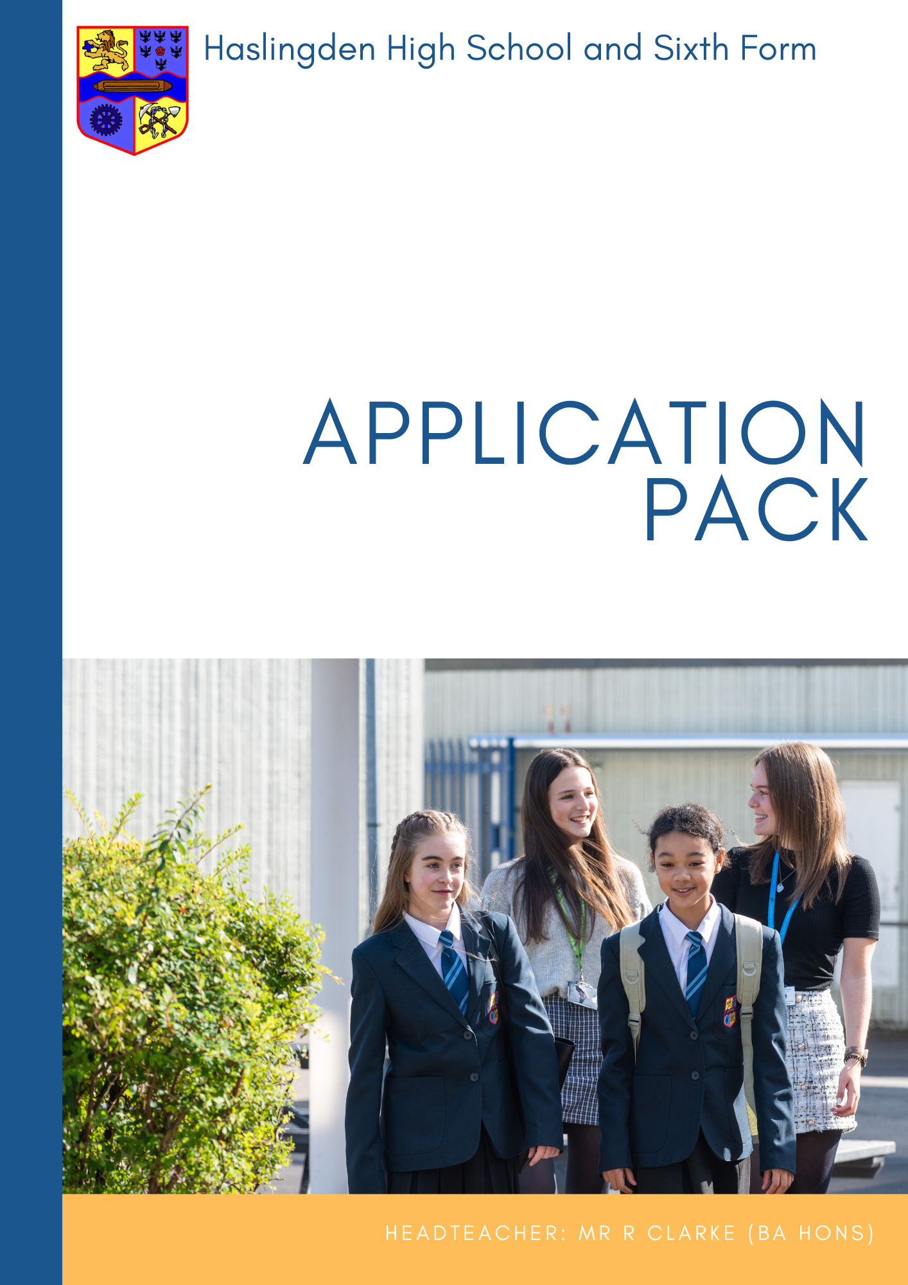
Teacher of History
Required from September 2024

Closing date for applications: Tuesday 7 May 2024 9am
Interview date: Friday 10 May 2024
Teacher of History
MPS
The governors of this high achieving 11-18 school are seeking to appoint a talented, highly motivated and dedicated teacher. We are looking for someone who would describe themselves as a team player, as possessing a positive mindset and someone who will maintain a solution focussed approach to their work. A sense of humour, a smile and empathy for young people and colleagues are all essential characteristics needed to be successful in this post. If this sounds like you, we look forward to reading your application.
Further details and an application form are available on our website: www.haslingdenhigh.com/vacancies

Haslingden High School and Sixth Form is committed to safeguarding and promoting the welfare of children and young people and takes its statutory duties and responsibilities in this context very seriously. We fully expect everyone working in or behalf of the school to share our commitment. As such, this post is subject to satisfactory DBS clearance and references.

Haslingden High School and Sixth Form
Headteacher: Russell Clarke (BA Hons)

Dear Applicant,

Thank you for your interest in this post. This is an excellent opportunity to join a highly successful department that has ambitious plans for the future and has a record of achieving strong academic results. The successful candidate should share our passion for creating and maintaining the best possible learning environment for our students, securing positive outcomes and have a willingness to contribute to the rich extra-curricular provision

I am extremely proud to be the headteacher at Haslingden High School and Sixth Form, a successful, caring and high performing 11-18 school in the beautiful Rossendale Valley. The school is regularly, heavily oversubscribed for the 270 places available in year 7 each year. We have a thriving sixth form with over 200 students studying mainly a range of Level 3 courses. We are a truly comprehensive school welcoming students of all backgrounds and abilities and are one of the largest maintained school in Lancashire, with over 1550 students on roll. There are just under 100 members of the teaching staff and approximately 80 support staff. Our supportive, experienced governing body play a crucial role in our success and provide clear direction, remaining heavily involved in the life of the school.

Our overarching aim is Achievement for All: for all our students to be safe, happy and successful, developing as individuals into caring, responsible citizens equipped for life in the 21st century. This is underpinned by the five school aims and we invite you to look at these closely when considering your application.

We strive to create successful learners and we believe that we achieve this by offering an exciting, ambitious and inclusive curriculum. The consistently high quality teaching and learning, taking place in a safe, supportive environment provides the basis upon which our students grow. We are passionate about providing access to a wide range of opportunities and experiences beyond the taught curriculum, guiding and helping students to become kind, resilient and ethical individuals who will make a positive contribution to their local community and beyond. We hope that you will also share this passion and on reading the whole school curriculum rationale, you feel it closely aligns to your own vision for education.

Students’ physical, mental and emotional wellbeing is at the forefront of everything we do. We recognise the importance of working in partnership with parents and external agencies to deliver a personalised approach to care, guidance and support that will ensure students feel safe and happy and that they are empowered to make informed choices, both now and in the future.

We are proud of our collective achievements – our examination success, our well designed and expertly delivered curriculum, the depth and diversity of our extra-curricular programme and our desire to contribute to our community. We are committed to the pursuit of the highest possible academic, personal and moral standards and to the development of informed citizens with lively, enquiring minds.
This commitment is underpinned by a belief in hard work and a culture of care, respect and support for others. If you share our ethos and feel that you want to join our dedicated staff to help us achieve our aims together, then we believe that Haslingden High School and Sixth Form is the place for you.

The successful applicant will find caring, friendly and supportive colleagues, committed to providing the very best life chances for all our students. We look forward to receiving your completed application form, together with a letter of application which should be no more than 2 sides. This should demonstrate how your skills, experience and vision make you a strong candidate for this position and clearly outline your track record of success. The closing date for applications is Tues 7 May 2024 at 9.00 am with interviews scheduled for Friday 10 May 2024.

Haslingden High School and Sixth Form is committed to safeguarding and promoting the welfare of children and young people and takes its statutory duties and responsibilities in this context very seriously. We fully expect everyone working in or on behalf of the school to share our commitment. As such, this post is subject to satisfactory enhanced DBS clearance and references.

Yours sincerely

Mr R Clarke
Headteacher

- Create successful learners, who achieve the best possible qualifications, alongside equipping them with the skills and motivation to overcome future challenges

- Ensure all students experience an exciting, ambitious and inclusive curriculum that is well-planned, broad, diverse and expertly delivered. Our curriculum will inspire and motivate all students to want to know and remember more, allowing them to become lifelong learners

- Provide access to a wide range of opportunities and experiences beyond the taught curriculum, enabling all our students to leave our school with high aspirations

- Work in partnership to offer a personalised approach to care, guidance and support that will ensure all students feel and know how to keep themselves safe and happy. Students’ physical, mental and emotional wellbeing is at the forefront of everything we do, empowering them to make informed choices

- Guide students, helping them to become kind, resilient and ethical individuals who will make a positive contribution to their local community and beyond. They will embrace change and leave as well-rounded individuals with a strong set of values and beliefs

Our curriculum is coherently planned and sequenced to ensure we deliver our overarching aim of ‘Achievement for All’: ‘for all our students to be safe, happy and successful, developing as individuals into caring, responsible citizens equipped for life in the 21st century’.
Achievement for All is underpinned by our school aims and it is as a result of our rich and challenging curriculum that we are able to meet the needs of our entire school community. We wholeheartedly believe that our curriculum is much broader than just our taught lessons and is present in every exciting opportunity and experience that we are so passionate about providing for the students within our school community.
“Learning is a constant process of discovery – a process without end”
Accepting that this statement is true, we firmly believe that our curriculum must look well beyond what is examinable and strive to develop well rounded, resilient individuals who are equipped with the necessary knowledge, skills and attitude to overcome future challenges. The curriculum at Haslingden High School and Sixth Form ensures students acquire a strong set of values and beliefs, leaving with the cultural capital to be successful learners in the future, who can confidently overcome new and more complex problems and are well equipped to navigate change.
The individual subjects combine to make up our curriculum and all recognise the unique contributions they can provide to a child’s development as they make their way through school. Our curriculum is broad, balanced and ambitious, with the national curriculum offering a foundation on which to build. The three year Key Stage 3 allows for students to develop the building blocks of what they need to know and do in preparation for future success.
Each year has its own place in our curriculum and builds sequentially on prior learning whilst also preparing students for the next stages of their education, employment or training. We prioritise opportunities to facilitate knowledge retrieval, assisting students to commit knowledge to long term memory and therefore reducing cognitive load when meeting new learning. This, in conjunction with our belief in the importance and value of metacognition and high-quality vocabulary, supports students in forming connections to other things they know, believe or have experienced, which in turn unlocks students’ potential to access further learning and understanding.
Our curriculum is designed to be inclusive for all learners. We recognise the challenges faced by our most vulnerable and disadvantaged learners and as such, our curriculum is adapted, designed and developed to overcome these barriers to success. We have placed greater emphasis on oracy, reading and vocabulary and seize opportunities within our curriculum to explicitly address these factors that limit performance.
With curriculum development being part of our daily practice, we believe that it is our coherent approach to planning and design, aided by expert delivery, that creates the perfect platform upon which to secure deep learning in the classroom and beyond. We believe we create the opportunities and experiences to motivate and inspire Haslingden High School and Sixth Form students to develop a passion for learning that will go with them into the world and ensure that they are both proud of their time at our school and that they are well prepared for their future.

HUMANITIES FACULTY

The Humanities Faculty at Haslingden High School and Sixth Form is a large, vibrant and successful team of 18 full and part time teaching staff. Each subject is led by an experienced Subject Leader and the faculty is led by a Curriculum Leader. There is a very strong team ethos. Highly dedicated and committed staff offer our students the opportunity to study a range of academic subjects at Key Stages 3, 4 and 5, in addition to extra opportunities within and outside of the school day. At KS3 the faculty consists of the Geography, History and Religious Studies departments, with GCSEs in each of these subjects offered at KS4. Whilst Religious Studies is compulsory for all students, all other Humanities subjects are optional; History and Geography being consistently popular choices with our students.

Post-16 optional subjects within the Faculty include History, Geography, Religious Studies, Psychology, Sociology, Criminology, Law and Economics. All Humanities subjects are taught by subject specialists and several faculty colleagues are involved in mentoring students who choose to complete the Extended Project Qualification in a field of study linked to their specialism.

The faculty is mainly located in the Broadway building, whilst the Social Sciences have teaching rooms in the Sixth Form building. There is a large faculty office closely situated to the faculty suite of rooms containing work areas and ICT provision. All departments are well resourced, staff are provided with iPads and the faculty have invested in a number of ICT packages to support learning and teaching including Kerboodle and Educake. Annual capitation allows for both short and long term development and expansion.

At Key Stage 3 students are placed in common Humanities sets for KS3 RS (year 7 to 9) and year 7 and 8 Geography and History with mixed ability classes in year 9. Students are assessed regularly, both formally and informally, culminating in formal block assessments, which inform student tracking and monitoring systems as well as target setting procedures.

All subject areas within the faculty make a significant contribution to the school’s strong PSHEE & Citizenship programme and to a number of extra-curricular activities. The Humanities Faculty has a very successful record of providing students with enhancement opportunities and in the last five years, faculty staff have arranged trips to destinations including France, Belgium and Iceland.

Teacher of History

ATTRIBUTES | DESCRIPTION | ESSENTIAL | DESIRABLE
QUALIFICATIONS, EXPERIENCE AND PROFESSIONAL DEVELOPMENT | - Teaching Qualification
 | - Good Honours degree or equivalent
 | - A commitment to CPD
KNOWLEDGE, SKILLS AND PERSONAL QUALITIES  KNOWLEDGE, SKILLS AND PERSONAL QUALITIES | - An ability and willingness to contribute to A Level History
 | - Experience of teaching A Level History
 | - A genuine belief in the value of each child
 | - A knowledge of the GCSE and NC requirements of the subject
 | - A good knowledge and understanding of current curricular developments in History
 | - The ability to maintain a high standard of teaching which ensures all students are actively engaged in their learning and make excellent progress
 | - The ability to establish an excellent climate for learning
 | - The ability to work well in a team
 | - High levels of commitment, motivation and initiative
 | - Ability to use ICT to enhance the quality of learning within the classroom
 | - The ability to relate well to all members of the school
 | - Excellent communication skills
 | - High personal standards and high expectations of themselves and others
 | - A flexible approach to school life
 | - Experience of teaching at KS3 and KS4
 | - An excellent health and attendance record
APPLICATION AND LETTER | - The letter should be clear and concise (no more than two sides) with organised views
 | - The letter should address how your skills, experience and vision make you a strong candidate for this position and clearly outline your track record of success
 | - Application form should be fully completed and clearly legible

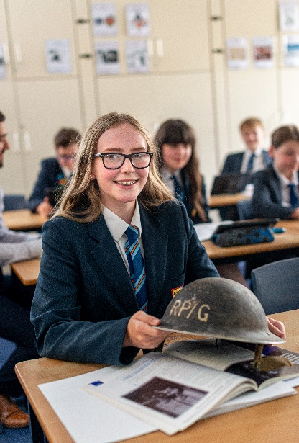

Responsible to Lead Teacher for History

Purpose

- Contribute to “achievement for all” by being a champion for the 5 school aims
- To raise standards of student attainment and achievement within your teaching groups and to monitor and support student progress
- To plan and deliver high quality lessons
- To assess and report on the achievement of students
- To act as a form tutor as required

Key Knowledge & Understanding:
- all teaching staff must understand and uphold the professional code of the General Teaching Council for England by demonstration of all the professional standards for QTS;
- a detailed knowledge of the relevant aspects of the National Curriculum and other statutory requirements and the demands expected of students in relation to KS3 & KS4.
- where appropriate, a knowledge of relevant post-16 courses;
- an understanding of subject progression from KS2 to KS5.

Key functions

Planning

- identify clear learning outcomes, content, lesson structures and sequences appropriate to the subject matter and the students being taught;
- select and make good use of textbooks, ICT and other learning resources to enable learning outcomes to be met;
- set appropriate and demanding expectations for students’ learning and motivation. Set clear targets for students’ learning, building on prior attainment;
- familiarise yourself with students who have special educational needs, and know where to get help in order to give positive and targeted support. Implement strategies from pupil passports and keep records on Support Plans;
- take account of the needs of all students in each class, including the most and least able;
- provide opportunities to develop students’ understanding by relating their learning to real and work-related examples;
- maintain records of the delivery of the curriculum and on student progress in line with school and Faculty policy.

2 Teaching & Managing Student Learning
- use teaching methods with whole classes, groups and individuals, adapting these where appropriate to ensure that students are engaged and stimulated, teaching outcomes are met, that momentum and challenge are maintained and best use is made of teaching time;
- set high expectations for students’ behaviour, establishing and maintaining a good standard of discipline through well-focused teaching and through positive and productive relationships.

- Assessment & Reporting

- assess how well learning outcomes have been achieved and use this assessment to inform future teaching;
- mark and monitor students’ classwork and homework, providing constructive feedback and setting targets for students’ progress.
- Work to secure progress towards targets;
- prepare and present informative reports to parents;
- provide accurate data for the school’s monitoring / ARR system as required.

4 Guidance & Welfare

Where appropriate, act as a form tutor, fulfilling the following functions:
- take overall responsibility for monitoring students’ academic and wider progress and development, acting in line with school policies in this area;
- carry out the tutor group registration, following up any absences as directed by school policy;
- implement whole school form time strategies as appropriate;
- review progress and support students in target setting and action planning;
- ensure that all students are valued and treated according to the aims of the school.

Wider Professional Effectiveness

- take responsibility for own professional development, keeping up to date with research and developments in pedagogy and in subject areas;
- understand professional responsibilities in relation to school policies and practices;
- set a good example to students in personal presentation and conduct;
- evaluate own teaching critically, using this to improve effectiveness;
- work effectively with other school colleagues, attending meetings and liaising with representatives of other agencies as necessary;
- contribute to, and through Faculty Assistants organise, displays of work in classroom and Faculty areas;
- contribute positively to the ethos of the school.

For the full Conditions of Employment please refer to the relevant pages of the School Teachers’ Pay and Conditions Document.

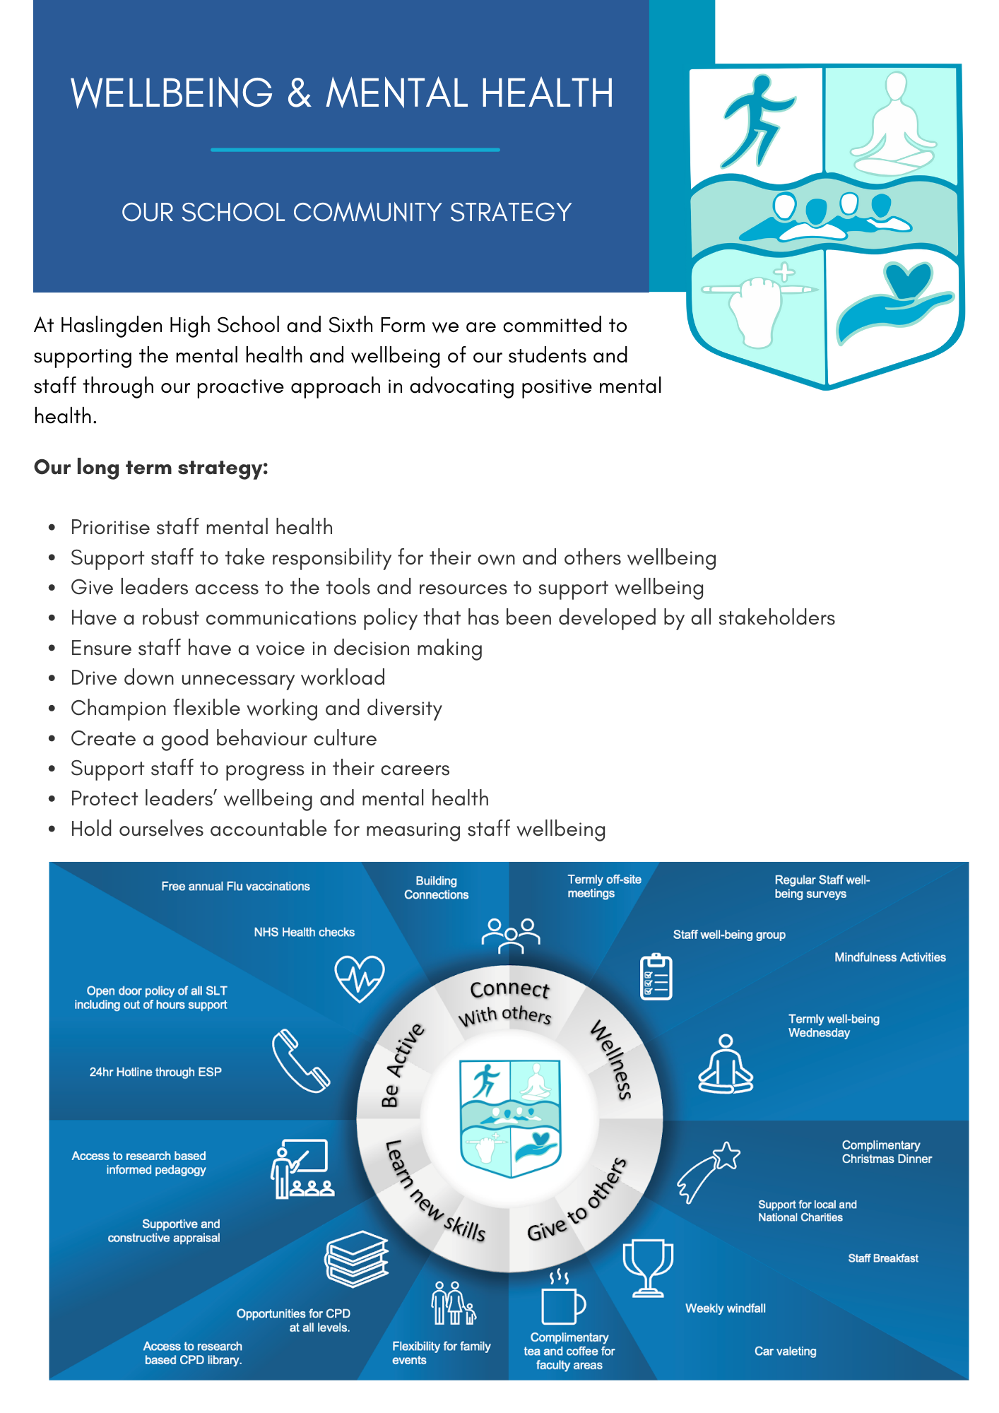

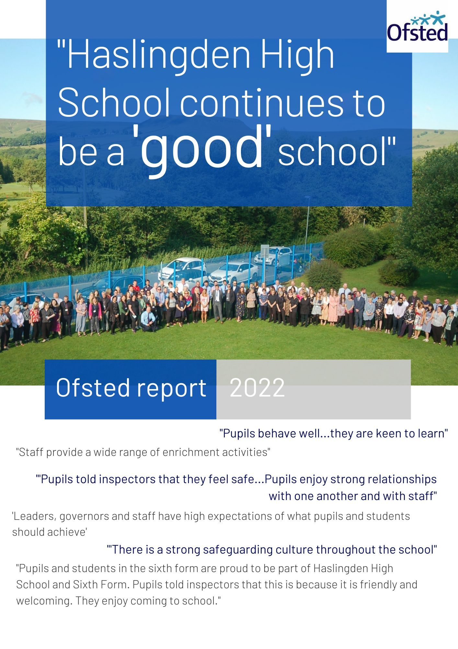
The full inspection report can be viewed here

Thank you for your interest in joining our incredible team of staff here at Haslingden High School and Sixth Form.
Application forms can be found at the bottom of the vacancies section of our website.
Please email your application to applications@haslingdenhigh.com
If you have any questions, please do not hesitate to get in touch.

Haslingden High School and Sixth Form
Broadway, Haslingden, Rossendale, Lancashire, BB4 4EY
01706 215726
www.haslingdenhigh.com
@HaslingdenHigh HaslingdenHigh

