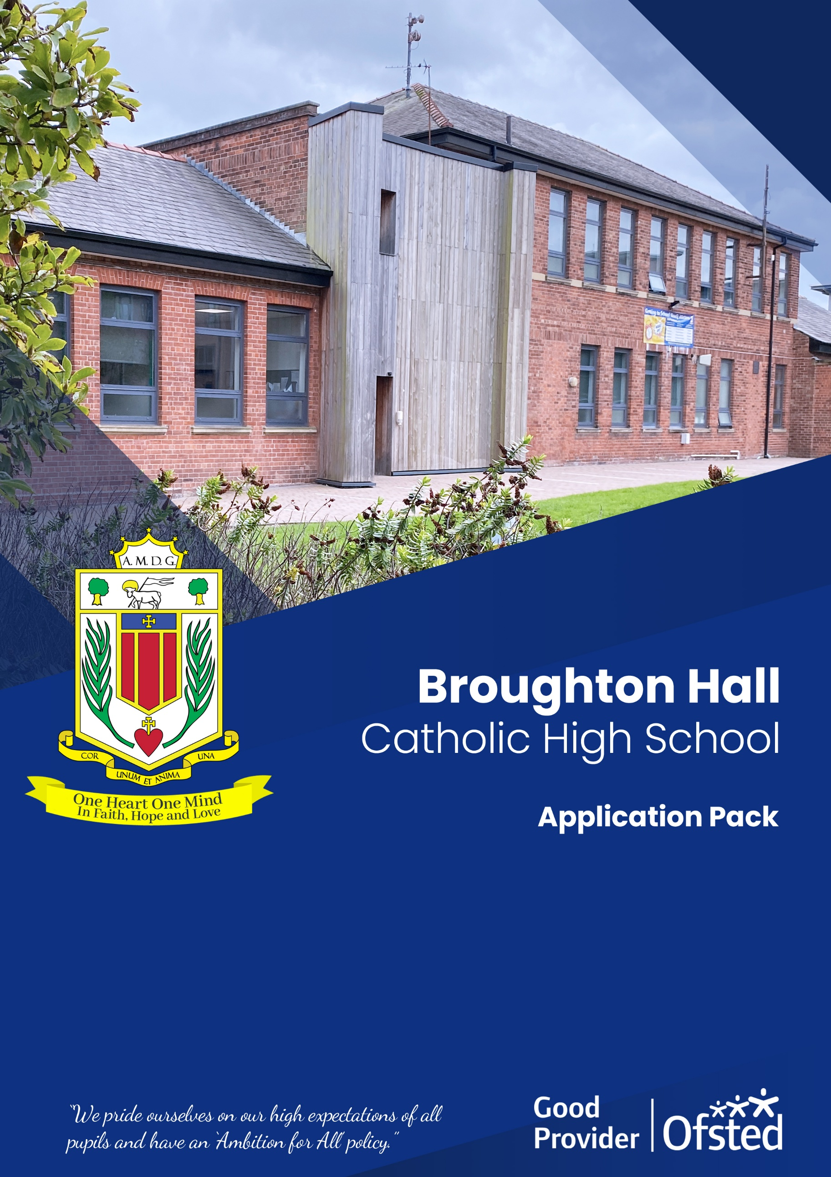

Role: HLTA – Cover and Intervention
Contract Term: Full-Time/Fixed Term 12 months (In the first instance)

Headteacher
Salary Scale: HLTA (Scale To Be Determined)

Headteacher
Interview Date: To be confirmed after closing date

Headteacher
Shortlisting Date: To be confirmed after closing date

Headteacher
Closing Date: Wednesday 12th August 2026 – 10:00am

Headteacher
Start Date: As soon as possible
Headteacher111

Broughton Hall Catholic High School
Founded in 1928 under the trusteeship of the Sisters of Mercy, Broughton Hall Catholic High School, an all-girls Catholic secondary school in Liverpool, provides the very best in modern education based on the Gospel values of mutual respect and care.
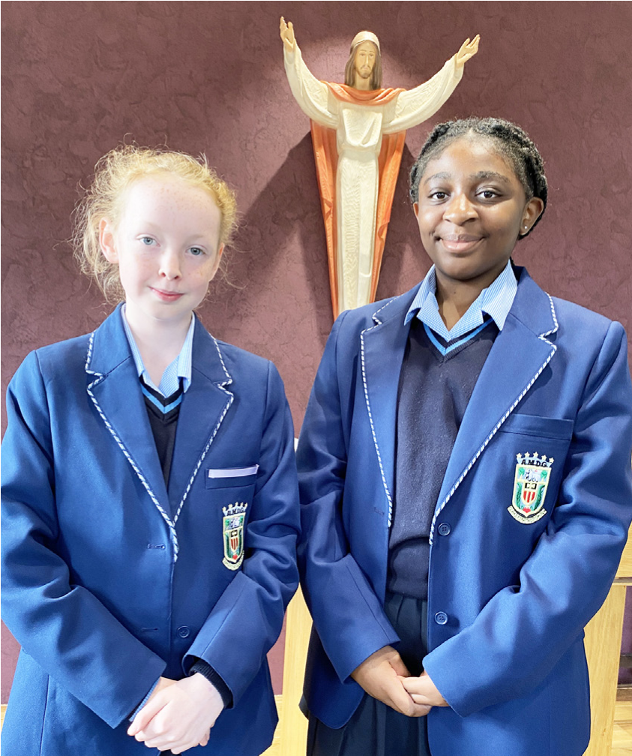
The central aim of our school is to provide excellent educational opportunities enabling each pupil to develop their God given talents, to grow in confidence and self-esteem and to fulfil their potential.

As a Catholic school Broughton Hall centres its mission on the person of Jesus Christ, and promotes the Gospel values throughout the school community and in all aspects of school life: spiritual, academic, pastoral, and personal. By proclaiming and living out the faith of the Catholic Church, we support each other in shared experiences of teaching and learning, prayer, worship and charity. Our mercy values permeate throughout our community.

Broughton Hall is Ofsted rated as a “Good” provider (November 2022).

Our facilities are bright, spacious, high tech and designed to meet the needs of all our pupils. We have a separate 6th Form facility, which is shared with our neighbouring boys school Cardinal Heenan Catholic High School. A full range of extra-curricular activities are provided to further the creative, sporting and academic talents of each pupil and offer Outward Bound and Duke of Edinburgh Award schemes as well as the opportunity to attend educational visits and residential trips.

We pride ourselves on our high expectations of all pupils and have an ‘Ambition for All’ policy. Whatever your role within the school, you will share these values and be able to encourage and motivate pupils with your passion, presence and personality.

Our school motto ‘Cor Unum et Anima Una’ - One Heart and One Mind, reflects the strong sense of community amongst pupils, staff, parents and Governors.

School has a weekly Newsletter – please click here to view our latest edition. https://www.broughtonhall.com/newsletter/

Welcome

Thank you for your interest in the position of HLTA.

This pack has been designed to help you should you choose to submit an application form, which we sincerely hope you do. We hope it answers your initial questions, but if not, please do not hesitate to contact us and we will endeavour to help you through your application process.

Broughton Hall Catholic High School is the largest all-girls school in Liverpool and serves many different areas making us a vibrant a diverse school. Our aim is to be a good school in all areas and we are seeking staff to apply to work with to be of that journey.

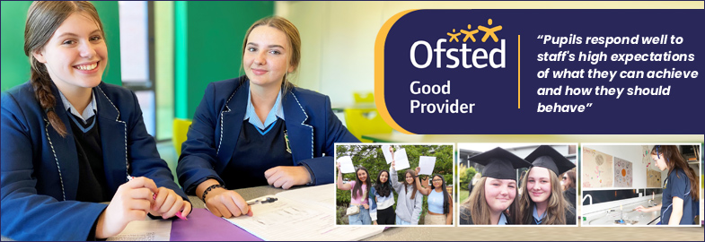

We work hard to ensure Broughton Hall Catholic High School remains a friendly and welcoming environment for all those who work, study or visit here and hope that you are the person we are looking for to bring creativity and innovation to the role.

The school actively supports the training of middle leaders through well-respected Teaching Leaders’ programme. Opportunities for promotion exist for suitable candidates. Our staff are passionate about teaching and are committed to develop exciting and stimulating lessons that not only engage students.

We look forward to hearing from you.
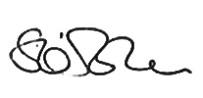
Sarah O’Rourke
Head Teacher

We Offer

- Pensions Scheme – Teacher Pension Scheme for teaching staff or Merseyside Pension Fund for support staff
- Regular training and development programme
- Access to occupational health
- An enhanced Occupational Health & Well-Being App (Smart Clinic) with access to a wide variety of services e.g.
- Virtual GP
- 24 hour employee assistance line
- Physiotherapy
- Mental Health Services
- Self-support and guidance tools
- Cycle2Work Scheme
- Tax Free Childcare Vouchers
- Supportive work environment where all staff are valued
- Continuous professional development for all staff and follow a whole school approach to staff performance and development

And that’s not all, we place the outcomes of the children in our school at the heart of everything we do, so you’ll wake every day in the knowledge that your role will have a significant positive impact on the lives of others.

Equal Opportunities

Broughton Hall Catholic High school is an equal opportunities employer.

We welcome applicants from all backgrounds and value everyone as an individual. We are committed to organisational practices, which promote diversity and inclusion for all employees and volunteers regardless of age, gender reassignment, marriage or civil partnership status, pregnancy and maternity status, disability, race (including colour, nationality, ethnic or national origin), religion or belief, sex, or sexual orientation. Connecting these differences creates a productive environment in which everyone feels valued.

Monitoring information in relation to job applicants will be to assist us in equality monitoring. The recruitment panel will not have access to job applicant’s monitoring information.

To assist us in monitoring the operation of equal opportunities policy, and for no other reason, please ensure you complete and submit the Equal Opportunities Monitoring Form with your application form.

Safeguarding & Enhanced DBS Checks

Broughton Hall Catholic High School is committed to safeguarding and promoting the welfare of young people and expect all pupils, staff, volunteers and visitors to share this commitment

All posts are subject to an enhanced DBS check and full pre-employment checks to comply with the current Keeping Children Safe in Education statutory guidance for schools.

All staff will be expected to follow Broughton Hall Catholic High School’s child protection policies, code of conducts and managing allegations against staff procedures.

All roles in school, including this post, are exempt from the Rehabilitation of Offenders Act (ROA) 1974. The Ministry of Justice’s guidance on Rehabilitation of Offenders Act 1974 and the Exceptions Order 1975 provides information about which convictions must be declared during job applications and can be accessed here.

All applicants must therefore declare all previous convictions and cautions, including those which would normally be considered ‘spent’ except those received for an offence committed in the United Kingdom if it has been filtered in accordance with the DBS filtering rules. Information about filtering offences can be found in the DBC Filtering Guide, which can be accessed here.

By engaging in this recruitment process, shortlisted candidates consent to an online search in line with the Keeping Children Safe in Education Statutory Guidance 2022.

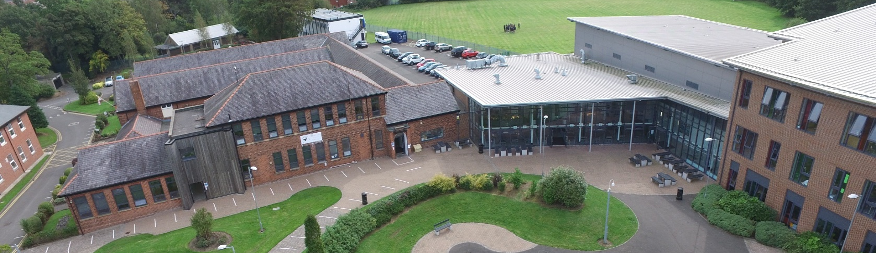

Advert

HLTA – Cover and Intervention

SALARY: HLTA (Scale to be determined)
CONTRACT: Fixed Term/12 months (in the first instance)
HOURS: 1.00 FTE
CLOSING DATE: Wednesday 12th August at 10.00 am
INTERVIEWS TO BE HELD: To be confirmed after closing date
START DATE: 1st September 2026

The Governors wish to appoint a first rate, enthusiastic higher level teaching assistant with the skill to cover lessons and facilitate interventions across the full age and ability range. If you are highly motivated, have a passion for teaching and have the ability to inspire our pupils then we would love to hear from you.
The successful candidate will be:
- · Excellent communication and interpersonal skills.
- · Ability to engage and motivate young people.
- · Strong organisational skills.
- · Ability to work independently and as part of a team.
- · Ability to prioritise workload and respond flexibly to changing demands.
- · Good ICT skill

About Broughton Hall Catholic High School
Broughton Hall is a Catholic High School, proud of its strong Catholic ethos and values. The school has an excellent reputation and promotes an inclusive education which develops creativity, confidence and independence. The school is committed to the continuous professional development of all staff including our Aspiring Leaders, NPQML and NPQSL programmes.
Applications to: recruitment@broughtonhall.com
For further information about the school please visit the school’s website www.broughtonhall.com

Broughton Hall Catholic High School is committed to safeguarding and promoting the welfare of children and we expect all staff and volunteers to share this commitment to keeping children safe. Any offer of employment will be subject to statutory pre-employment checks including satisfactory references and Enhanced DBS and Barred List checks. This post is exempt from the provisions of the Rehabilitation of Offenders Act - accessed here - and shortlisted candidates will be required to disclose any relevant criminal history prior to interview.

Job Description
Higher Level Teaching Assistant – Cover and Intervention

JOB DESCRIPTION

JOB PURPOSE
To support high-quality teaching and learning across the school by providing planned classroom cover for absent teachers and delivering targeted intervention programmes to support pupils' academic progress and personal development when cover is not required.
The post holder will be a key member of the school's Cover Team, ensuring continuity of learning during teacher absence while maintaining high expectations of behaviour, engagement and achievement.
Key Responsibilities
Classroom Cover
· Supervise whole classes during the short-term absence of teachers.
· Deliver pre-prepared lessons across a range of curriculum subjects.
· Ensure pupils remain engaged in learning and complete the work set.
· Manage classroom behaviour in line with the school's Behaviour Policy.
· Establish a positive learning environment that promotes high expectations.
· Provide feedback to teaching staff regarding lesson outcomes, pupil engagement and any concerns arising.
· Support pupils with varying learning needs during cover lessons.
· Ensure safeguarding procedures are followed at all times.
Intervention and Pupil Support
When classroom cover is not required, the HLTA will:
· Plan and deliver high-quality intervention programmes for individuals and small groups.
· Deliver literacy, numeracy and subject-specific interventions to improve pupil progress.
· Support pupils identified through assessment data as requiring additional support.
· Deliver catch-up programmes following periods of absence.
· Work with teachers and SEND staff to implement targeted intervention strategies.
· Monitor pupil progress and maintain accurate records of intervention outcomes.
· Adapt intervention approaches to meet individual learning needs.
· Contribute to raising attainment across the school.
Teaching and Learning Support
· Support teachers in improving pupil outcomes.
· Promote independent learning and resilience.
· Assist with assessment activities where appropriate.
· Help prepare learning resources and teaching materials.
· Support the Reflection and Inclusion room.
· Support pupils with SEND, EAL or additional learning needs as required.
· Encourage positive attitudes towards learning.

Behaviour and Safeguarding
· Promote excellent standards of behaviour.
· Apply the school's Behaviour Policy consistently.
· Build positive professional relationships with pupils.
· Report safeguarding concerns immediately in accordance with school procedures.
· Promote equality, inclusion and respect for all members of the school community.

Communication
· Liaise effectively with teachers, pastoral staff, SEND staff and senior leaders.
· Provide clear written and verbal feedback following cover lessons and interventions.
· Maintain accurate intervention records and pupil progress information.
· Attend relevant meetings, training and professional development.
General Responsibilities
· Support whole-school events where appropriate.
· Participate in CPD and training relevant to the role.
· Maintain confidentiality at all times.
· Promote the ethos and values of the school.
· Undertake any other duties appropriate to the grade of the post as directed by the Head teacher.

REPORTING
The post holder will report to the assistant head teacher (teaching and learning) Cover Manager (as appropriate)

CONDUCT

- Employees are expected to be courteous to colleagues, to be professional and punctual in the execution of their duties and responsibilities, model Gospel values and provide a welcoming, professional environment to visitors and external colleagues.
- Whilst every effort has been made to explain the main duties and responsibilities of the post, each individual task may not have been identified; therefore employees will be expected to comply with any reasonable request from a manager, including ad hoc projects, to undertake work of a similar level that is not specified in the job description.

Whilst every effort has been made to explain the main duties and responsibilities of the post, each individual task may not have been identified; therefore employees will be expected to comply with any reasonable request from a manager, including ad hoc projects, to undertake work of a similar level that is not specified in the job description.

The job description is current at the date shown, but, in consultation with you, may be changed by the Head Teacher to reflect or anticipate changes in the job commensurate with the grade and job title.

Person Specification
Post HLTA – COVER & INTERVENTION
Pay Spine HLTA SCALE (as applicable)
Responsible to ASSISTANT HEAD OF TEACHING AND LEARNING

1. QUALIFICATIONS AND TRAINING
- HLTA Status or willingness to achieve HLTA status.
- GCSE Grade C/4 or above (or equivalent) in English and Mathematics.
- Relevant Level 3 qualification in Supporting Teaching and Learning (or equivalent experience).

2. EXPEREINCE

- Experience working with secondary-aged pupils.
- Experience covering lessons or leading whole classes.
- Experience delivering targeted interventions.
- Experience supporting pupils with a range of learning needs.
- Experience managing behaviour positively.
DESIRABLE
- · Experience working in a secondary school.
- · Experience supporting examination classes.
- · Knowledge of restorative behaviour approaches.
- · First Aid qualification.
- · Experience using school MIS systems such as SIMS or Arbor.

4. PERSONAL QUALITIES
- Excellent communication and interpersonal skills.
- Ability to engage and motivate young people.
- Strong organisational skills.
- Ability to work independently and as part of a team.
- Ability to prioritise workload and respond flexibly to changing demands.
- Good ICT skills.

5. EQUAL OPPORTUNITIES AND EDUCATIONAL COMMITMENT
- A proven commitment to inclusion
- A proven commitment to curriculum access and opportunity
- A proven commitment to comprehensive education
- A proven commitment to professional development
- Support the school unreservedly in its commitment to safeguarding and promoting the welfare of children,
young people and vulnerable adults.


