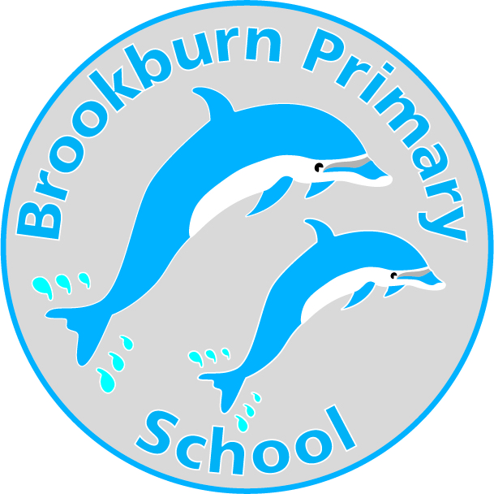

Person Specification

Teaching Assistant – Level 4 - EYFS

For this job we are looking for:

Experience of working with or caring for children of a relevant age

Numeracy/literacy skills (at a level equivalent to NQF Level 2)

NVQ level 3 for Teaching Assistants or equivalent qualification or experience, High Level Teaching certificate desirable.

Willingness and ability to undertake HLTA Level responsibilities (refer to HLTA standards)

Willingness to participate in training, performance management and self evaluate learning needs and actively seek learning opportunities

Training in the relevant learning strategies and /or in a particular curriculum or learning area, eg supporting positive interaction in early years

Ability to relate well to children and adults

Ability to work as part of a team

An understanding of the role of the Teaching Assistant and other professionals working in the classroom

Ability to use relevant technology eg photocopier

Effective use of ICT to support learning

Full working knowledge and understanding of national/foundation stage curriculum and other relevant learning programmes/strategic processes and barriers to learning

Ability to organise, motivate and lead a team

Understanding of statutory frameworks relating to teaching

Full working knowledge of relevant policies/codes of practice/legislation

Understanding of the principles of child development and learning processes

Ability to self-evaluate learning needs and actively seek opportunities

Willingness to undertake first aid training as appropriate

Personal Style and Behaviour

Tact and diplomacy in all interpersonal relationships with the public, pupils and colleagues at work.

Self motivation and personal drive to complete tasks to the required timescales and quality standards.

The flexibility to adapt to changing workload demands and new school challenges.

Personal commitment to ensure that the provision is equally accessible and appropriate to meet the diverse needs of pupils.

Personal commitment to continuous self-development.

A commitment to school improvement.

Be willing to consent to and apply for an enhanced disclosure to a CRB (Criminal Records Bureau) check.

