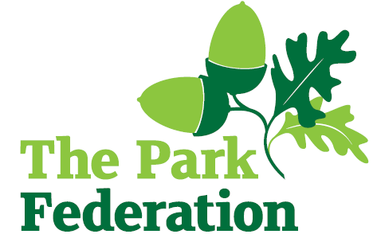

**Higher Level Teaching Assistant (EYFS)**

**Salary (actual):** £23,472 - £25,075

**Grade:** 6

**Hours:** 32.5 hours per week, Monday to Friday

**Work Pattern:** term time + INSET days (39 weeks per annum)

**Contract**: Permanent

**Holiday**: equivalent of 34 days holiday per annum pro-rated (inclusive of bank holidays)

**Pension**: 19.6% employer’s contribution

Lake Farm Park Academy is a three-form entry nursery and primary academy, with an SRP for 12 children with ASD.  It serves the children and families of the richly diverse and welcoming community of Hayes in West London and is now the educational home to over 700 children. The academy is part of The Park Federation Academy Trust, allowing us to benefit from a wealth of expertise across our academies, as well as enabling us to provide opportunities for sharing of good practice and high quality training. Candidates with experience and knowledge of either EYFS, Phonics or SEN would be welcomed.

We are seeking to appoint Higher Level Teaching Assistants, who have high expectations of themselves and are committed to improving the lives of our children.

We are looking for an individual who:

* has experience of leading whole class teaching
* has experience of supporting young people;
* is proactive, positive, calm and flexible;
* has high expectations of yourself and the children you work with;
* has excellent communication, organisational and interpersonal skills;
* is committed to working as part of a team;
* is resilient;
* shares our vision and aims for all of our pupils;
* is dedicated and committed to the success of the school.

For the right candidate, we will offer

* extensive support and CPD;
* the opportunity to work with other professional colleagues across the Multi-Academy Trust;
* a welcoming school, with friendly, enthusiastic and supportive staff team;
* an ambitious and dynamic Senior leadership Team;
* a dedicated Governing Body;
* supportive parents and children who are keen to learn;
* an employee assistance programme (EAP).

Please complete an application form for this vacancy. We do not accept CV’s.

**Interview date**: As and when we receive successful applications.

**The school is committed to safeguarding and promoting the welfare of children and young people and expect all staff and volunteers to share this commitment. The successful applicant will be required to undertake an Enhanced DBS Check with a check of the DBS Barred List.**