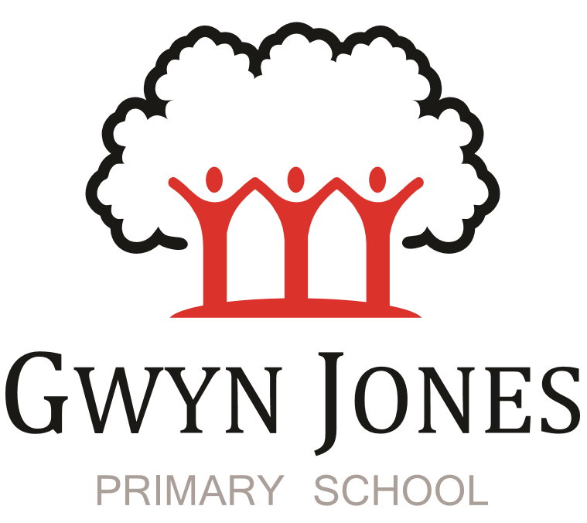

Recruitment Pack

Higher Level Teaching Assistant

Fixed term contract 1 year
Scale 6
Point: 18-20 (£30,699-£31,731) (Pro rata £22,103- £22,846)
(45.05 week term time only including 5 INSET DAYS contract
8.30am to 3.30pm with one hour for lunch
30 hours per week)

Dear Applicant,
Thank you for your interest in this exciting opportunity to join Gwyn Jones Primary School as a member of team in the role of HLTA September 2024 on a one-year fixed contract. You will be expected to work across N-Y6. One of the main focuses will be to cover ppa, teacher absences, leadership and management time. In an exciting role for someone who wants to gain further experience prior to starting teacher training! We particularly welcome applications from candidates who have interests in Music, Art, French or Computing.

We are a two-form entry, culturally diverse school based in East London and we are very proud of our school. Visitors comment on the warmth of the school and the friendliness of both staff and pupils alike. Our dedicated staff team are incredibly hard working and are committed to creating a happy, secure and stimulating environment in which every child can achieve their potential and develop a life-long love of learning.

At Gwyn Jones Primary School we are a Rights Respecting School and we actively teach our children about the rights of the child. The Rights Respecting ethos permeates all parts of school life and into our school motto “Inspired and Empowered”. This motto epitomises the staff’s genuine commitment to provide a rich, creative and challenging curriculum which inspires children’s curiosity and empowers our pupils to have a voice and be knowledgeable, active global citizens. We strive to ensure that every child thrives academically whilst benefiting from excellent pastoral care that nurtures and develops emotional wellbeing.

We are looking for someone who has good communication skills and is flexible in their approach when supporting children and working alongside other colleagues. We know it is important to be positive, inspirational and a real team player. To add to our team, we wish to appoint an excellent Teaching Assistant who will draw upon their experience and expertise in teaching to raise standards for all children including those with SEND. Together, we will drive outstanding learning and teaching that is challenging, interesting and motivational to all pupils building inquiring lifelong learners who care for their world and all that live in it.

I hope this application pack and the information available generally on our website and on social media will give you a flavour of our School. I would be delighted to show you around our friendly and caring school. To arrange a visit please contact the school office on 02085567904 or email: HR@gwynjones.waltham.sch.uk
I look forward to meeting with you
Sian Boutalbi
Headteacher

Dear Applicant,
Thank you for your interest in the position of Teaching Assistant at Gwyn Jones Primary School.
Gwyn Jones is a successful and very popular school within the local area. We are fortunate in having an engaged and culturally diverse community, a hardworking and talented staff team and amazing pupils.
As Governors, we work alongside the Head and her dedicated team in our common belief in the fundamental importance of Primary Education as the foundation for developing a lifelong love of learning in our children. Our Governing Board is keen to develop its skills and knowledge of the school and its community and supports the drive within school for continuous improvement within a nurturing and supportive environment.
Our curriculum is rich, diverse and challenging and aims to provide a range of exciting and meaningful experiences which foster confidence and provide aspirations. Staff plan for children to be academically challenged, creatively inspired and supported in their personal development.
Gwyn Jones maintains strong links with other local schools within Waltham Forest. As a member of our staff team you would receive ongoing support and development in your role.
If the thought of this role in our school excites you, we look forward to receiving your application.
Liz Jackson
Chair of Governors

Vision and Values

At Gwyn Jones, we are committed to ensuring that every member of our school community is inspired and empowered each day.
We aim to inspire and empower our children by:
- Providing excellent teaching which nurtures our children’s innate curiosity, allowing them opportunities to take risks and to think for themselves.
- Supporting our children to have responsibility for their own learning; to have their own opinions and the skills to articulate them.
- Allowing all children access to a rich and broad curriculum which fully prepares them to be active, global citizens.
- Ensuring all children participate in a variety of trips and visitors in their local and wider community.
- Acting as role models who respect others and enjoy the rich diversity of our school family.
- Insisting that every child is known well, safe and nurtured to achieve their personal best.
We aim to inspire and empower our staff by:
- Providing a wide range of relevant and innovative professional learning in school which focuses on collaboration and sharing good practice, including lesson study, planning support, team teacher and action research.
- Forging strong links with external agencies to deliver professional development - teaching schools, higher education institutes etc.
- Giving developmental feedback with clear and specific actions for staff and leaders.
- Establishing coaching and mentoring relationships which encourage reflection.
- Identifying and nurturing leadership talent.

Rights Respecting School

What is UNICEF's Rights Respecting Schools?
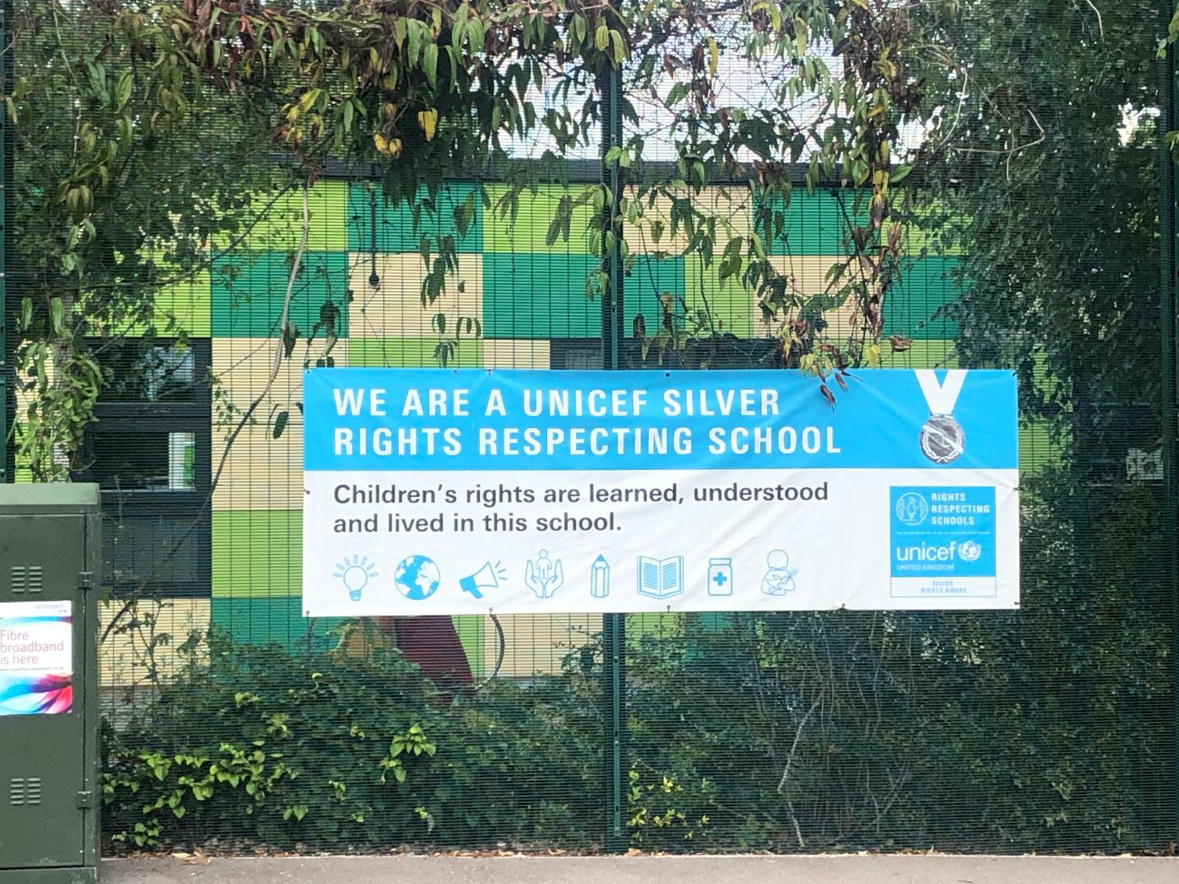

We are committed to placing the UN Convention on the Rights of the Child at the heart of our core values and ethos; believing children’s participation is integral to all aspects of school life. This results in empowered and self-confident children who can advocate for the rights of children everywhere.
This ethos further fosters a sense of community, respect and responsibility. It encourages the children to be active and informed citizens, who look to develop a positive future for all; campaigning and raising awareness.
The children’s experiences at Gwyn Jones Primary ensure the children know that they have the Rights of the Child and that these rights are inalienable. They also understand responsibilities they have as members of our local and global society.
How to Apply
Should you wish to apply for the post, please complete an application form and include a personal statement, which clearly demonstrates your suitability for this role. Please send your completed applications to HR@gwynjones.waltham.sch.uk

Closing Date
Please ensure your application arrives by Monday 15th July 2024 at 10am.

Shortlisting
Shortlisting will take place on Monday 15th July 2024 if you have not heard from us by Tuesday 16th July please assume that unfortunately, on this occasion, your application has not been successful.

Interview
Interviews will take place on Thursday 18th July 2024. Applicants called for interview are kindly requested to contact their referees so that references are received ahead of the interview dates.

Safeguarding
Applicants called for interview are kindly requested to contact their referees so that references are received ahead of the interview dates.
Gwyn Jones Primary School is committed to safeguarding and promoting the welfare of children and young people and expects all staff and volunteers to share this commitment. The school follows safer recruitment practices and the successful applicants will be required to apply for an Enhanced Disclosure and Barring Service check. A copy of our Safeguarding Policy is available to view on our website
Location
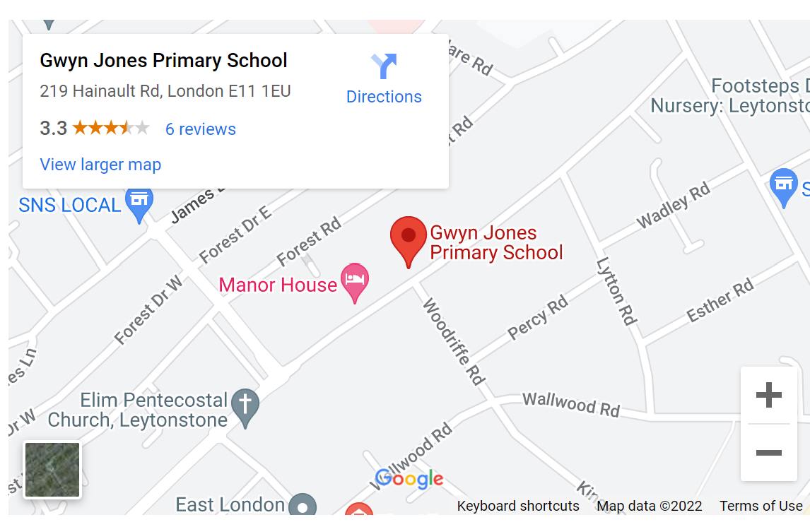

Job Description

School Name: | Gwyn Jones Primary School
Job Title: | HLTA - Teaching Assistant Level 4
Reports To: | Headteacher/ Deputy Headteacher
Role Summary:

- To complement the professional work of teachers by taking responsibility for agreed learning activities under an agreed system of supervision. This may involve planning, preparing and delivering learning activities for individuals/groups or short term for whole classes and monitoring pupils and assessing, recording and reporting on pupils achievement, progress and development.

- Assess the needs of pupils and use detailed knowledge and specialist skills to support pupils’ learning.
- Establish productive working relationships with pupils, acting as a role model and setting high expectations.
- Develop and implement IEP’s.
- Promote the inclusion and acceptance of all pupils within the classroom.
- Support pupils consistently whilst recognising and responding to their individual needs.
- Encourage pupils to interact and work co-operatively with others and engage all pupils in activities.
- Promote independence and employ strategies to recognise and reward achievement of self-reliance.
- Provide feedback to pupils in relation to progress and achievement.
- Organise and manage appropriate learning environment and resources.
- Within an agreed system of supervision, plan challenging teaching and learning objectives to evaluate and adjust lessons/work plans as appropriate.
- Monitor and evaluate pupil responses to learning activities through a range of assessment and monitoring strategies against pre-determined learning objectives.
- Provide objective and accurate feedback and reports as required on pupil achievement, progress and other matters, ensuring the availability of appropriate evidence.
- Record progress and achievement in lessons/activities systematically and providing evidence of range and level of progress and attainment.
- Work within an established discipline policy to anticipate and manage behaviour constructively, promoting self control and independence.
- Supporting the role of parents in pupils’ learning and contribute to/lead meetings with parents to provide constructive feedback on pupil progress/achievement etc.
- Administer and assess/mark tests and invigilate exams/tests.
- Production of lesson plans, worksheet, plans etc.
- Deliver learning activities to pupils within agreed system of supervision, adjusting activities according to pupil responses/needs.
- Deliver local and national learning strategies e.g. literacy, numeracy, early years and make effective use of opportunities provided by other learning activities to support the development of pupils’ skills.
- Use ICT effectively to support learning activities and develop pupils’ competence and independence in its use.
- Select and prepare resources necessary to lead learning activities, taking account of pupils’ interests and language and cultural backgrounds.
- Advise on appropriate deployment and use of specialist aid/resources/equipment.
- Comply with and assist with the development of policies and procedures relating to child protection, health, safety and security, confidentiality and data protection, reporting concerns to an appropriate person.
- Be aware of and support difference and ensure all pupils have equal access to opportunities to learn and develop.
- Contribute to the overall ethos/work/aims of the school.
- Establish constructive relationships and communicate with other agencies/professionals, in liaison with the teacher, to support achievement and progress of pupils.
- Take the initiative as appropriate to develop appropriate multi-agency approaches to supporting pupils.
- Recognise own strengths and areas of specialist expertise and use these to lead, advise and support others.
- Deliver out of school learning activities within guidelines established by the school.
- Contribute to the identification and execution of appropriate out of school learning activities which consolidate and extend work carried out in class.
- Attend to the pupils’ personal needs, and implement related personal programmes, including social, health, physical, hygiene (including intimate care), basic first aid and welfare matters.
- Assist with the development and implementation of EHCP objectives, including toileting and personal hygiene programmes, eating and drinking programmes, physical positioning, dressing and grooming.
- Manage other teaching assistants.
- Liaise between mangers/teaching staff and teaching assistants.
- Hold regular team meetings with managed staff.

General Information:
Equality of Opportunity | - As a member school staff to take individual and collective professional responsibility for reinforcing and promoting a working environment free from discrimination, victimisation, harassment and bullying.  - Ensure the development and progression of equality within the sphere of responsibility of this post and the fair and equal treatment of all colleagues, children, parents and visitors.
Confidentiality and Data Protection | - To treat all information acquired through employment, both formally and informally, in strict confidence.  - To be aware of the school's responsibilities under the GDPR for the security, accuracy and relevance of personal data held on such systems and ensure that all processes comply with this.
To contribute as an effective and collaborative member of the School team | - Any other duties as reasonably required by any manager of the school.  - Participating in the ongoing development, implementation and monitoring of the school plans.  - Attend regular meetings as required and make a positive contribution during meetings.
Child Protection | - Being aware of and complying with policies and procedures relating to child protection reporting all concerns to an appropriate person.
Key Skills and Competencies:

- Experience of working with or caring for children of relevant age.
- Meet Higher Level Teaching Assistant standards or equivalent qualification or experience.
- Excellent numeracy/literacy skills – equivalent to NVQ Level 2 in English and Maths.
- Training in relevant learning strategies e.g. literacy.
- Can use ICT effectively to support learning.
- Full working knowledge of relevant polices/codes of practice/legislation.
- Working knowledge and experience of implementing national/foundation stage curriculum and other relevant learning programmes/strategies.
- Good understanding of child development and learning processes.
- Understanding of statutory frameworks relating to teaching.
- Ability to organise, lead and motivate a team.
- Constantly improve own practice/knowledge through self-evaluation and learning from others.
- Ability to relate well to children and adults.
- Work constructively as part of a team, understanding classroom roles and responsibilities and your own position within these.
- Basic understanding teaching expectations at each level across the school
- Appropriate knowledge of first aid

