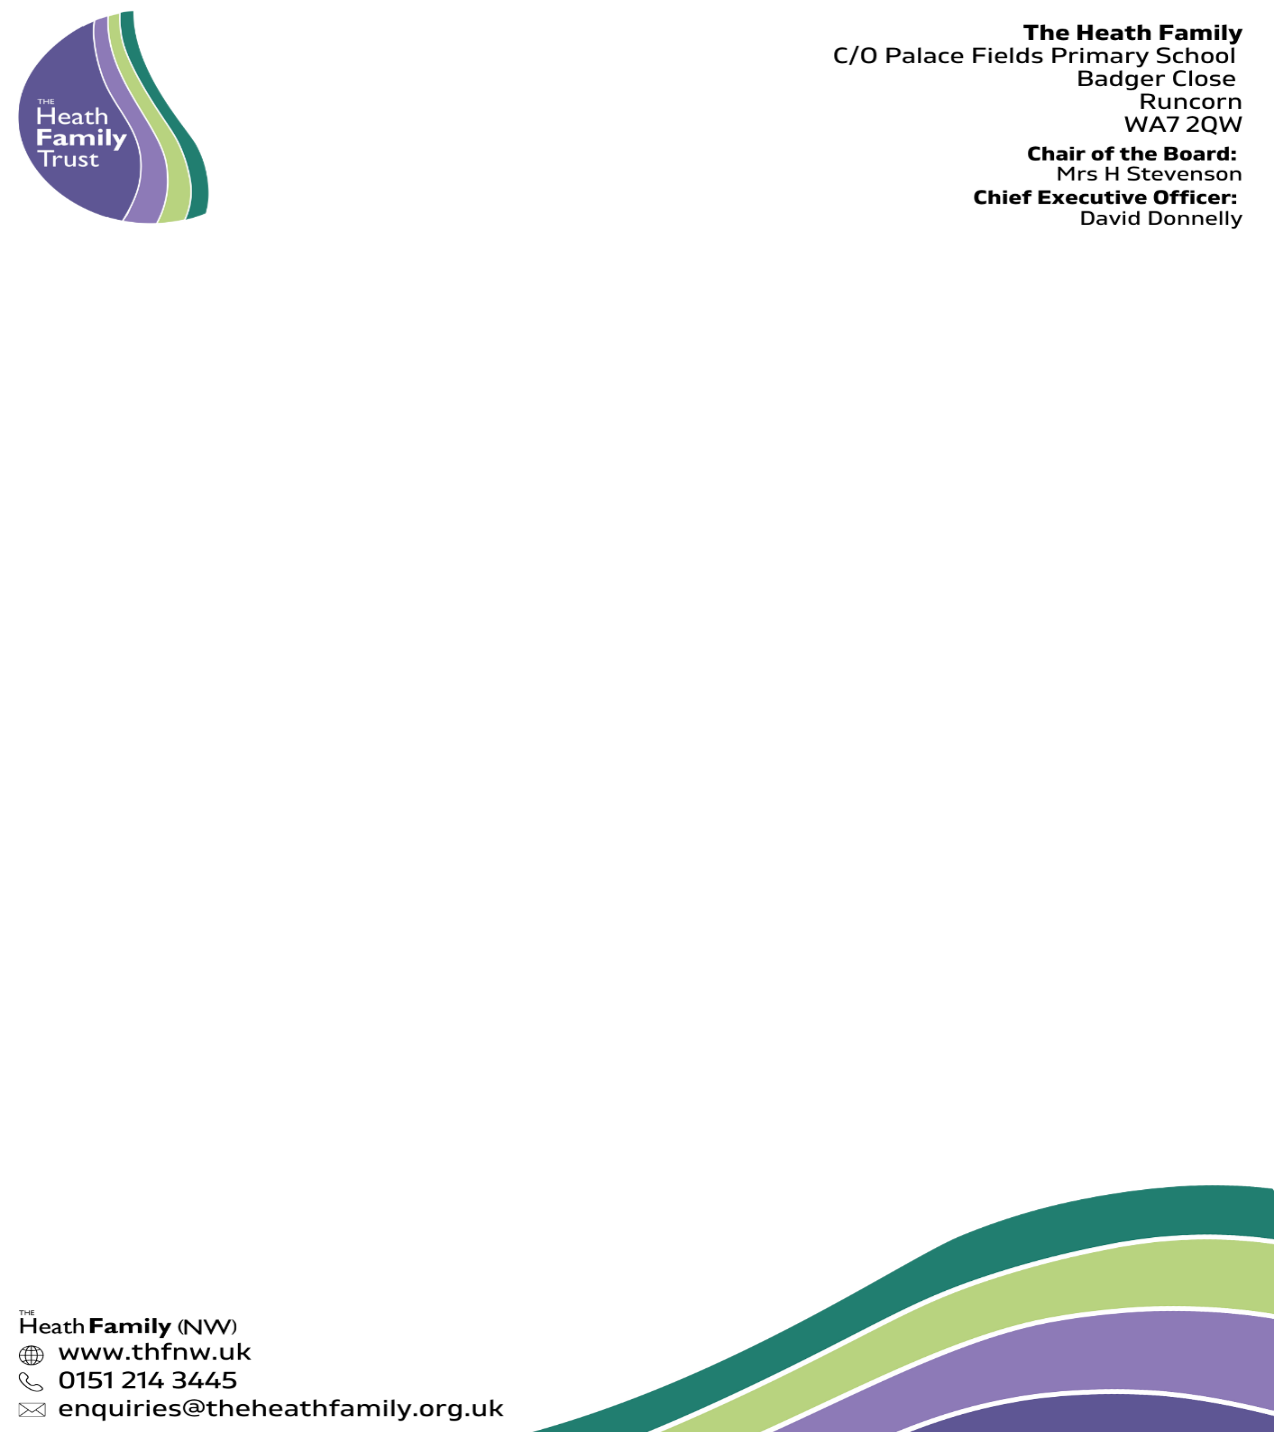

**Person Specification:**

**Post: HLTA (Higher Level Teaching Assistant)**

|  |  |  |
| --- | --- | --- |
| Attributes | Essential | Desirable |
| Qualifications | * Excellent English and Maths Skills – Equivalent to Level 1 in English & Maths | * Level 3 TA Qualification (or equivalent) * Level 2 in English & Maths |
| Knowledge & Skills | * Good understanding of child development and learning processes * Ability to relate well to children and adults * Work constructively as part of a team, understanding classroom roles and responsibilities and your own position within these. * Can use ICT effectively to support learning. * Full working knowledge of relevant policies/codes of practice legislation affecting SEND education. * Working knowledge and experience of implementing early years curriculum and other relevant programmes/strategies. * Understanding of statutory frameworks relating to EYFS * Constantly improve own practice/knowledge through self-evaluation and learning from others. | * Training in relevant learning strategies e.g., phonic * Ability to deliver training * Restorative practice training. * Paediatric first aid |
| Character | * Ability to work with and lead others * Excellent communication skills and ability to build positive relationships with students and their families | * Able to improve their own practice through observations, evaluation and discussion with colleagues |