Derbyshire County Council Church Lane
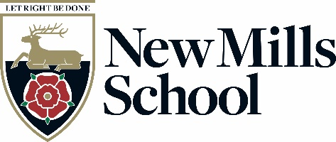
New Mills
High Peak
Derbyshire
SK22 4NR

Tel: 01663 743284
Fax: 01663 745134
email: head@newmillsschool.co.uk
Headteacher:
Mrs H Watts
web: www.newmillsschool.co.uk

April 2022

Dear Candidate

If you are looking to join a great community school, perfectly located for the city and the country life, then we would love to talk to you.

New Mills School is rated by OFSTED as a good school and we are focussed on our journey to outstanding.

We have a progressive and forward thinking leadership team that drive the school and its pupils to successful outcomes; preparing young adults for the challenges of tomorrow’s world.

Each of our staff are encouraged to make a difference; we unlock the potential of staff and students alike.

“Teachers invest time and effort to improve their skills. They value the opportunities provided by the school to develop their practice. As a result, the quality of teaching across the school is predominantly good.”
Ofsted 2017

We strive to be a school that offers the highest quality teaching, learning and assessment underpinned by considered and targeted professional development and training. We develop aspirational, creative, independent and resilient teachers and learners.

New Mills School is committed to safeguarding and promoting the welfare of children and young people and expects all staff and volunteers to share this commitment.

Yours sincerely

Heather Watts
Headteacher

