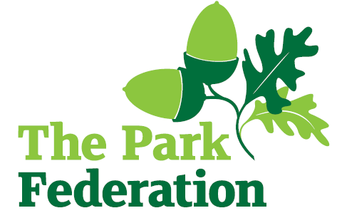
Higher Level Teaching Assistant

Salary (actual): £22,425 - £26,920 inclusive of fringe allowance
Grade: L5
Hours: 36 hours per week, Monday to Friday
Work Pattern: term time + INSET days – 39 weeks per annum
Contract: permanent
Pension: 21.6% employer’s contribution

This is an exciting opportunity to work at The Godolphin Junior Academy, a warm and vibrant multi-cultural junior school based in Slough. Our well-behaved children are eager and keen to learn and grow. Our school is part of The Park Federation Academy Trust, and our partnership means that there are opportunities for professional development that will further your own skills, knowledge and expertise.

We are seeking to appoint a Higher Level Teaching Assistant, who has high expectations of themselves and is committed to improving the lives of our children.

We are looking for an individual who:
- has experience of leading whole class teaching
- has experience of supporting young people;
- is proactive, positive, calm and flexible;
- has high expectations of yourself and the children you work with;
- has excellent communication, organisational and interpersonal skills;
- is committed to working as part of a team;
- is resilient;
- shares our vision and aims for all of our pupils;
- is dedicated and committed to the success of the school.

For the right candidate, we will offer
- extensive support and CPD;
- the opportunity to work with other professional colleagues across the Multi-Academy Trust;
- a welcoming school, with friendly, enthusiastic and supportive staff team;
- an ambitious and dynamic Senior leadership Team;
- a dedicated Governing Body;
- supportive parents and children who are keen to learn;
- an employee assistance programme (EAP).

We warmly welcome candidates coming to visit the school prior to application; please contact the school to arrange.

Please complete an application form for this vacancy.

Closing date: As and when we receive successful applications.

The school is committed to safeguarding and promoting the welfare of children and young people and expect all staff and volunteers to share this commitment. The successful applicant will be required to undertake an Enhanced DBS Check with a check of the DBS Barred List.

