
Wisewood Primary School
Recruitment Pack




Job Title: Higher Level Teaching Assistant (Permanent)
Salary Information: Scale 5 SCP 15-20
Start Date: September 2021


Wisewood Primary School

Recruitment Pack Contents

Tapton School Academy Trust - Vision & Ethos
Letter from the Chair of the Governing Body
About Wisewood Primary School
Job Description & Personal Spec
Job Advert
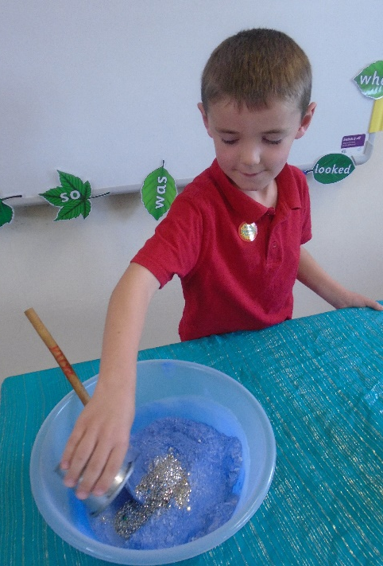
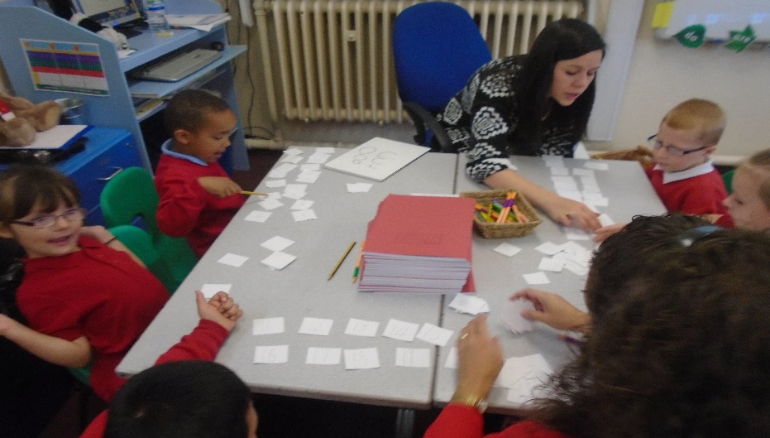

Wisewood Primary School
Tapton School Academy Trust - Vision & Ethos

Tapton School Academy Trust (TSAT) was formed in 2012 and sponsored Chaucer
School. Another ‘Outstanding’ Ofsted judgement for Tapton in 2013 gave the opportunity to partner with King Ecgbert School to build the Escafeld Teaching School Alliance. This has given rise to secure and effective leadership, training and support for our growing Trust family of schools.

In September 2015 we became eight schools – three secondary and five primary.
Tapton, Chaucer and Forge Valley are our Secondaries and our Primaries are Southey Green, Meynell, Hillsborough, Wisewood and Hallam. This year, we have been joined by Bradfield Secondary School.

They are all linked in a shared endeavour – our mission is to provide an outstanding
education to all our pupils 0 – 19. We are passionate that all our young people should see their time at school as safe, happy and fulfilling.

Our approach is founded on deeply effective partnership working – inextricably joining our schools, pupils, parents and their communities.

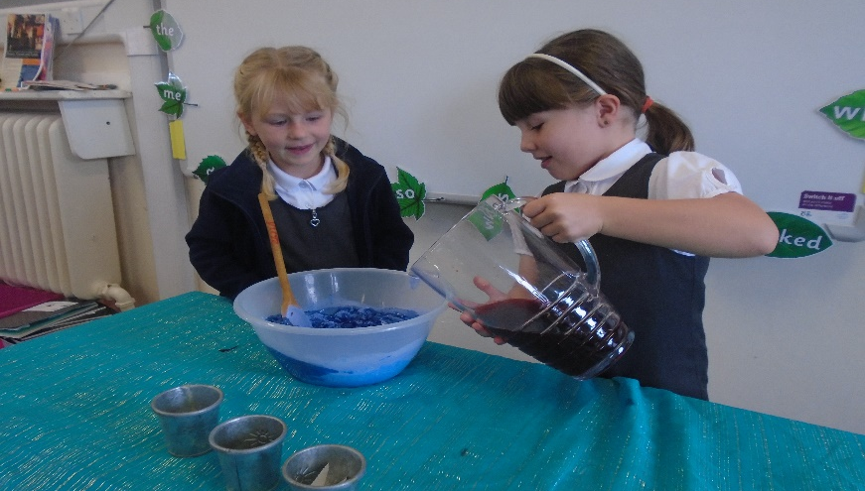

Wisewood Primary School

Our provision for pupils and parents

All Tapton School Academy Trust Schools will offer:

- A genuine inclusive approach which ensures the best possible attainment, progress and achievement for every pupil.

- A broad and balanced, enriched curriculum which is delivered by consistently high quality teaching.

- Safe and harmonious learning environments where behaviour is well managed, learning is uninterrupted and moral values are fostered.

- Our learners develop resilience and self-reliance which offers them the skills to successfully meet the challenges and opportunities they will encounter in our rapidly changing world.

- Investment in the professional development of our staff at all stages in the Trust.

Leadership will be secured which is able, proactive and focused on success for each school, our pupils and the wider community.

Partnerships

TSAT is founded on strong local partnerships, we only work within the Sheffield group of schools and are convinced that cross phase working is the very best way to secure our aims. Every Academy is non selective and our admissions are co-ordinated by Sheffield Local Authority. We work very closely with DfE, LA and the family of Sheffield Schools in order to plan strategically for our shared improvement agenda. All of our schools are founding members of Learn Sheffield, a new company operated to bring about a rapid improvement in all settings.

We value our excellent working relationships with Trade Unions. Recognition agreements are in place for all major Sheffield Unions and all TSAT Schools support union activities by paying into the facilities time agreement.

Wisewood Primary School

Letter from the Chair of Governors

Thank you for your interest in this position at Wisewood Primary School.

Tapton School Academies Trust – TSAT and the Governing Body are looking to appoint highly motivated and inspirational people who can take the school forward and deliver the Trust’s vision and ethos.

Our aim is to ensure that every child in our care is given the opportunity to enhance their life chances by realising their full potential. The successful applicant will become part of our vibrant Trust, which values its employees and encourages them to develop their skills in a supportive environment alongside lead professionals.
Our school has a team of dedicated staff who work closely as a team together with governors, parents, children, the local community and the other Primary academies across the Trust. I hope this will inspire you to apply for this unique opportunity and I look forward to receiving your application.

I do urge you to visit the school - this can be arranged by appointment and details are available in the application pack.

Once again thank you for your interest in the position.

Yours sincerely

Angela Lant
Chair of Governors

Wisewood Primary School

About Us
Wisewood Community Primary School is situated in a residential area in the North West of the City, close to both the urban area of Hillsborough and to open countryside towards Loxley Common and Bradfield. It has a catchment area consisting of Council and Housing Trust houses on the Wisewood Estate and also some private housing.

Despite the introduction of Universal Meals for all KS1 children the number of children we have on Free School Meals is 26%. 25% of children are on the Special Needs Register. There are very few ethnic minority children.

Despite the introduction of Universal Meals for all KS1 children the number of children we have on Free School Meals is 26%. 25% of children are on the Special Needs Register. There are very few ethnic minority children.

The school has approximately 179 children and the seven classes in the school are housed in a 1930’s building around two quads. Our classes consist of one class per year group We also have a pre-school attached to the school. Wisewood Community Pre-school joined us in September 2008 and we have forged strong links with the group.
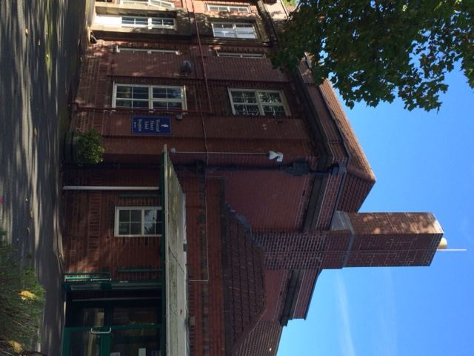
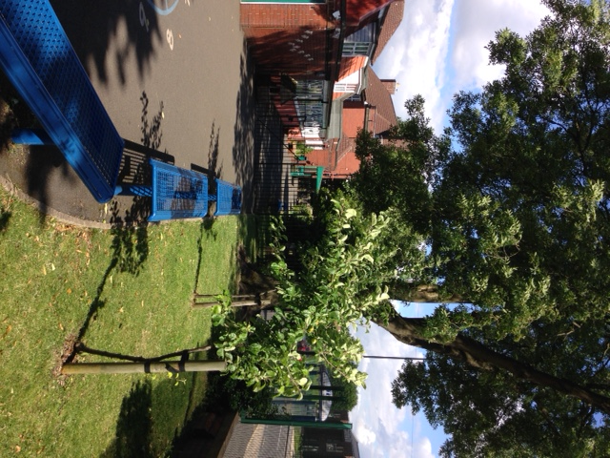
Despite the introduction of Universal Meals for all KS1 children the number of children we have on Free School Meals is 53%. 24% of children are on the Special Needs Register. There are some ethnic minority children. The school has approximately 163 children and the seven classes in the school are housed in a 1930’s building around two quads. Our classes consist of one class per year group We also have a pre-school attached to the school. Wisewood Community Pre-school joined us in September 2008 and we have forged strong links with the group. The school stands alone following the closure of Wisewood Secondary and demolition of the school buildings a few years ago.

Work is now complete on the site and an all-weather football pitch is now in use along with a café and charity shop. There are also plans for a children’s playground on the site. We also have strong links with the Sports Hall which is only a few minutes away.

Wisewood is a happy school providing a caring environment. Both teaching and non-teaching staff work hard to promote positive behaviour and the school has a strong anti-bullying policy

Candidates are encouraged to visit the school and should contact the school (0114 234 3304) to arrange an appointment.


Tapton School Academy Trust

Wisewood Primary School

Job Advert

Higher Level Teaching Assistant (HLTA)
Required September 2021
Grade 5 SCP 15 to 20 (£23,541 to £25,991 pro rata)
37 hours, 39 weeks - Permanent
The Tapton School Academy Trust are looking to appoint a Higher Level Teaching Assistant to cover PPA time and staff absence to start in September 2021 at Wisewood Primary School. Wisewood Primary is a 1-form entry school with 164 children on roll and is located in the north west of the city between Hillsborough, Loxley and Malin Bridge.
We are looking to appoint a high quality, enthusiastic professional who is keen to develop and go the extra mile for our children. The role currently involves working in our KS2 bubble to undertake whole class teaching cover as well as some small group interventions. However, subject to the lifting of COVID restrictions, it is envisaged that the successful candidate will be required to cover in all classes across school, therefore experience across all Key Stages would be advantageous.
The successful candidate will:

- Have a relevant teaching qualification, meet the National Higher Level Teaching Assistant Standards, or have an equivalent HLTA qualification If candidates do not currently have the HLTA qualification they must be willing to enrol on the course as soon as possible.
- Have a diverse set of skills which will enable you to be flexible working in the classroom
- Be passionate about teaching and learning
- Be able to work creatively and strategically and collaborate with teachers
- Be an innovative and reflective practitioner who is keen to learn
- Be positive, with a ‘can do’ attitude
- Be committed to improving the life chances of every child
- Have experience of working across EYFS, KS1 & KS2
- Have excellent classroom skills including high expectations and a commitment to challenging every learner through an exciting, inspiring enquiry-based curriculum
- Have outstanding interpersonal skills that motivate and inspire children to achieve their very best
- Have highly effective communication, organisational and teamwork skills.
Interested candidates should submit their application by midday on Monday, 21st June, 2021. Interviews will take place on Thursday, 24th June 2021 in school. A recruitment pack and job description can be found on our school website. Please send your application via the TES website at https://www.tes.com/jobs/vacancy/higher-level-teaching-assistant-sheffield-1458886?preview=1

In your personal statement please comment on these bullet points.

- Why do you want to be an HLTA at Wisewood Primary School?
- What experience do you have?
- What skills would you bring to the role?
- Reference to the National HLTA standards and how you plan to meet these standards is required as part of the letter
If you require any further information or would like more details about the role and school please contact us to arrange an informal discussion with the Head of School, Ben Ramsden. Please call Wisewood Primary School to arrange an appointment on 0114 2343304 or e-mail headteacher@wisewood.sheffield.sch.uk.
Please note:

- References for short-listed candidates will be requested before the interview.
- Successful applicants will be required to undertake a DBS Enhanced Disclosure check

PLEASE DO NOT USE THE SHEFFIELD CITY COUNCIL APPLICATION FORM.

You will need to be able to:
Demonstrate and deliver excellent teaching
Be able to work under pressure within a strong team focused towards challenging goals
Have high expectations of every child enabling them to make exceptional progress
Have excellent organisational and communication skills
Share in our vision for realising the life chances and dreams of every child

In return we can offer you:
A vibrant learning community with a team who are committed to great teaching and learning for all its pupils
Children who love learning and want to achieve
A high level of community involvement
A well-resourced and stimulating environment
An established MAT of schools which shares and builds on effective practice
A great place to work where colleagues are valued and receive high quality support with rich learning and development opportunities
If you are ready for such a challenge then please click below to apply today. Visits to the schools are warmly welcomed and encouraged, please call Hallam Primary School to arrange a time on 0114 2304430 or e-mail enquiries@hallam.sheffield.sch.uk.
Closing date for applications is Wednesday 15th May 2019.
Completed application forms for both posts to be returned to enquiries@hallam.sheffield.sch.uk
Interviews, which will include an observed teaching session will be held Thursday 23rd May at Hallam Primary School.
Please note:
We hope applicants will be flexible as to which school they are placed however please state clearly if you are only willing to be considered for a particular school.
Please do not complete a Sheffield City Council application form for this post.
References for short-listed candidates will be requested before the interview.
Successful applicants will be required to undertake a DBS Enhanced Disclosure check.
Links:
Hallam Primary Ofsted Report
Wisewood Community Primary Osted Report
Tapton School Academy Trust

You will need to be able to:
Demonstrate and deliver excellent teaching
Be able to work under pressure within a strong team focused towards challenging goals
Have high expectations of every child enabling them to make exceptional progress
Have excellent organisational and communication skills
Share in our vision for realising the life chances and dreams of every child

In return we can offer you:
A vibrant learning community with a team who are committed to great teaching and learning for all its pupils
Children who love learning and want to achieve
A high level of community involvement
A well-resourced and stimulating environment
An established MAT of schools which shares and builds on effective practice
A great place to work where colleagues are valued and receive high quality support with rich learning and development opportunities
If you are ready for such a challenge then please click below to apply today. Visits to the schools are warmly welcomed and encouraged, please call Hallam Primary School to arrange a time on 0114 2304430 or e-mail enquiries@hallam.sheffield.sch.uk.
Closing date for applications is Wednesday 15th May 2019.
Completed application forms for both posts to be returned to enquiries@hallam.sheffield.sch.uk
Interviews, which will include an observed teaching session will be held Thursday 23rd May at Hallam Primary School.
Please note:
We hope applicants will be flexible as to which school they are placed however please state clearly if you are only willing to be considered for a particular school.
Please do not complete a Sheffield City Council application form for this post.
References for short-listed candidates will be requested before the interview.
Successful applicants will be required to undertake a DBS Enhanced Disclosure check.
Links:
Hallam Primary Ofsted Report
Wisewood Community Primary Osted Report
Tapton School Academy Trust

In your personal statement please comment on these bullet points.

- Why do you want to be an HLTA at Wisewood Primary School?
- What experience do you have?
- What skills would you bring to the role?
- Reference to the National HLTA standards and how you plan to meet these standards is required as part of the letter
If you require any further information or would like more details about the role and school please contact us to arrange an informal discussion with the Head of School, Ben Ramsden. Please call Wisewood Primary School to arrange an appointment on 0114 2343304 or e-mail headteacher@wisewood.sheffield.sch.uk.
Please note:

- References for short-listed candidates will be requested before the interview.
- Successful applicants will be required to undertake a DBS Enhanced Disclosure check

PLEASE DO NOT USE THE SHEFFIELD CITY COUNCIL APPLICATION FORM.

Job Description & Person Specification

Please see the Job Description on the
Wisewood Primary School job page:

http://www.wisewoodprimary.co.uk/job-vacancies/

Wisewood Primary School

Thank you for taking the time to look through our
recruitment pack, we hope to hear from you soon.
Please remember to complete the Academy Trust
application form and not a Local Authority form.
All completed applications need to be emailed to:

enquiries@wisewood.sheffield.sch.uk



