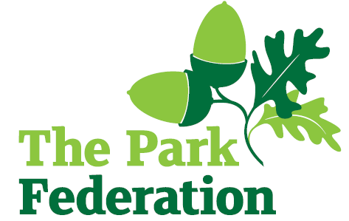
HLTA
Salary (actual): £23,369 - £24,966
Grade: 6
Hours: 32.5 hours per week, Monday to Friday
Work Pattern: term time + INSET days (39 weeks)
Contract: permanent
Pension: 22.2% employer’s contribution

Wood End Park Academy is home to over 900 children, including a 60-place nursery. It serves the children and families of the richly diverse and welcoming community of Hayes in West London. The academy is part of The Park Federation Academy Trust, allowing us to benefit from a wealth of expertise across our eight academies, as well as enabling us to provide opportunities for sharing of good practice and high-quality training.
We are seeking to appoint a Higher Level Teaching Assistant, who is able to work with small groups to help them make accelerated progress via catch up work or EAL provision. You will work in lower KS2 in the first instance.

We are looking for an individual who:
- has experience of developing language skills in young children
- can lead a whole class (e.g. afternoon cover for a Year 4 class will be required)
- can develop a programme of work and assess its impact
- is proactive, positive, calm and flexible;
- has high expectations and is resilient;
- has excellent communication, organisational and interpersonal skills;
- is committed to working as part of a team;
- shares our vision and aims for all of our pupils;
- is dedicated and committed to the success of the school.

For the right candidate, we will offer
- extensive support and CPD;
- the opportunity to work with other professional colleagues across the Multi-Academy Trust;
- a welcoming school, with friendly, enthusiastic and supportive staff team;
- an ambitious and dynamic Senior leadership Team;
- a dedicated Governing Body;
- supportive parents and children who are keen to learn;
- an employee assistance programme (EAP).

Please complete an application form for this vacancy.

Interview date: As and when we receive successful applications.

The school is committed to safeguarding and promoting the welfare of children and young people expect all staff, and volunteers to share this commitment. The successful applicant will be required to undertake an Enhanced DBS Check with a check of the DBS Barred List.

