

Applicant Pack

HR Administrator (Term-Time)

Salary: £15,800.28 to £16,885.25 per annum (£25,951.00 to £27,733.00 per annum FTE) – Points 7 to 10 of the SFCA Support Staff Pay Scale.

Working hours: 25 hours per week, 5 hours per day, Monday to Friday, plus a 30-minute unpaid break. The exact working hours can be flexible, but will need to fall between 8.30 am and 4.30 pm. For example, 9.15 am to 2.45 pm, with a 30-minute unpaid break in the middle of the day.

Working weeks: Term-time (39 weeks), plus 2 weeks during the College summer holiday period (41 weeks in total)

FTE: 0.6088

Pension: West Yorkshire Pension Fund, plus Death in Service Grant of 3 x your annual salary

Contract type: Permanent

Other benefits:
- Access to the Schools Advisory Service EAP, offering counselling, physiotherapy and other support services
- Free use of on site gym facilities (6.45 am to 8.15 am and 4.00 pm to 7.00 pm)
- Eye test vouchers
- Flu vaccination vouchers
- Cycle to work salary sacrifice scheme
- Health and wellbeing events throughout the year, including a dedicated staff wellbeing day
- Enhanced maternity and paternity pay
- Opportunities for personal and professional development

Reports to: HR Manager

Closing date: Sunday 1 November 2026

Start date: Monday 4 January 2027

Welcome Letter

On behalf of Greenhead College, thank you for your interest in the post of HR Administrator. We are pleased that you are considering Greenhead College as the next stage in your career, and we hope, subject to matching our criteria, you will apply.

Greenhead College is situated on a welcoming and attractive campus close to Huddersfield town centre, adjacent to the picturesque Greenhead Park. We are just a short drive from the M62 and within walking distance of both the train and bus stations, making the College highly accessible for applicants from across the Northwest and Yorkshire.

Approximately 3000 students attend the College studying predominantly A Level courses across 35 subjects. The academic structure of the College is based on Heads of Curriculum who are subject specialists. The College also employs a team of Tutors, experienced in pastoral care, careers guidance and trained in Mental Health First Aid. Alongside their academic studies, students benefit from a rich extra-curricular enrichment offer and a wide range of project and work placement opportunities through our Step Into Your Future scheme.

Our commitment to student and staff well-being is reflected in our achievements. In July 2024, we received the Further Education Mental Health Gold Award in recognition of the comprehensive support we provide. In March 2025, OFSTED once again graded the College as ‘Outstanding’ in all six key areas, and as making a strong contribution to skills needs, identifying no areas for improvement. Most recently in April 2025, we were honoured to be named Further Education College of the Year at the Educate North Awards. These accolades highlight the dedication and high standards demonstrated by our students and staff across all roles.

The College is a great place to work, with a warm, inclusive atmosphere existing between students and staff. Our staff are recognised for their hard work and are encouraged to inspire each another, and to develop and grow. We are proud to have a strong and able College Leadership Team, and a highly experienced Board, who work collaboratively to deliver the College’s purpose and principles, and strategic priorities.

This is an exciting time to be joining us. We were one of only 50 schools and colleges nationally to receive multi-million-pound funding for a new four-storey science building, which opened in November 2023, with the final building work and landscaping completed in August 2025. We continue to invest in our facilities and have an ambitious capital investment plan spanning the next five years.

If you have any queries about this role, please contact our Human Resources Team via email jobs@greenhead.ac.uk who will be happy to help.

We look forward to receiving your application.

Best wishes,

Mo Bunter
Principal


Job Description

Job Purpose

To provide a comprehensive, efficient and professional administrative support service to the HR team, assisting with a wide range of personnel, recruitment and operational activities. The postholder will contribute to the effective delivery of HR services across the College, ensuring administrative processes are completed accurately, efficiently and in a timely manner.

Duties and Responsibilities

General HR Administration

- Provide day-to-day administrative support to the HR team, assisting with a wide range of personnel and operational activities as required.
- Prepare, process and maintain HR correspondence, documentation, records and reports, ensuring accuracy and confidentiality at all times.
- Scanning, photocopying, filing and managing archives, including handling and moving physical files, boxes and paperwork.
- Maintain and update employee information, personnel files and HR systems in accordance with College procedures and data protection requirements.
- Arrange and coordinate meetings on behalf of members of the HR team, including managing diaries, preparing documentation and organising meeting arrangements.
- Attend meetings as required to take accurate minutes, prepare meeting notes and support the administration of any agreed actions.
- Respond to routine HR enquiries from staff, applicants and other stakeholders, referring more complex matters to appropriate members of the HR team.
- Assist with the preparation and maintenance of HR reports, spreadsheets and management information as required.

Recruitment and Selection

- Provide administrative support throughout the recruitment and selection process, including advertising vacancies across appropriate recruitment platforms.
- Download, organise, monitor and maintain accurate records of applications received, ensuring recruitment information is processed and stored appropriately.
- Monitor and manage the HR recruitment inbox, responding to enquiries and ensuring timely and professional communication with applicants and relevant stakeholders.
- Take prospective candidates and interview candidates on tours of the College.
- Request, monitor and obtain employment references in accordance with College safer recruitment procedures, including obtaining references prior to interview where required.
- Support the HR Manager with the coordinate interview arrangements, including scheduling interviews, communicating with candidates and panel members, preparing and distributing documentation and supporting interview administration.
- Provide administrative assistance with recruitment and selection activities for roles including cleaners, invigilators and language assistants, as required.
- Support the administration of pre-employment checks and other recruitment compliance requirements, ensuring appropriate documentation is obtained, recorded and securely maintained.

Onboarding and Employee Records

- Prepare and issue new starter documentation and onboarding packs, ensuring the timely completion and return of relevant paperwork.
- Establish, organise and maintain confidential personnel files for new employees, ensuring records are accurate, complete and managed in accordance with UK GDPR and College procedures.
- Assist with the coordination of onboarding and induction arrangements for new employees.
- Support the HR Manager with in-person training sessions, including the setting up of training rooms, arranging equipment and materials, and assisting participants.
- Maintain accurate and up-to-date records relating to volunteers and PGCE students, ensuring relevant documentation and safeguarding checks are completed and securely stored.
- Support the administration of changes to employment arrangements and employee leavers, including updating relevant systems and preparing associated documentation.

Employee Wellbeing and HR Support

- Provide administrative support for College employee wellbeing initiatives and activities.
- Coordinate the administration and distribution of employee wellbeing benefits, including eye test and flu vaccination vouchers, ensuring accurate record keeping and timely processing.
- Assist with the administration, organisation and communication of other staff benefits, wellbeing initiatives and HR activities as required.
- Support the HR team with the implementation and administration of HR policies, procedures, projects and initiatives.

General Responsibilities

- Develop and maintain positive and professional working relationships with colleagues, managers and external stakeholders.
- Maintain strict confidentiality and exercise appropriate discretion when handling personal, sensitive or employment-related information.
- Support the continuous improvement of administrative systems, processes and working practices within the HR team.
- Undertake training and professional development activities as required to maintain and develop the knowledge and skills necessary for the role.
- Work flexibly and collaboratively with colleagues, providing additional administrative support during periods of increased workload or absence.
- Promote, act as a role model and implement the College’s policies, practices and procedures including those relating to diversity and inclusion.
- Take reasonable care of the health and safety of self, other persons and resources whilst at work. This entails supporting the college’s responsibilities under the Health and Safety at Work Act.
- Demonstrate day to day commitment to the College’s core values of community and mission statement.
- Carry out such reasonable additional duties as may from time to time be determined by or on behalf of the Corporation.

Safeguarding

All staff and senior postholders have a duty for safeguarding and promoting the welfare of children and young persons. Staff must be aware of the College’s procedures for raising concerns about children's welfare and must report any concerns to the Designated Person without delay. Staff must also ensure they attend the appropriate level of safeguarding children training identified by the College as relevant to their role.

Diversity and inclusion

The College will seek to ensure that all existing and potential employees and students are given equal opportunities for employment and education. It is committed to the elimination of unlawful or unfair discrimination on the grounds of sex, age, marital status, colour, race, nationality or other ethnic or national origin, disability, sexual orientation, trade union membership or activity and religious background.

The College will seek to ensure that no applicant for employment or education is disadvantaged by conditions or requirements which cannot be justified. The College provides an open, welcoming and safe environment for all its students, employees and visitors.

Employee Wellbeing

The College is committed to promoting and supporting employee wellbeing to improve working lives and allow our staff to flourish and reach their potential. The employee wellbeing priorities of the College are integrated throughout, embedded in our culture, leadership, and management. Staff are encouraged to talk about mental health, have good self-care routines, and seek help where needed. Employee wellbeing is an integral part of the College’s performance management process, which allows Heads of Departments and the College Leadership Team to regularly review workloads and deadlines in a meaningful way. The College has a holistic framework in place to support staff, including early access to specialist sources of help, such as counselling and physiotherapy, as well as an employee assistance programme, occupational health service and dedicated employee wellbeing days.

Prevent

The successful applicant will be required to uphold the values of democracy, rule of law, individual liberty and tolerance and have mutual respect for those with different faiths and beliefs.

HR Structure
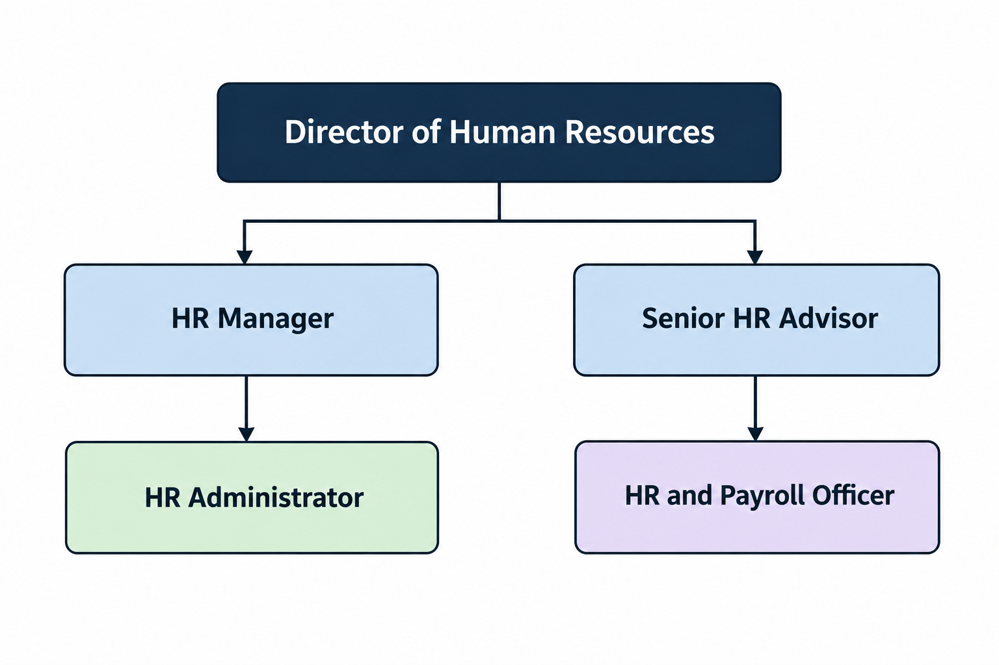
Person Specification

 | Essential | Desirable
QUALIFICATIONS:
A good standard of general education, including English and Maths at GCSE Grade 4/C or above, or equivalent | x
Relevant administrative, business or HR related qualification |  | x
First aid qualification or willingness to undertake one |  | x

 | Essential | Desirable
EXPERIENCE:
Previous experience of working in an administrative role | x
Experience of working in an office environment and managing a varied workload | x
Experience of producing accurate correspondence, documents, spreadsheets or records | x
Experience of arranging meetings, coordinating diaries or providing administrative support to colleagues |  | x
Experience of taking accurate meeting notes or minutes |  | x
Previous experience of working within HR, recruitment or a people related administrative environment |  | x
Experience of working within an education, public sector or similarly regulated environment |  | x
Experience of supporting recruitment or onboarding processes |  | x
Experience of handling confidential or sensitive information |  | x

 | Essential | Desirable
KNOWLEDGE / SKILLS
Strong administrative and organisational skills, with the ability to prioritise work effectively and meet deadlines | x
Excellent attention to detail and a high level of accuracy | x
Good written and verbal communication skills, with the ability to communicate professionally with a range of people | x
Good IT skills, including confidence using Microsoft office applications such as Word, Excel, Outlook and Teams | x
Fast and accurate typing skills | x
Ability to maintain accurate electronic and paper based records | x
Ability to handle confidential and sensitive information appropriately and exercise discretion | x
Ability to work independently while also contributing effectively as part of a team | x
Ability to organise meetings, appointments and administrative processes efficiently | x
Ability to manage competing priorities and remain organised during busy periods | x
Ability to provide a professional, approachable and customer-focused service | x
Understand the importance of data protection and confidentiality when handling employee information. | x

ATTRIBUTES
Professional, approachable and helpful manner | x
Reliable, conscientious and able to demonstrate a strong commitment to completing work accurately and on time | x
Able to demonstrate tact, diplomacy and discretion when dealing with sensitive matters | x
Flexible and adaptable, with a willingness to support colleagues and respond positively to changing priorities | x
Able to use initiative and identify when a matter should be referred to a more senior member of the HR team | x
A commitment to safeguarding and promoting the welfare of young people | x
A commitment to diversity and inclusion and an understanding of the College’s policies | x
A commitment to the College’s values, ethos and approach to employee wellbeing | x

The above criteria will be assessed by the: Letter of Application, Interview & Assessments.

