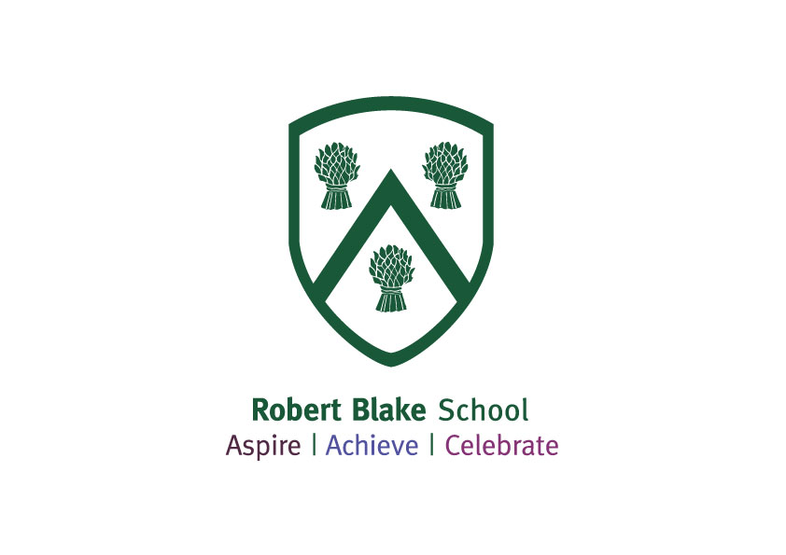

**Robert Blake School**

**General Application Information**

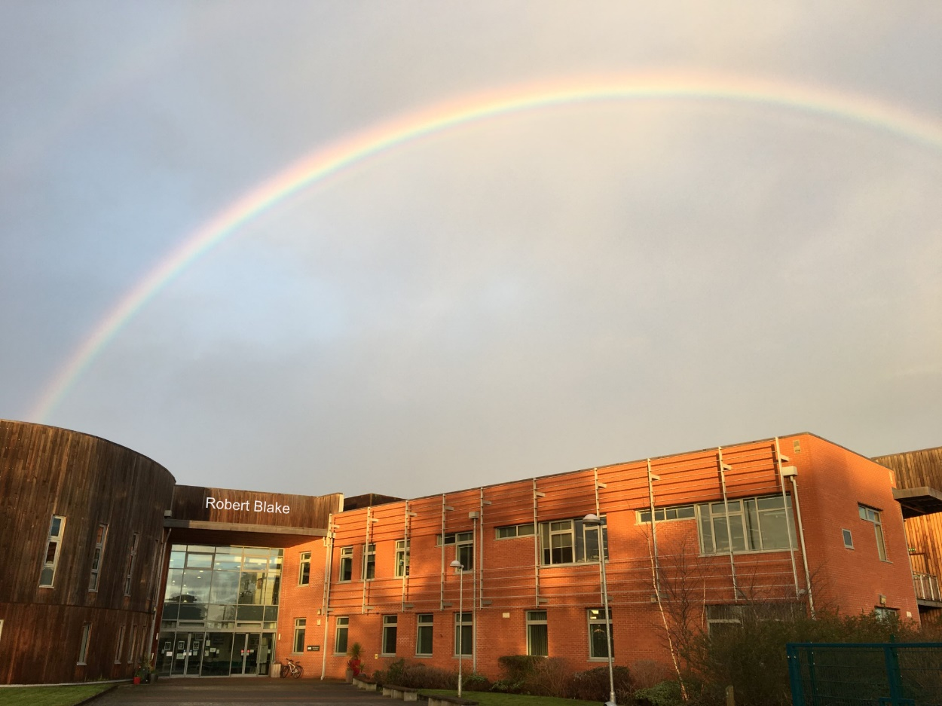

This pack contains some general information about the school. As separate documents, you will find a job description and an application form. I would also draw your attention to the school website, which contains a significant amount of additional information about the school. Our twitter feed (@RobertBlakeSC) and Facebook page (facebook.com/RobertBlakeSC) will give you a better insight into our most recent celebrations of student achievement.

Applications should be sent or emailed to Mrs Debbie Downton ([debra.downton@robertblake.org.uk](mailto:debra.downton@robertblake.org.uk))

Dear Applicant

I am delighted that you are interested in working at Robert Blake School and look forward to welcoming you to our friendly school for a visit if you wish. We are looking for staff committed to the school’s ethos of ‘Aspire|Achieve|Celebrate’.

All post holders take a lead role in improving the life chances and accelerating progress for all students regardless of their starting point. Ultimately, we want our students to be the best version of themselves and leave Robert Blake at the end of Year 11 academically and socially successful, ready to take their respectful place in society as a positive citizen whether globally or locally. Successful candidates will need to be committed to the school’s vision and have a relentless drive for improvement.

Robert Blake is at an exciting time of change with a rapidly growing student population, state of the art facilities, including new classrooms and science laboratories, which we recently moved into. Our expansion in student numbers has been matched by increased staffing to support those students. Over the last year, as well as more teaching posts, we have created a number of additional posts aimed at providing pastoral support to students post pandemic.

In our latest Ofsted Inspection (October 2023), we were delighted that Inspectors noted many of our positive attributes. Improvements since the previous inspection were recognised stating, “The school has raised its expectations for pupils.” The Personal Development of our students was recognised as ‘Good’ with the report acknowledging that, “Pupils in all year groups take part in a well-structured careers programme. Pupils enjoy wider opportunities.” The Behaviour and Attitudes of our students was also recognised as ‘Good’ with the report acknowledging that, “Pupils are punctual and typically follow routines well. Pupils have good attendance.” Despite having a 4-year trend of improvement in academic success prior to the pandemic, the school has found it challenging to regain this success. The school have been disappointed with outcomes over the last two years and is working hard to improve pupils’ achievement through specific strategies. We recognise that there is work to be done; however, there is also much to celebrate at the school and we are well placed to improve.

As the school has received two Ofsted judgements of ‘Requires Improvement’, despite improvements being made, the school has decided to join United Learning to support the schools development. The school has taken this decision after a robust consultation period and are very positive about joining this Trust.

At Robert Blake we value every person in our school community and we aspire to do our very best. We have high expectations of ourselves and our students and celebrate our achievements within and beyond the school community. We value teachers and will provide excellent opportunities for you to build on your skills and experience for promotion or progression in your career. Our fantastic CPD programme supports this and recognises the benefits of lifelong learning.

We have very close links with a number of partners including the COMPASS group of local primary schools, other secondary schools, FE colleges and alternative providers in the area. These partnerships support our key aims of ensuring that students make the best possible progress in order to achieve the qualifications and experience they need to reach their aspirations.

I look forward to receiving your application.

Yours sincerely

Miss Deb Loveridge  
Headteacher

**Choosing Robert Blake School**

**The School**

Robert Blake School has traditionally been, and still is, a welcoming, supportive school that promotes diversity, inclusivity and strong relationships with high aspirations for all children and young people. The school is housed within a modern, inspirational, well designed and well-equipped building.

More importantly, it is well led so that staff are carefully and considerately inducted, encouraged and supported so that each person is able to develop their professional practice at whatever stage of their career they may be. In our most recent survey, 100% of staff say they are proud to work at Robert Blake and 94% of staff believe the school is well led and managed.

Serving a catchment that includes a significant level of deprivation, our staff work as a strong team. You will encounter many delightful, sparky and talented students whom we encourage to Aspire, Achieve and Celebrate.

Whilst you will have seen that our most recent Ofsted inspection designated Robert Blake School as Requiring Improvement, the inspectors praised the progress that the school has made in recent years; areas they identified for improvement are being addressed in a determined and conscientious manner.

In order to make faster progress towards improving outcomes for our students, the governing board took the decision in November 2023 to join the United Learning Trust. This will bring many benefits for our community and we look forward to joining them in the near future.

**United Learning**

United Learning is a leading group of schools aiming to offer life-changing education to young people across England. Whilst each school retains its individuality and distinctiveness, they also work as a team and achieve more through collaboration than any single school could. Trust subject specialists, a group-wide intranet, a carefully sequenced curriculum and an on-line learning portal promote the sharing of knowledge and resources, thereby simplifying work processes and making an improved work-life balance much more attainable.

In addition, United Learning can reward staff with good career opportunities, better pay, benefits, and ultimately the satisfaction of helping students succeed. Academies in the United Learning Trust also invest in staff wellbeing and promote ‘the best in everyone’, which directly aligns with our school values and vision.

United Learning offers:

* a competitive salary;
* excellent ongoing CPD, career development and promotion;
* disruption-free learning through an effective behaviour system;
* up to 8 inset days per year, dedicated to personal wellbeing, subject knowledge development and planning/resource development;
* the opportunity to save money across hundreds of major retailers, through Perkbox (over 250 exclusive benefits);
* employee Assistance Programme;
* staff recognition schemes;
* free membership to Chartered College of Teaching for all teachers;
* specialist subject advisors;
* access to a contributory pension scheme;
* enhanced parental leave policies.

**Bridgwater, Somerset and the West Country**

**Bridgwater** is a historic [market town](https://en.wikipedia.org/wiki/Market_town) with a population of approximately 41,000. The town lies along both sides of the [River Parrett](https://en.wikipedia.org/wiki/River_Parrett) and has been a major inland port and trading centre since before the industrial revolution. It was from Bridgwater that the Duke of Monmouth led his troops to the last battle fought on English soil at Sedgemoor.

The town’s most famous son, however, was a more successful commander, the Admiral-General Robert Blake who reorganised the navy and led it to many victories in the 17th century. He bequeathed land to the town on which our school stands.

In recent years the town centre has undergone redevelopment to provide a better shopping experience and easier access to its train station. In addition to a wide range of shops, the town has an arts centre, a theatre and plays host to the famous [Bridgwater Guy Fawkes Carnival](https://en.wikipedia.org/wiki/West_Country_Carnival).

Situated just off the M5, transport links to the rest of the country are good. There are regular trains to Bristol, Taunton and Exeter, whilst the Berry’s Superfast service provides very cost-effective coach travel to London, and the Megabus can quickly take you to nearby Bristol Airport. If you are in less of a hurry, you can walk or cycle along the canal to Taunton, taking in the Somerset Space Walk as you do so.

Easily accessible from the town is some of the most beautiful countryside in the UK. To the west lie the Quantock Hills, a National Landscape. This was the first piece of countryside to be designated an Area of Outstanding Natural Beauty. Explore and you will find rocky Jurassic coastline, exposed heathland summits, deep wooded combes, undulating farmland and attractive villages. To the east are the [Somerset Levels](https://en.wikipedia.org/wiki/Somerset_Levels), a land of Arthurian legend above which presides Glastonbury Tor. Head North and you find the traditional seaside resorts of Burnham-on-sea, Weston-Super-Mare and Clevedon. To the south of Bridgwater is the county town of Taunton and from there Exeter, Exmoor (a National Park), Dartmoor and the Devon and Dorset coastlines are within easy reach.

Whether you are looking for the energy of city life or the gentle charms of the countryside, nearby you have both!

**The School Context**

Robert Blake School is an 11-16 comprehensive with an admission number of 210 students per year group, with the likelihood of this increasing in the future. The school currently has just short of 1070 students on roll and we expect this to continue to grow over the coming years. We have been oversubscribed for the last few years and have taken a bulge year group of 240 into Year 7 in September2023. We have recently expanded into a number of additional classrooms and science laboratories, as well as increased dining, social, and office spaces. This space was previously occupied by Elmwood School, but has now been remodelled to provide us with further state of the art facilities.

The school serves the most deprived community in Somerset in terms of social and economic deprivation. Currently 37.7% of students are categorised as disadvantaged. We are an inclusive school with high levels of SEN (20.1%) and we have an increasing number of students from minority ethnic groups (17.6%).

We value the individual and get to know our students really well. We strive to ensure each student achieves their potential through an intensive system of monitoring progress and by challenging and supporting at all levels. Our knowledge of the individual student enables us to provide stimulating and challenging opportunities for the highly-able and scaffolding support for the less able.

The school has an incredibly strong culture of staff togetherness and sharing practice and it is this drive for school improvement, through the improving leadership and quality of teaching and learning, which makes Robert Blake such an exciting place to work.

**Accommodation and Facilities**

In November 2012 Robert Blake School moved into a contemporary new building, one of the last under the Building Schools for the Future programme. The building has been designed to a very high standard and boasts wonderful facilities throughout all areas. It is light, airy, and has been designed to allow a flexible approach to learning.

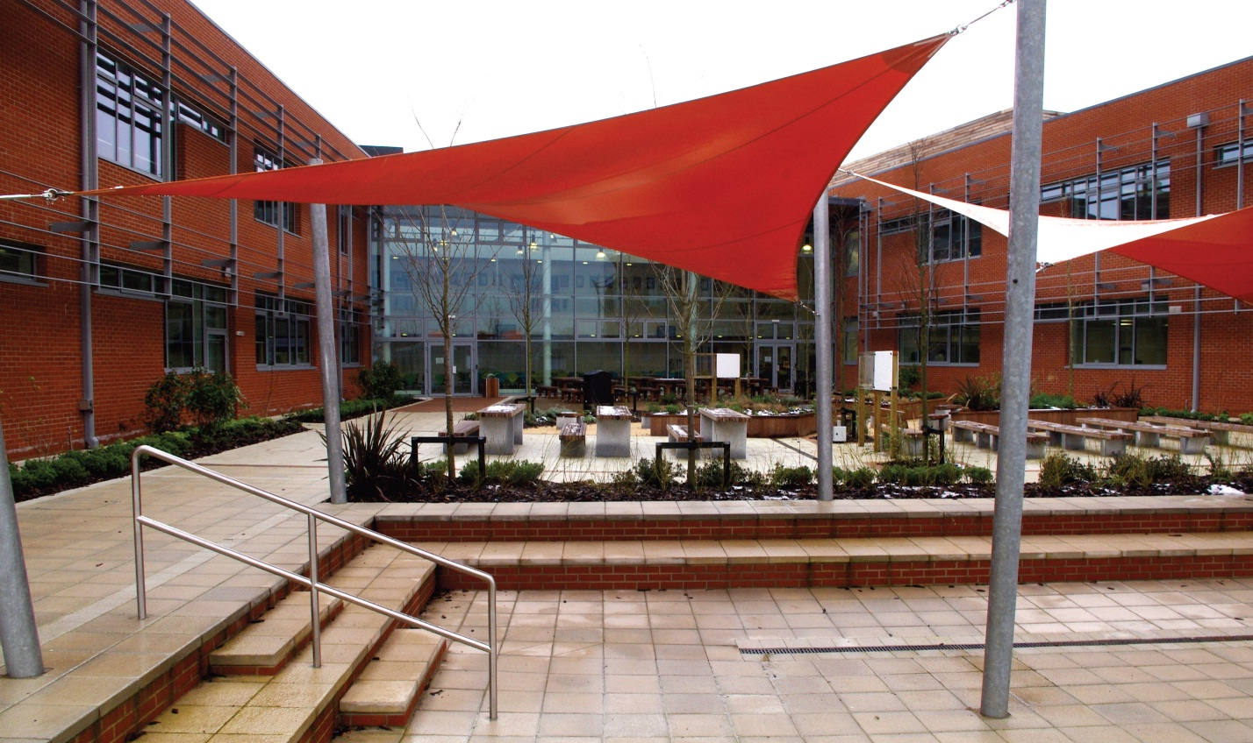

Following the move of Elmwood School to a new site in another part of Bridgwater, we have been able to expand our provision within the building to allow for an eventual student population of 1200. The new facilities have given us another 12 general classrooms, 3 additional science laboratories, increased dining facilities and social spaces, as well as associated meeting rooms and offices. Also on site, accessed through the main entrance, is a paediatric health centre funded through the NHS as part of the build.

The school has been built by BAM under a PFI scheme, with BAM FM carrying out all facilities management under the terms of the 25 year contract. Previous school site staff were TUPE transferred to BAM FM in November 2012. Outside of school core hours (7am-6pm) leisure services are managed by 1610, a Somerset based leisure trust. **Staff have free access to the fitness facilities.**

ICT technical support in the school is delivered by Research Machines (RM) through a managed service contract. Facilities are extensive and include:-

* 2 ICT suites with fixed PCs;
* The latest Smartscreens in all learning spaces;
* Laptops and iPads for all curriculum areas.

[https://concept4photography.com/Robert_Blake_2017/Media/transparent.gif](https://concept4photography.com/Robert_Blake_2017/Photography.html#106) [https://concept4photography.com/Robert_Blake_2017/Media/transparent.gif](https://concept4photography.com/Robert_Blake_2017/Photography.html#106)

As the school expands, we will continue to push the boundaries of technological innovation in order to support learning inside and outside of the classroom.

The school’s budget is in a healthy position. Long term planning and investment has protected the budget against the adverse effect of the PFI Scheme. The school moved into the 2023/24 financial year with a healthy revenue, together with a rising roll. In addition, the new National Funding Formula has seen an improved allocation for Somerset schools; however, we are always financially vigilant and wary of increasing financial pressures on schools, most recently through energy price rises and pay awards.

**Partnerships and Collaboration**

Robert Blake is firmly committed to working in effective partnership with secondary schools, primary schools, special schools, Bridgwater and Taunton College, and alternative providers both on and off site; sharing learning and resources, extending opportunities for students, and ensuring post 16 progression.

The school works closely with our cluster of primary schools, known as the COMPASS group, to ensure smooth primary to secondary progression and develop a strong culture of achievement. We continue to work on effective pastoral transition of students from the primary to secondary phase and with a Post 16 panel to focus on a smooth transition from KS4 to KS5 in local colleges and businesses. We are members of the Somerset Association of Secondary Headteachers (SASH) and also work closely with other Sedgemoor schools. We also maintain strong working links with Polden Bower School, having been co-located with Elmwood School for a number of years.

We are heavily involved with PiXL programmes. We have a very strong relationship with TeachFirst, enabling us to recruit and support the development of new teachers into the profession within the subject areas of Maths, English, Science, History, Geography and MFL. To date every teacher completing the TeachFirst programme at Robert Blake has been judged as outstanding. We also work with the Mid Somerset Consortium (MSC) and offer appointments to trainee teachers in many subject areas through salaried routes. We have received very positive reports from our partners regarding the work we do with our Early Career Teachers.

**As a New Member of Staff**

As a new member of staff, in addition to working with our fantastic students, being part of a wonderfully supportive staff group, and working in an inspiring environment, you will benefit from the following:

* the offer of a welcome visit to school before your start;
* a full induction pack in advance of your start;
* a ‘buddy’ to support you in your day to day life at school as you get to know your way around;
* specific support and training sessions geared to new staff;
* tailored CPD, which underpins the development needs of the school, but is also personalised to recognise individual needs for staff at different points of their career;
* development opportunities beyond your immediate role, to support personal development and career goals;
* priority given to staff wellbeing.

**As a member of staff new to the profession**

We welcome applications from teachers who are new to the profession and offer an exceptional package of support. As well as all that is mentioned above, trainees and Early Career Teachers will benefit from having a fully trained mentor to assist them with subject specific support. We ensure that meeting time is prioritised and protected within the school day and we ensure the correct amount of non-teaching time is allocated for you and your mentor. We use an external, accredited provider to maintain the consistency and quality of training throughout the first two years in the profession.  A member of the senior leadership team will also have specific responsibility for quality assuring the in-school training and support and will meet regularly with ECTs as part of the school’s commitment to inducting and supporting all teachers.