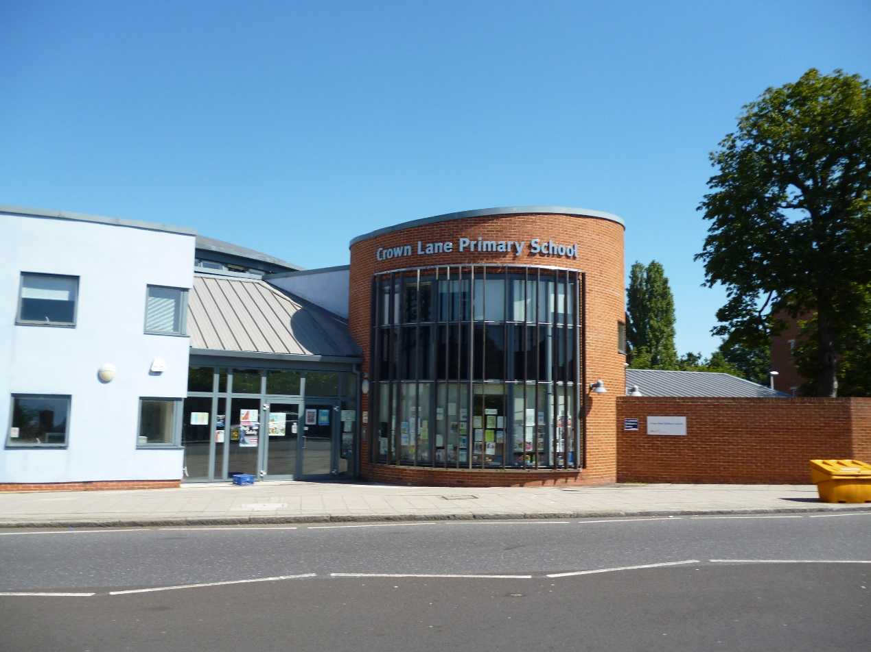

Human Resources/Finance Officer and Deputy Safeguarding Lead
Application Pack

Crown Lane Primary School and Children’s Centre

Head Teachers Welcome

Welcome to Crown Lane Primary School and Children’s Centre. We are a closely knit community situated on the borders of Lambeth and Croydon. At Crown Lane we work seamlessly with our neighbouring family of schools, however what makes us so very special is the fact that we are a truly inclusive community and we are incredibly proud to be so!

We are a happy school and we delight in being friendly and approachable. We welcome families from every corner of the globe and more than 20 languages are spoken within our walls. These are celebrated at my weekly assemblies. While we are not a faith school, we recognise and respect every religion and we regularly have celebrations for events such as Easter, the Chinese New year, Diwali and Eid. We love diversity and we celebrate this at every available opportunity!

Although we are a mainstream school, we have children with a variety of special educational needs and we are fortunate enough to have a Specialist Autism Resource Base. We believe in regularly celebrating the successes of every member of our community, no matter how small. We continue to hold the award of ‘Centre of Excellence’ for our highly inclusive approach to how we work with our community.

I am incredibly lucky to work with such a generous, friendly and hardworking team of staff who consistently do their absolute best for the children in our care. Our team come from a variety of backgrounds and experiences which bring a wealth of skill to our school. At Crown Lane we have a programme of staff wellbeing to ensure that staff work life balance remains at the forefront of how we work.

We have a vibrant Parent Teacher Association who host fun events for our children and help to raise much needed funds.

We want all of our families to know that their voices are heard and so we also run a ‘Parent Forum’ where parents and carers can help me to make important decisions that shape our future.

I would encourage you to come and visit with us and see for yourself the rich and colourful tapestry that is Crown Lane!

Gavin Farrell

