

**HR & Office Manager**

**Candidate Information Pack**

**February 2025**

**Welcome from the Headteacher**

Dear Prospective Candidate,

Thank you for your interest in joining our dedicated and compassionate team at Cann Bridge School as our new HR & Office Manager. I am delighted to introduce you to our school and the exciting opportunities that await you here.

Located in Estover, Plymouth, Cann Bridge School is a local authority-maintained special school serving children and young people aged 3 to 19 years from Plymouth, Devon, and Cornwall. With a capacity for 108 pupils, we are an oversubscribed school, currently educating 118 learners. Our students have complex cognition and learning needs, with many having additional specific learning difficulties or complex medical conditions. To learn more about our school, please visit:

* Website: [www.cannbridgeschool.co.uk](http://www.cannbridgeschool.co.uk)
* Facebook: [www.facebook.com/cannbridgeschool](http://www.facebook.com/cannbridgeschool)
* School Newsletters: [www.cannbridgeschool.co.uk/families/newsletters-forms](http://www.cannbridgeschool.co.uk/families/newsletters-forms)

We are seeking an exceptional candidate to join our dynamic team and contribute to our collaborative and progressive environment where every learner thrives. In this role, you will oversee office operations, manage our administrative team, and ensure the accuracy of our information system, Bromcom. Your dedication to continuous improvement will help refine our processes and procedures, creating a welcoming, organised, and efficient front office that supports staff, learners, and visitors alike.

You will be responsible for managing payroll, recruitment, and staff retention, working closely with our team of over 130 personnel. Your expertise in HR policies, employee relations, and compliance will ensure we stay at the forefront of educational excellence. As a member of the Staff Wellbeing Group, you will promote staff well-being and coordinate performance management, staff induction, and professional development.

As the main GDPR contact, you will manage data protection processes, handle Subject Access Requests and Freedom of Information requests, and oversee data breaches. You will collaborate closely with our Finance & Data Manager and Headteacher and report to Governors regularly.

If you are passionate about nurturing a warm, welcoming, and learner-focused environment while ensuring smooth operations, this is the ideal role for you. Join us in shaping our school's success, and let's make a difference together. We welcome applicants to visit the school prior to applying and look forward to receiving your application.

Warm regards,



Shane Baker

Headteacher

**Our Vision & Values**



**The Role**

* School Administration – Oversee office operations, manage administrative staff, manage the school information systems (MIS) ensuring system remains accurate and up to date. Actively work to improve and refine systems, processes and procedures ensuring the front office remains welcoming, organised and efficient.
* Staff Personnel Management – Manage payroll, recruitment and retention (i.e. adverts, coordinate recruitment process, process contracts, badges, email accounts, welcome packs), HR policies, employee relations and HR queries from staff (be an active member of the Staff Wellbeing group), compliance (SCR, DBS checks), absence processes, recording, monitoring and reporting (including holding initial return to work meetings) action welfare meetings and 100% attendance, cover arrangements, coordinate performance management process and tracking, and staff induction and tracking. Process Employer Assistant Programme insurance claims timely. Administrate and coordinate all investigations and formal processes, minuting meetings where necessary. Provide HR advice to Governors and ensure legal compliance. Oversee leavers processes including coordinating and tracking exit questionnaires and interviews. Process Occupational health Referrals.
* Continuous Professional Development – Maintain CPD records, oversee staff training, and ensure compliance for Ofsted inspections working closely with Deputy Headteacher and Finance Manager.
* GDPR Compliance – Act as the main GDPR contact, oversee data protection processes, handle Subject Access Requests and Freedom of Information requests, and manage data breaches, uploading these to Judicism.

Working closely with Finance Manager and Headteacher

Report termly on areas of responsibility in Headteacher Report to Governors. Attending Governor Meeting Regularly.

Contribute to sharing school news on website, social media, newsletters and local media

**Line Manage:** Administration Team

**Organisation Structure**

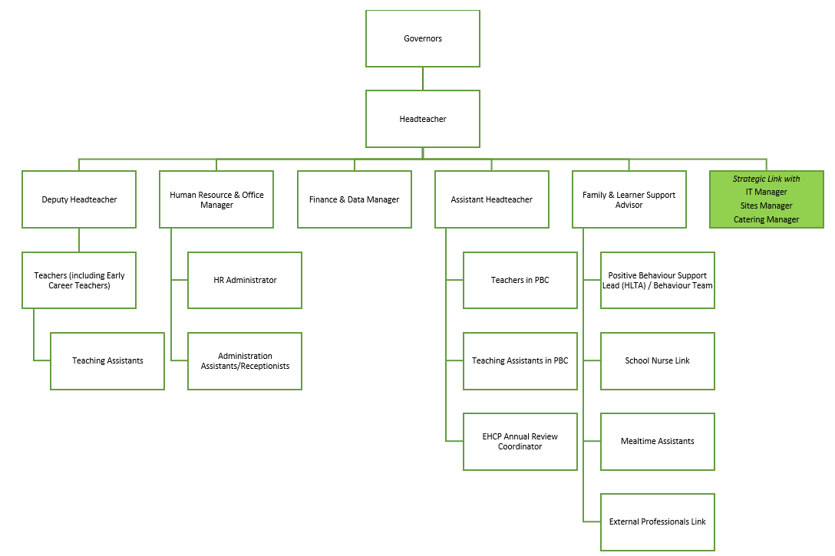

**Why Work for Us?**

At Cann Bridge School, we cultivate an environment where both learners and staff can thrive. Our learners benefit from a well-structured curriculum, a supportive staff team, and a purposeful learning environment, all designed to help them grow into confident, well-rounded, and independent young adults. This success is made possible by our talented and dedicated team, who work together to ensure that every child has the opportunity to succeed both academically and personally.

When you join Cann Bridge School, you’ll become part of a committed team that values your professional growth.

We offer:

* Bespoke Continuing Professional Development (CPD) tailored to your individual needs and career goals
* Access to the Local Government Pension Scheme for future financial security
* An excellent Employee Assistance Programme, offering physiotherapy, counselling, wellbeing services, and private healthcare options (where applicable) through Education Mutual
* Staff Discounts on a wide range of products and services through the Blue Card professional student discount scheme
* The opportunity to work with incredible children, young people, and a dedicated staff team

**Recruitment Timeline**

* Opportunities to visit Cann Bridge School: Please contact the school to arrange your visit 01752 207909 or [HR@cannbridge.co.uk](mailto:HR@cannbridge.co.uk)
* Application closing date: 9am 28th February 2025
* Candidate shortlisting: Afternoon 28th February 2025
* Interviews: Tuesday 4th March 2025

Complete applications should be sent to: HR@cannbridge.co.uk



**Job Description: HR & Office Manager**

Cann Bridge School is committed to creating a diverse workforce. We’ll consider all qualified applicants for employment without regard to sex, race, religion, belief, sexual orientation, gender reassignment, pregnancy, maternity, age, disability, marriage, or civil partnership.

**Job details**

**Position:** HR & Office Manager

**Location:** Cann Bridge School, Estover, Plymouth

**Grade:** G

**Job Type:** School Management Role

**Salary:** **£36,124 – £38,626 FTE £25,083 - £26,820 Pro Rata**

**Contract type:** 30 hours per week, term-time, permanent

**Reporting to:** Headteacher & Designated Safeguarding Lead

**Responsible for:** Administration Team

**Start Date:** As soon as possible

**Main purpose**

The primary purpose of the School HR and Office Manager role is to ensure the smooth and efficient operation of the school's administrative functions, with a particular focus on human resources and office management. This role supports the overall functioning of the school by managing recruitment, staffing (including supply cover), employee relations, compliance, performance management, payroll, managing absence processes, and benefits administration. Additionally, the role provides strategic support in policy implementation, data analysis, and process improvement, as well as leading specific projects assigned by the school leadership team. The School HR and Office Manager also oversees the administration team, ensuring the integrity of its processes and the achievement of objectives and targets, facilitating the performance management, capability and focussed productivity of people they manage

**Duties and responsibilities**

**School Administration Management**

* Oversee administrative procedures to ensure the efficient and effective running of the offices, acting as one of the school's main points of public contact. Liaise with visiting professionals and facilitate meetings and appointments.
* Act as line manager for the administrative assistants and reception staff (office team).
* Conduct regular team meetings and provide guidance.
* Evaluate team performance and provide feedback through the annual performance management system, identifying any training needs for the administration team.
* Ensure the School Information Management System (Bromcom) is maintained and up-to-date to meet the school's needs.
* Liaise with the ICT technician to ensure the smooth operation of office and school ICT systems.
* Organise, pace, and monitor the work of the office and associated staff.

**Staff Personnel Management**

* Responsible for payroll services for all school staff, including processing overtime, supply claims, and claims for travel and subsistence.
* Liaise with LA HR officers as appropriate.
* Compile absence reports and manage attendance documentation.
* Minute confidential staff meetings and distribute documents to attendees.
* Advise the Governors on policies required to comply with current legislation concerning employment protection, equal pay, sex discrimination, etc., and implement these policies in school.
* Liaise with Legal and HR advisors to ensure compliance with employment legislation.
* Support the Headteacher with all aspects of appointments, including advert placement, reference requests, authentication of references, payroll forms, offer letters, and completion of employment contracts for all teaching and non-teaching staff.
* Manage the DBS applications and identification process.
* Manage the collection of staff and pupil data and annual permissions and declarations in accordance with GDPR.
* Supply staff induction/probation documentation and conduct initial staff induction meetings, ensuring staff ID badges and email addresses are arranged.
* Manage and update the Single Central Record (SCR) for all contracted and supply staff, volunteers, Governors, and Agency Staff.
* Lead regular monitoring and audits of the SCR with DSL, Governors, and external scrutiny (e.g., Ofsted and School Audit).
* Contact all visiting professionals and organizations annually for updated letters of assurance and hyperlink evidence to the central record.
* Manage all referrals to Occupational Health.
* Responsible for personnel matters for all staff, including clearance for new staff (medical, child protection, qualifications), and day-to-day aspects (e.g., staff sickness records, leave of absence, personal records).
* Manage all staff absence claims through the absence insurance provider.
* Provide advice to Governors, in conjunction with the Headteacher, on salaries, sickness and maternity procedures, redundancy, and other matters of dismissal.
* Complete Teachers Salary Statements annually.
* Provide Governors with Termly Staff Absence monitoring reports.
* Maintain confidential staff records, including staff accident records.
* Assist in organizing supply cover as needed.
* Review and authorise all agency supply claims.
* Manage the school administration team and conduct annual staff appraisal meetings.
* Conduct initial return-to-work meetings with staff who do not meet the triggers for a welfare or absence review meeting.

**Continuous Professional Development**

* Oversee the record-keeping of all in-service training for all staff. Manage the CPD database and link the spreadsheet to the SCR for Ofsted inspections.
* Oversee the organisation of attendance at external training courses.

**GDPR**

* As the schools main GDPR contact, oversee any Subject Access Requests and Freedom of Information Requests.
* Record any data breaches, keep accurate records, and liaise with the Data Protection Officer (DPO).

**General**

* Attend relevant Governors' committee meetings when personnel information is required.
* Manage all aspects of school management in a sustainable and eco-friendly manner.
* Undertake duties and work hours as agreed with the Headteacher and carry out additional tasks as required by the Headteacher.

Please note that this is illustrative of the general nature and level of responsibility of the role. It is not a comprehensive list of all tasks that the HR & Officer Manager will carry out. The postholder may be required to do other duties appropriate to the level of the role, as directed by the headteacher or line manager.



**Person Specification: HR & Office Manager**

|  |  |  |  |
| --- | --- | --- | --- |
| **Criteria** | **Qualities**  **Essential** | **Qualities**  **Desirable** | **Method of Assessment** |
| **Qualifications and knowledge** | * CIPD (Chartered Institute of Personnel and Development) Level 3 Foundation in People Practice. * A relevant qualification in Business Administration. * GCSE Grade C or 5 in English and Maths * Full working knowledge of HR regulations, relevant policies, codes of practice, and awareness of legislation such as Child Protection and Data Protection. * Understanding of employment laws and regulations. * Knowledge of GDPR and data protection principles | * Bachelor's degree in Human Resources, Business Administration, Education Management, or a related field. * CIPD (Chartered Institute of Personnel and Development) Level 5 Diploma. * Knowledge of Single Central Record (SCR) requirements. * Familiarity with educational policies and procedures. * Understanding of Ofsted inspection requirements and processes. | Application form |
| **Experience** | * Proven experience in HR management, office management, or a related administrative role. * Experience in managing payroll and benefits administration. * Experience in office management or a related administrative role, ensuring efficient and effective office operations. * Experience with recruitment processes and performance management. * Experience in minuting confidential staff meetings and collating reports for disciplinary hearings. * Experience in the development, management, and operation of administrative systems and leading a team. * Experience of dealing with confidential information * Knowledge of GDPR and data protection principles * Experience in absence management monitoring. | * Experience working in an educational setting, preferably in a school environment. * Experience of managing medical emergencies in a calm and professional manner * As first point of contact, experience of dealing with confrontational members of the public or parents in difficult situations * Experience in leading and managing a team, including conducting regular team meetings and providing performance feedback. | Application form  Interview process |
| **Skills** | * Ability to handle situations as they arise and experience dealing with difficult conversations and challenging situations. * Strong problem-solving skills and attention to detail. * Strong organisational, prioritisation, and multitasking abilities to meet all deadlines. * Excellent written and verbal communication and interpersonal skills. * Ability to maintain a high level of integrity and confidentiality. * Ability to lead and motivate a team. * Effective use of specialist ICT packages to support office functions. * Proficiency in using HR software and School Information Management Systems (Bromcom). * Proficient in Microsoft Office Suite (Word, Excel, PowerPoint, Outlook, Sharepoint, Forms, Teams). * Ability to face new demands, manage conflicting deadlines, and frequently switch attention to cover a wide range of unanticipated tasks daily. * Capability to focus for long periods to research, analyse, and collect a range of information. * Ability to build and maintain effective working relationships with all members of the school community. * Ability to interpret advice/statutes and devise policies/practices accordingly. * Ability to produce management and statistical information in a clear and understandable manner. * Ability to work on own initiative. * A commitment to continuous professional development and improving working practices. | | Application form  Interview process |

This job description may be amended at any time in consultation with the postholder.

**Last review date:** February 2025

**Line manager’s signature:** _______________________________________

**Date:** _______________________________________

**Postholder’s signature:** _______________________________________

**Date:**  _______________________________________