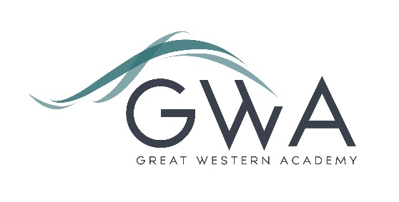

# Information for Applicants

**HR Officer (37 hours per week)**

Great Western Academy opened in brand new, state-of-the-art facilities in North Swindon in September 2018. The Academy is heavily oversubscribed in years 7 to 11 and our first cohort of Year 12 students formed our expanding Sixth Form in September 2019.

Now that the Academy is nearing capacity there is a need for a full-time HR Officer to ensure that all aspects of Human Resource management are well supported.

Application process

Please complete the application and equalities forms supplied and enclose a supporting letter, either in the space provided on the application form or as a separate document. The application form should be completed in full in black ink or type. A CV is not requiredand should not be submitted as part of the application.

Your supporting letter should be no more than 2 sides of A4 (with a font size no smaller than 11) and should enhance your application by providing further information, matched to the person specification, about your suitability for the post. This should include evidence of the impact of any previous work you have undertaken.

Electronic applications should be completed on Eteach or returned via email to [recruitment@gwacademy.co.uk](mailto:office@gwacademy.co.uk)

If you have any questions prior to applying please contact the current HR officer, Mrs D Horn, on [recruitment@gwacademy.co.uk](mailto:recruitment@gwacademy.co.uk)

**References:** References will be taken up prior to interview.

**Closing Date:** 9am Monday 26th February 2024

**Interviews:** Week beginning 4th March 2024

**Please note we may close this advert early depending on the number and strength of applications received.**

*Great Western Academy is committed to safeguarding and promoting the welfare of children, young people and vulnerable adults and we expect all staff to share this commitment and undergo appropriate checks. All posts within the Trust are therefore subject to an Enhanced DBS and barred list check.*