EAST SUSSEX COUNTY COUNCIL Danehill CE Primary
School Lane
Danehill
Haywards Heath
East Sussex
RH17 7JB

Headteacher: Lizzie Overton Tel: 01825 790388 Fax: 01825 790795
Email: office@danehill.e-sussex.sch.uk

26th April 2021

Dear Applicant

Thank you for your interest in applying for the post of Individual Needs Assistant/Breakfast Club Co Ordinator at Danehill Primary School.

We are a small school set within the Ashdown Forest, an area of outstanding natural beauty.
We are looking for someone who is able to take on the above role to work with a child in year 2 for 18.75 hours a week, 8.30am -12.15pm daily (term time only).

The breakfast club co-ordinator role would involve supervising a small number of children whilst providing breakfast for the attendees. All breakfast items would be supplied by the school. The hours would be 7.45am – 08.30am (term time only).

We are developing an innovative approach to Primary Education and would strongly encourage that you visit the school before applying in order to ascertain whether our ethos is one that you would be keen to support. Please contact the school office to arrange a convenient time for this.

Yours sincerely

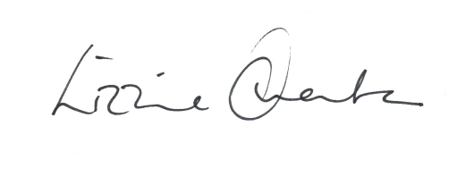

Lizzie Overton
Headteacher

