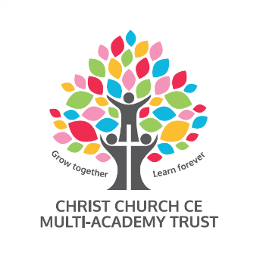

Christ Church CE Multi Academy Trust
School | St John’s CofE Primary School
Post | Inclusion and Pastoral Teaching Assistant L3
Hours | 25
Pattern | To be discussed at interview
Contract | Permanent – Term Time only
Grade | Grade 8 – Scale Point 12 – 17
Salary | £22,183 - £24,491 FTE
Required from | 1st November 2021 or as soon after
Closing date | Friday 8th October 2021 noon
Shortlisting date | Friday 8th October 2021
Interview date | Thursday 14th October 2021

Our Trustees are seeking to appoint a highly skilled Teaching Assistant to work as part of the Pastoral Team to support the teaching and learning of all children with additional needs across the primary age range.
The successful candidate will provide one to one and group support for the academic, behavioural and emotional development of children. The role includes the delivery of a range of activities across the curriculum.
We are looking for someone who is:
- Patient and nurturing
- Skilled in supporting children with complex special education, SEMH, and challenging behaviour.
- Able to identify barriers to learning and know how to provide a range of strategies for overcoming those barriers.
- Knowledgeable about how children learn across the full primary age.
- Flexible and able to adapt quickly to support colleagues and children.
- Able to work in partnership with colleagues, parents, carers and outside agencies to secure the best outcomes for our children.
We are looking for someone who has:
- High expectations of themselves and the children they work with.
- Excellent communication, interpersonal and administration skills
In return, we can offer a friendly, supportive and committed staff team, wonderful children and good opportunities for professional development.

As a member of the team, you will work with:

- A friendly, welcoming community
- Children who enjoy coming to school
- A committed and enthusiastic team of staff under the Christ Church Multi Academy Trust
- An engaged, proactive and supportive Local Academy Committee
- Regular high quality professional development and coaching

We place wellbeing central to our work, striving to ensure that children and adults learn in a safe, supported, nurturing environment, where they feel confident, worthy, enthusiastic and valued.
The Trust is committed to safeguarding and promoting the welfare of children and young people and expects all staff and volunteers to share this commitment.

For further information regarding this post please contact stjohnsradcliffe@bury.gov.uk

Shortlisted applicants will be contacted within 48 hours of the closing date to be invited for interview. If you are not contacted within two weeks of the closing date, please assume that your application has been unsuccessful on this occasion.

The Trust has an Equal Opportunities policy. If you consider yourself to be disabled, please state the nature of your disability, giving details of how we can accommodate your needs should you be selected for interview and subsequently appointed.

In accordance with the Data Protection Act, the details provided in the application form will be used for selection and interview procedures and for employment records if your application is successful. A copy of our Recruitment Privacy Notice can be found on The Trust’s website. Safer recruitment practice will be followed at all times.

Prior to taking up the appointment, the successful candidate, will be asked to provide documentary evidence (including National Insurance Number) showing their entitlement to work in the UK.

Appointment is subject to a satisfactory enhanced disclosure from the Disclosure and Barring Service, Childcare Disqualification Check and other pre-employment checks.

To apply for this position please download the application form and supporting documentation and send completed applications to recruitment@ccmat.co.uk clearly stating the post and school you are applying for.

