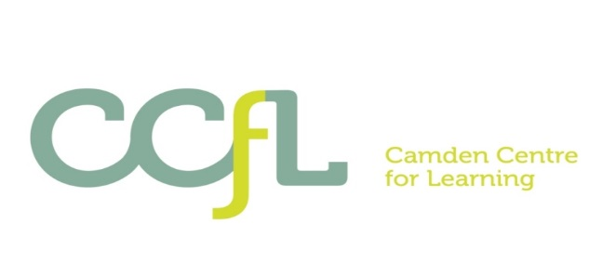

Camden Centre for Learning (CCfL)

Inclusion Coordinator

PAY LEVEL SO2 £32,286 - £34,060 FTE
HOURS OF WORK: 36 hours a week x 39 weeks

The CCfL requires a dynamic and innovative professional to be a part of the CCfL behaviour and safety team. To play a key role in assisting in support, inclusion and intervention for students with social, emotional, and mental health difficulties (SEMH) and learning needs.

Please see job description for more details.

The CCfL is an integrated Special School and Pupil Referral Unit for secondary aged students with Social Emotional and Mental Health (SEMH) difficulties and additional learning difficulties across Camden.

We cater for 100 young people who require specialist SEMH provision, including those identified as requiring such provision through an EHCP, those who have been permanently excluded from mainstream school, or are at risk of being permanently excluded, and those needing a short-term intervention to prevent exclusion.

How to Apply
Please visit our website www.ccfl.camden.sch.uk to download application pack. Please send completed applications to admin.ccfl@camden.gov.uk . If you would like any information about this post, please contact 0207 974 8906 and speak to Assistant Headteacher – Laurel Endelman

The CCfL School is committed to safeguarding children and promoting the welfare of young people and the successful candidates will be subject to an Enhanced DBS check.

Closing date for applications: Tuesday 25.01.2022 at 9.00am. Interviews w/b 31.01.22

