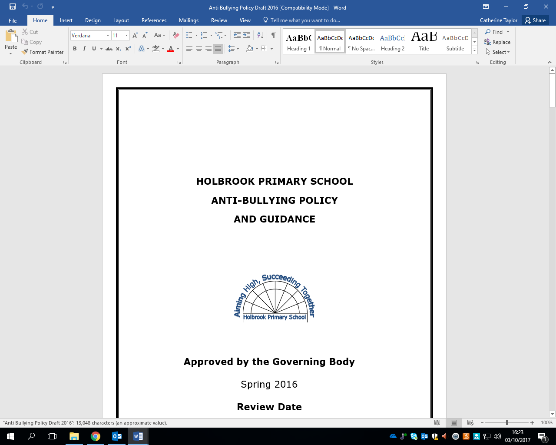HOLBROOK PRIMARY SCHOOL
Headteacher: Mr Ian Holmes BSc. (Hons) NPQH
Holbrook School Lane, Horsham,
West Sussex RH12 5PP
Tel: 01403 272500
http://holbrookschool.co.uk
mail: office@holbrookprimaryschool.com

June 2026

Dear Applicant,

Thank you for expressing an interest in the role of SENDCo/Inclusion Lead at Holbrook Primary School. This is an exciting opportunity for an enthusiastic person to join in the future development of our happy and successful primary school, with high standards of behaviour and achievement.

Holbrook Primary School is a popular and highly-regarded two-form entry primary school located in Horsham, with 420 pupils from Reception to Year 6. We value professional relationships and work hard to create a healthy school culture that is focused on engaging learning and excellent teaching, underscored by a warm and welcoming nature with pupils, teachers, support staff, parents and the community at large. We are also committed to staff well-being and manageable workloads. Consequently, staff turnover is very low as people love working and being here.

At Holbrook, we have high aspirations for every child at the school and are committed to every child attaining their potential through experiencing a broad range of learning opportunities. We are dedicated to delivering a rich and exciting curriculum that will provide all children with valuable skills to go on to become successful life-long learners, confident individuals and responsible citizens.

Our talented and dedicated team of teachers and support staff work exceptionally hard to offer the best possible education for all our pupils, challenging each individual within a caring and supportive culture.

If you have any questions or queries about the post prior to application, please call 01403 272500 or email me via office@holbrookprimaryschool.com

If you have a strong desire to help pupils of all abilities achieve the best they can, whilst fulfilling your own potential, we would very much welcome your application.

Yours sincerely

Ian Holmes

Ian Holmes
Headteacher

