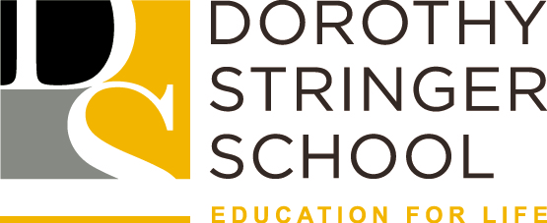 | PERSON SPECIFICATION

JOB TITLE: | Inclusion Manager
SECTION: | Secondary School
___________________________________________________________________

Essential criteria

Job-related education, qualifications, and knowledge
- NVQ Level 3 or higher qualifications in relevant areas or equivalent experience
- Comprehensive and up-to-date knowledge of inclusion regulations and current guidance
- Good understanding of child protection policies, legislation and issues
- Good understanding of school systems and processes
- Good understanding of the intellectual, personal, social, and emotional needs and expectations of students

Experience
- Significant experience of working in a school’s inclusive provision e.g. Alternative Curriculum, Inclusion Mentors and other SEMH interventions
- Significant experience of line management; lead, motivate, support, challenge and develop staff to secure high standards of work and continuous improvement.
- Good experience of direct work with children with additional needs and their families
- Experience of managing/handling/resolving conflict between parties

Skills and abilities
- To be able to build strong working relationships, in particular to forge close partnership with the SENCO and Deputy Head to lead, motivate, support, challenge and develop staff to secure high standards of work and continual improvement.
- To be able to identify and allocate resources, so that the caseloads of the Inclusion mentors is suitably managed.
- To think creatively to develop and manage the school’s inclusive provision.
- To be able to lead staff in the development of SEMH interventions and review their effectiveness.
- A high level of communication skills, to keep whole staff groups as appropriate, informed about the developments with student groups coursing concern.
- To advice, plan and support staff groups working with student coursing concern.
- The ability to work with other professionals and partners in the community to promote the good name of the school, contributing to positive outcomes for all students through developing and maintaining strong partnerships.

Health and safety knowledge
- Commitment to acquiring awareness and knowledge of Health and Safety policy and practice as it applies in their area of work.
- Ability to co-operate and adhere to Health and Safety Policy, practices, and instructions.

Diversity and inclusion
- Demonstrate a genuine commitment to the council’s values in relation to embracing diversity and provide a service based on fairness and inclusion.

Personal Qualities

- Enthusiasm, optimism and resilience
- High expectations and energy with a capacity for sustained hard work
- Innovative in thought and practice
- Has an understanding of the intellectual, personal, social, and emotional needs and expectations of students.
- Passionate about the education of young people.
- Good sense of humour with the ability to stay calm under pressure
- Can do attitude

Dorothy Stringer is committed to safeguarding and promoting the welfare of children and young people and expects all staff and volunteers to share this commitment and comply with the Department of Education Statutory Guidance ‘Keeping Children Safe in Education’.

