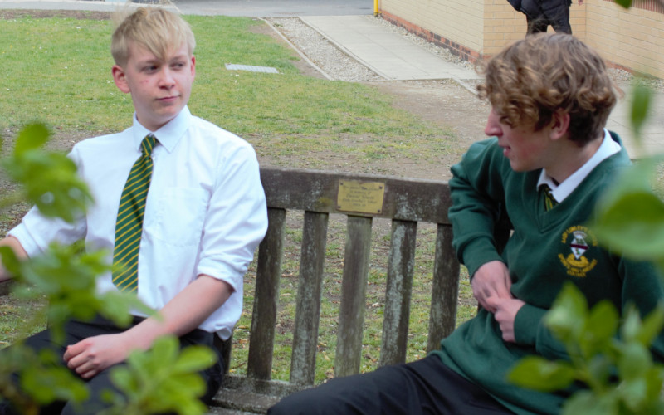

Inclusion Room Manager

Recruitment Information Pack
Lady Lumley’s School
Swainsea Lane, Pickering, North Yorkshire
YO18 8NG

Contents

Welcome from the Headteacher 3-4
Our Visions and Values 4
Our Schools 6-7
Application Process and How to Apply 8
Job Description/Person Specification 8-12

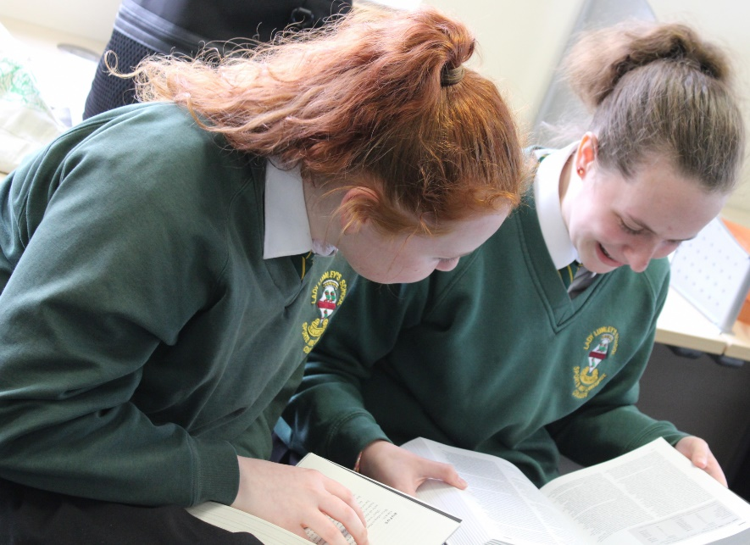

Dear Applicant,

Thank you for taking an interest in joining our staff at Lady Lumley’s. I hope reading about our school gives you a sense of a driven community school, ambitious to do all we can to see staff and students thrive.
Lady Lumley’s has a proud tradition and heritage of providing quality education. A trailblazer in the pursuit of education for all – welcoming the children of farming families and girls long before this was a requirement. Building on those foundations, Lady Lumley’s is a truly comprehensive school of 900 students drawing from the town of Pickering, surrounding rural villages, as well as from Scarborough and all points in-between.

‘Being our best’ signals Lady Lumley’s commitment to school improvement. We are ambitious for all our students and staff to strive to improve teaching and learning through constant evaluation and positivity. Our curriculum offer is broad and balanced, giving students a clear progression route through the school that builds the fundamental knowledge and understanding to allow them to specialise for Key Stage 4 then again at Key Stage 5. Lady Lumley’s curriculum gives all students the best chance of being successful at GCSE, A-Level and Vocational Provision, ensuring our above national average outcomes open doors for life chances.

Our staff are integrated into thorough well-constructed CPD that looks to build strength in the classroom, as well as modelling the pursuit of improvement. Ensuring all our strategic planning is built of evidential educational research is fundamental to ensuring we are investing staff time where it will reap rewards. A love of learning is a necessary mindset to thrive at Lady Lumley’s.

Lady Lumley’s is equally ambitious for our students to experience an enriched learning journey with a diverse offer of experiences. From trips abroad to Bordeaux, Saint Émillion, and Dune de Pyla in France and Weiz in Austria. Our students also visit Belgium and France in Year 10 for the GCSE Battlefields Experience, as well as Krakow and Auschwitz in Year 11, 12 and 13 for Religious Education. There are numerous theatre and music trips and visits taking in everything from opera to pantomime.

The excellent sporting facilities are always fully booked, offering traditional team sports, running, as well as rock climbing and table tennis. Our Duke of Edinburgh scheme is ever popular and Lady Lumley’s students show leadership in this testing qualification right through to the Gold Award. With regular orienteering, canoeing and mountain biking our students also contribute hundreds of hours to volunteering and raising thousands of pounds for charity. Nurturing the growth of students through Enriching their experience enables Lady Lumley’s to prepare students to thrive locally or to move on to different cultures and experiences.

We value our pastoral staff and system as the cement that holds the school together. There are very high expectations of students conduct and a transparent and fair policy for rewards and consequences. All our students are supported through school with dedicated tutors and a Pastoral Officer with additional expertise available from the Pastoral Team and SLT. There are weekly ‘Life’ lessons to educate students with powerful knowledge to enable them to keep themselves safe and to have well placed confidence outside of school. Our staff and students deserve to feel safe and valued throughout their time at Lady Lumley’s.

Lady Lumley’s benefits from the knowledge and experience of Coast and Vale Trust as we are a unique school with a shared Trust vision. Through leadership development, collaboration and investment Lady Lumley’s is enabled to maintain its identity whilst belonging to a larger family of schools.

If you have read this and are committed to joining a school that is driven by ambition to be better, values a comprehensive community school and thrives on being part of a team, then we look forward to meeting you.

Yours sincerely

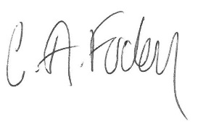
Clair Foden
Headteacher

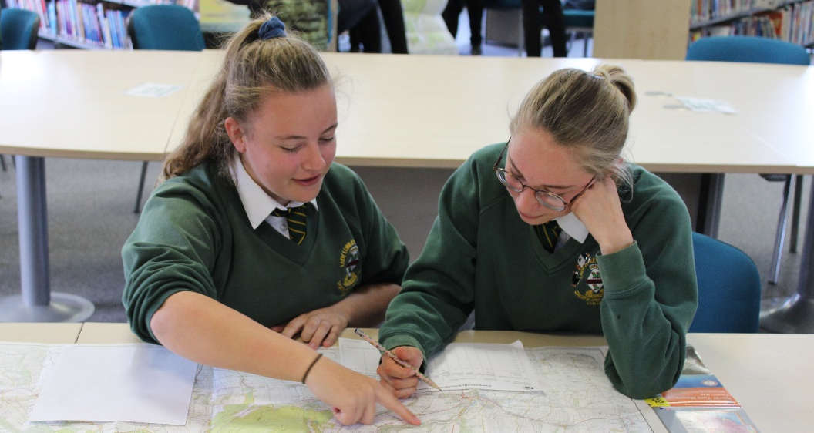

Visions and Values

Lady Lumley’s School is driven by the vision of ‘Being our best’. All staff and all students are asked to commit to our core values:

Learning
Lady Lumley’s core purpose is supporting our students and staff to make progress and continually adapt and develop to become lifelong learners.

Leading
Students and staff have regular opportunities to lead within and outside of the classroom to improve themselves and the community.

Ambition
We are relentlessly positive about improving and seeing all mistakes as ways to learn and improve and exceed our potential.

Progress
The journey through Lady Lumley’s for staff and students is a journey of improvement. Through striving to be our best we will face some setbacks but will build progress over time.

Our schools

Newby and Scalby Primary School

We are one of the schools of choice in our community and we are within commutable distance of Whitby, Teesside, York, and surrounding areas. Ofsted in 2018 judged us to be ‘good’ in all areas and as a school we are very much outward facing both in terms of teaching and learning and in constantly thinking about how we can improve.
Since our “good” Ofsted rating, we continue to build on our successes and we are a family and a team, where everyone is given the challenge and support to be the best they can possible be in a safe, welcoming and positive environment. Children and staff will work and play together developing skills so that we all become ambitious and reflective lifelong learners as well as being respectful and respected members of the community.
To learn more about us please visit us at:
Newby and Scalby Primary School - Home (coastandvale.academy)

Friarage Primary School
We are proud to serve the communities around the Castle Ward area of Scarborough as ‘Together we can’ make a real difference to the lives of children and young people in Scarborough.

Children and staff will work and play together developing skills so that we all become ambitious and reflective lifelong learners as well as being respectful and respected members of the community.
We are committed to Restorative Practice Principles to nurture respect for all in our school community.

To learn more about us please visit us at: Friarage Community Primary School - Home (coastandvale.academy)

Scalby School
Scalby School is a successful and popular 11-16 community school and in recent years we have become the school of choice in our local community. We were judged ‘good’ by Ofsted in 2019 and in 2019 we celebrated sustained results. Our provisional P8 score has placed us in the top 20% of schools nationally. We are proud of our broad and balanced GCSE based curriculum.
To learn more about us please visit us at: Scalby School - Home (coastandvale.academy)

Lady Lumley’s School
Lady Lumley’s School (11-18) in Pickering is on a transformational journey. We are a school that is popular with parents and is easily accessible across North Yorkshire, East Riding and Wolds and Vale. The communities we serve around the Pickering, Ryedale and wider Coastal area deserve and need our school to play a leading role in terms of teaching, learning, progress and outcomes.

In April 2020 we welcomed our new Headteacher Clair Foden who joined us at the same time we joined our Trust - Coast and Vale Learning Trust. Lady Lumley’s is on an ambitious journey of school improvement.

To learn more about us please visit us at Lady Lumley's School - Home (coastandvale.academy)

Scarborough University Technical College

Scarborough UTC is a growing University Technical College (year 9 to year 13) based in a new building, with fantastic technical facilities in the centre of Scarborough. As a University Technical College, we offer a high quality academic and technical education for our students through the specialisms of engineering, health and cyber security. Our unique approach provides students with an excellent range of opportunities including Combined Cadet Force (CCF Navy), strong links to our industrial partners, project-based learning and our flagship Career Development Programme for our Sixth Form students.

Our work with employers and universities ensure we are able to deliver an innovative blend of technical, practical and academic learning which ensures our students make good progress and go on to outstanding destinations.

Our staff are our greatest resource and we have invested in both our teaching and support staff teams which has ensured that educational standards have improved significantly. We have built a staff team of key support and teaching practitioners who are proud to work at our University Technical College.

To learn more about us please visit us at: https://www.scarboroughutc.co.uk

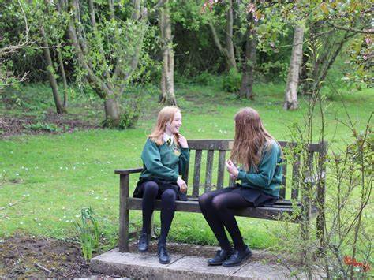

Application Process

Please complete the Trust’s application form which can be downloaded from NYCC Jobs or the school’s website at https://www.ladylumleys.coastandvale.academy/about-our-school/vacancies/ and email your completed form to Helen Poole the Trust’s Recruitment Partner helen.poole@northyorks.gov.uk Tel: 07890 055186.
Please contact us if you need an application form in a different format.
Please note we do not accept CVs.
If you would like to discuss this vacancy or arrange to visit us, please contact as described above.
We will be interviewing for this role as we receive applications, and reserve the right to close this vacancy early on the successful appointment to the post.

Job Description

Job title: Inclusion Room Manager

Grade: F (37 hours per week term time only)

Responsible to: Assistant Headteacher
(Improving Student Engagement and Student Welfare)

Role purpose:
Inclusion Room Manager will provide high quality leadership and supervision of our Internal Inclusion Room (Reflection Room). This facility will form a key element of the school’s overall Positive Behaviour for Learning Policy. The Inclusion Manager will work to develop resources and strategies to support students embrace our vision of “Being Our Best”.

- To manage and be responsible for the Internal Inclusion room
- To coordinate the production of the curriculum and restorative/reflective student work packs
- To work with the Pastoral Team promoting good behaviour

Main Duties

1.To manage and be responsible for the Internal Inclusion room

- To manage and be responsible for the IIR, organising students when they arrive and ensuring students are kept on task, maintaining a strong discipline and work approach
- To liaise with parents and staff of students placed in the IIR preparing a daily report on each student on attendance, behaviour, attitude and work carried out.
- To prepare and maintain spreadsheet showing when and how often each student is placed in the IIR each academic year and provide additional data regarding the IRR, as requested.
- To distribute updated IRR status to line manager and others
- To respect confidentiality and safeguarding at all times
- Liaise with other inclusion rooms at Trust schools and other local schools, regarding the use of the IIR to support Managed Moves and “Time Out” students.
- To supervise students who may have alternative timings in their school day.
- To support students who may be completing After-School detentions within the IIR.

2. To coordinate the production of the curriculum and restorative/reflective student work packs

- To liaise with Curriculum Leaders and Teachers to ensure appropriate resources are available for students to access in line with Subject Curriculum maps
- Ensure that students in the IIR are not disadvantaged and are able to access learning in line with Lady Lumley’s Curriculum.

3.To work with the Pastoral Team promoting good behaviour

- Model and uphold high standards of professionalism.
- Promote positive student behaviour in line with school policies and keep students on task
- Supporting the implementation of individual behaviour plans
- To support the On Call system when needed
- To support the Duty Rota when needed.
- Working flexibly to meet the needs of the School/students.

Person Specification

Post Title: Inclusion Room Manager – Grade F

ATTRIBUTES | ESSENTIAL | HOW IDENTIFIED
EDUCATION AND TRAINING | - To possess GCSE English and Mathematics at Grade A*- C, or GCSE  Level 4 - 9, or a Level 2 qualification in Literacy and Numeracy.  - Open to active involvement in professional development | - Letter/application form  - References  - Interview process
RELEVANT EXPERIENCE | - Experience or understanding of working with children and young people to overcome mental and physical barriers to their personal, social, or learning development.  - Has or is willing to work towards an understanding of current developments in Pastoral Care  - Has experience of or is willing to work towards an understanding of the use of Pastoral Support Plans.  - Has experience of or is willing to work towards working with parents to secure better engagement for students with their school experience  - A measurable understanding of how removing barriers to learning can support the progress of students.  - An understanding and preferably experience of producing learning/reflective resources | - Letter/application form  - References  - Interview process
SKILLS | - Excellent ICT skills  - Initiative and creativity to develop a range of options/alternatives to support children and young people.  - Ability to use data to inform plans and strategies.  - Ability to keep accurate records and write reports.  - Ability to promote a positive ethos and act as a role model.  - Knowledge of personal, social and educational topics which relate to adolescent concerns.  - Commitment to safeguarding and maintain confidentiality.  - To be passionate about achieving the best for each student.  - To show a willingness to work flexibly to meet the best interests of the school.  - To retain a sense of humour and an empathetic approach in working well with other colleagues.  - To be able to take initiative and work independently. | - Letter/application form  - References  - Interview process
CHARACTERISTICS | - To relate well to young people.  - To remain calm and measured when dealing with difficult situations and incidents.  - Model and drive high expectations for all  - High levels of integrity and professionalism  - Strong attention to detail  - Enthusiasm, energy, commitment and resilience  - Ability to engender trust and respect from students and colleagues. | - Letter/application form  - References  - Interview process

