Dear Applicant

Thank you for taking an interest in applying for an NQT post at Churchfields Junior School.

I hope that you will find the attached Job Description and Person specification helpful to you. Please look at our school website ([www.churchfieldsjunior.com](http://www.churchfieldsjunior.com)) for further information about the school.

We are a four-form-entry Junior School, situated in South Woodford in the London Borough of Redbridge. Our school community is diverse and ever-changing. CJS is a vibrant and forward thinking School, with exceptional teachers. In Dec 2014, the School was rated ‘Outstanding’ in all categories by Ofsted and has a supportive and positive ethos. We are an outward facing School and it is our aim to build on this and share our expertise with others.

We are committed to a highly academic education and to ensuring that every child in our community has access to the highest possible standard of education. In order for all children to achieve deep understanding, teachers teach children to connect new knowledge with existing knowledge so they are fluent and unconsciously competent at applying their knowledge as skills. Our traditional, knowledge led approach to teaching and learning ([Teaching and Learning Policy](http://churchfieldsjunior.com/wp-content/uploads/2019/06/Teaching-and-Learning-Policy-2.pdf)) is based upon Rosenshine’s Principles of Instruction. As a Class Teacher you will plan, teach and assess English, Maths, Science, History, Geography, PHSE, RE and Computing. We have a specialist teaching team who plan, teach and assess Art, Gymnastics, Dance, D&T, Music, French and Outdoor PE. Our school has successfully promoted the creative and performing arts over a long period of time and has been accredited with Arts Mark Gold on five occasions. Our sporting achievements are legion and we have won many national competitions. The teaching team at Churchfields Junior has a wide range of experience and skills and has worked together over a period of time to achieve consistently high standards in national tests.

We want to appoint a teacher who has the highest expectations of everyone in our community, who enjoys working as a member of a team and who takes a solution-focused approach. The successful candidate will be well supported by an experienced team, with a bespoke programme to develop their teaching craft. We welcome applications from professionals who are keen to further develop their own career. This is an exciting time in the school’s development, with an outstanding Ofsted judgement, enthusiastic staff and governors who are committed to ensuring that we achieve the very best for all our children. I look forward to working with someone who wants to take an important role in ensuring that our school continues on its journey of developing into a world class school.

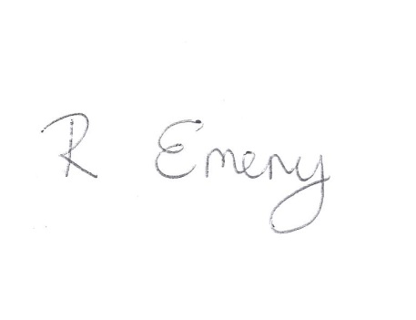

I look forward to reading your application.

Rebecca Emeny

Head Teacher