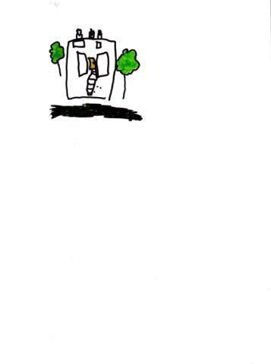
MOSS HALL
NURSERY SCHOOL
Deputy Headteacher One Year Interim Position

Salary: L4 - L8 £59,859 - £65,642
Deadline for applications: We are reviewing applications as they arrive and we reserve the right to close the vacancy before the deadline, so please apply as soon as possible.
Please note that due to the volume of applications we receive, we are unable to provide individual feedback except to those candidates who are invited to interview.
Start date: Tuesday 1st September 2026

Moss Hall Nursery School: 189 Nether Street. London N3 1NR
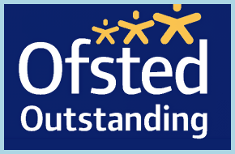

We are looking for a dynamic and highly effective Deputy Headteacher for initially one year (with scope to extend for a successful applicant) to join our child centred outstanding nursery school. Your post will involve the following responsibilities:
- Teaching up to 0.5% across the school
- School SENCo
- Deputy Headteacher: responsible for assessment across the school
Moss Hall Nursery School is a popular school; the children come from a rich variety of cultural backgrounds and they love to learn. The school is committed to a child centred pedagogy where children are engaged in rich and motivating learning experiences. Moss Hall Nursery School is set in a spacious Victorian building with an extensive, well-resourced outdoor learning environment and the staff team are experienced, enthusiastic and committed to providing an environment which supports active and independent learning. Close links with the adjoining infant and junior schools are maintained.

Applicants should:
- Be highly organised, inspiring, passionate and committed to providing high quality learning opportunities in an inclusive environment
- Have high levels of knowledge about effective child-centred pedagogy
- Be committed to ensuring the best outcomes for children and staff
- Be knowledgeable and experienced in managing a staff team and in delivering training across the school
We can offer you:
- A school which puts the interests of the children and their families first in all that we do
- A happy working environment with a supportive and committed team of staff
- An opportunity to develop professionally
- Children who are enthusiastic and eager to learn
- A school that values creative and dynamic individuals and supports a cross curricular and creative learning approach
- Close partnership working with parents/carers

To organise a visit please contact our school office on 020 8445 2518 or email office@mosshallnursery.barnetmail.net.

To apply for the role please complete the attached application form and submit to the school office: office@mosshallnursery.barnetmail.net

We are committed to promoting equality and challenging discrimination. Barnet is committed to safeguarding and promoting the welfare of children, young people, and vulnerable adults and expects all staff and volunteers to share this commitment. This post will be subject to an Enhanced DBS Clearance.
Barnet operates stringent safer recruitment procedures.

