

Interim Headteacher

Federation of Middleham and Spennithorne Primary Schools (VA)

Recruitment Information Pack



Contents

About the Schools 3
Application Process 10
Job Description and Person Specification 11
Applying for a job with North Yorkshire Council 14





Middleham and Spennithorne Primary Schools

About the Federation

We are a small, friendly federation of two schools in the North Yorkshire Dales. The school operates as a federation across two village sites, 3 miles away from each other. From September 2026 a formalisation of our current structure will take place: Reception and KS1 at Spennithorne, with KS2 based at Middleham. Interschool transport is provided by the schools. This structure allows for age-appropriate learning environments while also ensuring smooth transitions through the primary phase. Staff work collaboratively across both sites, and pupils regularly come together for shared learning experiences, whole-school events, and collective worship, helping to foster a strong sense of unity and belonging.

We are proud to be known in the area for our welcoming atmosphere, strong Christian values and commitment to nurturing the whole child. We are truly an inclusive school, with a family-oriented environment where every child is known, valued, and supported as an individual. Our strong community ethos, combined with a commitment to academic excellence and personal development, makes our schools a distinctive and valued part of both the local and wider educational landscape.

Situated in an attractive rural setting within an Area of Outstanding Natural Beauty, our schools serve a close-knit and vibrant community that is popular with visitors and rich in local heritage. The catchment includes the village of Spennithorne (population c.220), with its pub, church and active cricket club, and the nearby township of Middleham (population c.800 and at least 500 horses!), renowned for its historic castle associated with Richard III and its thriving horse racing training community. Middleham offers a range of local amenities including pubs, shops, and sports clubs, contributing to a strong community spirit. The schools are also closely connected to the surrounding areas of Coverdale, Harmby and the nearby market town of Leyburn, where recent housing developments are expected to positively influence pupil numbers.

Despite the rural location, the area benefits from good road links to Leyburn, Bedale and Masham, with Richmond and Northallerton within easy commuting distance via the A1 corridor. As Church of England schools, we maintain strong and valued links with our parish churches in Middleham and Spennithorne, which play a central role in the spiritual and community life of the schools, reflecting our commitment to nurturing the whole child within a welcoming and values-driven environment.

Our Vision and Values

Fruitful lives, rooted in love: a place to learn, love and grow.

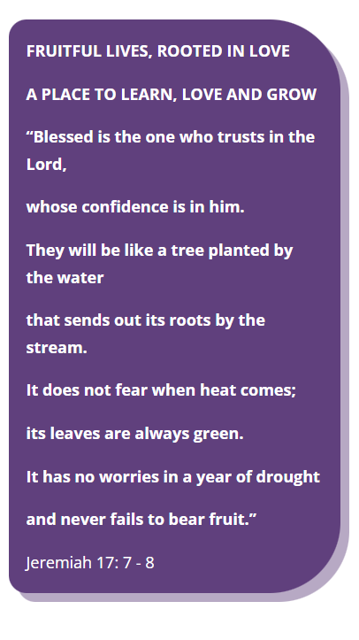


The above bible passage is the foundation of our federation’s vision. It reflects the unique location of our schools, close to the rivers Ure and Cover. The nearby confluence of these two rivers helps us to visualise our families, children and staff from each school coming together.

As rural schools, beautiful trees surround us, and we feel that the tree symbolises the way we are growing together in community as well as individuals. In our logo, the tree is in the shape of the cross to remind us that Christ is at the centre of our federation, that we can put our trust in Him and that all our values are rooted in His love.

We seek to give our children and staff healthy roots, to enable them to learn and live fruitful lives: to love one another, to care for the environment in which they are planted and the wider world, and to grow in whatever they do.
Pupils and staff flourish and the experience woven throughout the life of our federation embodies the opportunity for all to live... ‘FRUITFUL LIVES, ROOTED IN LOVE: A PLACE TO LEARN, LOVE & GROW’.

Christian Values
Each half term, we focus on a different Christian value, chosen by the children. This is done explicitly through our Collective Worship time but is also woven throughout our whole curriculum. Children and staff have regular opportunities to reflect on each value and to develop an understanding of the value in action. Underpinning all of this is our core Christian value of Love.

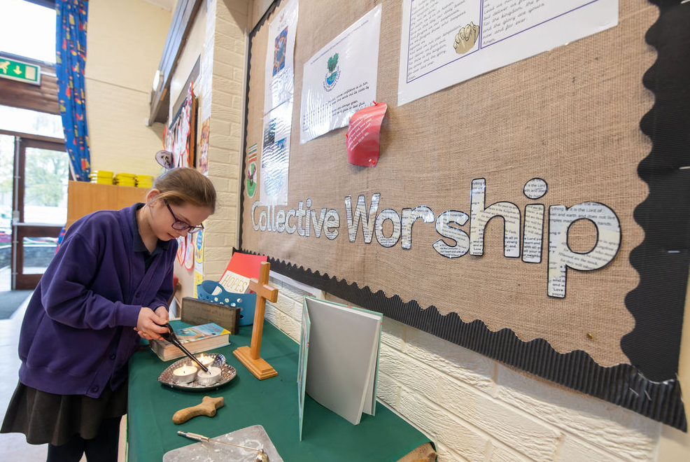

SIAMS and OFSTED have both celebrated the sense of belonging and mutual care that arises from our vision and ethos.
Spennithorne SIAMS 2024: ‘A warm, welcoming school, ‘rooted in love’ where ‘care and nurture for each unique individual is exceptional.’
Middleham SIAMS 2023: ‘This is a community rooted in love.’

This love extends beyond the school and immediate local community. We received the Bronze Global Neighbours Award following work to purchase land that will now be saved from deforestation, as well as more local engagement with food banks and the children are beginning to see ‘how they can impact the lives of those beyond their own community and seek justice for others.

Download our Spirituality Document here.

Our Pupils

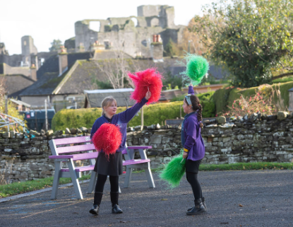
Pupils at Middleham and Spennithorne schools are friendly, welcoming and demonstrate a genuine care for one another. They recognise and respond thoughtfully to the needs of those around them, contributing to a strong culture of peer support. Pupils actively encourage and help each other to succeed, reflecting the school’s core Christian value of love, alongside its inclusive and community-focused ethos. They respond well to praise, structure and consistency, and understand the link between positive behaviour and being ready to learn. Pupils are naturally curious about the world and show a strong desire to engage in their learning.

Pupils are nurtured as individuals and empowered as leaders across the federation. Through roles such as school councillors, collective worship leaders, eco-club members and peer mentors, pupils develop confidence, moral purpose and a sense of responsibility. These opportunities enable them to contribute meaningfully to school life while embodying the federation’s vision and values.

The federation is seeing a notable increase in the number of pupils with Special Educational Needs and Disabilities (SEND). A significant proportion of these pupils require carefully targeted support to access the curriculum and achieve expected progress. This presents both a challenge and an opportunity to further strengthen inclusive practice and provision. Work to improve these areas has begun but continues to present challenges and needs to be deeply embedded

Behaviour across the federation is generally very good. Pupils with more complex needs can present behavioural challenges. Staff respond using a range of strategies, with a strong emphasis on restorative approaches that promote reflection, responsibility and long-term personal growth. Continuing professional development remains a priority to ensure that all staff are equipped to support every child effectively, enabling each pupil to flourish and lead ‘a fruitful life, rooted in love.’

Attendance is broadly in line with national averages at around 95%, although the federation aspires to reach 97%. Absence is carefully tracked and monitored, with a proactive approach taken through close engagement with families and consistent application of the attendance policy. A particular area of focus is reducing the number of holidays taken during term time.

Ofsted and SIAMS

The most recent Ofsted report (October 2022) judged The Federation of Middleham & Spennithorne Church of England Primary Schools to be good in all areas. The inspection highlighted its warm, welcoming and family-oriented ethos noting that pupils “love coming to school and attend well.” The quality of education was judged to be good, reflecting improvements in curriculum design and delivery that have led to strong engagement and positive outcomes, particularly in reading and mathematics. Pupils described as kind, respectful and supportive of one another. Inspectors commended leaders for their high expectations and ambition for all pupils, including those with SEND, and recognised the carefully designed personal development curriculum, which prepares pupils well for life in modern Britain. Safeguarding was found to be effective, and the report acknowledged the school’s continued improvement, underpinned by strong leadership and effective governance.

Areas where practice could be strengthened included embedding systems for assessing pupil’s prior knowledge. In response, leaders have placed a strong focus on the ongoing evaluation of the curriculum, with a newly revised curriculum due to be introduced in September 2026 to ensure learning builds more securely over time. Additionally, the school has taken positive steps to address times when important knowledge wasn’t emphasised clearly enough through targeted professional development, particularly for subject leaders, alongside strengthening monitoring to ensure key knowledge is consistently prioritised and embedded across the curriculum.

Middleham’s most recent SIAMS inspection (November 2023) recognised that “at its heart, Middleham School is a place where all are nurtured,” with the embedded Christian vision ensuring that all members of the community are valued and able to flourish. Inspectors highlighted the strong, inclusive ethos, the impact of leaders in living out the vision, and the central role of collective worship in bringing the community together. Rich opportunities for spiritual development and pupils’ engagement in meaningful work that challenges injustice were also key strengths.

Spennithorne’s most recent SIAMS inspection was in January 2024. The strength of its Christian vision was highlighted, which underpins all aspects of school life and enables pupils to grow as confident and resilient learners. Inspectors recognised the impact of effective leadership and supportive governance in driving rapid improvement, resulting in a community where both pupils and staff flourish. Collective worship was identified as a particular strength, alongside the school’s exceptional culture of care and compassion, which fosters strong relationships and a sense of belonging. Spiritual development is central, with pupils demonstrating curiosity and thoughtfulness as they engage with big questions.

Read more about our Ofsted and SIAMS inspections here

Our Priorities and Ambitions

At the Federation of Middleham and Spennithorne Primary Schools, our ambition is to provide a high-quality, inclusive education for every child, rooted in our Christian vision.

We are committed to ensuring all pupils achieve well through a well-sequenced, ambitious curriculum, alongside strong and consistent approaches to SEND and inclusion so that every child is supported to thrive. Following a period of change, we aim to establish stable, visible leadership that strengthens trust, develops staff, and unites our two schools in a shared sense of purpose. At the same time, we will continue to nurture a calm, supportive culture where pupils and staff feel valued and able to flourish.

As a federation at the heart of its rural community, we are ambitious for our role beyond the classroom, working in close partnership with families, the church and the wider community. Ultimately, we want every child to leave us equipped with the knowledge, values and aspiration to make a positive difference in the world.

Short‑Term Priorities from SDP

- Establish and embed a graduated SEND identification and response system across both sites so that 100% of children with emerging SEND are identified within 6 weeks of a concern being raised and have an agreed, evidence-based Individual Support Plan (ISP) or One Page Profile with review dates and measurable outcomes.

- Ensure all teachers and classroom TAs use at least three identified adaptive teaching strategies (differentiation, scaffolded questioning, flexible groupings) routinely in lessons, with lesson observation and work-scrutiny evidence showing consistent implementation in 85% of lessons across the federation.

- Produce and ratify a clear, sequenced wider-curriculum map (foundation subjects + RE) that shows progression across each year group, with specific knowledge and skills statements for each year group and clear links to prior learning.

- To maintain an effective and robust culture of safeguarding, and health & safety across the federation.

As this is a new plan, detailed milestones relating to these Key Priorities have been identified for each term for the next 4 terms as they are implemented and reviewed.


We are seeking an interim Executive Headteacher who will bring stability, clarity and confidence to our federation at an important point in our journey. This is an opportunity for a capable and compassionate leader who can quickly build trust, maintain momentum and provide decisive leadership across two schools, ensuring consistency, high expectations and a strong sense of shared purpose.

The successful candidate will have a clear understanding of how to raise standards, particularly through curriculum development and inclusive practice, and will be confident in leading SEND provision and supporting staff with increasingly complex needs. Above all, they will be a visible and values-driven leader, committed to embedding our Christian vision in all aspects of school life and strengthening relationships with pupils, staff, families and the wider community.


In return, the federation offers a warm, welcoming and highly supportive environment, underpinned by strong relationships and a genuine sense of community. You will be supported by a dedicated and collaborative staff team, an engaged governing body, and strong partnerships with the local authority, diocese and wider school networks.
This is a rewarding opportunity to make a meaningful difference in a federation where people care deeply, work closely together, and are committed to ensuring every child can flourish and live a fruitful life, rooted in love.

Application Process

The closing date for all applications is 23.59 Sunday 14th June 2026 – please note we will be reviewing applications upon receipt and reserve the right to close this role early

Queries
Please contact Ashley Benford at ashley.benford@northyorks.gov.uk or on 07814 932 389 for further information

Apply via NYC jobs

Please contact us if you need an application form in a different format.

We do not accept CVs. An email will be sent to shortlisted candidates with the details of the interview process.

When applying please take into account the following:

Supporting Information
The supporting information section of your application should clearly evidence your ability to meet the requirements we have outlined in the job description and person specification. This will be used to shortlist applicants for this role and therefore is it imperative that you provide evidence as requested.

References
When completing your application, please provide two employment referees. Generally this is your current employer and most recent employer.

Please note this post is in regulated activity and exempt from the rehabilitation of Offenders Act 1974 and therefore subject to an enhanced DBS certificate and barred list check. An online search may be conducted for successfully shortlisted applicants.

JOB DESCRIPTION
Executive Headteacher at the Federation of Middleham and Spennithorne Primary Schools
Statutory

1. To fulfil all the requirements and duties as set out in the School Teachers’ Pay and Conditions Document relating to the Conditions of Employment of Headteacher.

2. To seek to achieve any performance criteria, objectives or targets agreed with or set by the School’s Governing Board in accordance with the requirements set out in the agreed School Teachers’ Pay and Conditions Document and ensure that the school is compliant with all statutory guidance and legislation.

3. To promote and safeguard the welfare of all children and young people within the School, by ensuring that the School’s policies and procedures relating to safeguarding children and child protection are fully implemented and followed by all staff; resources are allocated to allow staff to discharge their responsibilities; and that staff, pupils, parents and other stakeholders feel able to raise concerns and that these are addressed sensitively and effectively. The Headteacher will be appointed to the role of Designated Safeguarding Lead for the school.

The School's Governing Body wish a particular emphasis to be placed upon the following:

- To meet the National Standards for Headteachers as published by the DfE.

- To raise standards across the school with particular reference to academic performance so that all pupils achieve to the very best of their ability.

- To lead in the provision of and delivery of excellent learning and teaching.

- To establish a vision for school improvement and to lead the staff and Governing Board to plan, implement, review, and evaluate the impact of the School Development Plans.

- To be accountable to the School’s Governing Board on progress made against School Development Plan objectives, making recommendations as to future priorities and actions based on robust evidence-based self-evaluation.

- To further develop and extend partnership working with a variety of stakeholders and other bodies (including local churches and the diocese) through co-operation and collaboration.

- To establish a reflective culture through a process of rigorous self-evaluation, including quality assurance and performance management at all levels.

- To develop, inspire and motivate effective teams to deliver high quality education and thereby raise standards across the school.

- To manage the school’s budget to ensure efficient and effective use of resources in line with the School’s objectives and priorities.

- To ensure the school always operates within the school’s policies and legislation

- To foster a positive, caring and inclusive Christian ethos, whilst promoting an understanding of and respect for other faiths and cultures.

- To take lead responsibility for safeguarding and child protection (including online safety and understanding the filtering and monitoring systems and processes in place)

These duties are neither exclusive nor exhaustive and the post holder will be required to undertake other duties and responsibilities as agreed with the employer. This Job Description may be amended at any time after consultation with the post holder and will be reviewed annually.

Person Specification

Interim Executive Headteacher – Federation of Middleham and Spennithorne Primary Schools

The Selection Panel will be looking for evidence that the candidate has demonstrated their ability to fulfil the following criteria within the National Standards for Headteachers. Whilst the below characteristics are assessed throughout all of the recruitment process, it is indicated when each dimension is most likely to be assessed:

TECHNICAL
QUALIFICATIONS AND TRAINING | Essential on appointment | Desirable on appointment (if not attained, development may be provided for successful candidate) | Assessment  Application  Interview  Clearances
Qualified Teacher status | X |  | A C
Further professional/academic study e.g. MA, SEND qualifications |  | X | A C
Evidence of gaining or working towards NPQH or NPQEL qualification or equivalent |  | X | A C
Evidence of continuous professional development used to develop self and others including recent leadership training and development | X |  | A I
SKILLS AND KNOWLEDGE | Essential on appointment | Desirable on appointment | Assessment  Application  Interview  Clearances
A detailed understanding of current legislation relating to schools and of national and local education priorities | X |  | A I
Up-to-date knowledge of school improvement planning, evaluation, and quality assurance processes | X |  | A I
Knowledge of the statutory documentation and legislation applicable to the leadership and management of schools e.g child protection, the SEND Code of Practice, inclusion and health and safety | X |  | A I
An excellent understanding of outstanding curriculum design which embeds inclusive practices appropriate for the setting | X |  | A I
Knowledge of a range of effective communication strategies including for developing and maintaining high standards of attainment, behaviour, and attendance appropriate for the setting | X |  | A I
Up-to-date knowledge of research relating to education and of current and emerging DFE policy and accountability frameworks | X |  | I
SAFEGUARDING: Demonstrate a secure commitment to safeguarding and the welfare of children and young people and demonstrate proactive leadership in promoting wellbeing as part of a wider safeguarding culture, particularly for the school’s vulnerable learners. | X |  | A I C
SAFEGUARDING: Form and maintain appropriate relationships and personal boundaries, demonstrating and maintaining appropriate authority | X |  | I C
SAFEGUARDING: Secure knowledge of current statutory safeguarding guidance for schools and understanding of the strategic and operational management of safeguarding to protect the health and wellbeing of children and young people, and staff. | X |  | I C
CHURCH SCHOOL
Up-to-date knowledge and understanding of the mission and distinctive nature of a Church school including knowledge of the current SIAMS framework | X |  | A I
A commitment to developing and maintaining a theologically rooted Christian vision and culture for a school; upholding and promoting the school’s Christian ethos and playing a key role in the spiritual development of the school | X |  | A I C
Inclusive of all faiths and beliefs | X |  | A I
EXPERIENCE
 | Essential on appointment | Desirable on appointment | Assessment  Application  Interview  Clearances
Successful experience of workforce development, that includes performance management and the supervision of staff wellbeing and workload | X |  | A I
Experience of using data, and other contextual information insightfully to meet challenging targets | X |  | A I
Proven track record of leading inclusive practice and improving outcomes for diverse groups of learners, particularly those learners identified as vulnerable. | X |  | A I
Experience with whole-school organisational management, ensuring systems, processes and policies are effectively developed and implemented | X |  | A I
Evidence of communicating and working effectively with staff, governors and other key stakeholders in school and externally | X |  | A I
Experience of implementing professional development strategies for staff to ensure quality provision and outcomes for pupils | X |  | A I
Experience of an Ofsted inspection at a leadership level |  | X | A I
CHURCH SCHOOL
Experience of working in a Church school setting and/or working in partnership with a local Church setting |  | X | A I
Experience of SIAMS inspection at a leadership level |  | X | A I
APTITUDE
 | Essential on appointment | Desirable on appointment | Assessment  Application  Interview  Clearances
The ability to develop and maintain skills to enable successful partnerships and collaborative working to improve the quality of education and outcomes for all children and young people | X |  | I

There will be a particular focus on the following key competencies:

COMPETENCIES
Key Competencies identified to be assessed | Essential on appointment | Assessment  Application  Interview  Clearances
Resilience | X | I
Setting and achieving challenging goals | X | I
High expectations of self and others | X | I
Skilful communication according to audience | X | I
Organisational sensitivity | X | I
Partnership working | X | I

APPLYING FOR A JOB WITH NORTH YORKSHIRE COUNCIL

IMPORTANT ADVICE ON COMPLETING THIS APPLICATION

Your application form plays an important part in your selection. Please ensure you address all the essential requirements listed in the specifications. The following advice should help you to complete the application form as effectively as possible.
Data Protection
The information that you state on this application form will be used by the school and the Council to consider you for a job vacancy. To find out about how we use your personal data for the purposes of recruitment please see our Privacy Notice at www.northyorks.gov.uk/working-us.

Rehabilitation of Offenders
The post you are applying for requires you to have an enhanced Disclosure and Barring Service criminal records check for work with children, with a barred list check if you work in regulated activity. This check for disclosure of criminal history will include spent convictions, pending prosecutions / current court proceeding and police enquiries.

Should you be shortlisted, you will be asked to disclose full details of your criminal history prior to your interview. This includes any information deemed relevant as part of Keeping Children Safe in Education which may arise in an online search undertaken on shortlisted candidates. This information may be discussed with you at your interview in order to assess job related risks, but we emphasise that your application will be considered on merit and ability and you will not be discriminated against unfairly. Failure to disclose this information will result in any offer of employment being withdrawn.

Please also see the policy statement on the Recruitment of Ex-offenders below.

Information in Support of your Application
Every post advertised is supported by a full person specification. The specification lists all the essential skills, experience and qualifications which are necessary for the job and the criteria against which you will be assessed, both through your application form and at interview.

As part of the application process, you may have been asked to demonstrate within this application form how you meet some or all of the criteria or key competencies outlined in the person specification. Rather than simply repeating your career history, look at the skills and experience required by the job and provide evidence that you possess them by giving specific and detailed examples which include a focus on outcomes and on your own contribution to the scenario. Try to use different and varied examples wherever possible.

When completing these sections, do not forget the skills and experience you have gained outside full-time work. Outlining your previous work experience or other responsibilities may help you to uncover skills which you have taken for granted and which are clear signs of your ability to do the job.

Canvassing
You must not try to influence an elected Council Member, any council employee or a member of the school governing body, to act in your favour, as this will disqualify you. If you are related to a Councillor, a Council employee or a governor you must indicate this in the relevant section of the application form.
Policy Statement on the Recruitment of Ex-offenders (Source www.gov.uk)
- As an organisation assessing applicants’ suitability for positions which are included in the Rehabilitation of Offenders Act 1974 (Exceptions) Order using criminal record checks processed through the Disclosure and Barring Service (DBS), this school complies fully with the DBS code of practice and undertakes to treat all applicants for positions fairly.

- This school undertakes not to discriminate unfairly against any subject of a criminal record check on the basis of a conviction or other information revealed.

- This school can only ask an individual to provide details of convictions and cautions that it is legally entitled to know about. Where a DBS certificate can legally be requested (where the position is one that is included in the Rehabilitation of Offenders Act 1974 (Exceptions) order 1975 as amended, and where appropriate Policy Act Regulations as amended) this school can only ask an individual about convictions and cautions that are not protected.

- This school is committed to the fair treatment of its staff and potential staff, regardless of race, gender, religion, sexual orientation, responsibilities for dependents, age, physical/mental disability or offending background.

- This school has this written policy on the recruitment of ex-offenders, which is made available to all DBS applicants at the start of the recruitment process.

- This school actively promotes equality of opportunity for all with the right mix of talent, skills and potential and welcome applications from a wide range of candidates, including those with criminal records. Candidates are selected for interview based on their skills, qualifications and experience and criminal record information is only requested from short-listed candidates.

- A disclosure is only requested from the DBS after a thorough risk assessment has indicated that one is both proportionate and relevant to the position concerned. For those positions where a criminal record check is identified as necessary, all application forms, job adverts and recruitment briefs will contain a statement that a DBS certificate will be requested in the event of the individual being offered the position.

- This school ensures that all those who are involved in the recruitment process have been suitably trained to identify and assess the relevance and circumstances of offences.

- This school also ensures that they have received appropriate guidance and training in the relevant legislation relating to the employment of ex-offenders, e.g. the Rehabilitation of Offenders Act 1974.

- At interview, or in a separate discussion, this school ensures that an open and measured discussion takes place on the subject of any offences or other matter that might be relevant to the position. Failure to reveal information that is directly relevant to the position sought could lead to withdrawal of an offer of employment.

- This school makes every subject of a criminal record check submitted to DBS aware of the existence of the code of practice and makes a copy available on request.

- This school undertakes to discuss any matter revealed on a DBS certificate with the individual seeking the position before withdrawing a conditional offer of employment.

