

Interim Headteacher
The Sunbeck Centre

Recruitment Information Pack



Contents

About the School 3
Application Process 7
Job Description and Person Specification 8
Applying for a job with North Yorkshire Council 11



Wheatcroft Community Primary School

About the School

The Sunbeck Centre is an alternative education provision for young people aged 11–16 (Key Stages 3 and 4), predominantly serving secondary schools across Hambleton and Richmondshire in North Yorkshire. The centre supports nine partner schools by providing both preventative placements and 6th day provision for permanently excluded pupils.
Our centre is located in the market town of Northallerton, North Yorkshire. Pupils travel from across the Hambleton and Richmondshire area, with transport arranged by the local authority or referring schools.
In recent years, the centre has developed its offer to focus increasingly on short-term, preventative placements, particularly at Key Stage 3, alongside part-time provision for Key Stage 4 pupils, with the aim of supporting reintegration into mainstream education wherever possible.

Our Vision and Values

At The Sunbeck Centre, our vision is rooted in a deep commitment to improving the life chances of every pupil within our community. We believe that all young people deserve the opportunity to thrive, and we are unwavering in our ambition to support them to succeed both academically and personally. We achieve this through a highly personalised curriculum that is carefully designed to meet the individual needs, strengths and aspirations of each pupil. Our approach is centred on understanding the whole child, enabling them to engage, grow and build confidence within a welcoming, inclusive and safe environment where they feel valued and supported.

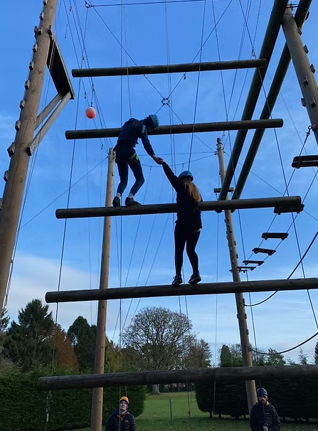
Our community is guided by our core values of Pride, Respect and Safety. These values underpin everything we do, shaping our culture and relationships and promoting a strong sense of belonging. We strive to create a calm and purposeful environment where pupils and staff alike can flourish. By fostering high expectations and a culture of continuous improvement, we empower both young people realise their full potential and develop into confident, capable and successful individuals.

Our ethos is captured in our guiding principle:

“Challenging the past, embracing the future.”
This reflects our commitment to supporting pupils to overcome barriers, build resilience and move forward with confidence, ready to engage positively with the opportunities ahead.

Our Students


Students join The Sunbeck Centre for a variety of reasons, but all share a need for a more personalised approach to education. This includes smaller class sizes, higher staff-to-student ratios and, for many, access to a more bespoke and often vocational curriculum pathway. Some pupils attend the Centre on a short-term basis while awaiting a placement in a mainstream school following exceptional circumstances.

Many of our students present with social, emotional and mental health needs, and their behaviours often reflect underlying challenges. They benefit from a nurturing environment where staff understand attachment, child development and the impact of adolescence on behaviour. While pupils can at times be challenging, they are also engaging, resilient young people who build strong, trusting relationships with adults and bring positivity and character to our community. We are proud that they leave us feeling valued and with a renewed sense of self-belief.

All students are referred to The Sunbeck Centre following clear evidence that their mainstream setting has implemented a range of support strategies and interventions. Each student arrives with their own unique experiences and needs. Our role is to help rebuild confidence, re-establish trust in education and support them to see themselves once again as successful members of a school community.

Where appropriate, we work closely with partners to support pupils in returning to mainstream education, ensuring that future placements are well-matched and able to meet their needs effectively.

Our Staff Team

The Sunbeck Centre is supported by a stable and committed staff team, led by the Headteacher, who also serves as Designated Safeguarding Lead, and a Deputy Headteacher who is the SENCo. The wider team includes experienced teachers, instructors, a Higher Level Teaching Assistant, a careers advisor, exams officer and administrative colleagues, enabling the Centre to deliver a broad and balanced curriculum. This includes core subjects of English, mathematics and science, alongside a range of additional subjects such as art, catering, design technology, PSHE, careers, RE, humanities, outdoor education and targeted one-to-one interventions.

The Centre also benefits from the regular input of a trained psychotherapist, who works on site weekly to support pupils’ emotional wellbeing.

The Centre works closely with a wide range of partners, including local secondary schools, the Local Authority, SEN casework teams, the SEND Hub, Inclusion services, social care and the Fair Access Panel. The Interim Headteacher will play a key role in maintaining and strengthening these relationships, ensuring a collaborative and coordinated approach to meeting pupils’ needs.

Ofsted

Our most recent Ofsted inspection took place in July 2025, with the school judged as Requires Improvement across all key areas.

While this judgement reflects areas where further work is needed, the report also recognises many important strengths and the positive direction of travel for the school.

Inspectors noted that “the school is a warm and welcoming place” where “pupils are happy and safe.” Relationships are a clear strength, with pupils developing trust in staff and understanding expectations for their behaviour. Most pupils behave well and value the supportive environment around them.

The report highlights that pupils access a broad and increasingly engaging curriculum. The school has established effective systems for identifying additional needs and has placed a strong emphasis on reading, investing in high-quality texts and appropriate support, including phonics provision for those at an early stage of reading.

There is clear evidence that leaders are taking decisive action to secure improvements, supported by strengthened governance arrangements and increasing levels of accountability. Encouragingly, most staff report that leaders prioritise their workload and well-being, contributing to a positive and collaborative culture.

Since the inspection, the Centre has continued to build on these foundations. It benefits from subject specialist teaching in English, Mathematics and Science, alongside dedicated intervention support. Beyond the core curriculum, pupils can access a wide range of subjects including Art, PSHE, careers, catering, design technology, PE and outdoor education, Humanities and RE.

The Centre has also recently achieved NCFE accreditation, enabling it to offer vocational qualifications (V Certs) in areas such as catering, art and design technology, further strengthening its ability to provide relevant and meaningful pathways for its students.

The Sunbeck Centre is a school with strengths, a committed staff team and a firm trajectory of improvement. An environment where strong leadership can make a tangible and lasting difference.

Read more about our Ofsted inspection here

Our Priorities and Ambitions

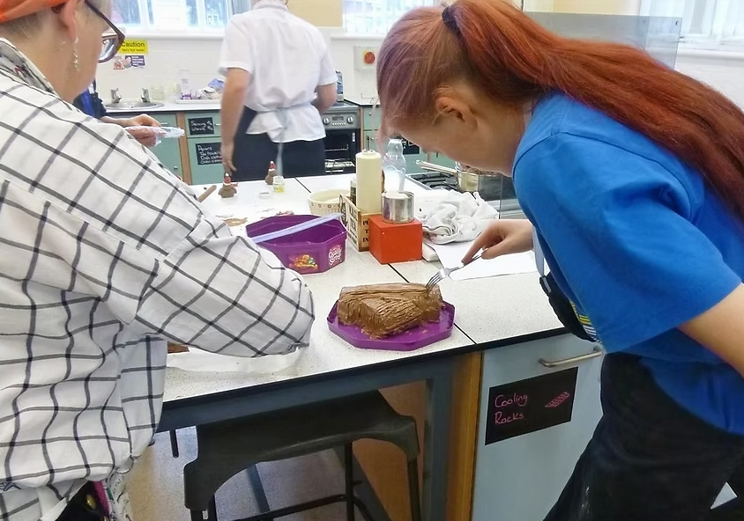
The Sunbeck Centre is on a journey of improvement, with a strong commitment to ensuring that every pupil receives a high-quality, inclusive education that enables them to succeed. Our priorities reflect both immediate areas of focus and our longer-term ambition to strengthen and develop the provision further.

Short-Term Priorities (0–6 months)
In the immediate term, the focus is on embedding consistency and strengthening the core offer for pupils. Key priorities include:
- Embedding the newly designed curriculum to ensure it is well sequenced, engaging and fully meets the needs of all learners
- Improving pupil attendance and engagement across the Centre
- Developing and embedding a consistent approach to assessment, including the effective use of the Arbor MIS system
- Securing consistently high-quality teaching, with staff confidently using adaptive approaches to meet pupils’ complex needs
- Ensuring agreed strategies and support for vulnerable pupils are implemented consistently
- Continuing to strengthen pupils’ personal development, including building their understanding of tolerance, respect and diversity

These priorities are underpinned by a drive to create a consistent, high-quality experience for every pupil, every day.

The Centre is also working closely with the Local Authority to ensure long-term financial sustainability, with a focus on aligning curriculum design, staffing structures and provision to future need.

Together, these ambitions, together with our longer term goals, reflect a clear vision: to build a provision that not only meets the needs of its pupils today, but also plays a proactive and influential role in shaping inclusive practice across the wider system.

Key Challenges for the incoming Interim Headteacher
The successful candidate will need to address several key challenges as part of the Centre’s next phase of development:
- Sustaining and accelerating the current improvement journey, ensuring that recent developments have a measurable and lasting impact on pupils’ outcomes
- Embedding a consistently high standard of teaching and learning across all subjects, supported by robust quality assurance and professional development
- Improving attendance and engagement for a cohort of pupils with complex needs and often disrupted educational experiences
- Strengthening and further developing partnerships with local secondary schools, ensuring the Centre continues to play a proactive role in reducing exclusions and supporting reintegration
- Ensuring that the curriculum model, staffing structure and provision remain aligned and financially sustainable over time

Application Process

The closing date for all applications is 23.59 Sunday 21st June - please note we will be reviewing applications upon receipt and reserve the right to close this role early

Queries
Please contact Helen Poole at helen.poole@northyorks.gov.uk or on 01609 532254 for further information

Apply via NYC jobs

Please contact us if you need an application form in a different format.

We do not accept CVs. An email will be sent to shortlisted candidates with the details of the interview process.

When applying please take into account the following:

Supporting Information
The supporting information section of your application should clearly evidence your ability to meet the requirements we have outlined in the job description and person specification. This will be used to shortlist applicants for this role and therefore is it imperative that you provide evidence as requested.

References
When completing your application, please provide two employment referees. Generally this is your current employer and most recent employer.

Please note this post is in regulated activity and exempt from the rehabilitation of Offenders Act 1974 and therefore subject to an enhanced DBS certificate and barred list check. An online search may be conducted for successfully shortlisted applicants.

JOB DESCRIPTION
Interim Headteacher at The Sunbeck Centre
Statutory

- To fulfil all the requirements and duties as set out in the School Teachers’ Pay and Conditions Document relating to the Conditions of Employment of Headteacher.

- To seek to achieve any performance criteria, objectives or targets agreed with or set by the School’s Governing Board in accordance with the requirements set out in the agreed School Teachers’ Pay and Conditions Document and ensure that the school is compliant with all statutory guidance and legislation.

- The Headteacher will be appointed to the role of Designated Safeguarding Lead and will promote and safeguard the welfare of all children and young people within the School, by ensuring that the School’s policies and procedures (including online safety and understanding the filtering and monitoring systems and processes in place) relating to safeguarding children and child protection are fully implemented and followed by all staff; resources are allocated to allow staff to discharge their responsibilities; and that staff, pupils, parents and other stakeholders feel able to raise concerns and that these are addressed sensitively and effectively.

The School's Governing Body wish a particular emphasis to be placed upon the following:

- To meet the National Standards for Headteachers as published by the DfE, ensuring leadership decisions reflect Ofsted's Education inspection framework aiming for exceptional practice.

- To ensure high-quality inclusive education that enables every learner, including those with SEND and from disadvantaged backgrounds, to thrive academically and personally.

- To lead in the provision and implementation of an ambitious and accessible curriculum for all learners, ensuring it is inclusive and accessible for all learners.

- To establish a vision for school improvement that prioritises inclusion and pupil wellbeing, and to lead the staff and Governing Board to plan, implement, review, and evaluate the impact of the School Development Plans on experiences and outcomes for pupils.

- Champion and monitor an inclusive culture where diversity is valued, barriers to learning are removed, and equity of opportunity is embedded across all aspects of school life.

- To be accountable to the School’s Governing Board on progress made against School Development Plan objectives, making recommendations as to future priorities and actions based on robust evidence-based self-evaluation.

- To further develop and extend partnership working with families, system and multi-agency partners, including the Local Authority and the Diocese to support inclusive practice through co-operation and collaboration.

- To establish a reflective culture through a process of rigorous self-evaluation, including quality assurance and performance management at all levels.

- To develop, inspire and motivate effective teams to deliver high-quality, inclusive education and thereby raise standards across the school, ensuring staff are equipped to meet the needs of all pupils effectively.

- To foster a positive working environment that prioritises staff wellbeing and professional growth.

- To manage the school’s budget to ensure efficient and effective use of resources in line with the school’s objectives and priorities.

- To ensure the school always operates within the school’s policies and legislation

These duties are neither exclusive nor exhaustive and the post holder will be required to undertake other duties and responsibilities as agreed with the employer. This Job Description may be amended at any time after consultation with the post holder and will be reviewed annually.

PERSON SPECIFICATION
Interim Headteacher – The Sunbeck Centre

The Selection Panel will be looking for evidence that the candidate has demonstrated their ability to fulfil the following criteria within the National Standards for Headteachers. Whilst all the below characteristics are assessed throughout the recruitment process, it is indicated when each dimension is most likely to be assessed:

TECHNICAL
QUALIFICATIONS AND TRAINING | Essential on appointment | Desirable on appointment (if not attained, development may be provided for successful candidate) | Assessment  Application  Interview  Clearances
Qualified Teacher status | X |  | A C
Further professional/academic study e.g. MA, SEND qualifications |  | X | A C
Evidence of gaining or working towards NPQH or NPQEL qualification or equivalent |  | X | A C
Evidence of continuous professional development used to develop self and others including recent leadership training and development | X |  | A I
SKILLS AND KNOWLEDGE | Essential on appointment | Desirable on appointment | Assessment  Application  Interview  Clearances
A detailed understanding of current legislation relating to schools and of national and local education priorities | X |  | A I
Up-to-date knowledge of school improvement planning, evaluation, and quality assurance processes | X |  | A I
Knowledge of the statutory documentation and legislation applicable to the leadership and management of schools e.g. child protection, the SEND Code of Practice, inclusion and health and safety | X |  | A I
An excellent understanding of outstanding curriculum design which embeds inclusive practices appropriate for the setting | X |  | A I
Knowledge of a range of effective communication strategies including for developing and maintaining high standards of attainment, behaviour, and attendance appropriate for the setting | X |  | A I
Up-to-date knowledge of research relating to education and of current and emerging DFE policy and accountability frameworks | X |  | I
SAFEGUARDING: Demonstrate a secure commitment to safeguarding and the welfare of children and young people and demonstrate proactive leadership in promoting wellbeing as part of a wider safeguarding culture, particularly for the school’s vulnerable learners. | X |  | A I C
SAFEGUARDING: Form and maintain appropriate relationships and personal boundaries, demonstrating and maintaining appropriate authority | X |  | I C
SAFEGUARDING: Secure knowledge of current statutory safeguarding guidance for schools and understanding of the strategic and operational management of safeguarding to protect the health and wellbeing of children and young people, and staff. | X |  | I C
EXPERIENCE
 | Essential on appointment | Desirable on appointment | Assessment  Application  Interview  Clearances
Successful experience of workforce development, that includes performance management and the supervision of staff wellbeing and workload | X |  | A I
Experience of using data, and other contextual information insightfully to meet challenging targets | X |  | A I
Proven track record of leading inclusive practice and improving outcomes for diverse groups of learners, particularly those learners identified as vulnerable. | X |  | A I
Experience with whole-school organisational management, ensuring systems, processes and policies are effectively developed and implemented | X |  | A I
Evidence of communicating and working effectively with staff, governors and other key stakeholders in school and externally | X |  | A I
Experience of implementing professional development strategies for staff to ensure quality provision and outcomes for pupils | X |  | A I
Experience of an Ofsted inspection at a leadership level |  | X | A I
APTITUDE
 | Essential on appointment | Desirable on appointment | Assessment  Application  Interview  Clearances
The ability to develop and maintain skills to enable successful partnerships and collaborative working to improve the quality of education and outcomes for all children and young people, including those with SEND and from disadvantaged backgrounds | X |  | I

There will be a particular focus on the following key competencies:

COMPETENCIES
Key Competencies identified to be assessed | Essential on appointment | Assessment  Application  Interview  Clearances
Resilience | X | I
Accepts accountability and holds others to account | X | I
Skilful communication according to audience | X | I
Organisational sensitivity | X | I
Partnership working | X | I
Building effective teams | X | I

APPLYING FOR A JOB WITH NORTH YORKSHIRE COUNCIL

IMPORTANT ADVICE ON COMPLETING THIS APPLICATION

Your application form plays an important part in your selection. Please ensure you address all the essential requirements listed in the specifications. The following advice should help you to complete the application form as effectively as possible.
Data Protection
The information that you state on this application form will be used by the school and the Council to consider you for a job vacancy. To find out about how we use your personal data for the purposes of recruitment please see our Privacy Notice at www.northyorks.gov.uk/working-us.

Rehabilitation of Offenders
The post you are applying for requires you to have an enhanced Disclosure and Barring Service criminal records check for work with children, with a barred list check if you work in regulated activity. This check for disclosure of criminal history will include spent convictions, pending prosecutions / current court proceeding and police enquiries.

Should you be shortlisted, you will be asked to disclose full details of your criminal history prior to your interview. This includes any information deemed relevant as part of Keeping Children Safe in Education which may arise in an online search undertaken on shortlisted candidates. This information may be discussed with you at your interview in order to assess job related risks, but we emphasise that your application will be considered on merit and ability and you will not be discriminated against unfairly. Failure to disclose this information will result in any offer of employment being withdrawn.

Please also see the policy statement on the Recruitment of Ex-offenders below.

Information in Support of your Application
Every post advertised is supported by a full person specification. The specification lists all the essential skills, experience and qualifications which are necessary for the job and the criteria against which you will be assessed, both through your application form and at interview.

As part of the application process, you may have been asked to demonstrate within this application form how you meet some or all of the criteria or key competencies outlined in the person specification. Rather than simply repeating your career history, look at the skills and experience required by the job and provide evidence that you possess them by giving specific and detailed examples which include a focus on outcomes and on your own contribution to the scenario. Try to use different and varied examples wherever possible.

When completing these sections, do not forget the skills and experience you have gained outside full-time work. Outlining your previous work experience or other responsibilities may help you to uncover skills which you have taken for granted and which are clear signs of your ability to do the job.

Canvassing
You must not try to influence an elected Council Member, any council employee or a member of the school governing body, to act in your favour, as this will disqualify you. If you are related to a Councillor, a Council employee or a governor you must indicate this in the relevant section of the application form.
Policy Statement on the Recruitment of Ex-offenders (Source www.gov.uk)
- As an organisation assessing applicants’ suitability for positions which are included in the Rehabilitation of Offenders Act 1974 (Exceptions) Order using criminal record checks processed through the Disclosure and Barring Service (DBS), this school complies fully with the DBS code of practice and undertakes to treat all applicants for positions fairly.

- This school undertakes not to discriminate unfairly against any subject of a criminal record check on the basis of a conviction or other information revealed.

- This school can only ask an individual to provide details of convictions and cautions that it is legally entitled to know about. Where a DBS certificate can legally be requested (where the position is one that is included in the Rehabilitation of Offenders Act 1974 (Exceptions) order 1975 as amended, and where appropriate Policy Act Regulations as amended) this school can only ask an individual about convictions and cautions that are not protected.

- This school is committed to the fair treatment of its staff and potential staff, regardless of race, gender, religion, sexual orientation, responsibilities for dependents, age, physical/mental disability or offending background.

- This school has this written policy on the recruitment of ex-offenders, which is made available to all DBS applicants at the start of the recruitment process.

- This school actively promotes equality of opportunity for all with the right mix of talent, skills and potential and welcome applications from a wide range of candidates, including those with criminal records. Candidates are selected for interview based on their skills, qualifications and experience and criminal record information is only requested from short-listed candidates.

- A disclosure is only requested from the DBS after a thorough risk assessment has indicated that one is both proportionate and relevant to the position concerned. For those positions where a criminal record check is identified as necessary, all application forms, job adverts and recruitment briefs will contain a statement that a DBS certificate will be requested in the event of the individual being offered the position.

- This school ensures that all those who are involved in the recruitment process have been suitably trained to identify and assess the relevance and circumstances of offences.

- This school also ensures that they have received appropriate guidance and training in the relevant legislation relating to the employment of ex-offenders, e.g. the Rehabilitation of Offenders Act 1974.

- At interview, or in a separate discussion, this school ensures that an open and measured discussion takes place on the subject of any offences or other matter that might be relevant to the position. Failure to reveal information that is directly relevant to the position sought could lead to withdrawal of an offer of employment.

- This school makes every subject of a criminal record check submitted to DBS aware of the existence of the code of practice and makes a copy available on request.

- This school undertakes to discuss any matter revealed on a DBS certificate with the individual seeking the position before withdrawing a conditional offer of employment.

