



**Interim Headteacher**

**Recruitment Information Pack**



## Contents

Welcome from the Chairs of Governors 3

About Us 4 - 6

Application Process 7

Job Description and Person Specification 8 – 11

Applying for a Job with North Yorkshire Council 12 - 14



**Welcome from the Chair of Governors**

Dear Applicant,

Thank you for your interest in the Interim Headteacher position at Grove Road Community Primary School. On behalf of the Governing Body, we are delighted to introduce you to our vibrant and inclusive school community, and to share this exciting opportunity to lead a school full of energy, diversity, and ambition.

Grove Road is a school where relationships matter. We are a close-knit, caring community that celebrates individuality and works together to ensure every child feels seen, supported, and inspired. Our pupils are curious, kind, and full of potential. Our staff are dedicated, collaborative, and deeply committed to inclusive education. Our families are engaged and supportive, playing an active role in school life.

Our Curriculum of PRIDE rests firmly on the foundations of our school values and we strive to make sure that every child feels represented throughout their learning journey. Our children have the opportunity to build the foundations of learning that they will take with them through secondary school and beyond, becoming lifelong learners. We have a highly skilled and cohesive staff team who always put our children first and strive for excellence in everything they do. Our positive and ‘growth mindset’ attitude means we adopt a solution-focused approach to overcome obstacles and enable all children and adults to achieve their full potential. We encourage our children to be confident, independent learners, who understand that achieving success requires effort, practice and perseverance and that making mistakes is an essential part of the learning process.

We are seeking a Headteacher who shares our commitment to inclusion, high expectations, and community partnership. Someone who will embrace our values, champion our children, and lead with both heart and vision. This is a wonderful opportunity for a compassionate and visionary leader to build on our strengths and guide us into the next chapter of our journey. If you are passionate about making a meaningful difference in the lives of children and families, we warmly invite you to apply.

We look forward to hearing from you.

Yours faithfully,

**Mrs Lucy Merrett and Mr Alex Tomlin**

**Co-Chairs of Governors**

**About us**

**Welcome to Grove Road Community Primary School**

Grove Road Community Primary School is a thriving, inclusive school at the heart of our community in Harrogate. We are proud of our strong ethos, built around the core values of PRIDE—Passionate, Resilient, Intrepid, Dependable and Empathetic. These values shape our culture, guide our decisions, and inspire our pupils and staff every day. We are a school that believes in nurturing the whole child, fostering a love of learning, and preparing our pupils to be confident, compassionate, and capable citizens of the future.

We are especially proud of the rich diversity within our school community. Our pupils come from a wide range of backgrounds, and we celebrate the unique contributions of every child. A significant number of our children speak English as an additional language, and many have special educational needs and disabilities (SEND). This diversity enriches our school life and strengthens our commitment to inclusion, equity, and high expectations for all. Our curriculum is broad, balanced, and ambitious, designed to spark curiosity and creativity while ensuring high standards of achievement.

As we look to the future, we are seeking a visionary and compassionate Headteacher who will build on our successes and lead us into the next exciting chapter of our journey. If you are passionate about inclusive education and committed to making a lasting difference, we would love to hear from you.

**Classes & Staff**

The staff at Grove Road Community Primary School in Harrogate are a dedicated and diverse team committed to nurturing every child’s potential. The school’s leadership is supported by a strong team of teachers, teaching assistants, and support staff across Early Years, Key Stage 1, and Key Stage 2. Each member brings unique strengths—from pastoral care and SEND support to creative curriculum delivery—ensuring a warm, inclusive, and engaging learning environment. Their collective passion for education and community spirit makes Grove Road a vibrant and supportive place for children to grow and thrive

[Read more about our staff structure here](https://groveroad.n-yorks.sch.uk/our-school/our-staff)

**Relationships - Parents/Carers and Wider Community**

At Grove Road, we believe that strong partnerships with parents, carers, and the wider community are essential to a child’s success. We are proud of the warm, inclusive atmosphere we have cultivated, where families feel welcomed, listened to, and involved in their children’s learning journey.

We maintain open and transparent communication through platforms such as ParentMail and SeeSaw, and we actively encourage parental involvement in school life - from supporting learning at home to participating in school events and decision-making processes. Our staff are approachable and committed to working collaboratively with families to ensure the best outcomes for every child.

The school also embraces the “Thrive Approach”, which supports children’s social and emotional development through strong, secure relationships. By working closely with families to assess and respond to children’s emotional needs, we ensure that both school and home environments are aligned in nurturing each child’s well-being and growth.

**Further reading:**

* [**Visit our website**](https://groveroad.n-yorks.sch.uk/)
* **[Grove Road Community Primary School Data and Ofsted](https://www.compare-school-performance.service.gov.uk/school/121395/harrogate%2c-grove-road-community-primary-school)**

**Vision & Values**

At Grove Road we are all working together to achieve our vision for the school

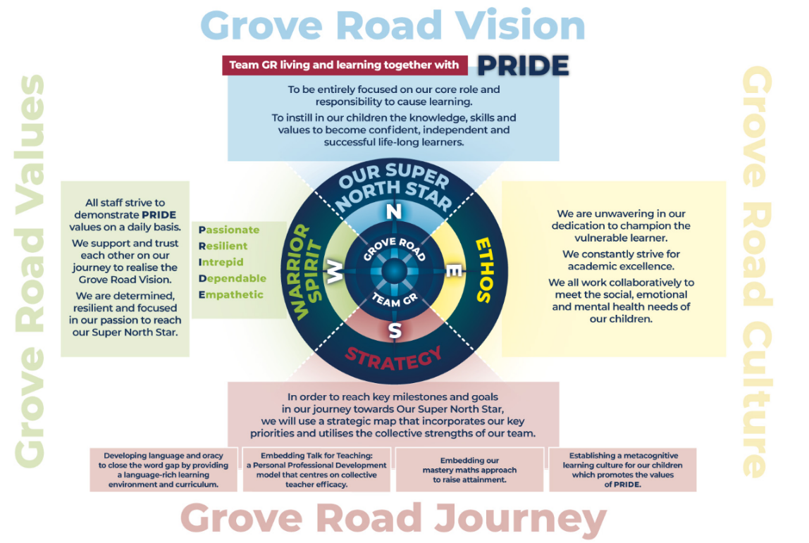

We encourage all children to embrace the values of PRIDE

**P**assionate – Think big, dig deep, aim high. We have ambition to achieve our goals.

**R**esilient – We show “grit” and a determination to succeed.

**I**ntrepid – We are brave and bold; we dare to seek challenge.

**D**ependable – We seek out opportunities to prove ourselves to be honest, trustworthy and responsible.

**E**mpathetic – As a team, we support each other – working together and looking after each with kindness and understanding.

[Read more about our Vision and Values here](https://groveroad.n-yorks.sch.uk/our-school/vision-values)

## Application Process

**Closing date:** Tuesday 10th June

**Interview date:** w/c 16th June

Please note we do not accept CV’s.

Please apply via NYC Jobs. However, please contact us if you need to apply in a different format.

**When applying please take into account the following:**

**Supporting Information**

Every post advertised is supported by a full person specification. The specification lists all the essential skills, experience and qualifications which are necessary for the job and the criteria against which you will be assessed, both through your application form and at interview.

As part of the application process, you may have been asked to demonstrate within this application form how you meet some or all of the criteria or key competencies outlined in the person specification. Rather than simply repeating your career history, look at the skills and experience required by the job and provide evidence that you possess them by giving **specific and detailed examples** which include a focus on outcomes and on your own contribution to the scenario. In addition, consider how you can apply this to the school from any prior knowledge and your research into the position. Try to use different and varied examples wherever possible.

When completing these sections, do not forget the skills and experience you have gained outside full-time work. Outlining your previous work experience or other responsibilities may help you to uncover skills which you have taken for granted and which are clear signs of your ability to do the job.

**References**

When completing your application, please provide two employment referees. Generally, this is your current and most recent employer and a person in a position of authority.

**Job Description**

**Statutory**

1. To fulfil all the requirements and duties as set out in the School Teachers’ Pay and Conditions Document relating to the Conditions of Employment of Headteacher.

2. To seek to achieve any performance criteria, objectives or targets agreed with or set by the School’s Governing Board in accordance with the requirements set out in the agreed School Teachers’ Pay and Conditions Document and ensure that the school is compliant with all statutory guidance and legislation.

3. To promote and safeguard the welfare of all children and young people within the School, by ensuring that the School’s policies and procedures relating to safeguarding children and child protection are fully implemented and followed by all staff; resources are allocated to allow staff to discharge their responsibilities; and that staff, pupils, parents and other stakeholders feel able to raise concerns and that these are addressed sensitively and effectively. The Headteacher will be appointed to the role of Designated Safeguarding Lead for the school.

The School's Governing Body wish a particular emphasis to be placed upon the following:

1. To meet the National Standards for Headteachers as published by the DfE.
2. To raise standards across the school with particular reference to academic performance so that all pupils achieve to the very best of their ability.
3. To lead in the provision of and delivery of excellent learning and teaching.
4. To establish a vision for school improvement and to lead the staff and Governing Board to plan, implement, review, and evaluate the impact of the School Development Plans.
5. To be accountable to the School’s Governing Board on progress made against School Development Plan objectives, making recommendations as to future priorities and actions based on robust evidence-based self-evaluation.
6. To further develop and extend partnership working with a variety of stakeholders and other bodies through co-operation and collaboration.
7. To establish a reflective culture through a process of rigorous self-evaluation, including quality assurance and performance management at all levels.
8. To develop, inspire and motivate effective teams to deliver high quality education and thereby raise standards across the school.
9. To manage the school’s budget to ensure efficient and effective use of resources in line with the School’s objectives and priorities.
10. To ensure the school always operates within the school’s policies and legislation
11. To take lead responsibility for safeguarding and child protection (including online safety and understanding the filtering and monitoring systems and processes in place).

These duties are neither exclusive nor exhaustive and the post holder will be required to undertake other duties and responsibilities as agreed with the employer. This Job Description may be amended at any time after consultation with the post holder and will be reviewed annually.

**Person Specification**

The Selection Panel will be looking for evidence that the candidate has demonstrated their ability to fulfil the following criteria within the National Standards for Headteachers.

|  |  |  |
| --- | --- | --- |
| **TECHNICAL** | | |
| **QUALIFICATIONS AND TRAINING** | **Essential on appointment** | **Desirable on appointment** (if not attained, development may be provided for successful candidate) |
| Qualified Teacher status | **X** |  |
| Further professional/academic study e.g. MA, SEND qualifications |  | **X** |
| Evidence of gaining NPQH or NPQEL qualificationor equivalent | **X** |  |
| Evidence of continuous professional development used to develop self and others including recent leadership training and development | **X** |  |
| **SKILLS AND KNOWLEDGE** | **Essential on appointment** | **Desirable on appointment** |
| A detailed understanding of current legislation relating to schools and of national and local education priorities | **X** |  |
| Up-to-date knowledge of school improvement planning, evaluation, and quality assurance processes | **X** |  |
| Knowledge of the statutory documentation and legislation applicable to the leadership and management of schools e.g child protection, the SEND Code of Practice, inclusion and health and safety | **X** |  |
| An excellent understanding of outstanding curriculum design and implementation appropriate for the setting | **X** |  |
| Knowledge of a range of effective communication strategies including for developing and maintaining high standards of attainment, behaviour, and attendance appropriate for the setting | **X** |  |
| Up-to-date knowledge of research relating to education and of current and emerging Ofsted policy and practice | **X** |  |
| **SAFEGUARDING**: Demonstrate a secure commitment to safeguarding and the welfare of children and young people | **X** |  |
| **SAFEGUARDING:** Form and maintain appropriate relationships and personal boundaries, demonstrating and maintaining appropriate authority | **X** |  |
| **SAFEGUARDING:** Secure knowledge of current statutory safeguarding guidance for schools and understanding of the strategic and operational management of safeguarding to protect the health and wellbeing of children and young people, and staff. | **X** |  |
| **EXPERIENCE** | | |
|  | **Essential on appointment** | **Desirable on appointment** |
| Successful experience of workforce development, that includes performance management and the supervision of staff wellbeing and workload | **X** |  |
| Experience of using data, and other contextual information insightfully to meet challenging targets | **X** |  |
| Experience with whole-school organisational management, ensuring systems, processes and policies are effectively developed and implemented | **X** |  |
| Evidence of communicating and working effectively with staff, governors and other key stakeholders in school and externally | **X** |  |
| Experience of implementing professional development strategies for staff to ensure quality provision and outcomes for pupils | **X** |  |
| Experience of an Ofsted inspection at a leadership level | **X** |  |
| **APTITUDE** | | |
|  | **Essential on appointment** | **Desirable on appointment** |
| The ability to develop and maintain skills to enable successful partnerships and collaborative working to improve the quality of education and outcomes for all children and young people | **X** |  |

There will be a particular focus on the following key competencies:

|  |  |
| --- | --- |
| **COMPETENCIES** | |
| **Key Competencies identified to be assessed** | **Essential on appointment** |
| Decision making and calculated risk taking | **X** |
| High expectations of self and others | **X** |
| Skilful communication according to audience | **X** |
| Organisational sensitivity | **X** |
| Building effective teams | **X** |
| Seeks organisational reflection | **X** |

**APPLYING FOR A JOB WITH NORTH YORKSHIRE COUNCIL**

**IMPORTANT ADVICE ON COMPLETING THIS APPLICATION**

Your application form plays an important part in your selection. Please ensure you address all the essential requirements listed in the specifications. The following advice should help you to complete the application form as effectively as possible.

**Data Protection**

The information that you state on this application form will be used by the school and the Council to consider you for a job vacancy. To find out about how we use your personal data for the purposes of recruitment please see our Privacy Notice at [www.northyorks.gov.uk/working-us](http://www.northyorks.gov.uk/working-us).

**Rehabilitation of Offenders**

The post you are applying for requires you to have an enhanced Disclosure and Barring Service criminal records check for work with children, with a barred list check if you work in regulated activity. This check for disclosure of criminal history will include spent convictions, pending prosecutions / current court proceeding and police enquiries.

Should you be shortlisted, you will be asked to disclose full details of your criminal history prior to your interview. This includes any information deemed relevant as part of Keeping Children Safe in Education which may arise in an online search undertaken on shortlisted candidates. This information may be discussed with you at your interview in order to assess job related risks, but we emphasise that your application will be considered on merit and ability and you will not be discriminated against unfairly. Failure to disclose this information will result in any offer of employment being withdrawn.

Please also see the policy statement on the Recruitment of Ex-offenders below.

**Canvassing**

You must not try to influence an elected Council Member, any council employee or a member of the school governing body, to act in your favour, as this will disqualify you. If you are related to a Councillor, a Council employee or a governor you must indicate this in the relevant section of the application form.

**Policy Statement on the Recruitment of Ex-offenders (Source** [**www.gov.uk**](https://www.gov.uk/government/publications/dbs-sample-policy-on-the-recruitment-of-ex-offenders/sample-policy-on-the-recruitment-of-ex-offenders)**)**

1. As an organisation assessing applicants’ suitability for positions which are included in the Rehabilitation of Offenders Act 1974 (Exceptions) Order using criminal record checks processed through the Disclosure and Barring Service (DBS), this school complies fully with the DBS [code of practice](https://www.gov.uk/government/publications/dbs-code-of-practice) and undertakes to treat all applicants for positions fairly.
2. This school undertakes not to discriminate unfairly against any subject of a criminal record check on the basis of a conviction or other information revealed.
3. This school can only ask an individual to provide details of convictions and cautions that it is legally entitled to know about. Where a DBS certificate can legally be requested (where the position is one that is included in the Rehabilitation of Offenders Act 1974 (Exceptions) order 1975 as amended, and where appropriate Policy Act Regulations as amended) this school can only ask an individual about convictions and cautions that are not protected.
4. This school is committed to the fair treatment of its staff and potential staff, regardless of race, gender, religion, sexual orientation, responsibilities for dependents, age, physical/mental disability or offending background.
5. This school has this written policy on the recruitment of ex-offenders, which is made available to all DBS applicants at the start of the recruitment process.
6. This school actively promotes equality of opportunity for all with the right mix of talent, skills and potential and welcome applications from a wide range of candidates, including those with criminal records. Candidates are selected for interview based on their skills, qualifications and experience and criminal record information is only requested from short-listed candidates.
7. A disclosure is only requested from the DBS after a thorough risk assessment has indicated that one is both proportionate and relevant to the position concerned. For those positions where a criminal record check is identified as necessary, all application forms, job adverts and recruitment briefs will contain a statement that a DBS certificate will be requested in the event of the individual being offered the position.
8. This school ensures that all those who are involved in the recruitment process have been suitably trained to identify and assess the relevance and circumstances of offences.
9. This school also ensures that they have received appropriate guidance and training in the relevant legislation relating to the employment of ex-offenders, e.g. the Rehabilitation of Offenders Act 1974.
10. At interview, or in a separate discussion, this school ensures that an open and measured discussion takes place on the subject of any offences or other matter that might be relevant to the position. Failure to reveal information that is directly relevant to the position sought could lead to withdrawal of an offer of employment.
11. This school makes every subject of a criminal record check submitted to DBS aware of the existence of the [code of practice](https://www.gov.uk/government/publications/dbs-code-of-practice) and makes a copy available on request.
12. This school undertakes to discuss any matter revealed on a DBS certificate with the individual seeking the position before withdrawing a conditional offer of employment.